Remove Watch Items from To Do List in Ariba Quick Reference Guide
Last Updated: 07/2023
This QRC provides the steps to remove watch items from the To Do list on your Home tab dashboard.

Access Ariba
Visit the OneCampus Portal and select Procurement – Ariba. | https://one.purdue.edu/
Log in using your Purdue Career Account Username and Password.  Click Log in. | 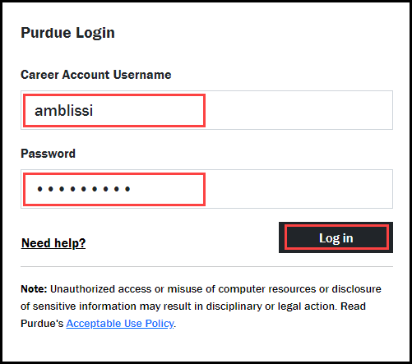

Remove Watch Items
Select the Home tab. | 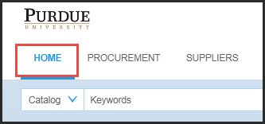
Click View All in the To Do box. | 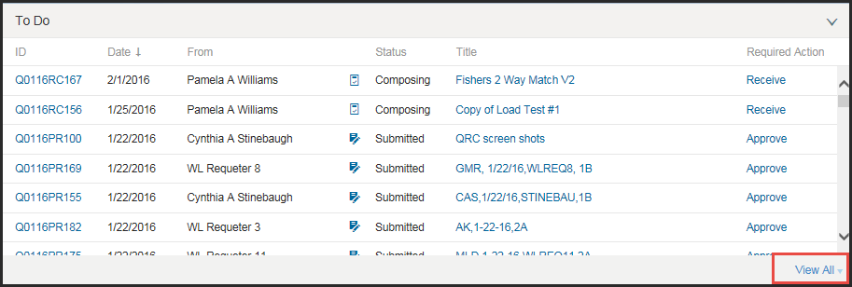
Select Watch from the drop-down. | 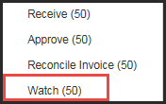
Click the checkbox next that correspond to the document(s) to remove.  Click Archive to Label and select Archive Items from the drop-down. | 