New Ariba Purchase Order (PO) Supplier Request Form Quick Reference Guide
Last Updated: 08/18/2020
This QRG provides the basic steps to prepare and submit a new supplier request. This document is a power form and is submitted using DocuSign.
Jump Links: Access Form, Complete Form, Attachments, Submission, Approvals

Access Form
Launch the form. | New PO Supplier Request Form
Enter Your Name and Email.  NOTE: Include the name of the supplier following your name. This helps reference the form with the supplier when searching DocuSign.  Click Begin Signing. | 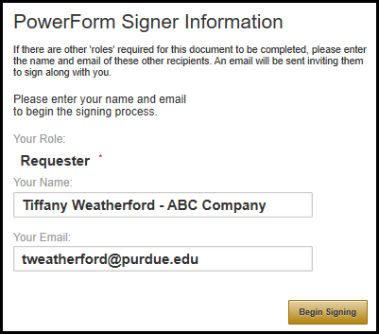
 | 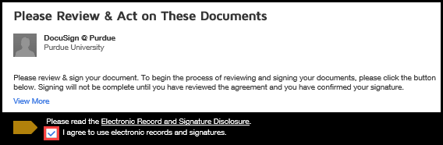
Click Continue to begin preparing the form.

Complete Form
Enter the Reason for requesting new supplier.  Mark the radio button to indicate if the request is being initiated by the Customer or as a Result of bid/contract process. | 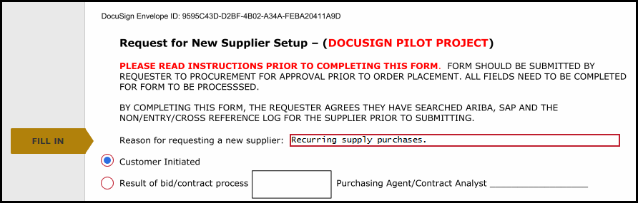
Enter Requester Information which includes:  - Contact name  - Department name  - Contact phone#  - Contact email | 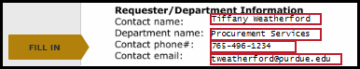
Enter Supplier Information, including:  - Supplier Contact name  - Supplier Contact Phone  - Supplier Contact Email  - Supplier Name  - Supplier Address  - Supplier Phone  - Supplier Email  - Supplier Fax  - Supplier Website | 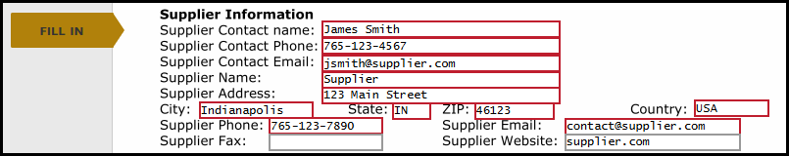
Complete the Supplier/Commodity Information:  - Total Price  - Description  - Is this a one-time buy?  - If no, Number of Annual Purchases and Total Annual spend.  - Have you used this supplier prior to the request? | 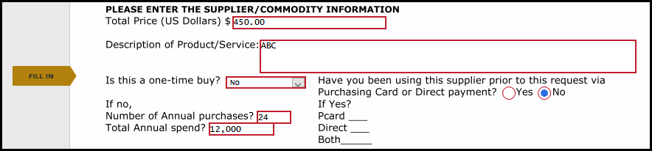
Current Supplier Information should be completed.  The intent of this section is to demonstrate existing Purdue suppliers have been reviewed for the product/service needed. This indicates due diligence in reviewing existing suppliers before asking for a new one. | 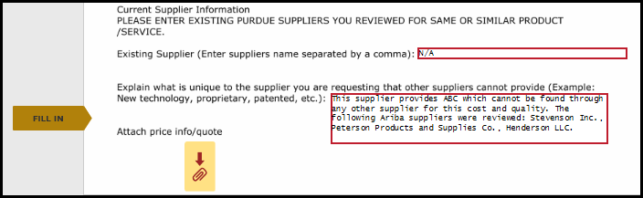

Attachments
Quotes and communications providing pricing details should be attached to the form, if applicable.  Click the paperclip icon. | 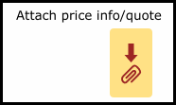
Click Upload A File. | 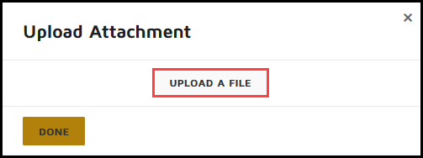
Click to select desired file.  Click Open. | 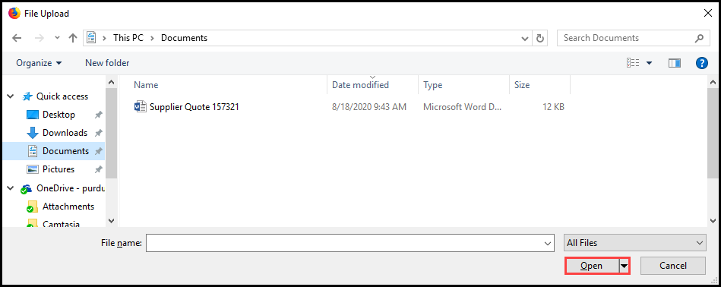
Attached file name is displayed.  Once all attachments are uploaded, click Done. | 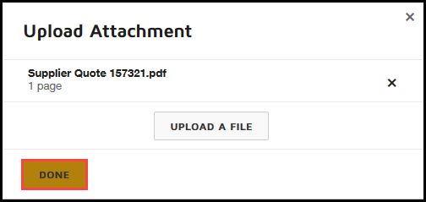

Submission
This page will be completed by Procurement Services. | 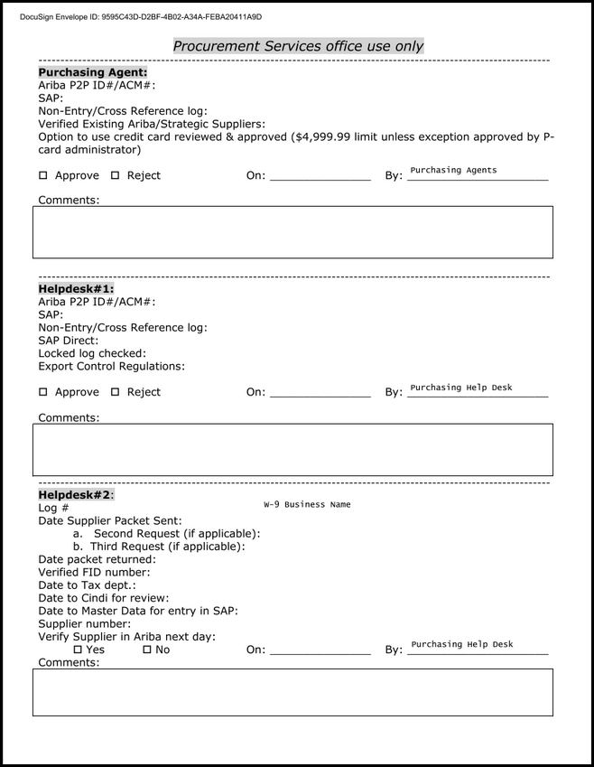
Click Finish to submit completed form.

Approvals
Purchasing Agent | A purchasing agent will review the request and approve or reject.  If approved, the request will move on to the helpdesk.  If rejected, the requester will be notified. A rejection could occur because the supplier is already in Ariba, an alternate supplier is available, or the use of the PCard or ZV60 is more appropriate.
Procurement Services Help Desk | The helpdesk will review the request and send a packet to the supplier.  Once the supplier has provided the necessary information and they are setup in Ariba, the helpdesk will notify the submitter that the supplier is ready for use.  Delays in the supplier returning the new vendor packet will result in delays in the setup process.

