Invoice Reconciliation Exceptions – Invoice Reconciler Quick Reference Guide
Last Updated: 07/2023
Roles: The P Invoice Reconciler role AND the attribute Invoice Reconcile with a cost center (assigned at the 4, 7 or 10 digit level) are required. To request roles use the SAP Identity Management system (IDM), for detailed instructions see the Request Business Roles QRG.
This QRC outlines the steps for those individuals with the Invoice Reconciler role to reconcile Invoice Reconciliation Exceptions, for fiscal and receiving; and approve the receiving exception in Ariba using the new invoice user interface.
NOTE: If at any time the variance cannot be resolved with the vendor, work with the appropriate Purdue Sourcing Specialist.
Business Process: This QRG is part of the Invoice Reconciliation Exceptions in Ariba business process.
Jump Links: Access Ariba, View List of Exceptions, Review Invoice Reconciliation Exceptions, Reject Invoice, Reconcile Invoice, PO Received Quantity Variance, PO Price Variance, PO Received Line Amount Variance, PO Quantity Variance, Shipping/Special Handling Variance, PO Payment Terms Mis-Match, Purdue Over-Tax, Withholding Tax-AP, Withholding Tax, Saving Invoice, Submit Invoice, View Invoice Status

Access Ariba
Visit the OneCampus Portal and select Procurement – Ariba. | https://one.purdue.edu/
Log in using your Purdue Career Account Username and Password.  Click Log in. | 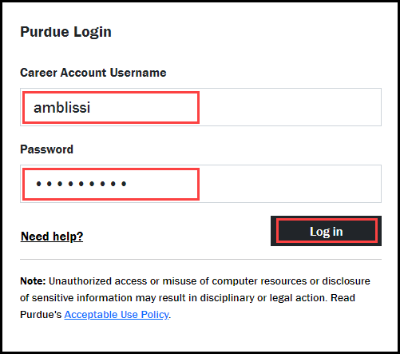

View List of Exceptions
Click the Home tab.
Locate the To Do tile.  To view all outstanding items with the Request Action of Reconcile, the tile settings must be changed. | 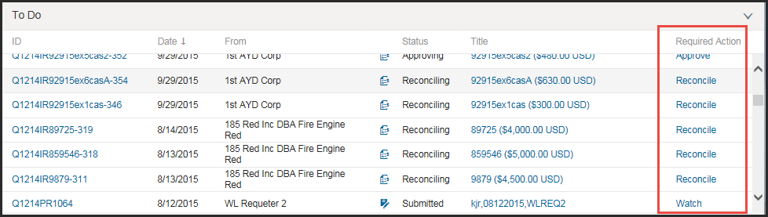
Click View All. | 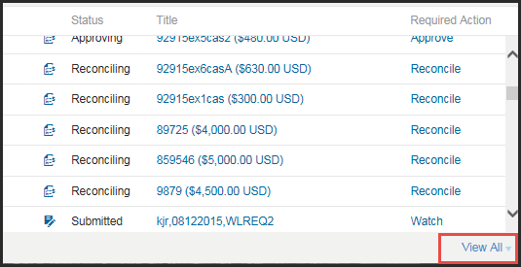
Select Reconcile Invoice from the drop-down. | 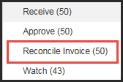
Click the arrow to expand Search Filters.  NOTE: Approvable Type should be Invoice Reconciliation. | 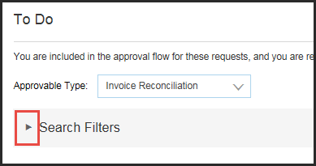
Select No Choice from the Invoice Date drop-down. | 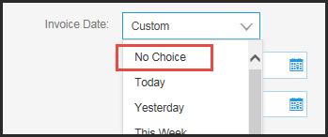
Click Search.
The full To Do List showing all outstanding invoice reconciliation exceptions is displayed.

Review Invoice Reconciliation Exceptions
All invoice exceptions are composed of the same pieces of data: Exceptions, Line View, Approval Flow, Reference, and History.
To view the exception, click Actions next to the exception to view and select Reconcile from the drop-down. | 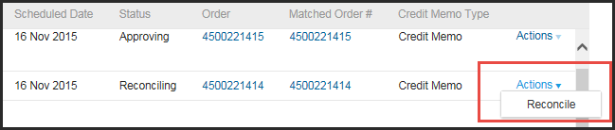
The Exceptions tab contains the following information:  - Invoice ID and Purchase Order  - A link to Header Information  - Number of Exceptions Assigned to Me  - List of All Exceptions | 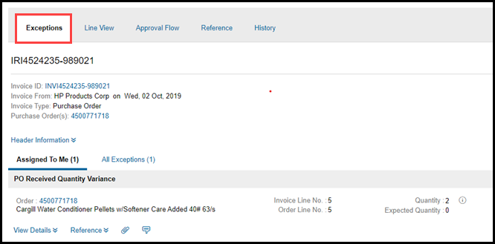
The Line View tab contains the following information:  - Header Information  - Line Items with open exceptions | 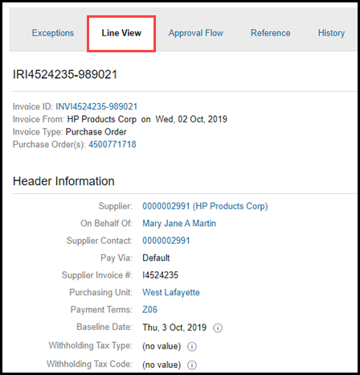
The Approval Flow tab contains a list of all required Approvals for the PO. | 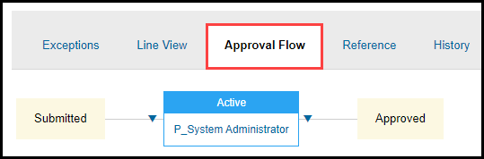
The Reference tab contains the following information:  - Order ID/PO  - Receipt(s) ID  - Invoice ID | 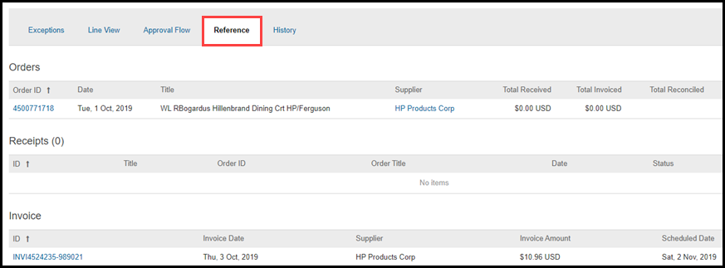
The History tab contains a list of activity for the exception. | 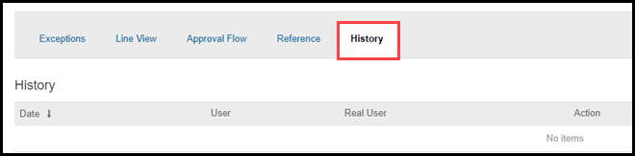

Reject Invoice
If the invoice is incorrect with the wrong price or quantity or it is a duplicate, it should be rejected. Delayed delivery of items is not a reason for rejecting an invoice. An invoice should not be rejected if it will eventually be paid.
The status of the exception must be Reconciling or Approving to reject.

Click Actions next to the exception to view.

Select Reconcile from the drop-down.
Click Open. | 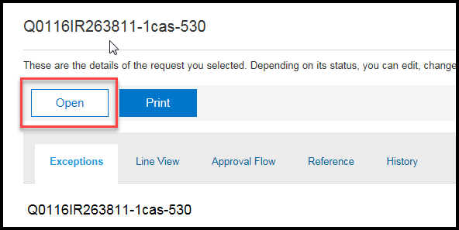
Click Reject. | 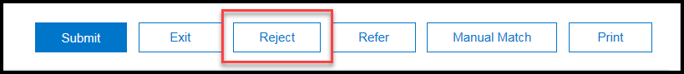
If the supplier is on the Ariba network, enter Comments in the Comments to Supplier text entry box.  NOTE: If the Comments to Supplier box is missing, the supplier is not on the Ariba network and cannot receive notes within Ariba. Contact supplier directly to request revised invoice, if necessary. | 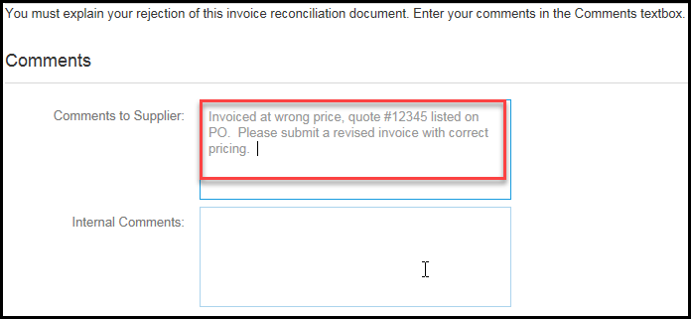
Enter any additional notes in the Internal Comments text entry box. | 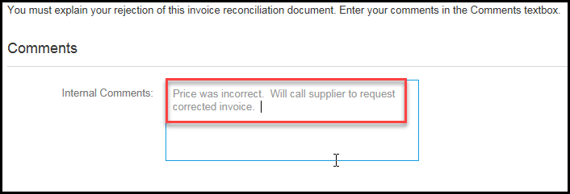
Click Submit. | 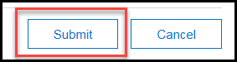
Click View to view the status of the request. | 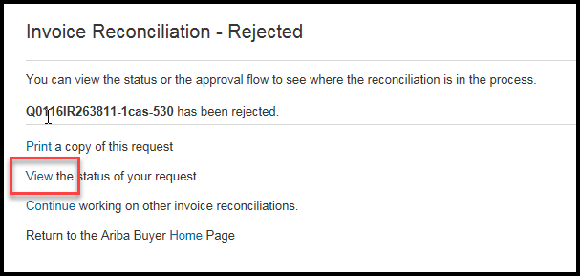
The Approval Flow tab shows the approval as Rejected. | 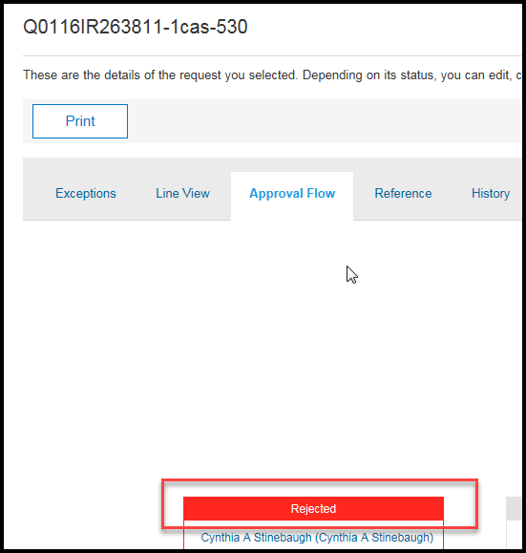

Reconcile Invoice
Click Actions next to the exception to view.

Select Reconcile from the drop-down.
All exceptions for the PO are listed using the Variance Name. | 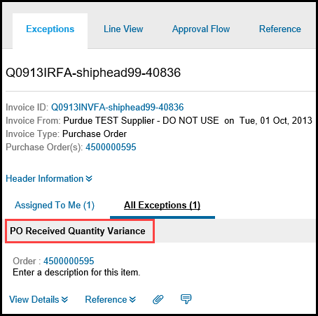
Once ready to accept the variance click Action and select Accept Invoice Amount from the drop-down. | 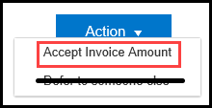
Once the variance is accepted, a green check with Amount Accepted will appear. | 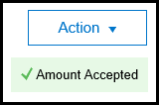
Click Comment icon.
Enter comment for each variance.  Example: Price variance was accepted by Requester Name.  Click Add Comment. | 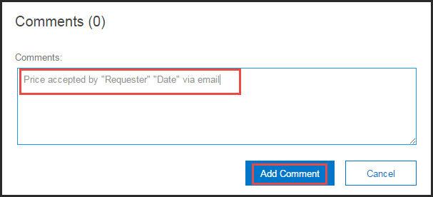
Exceptions with comments will have a numeric indicator next to the Comment icon.
To add an attachment, click the Paperclip icon.
If more than one variance exists for the same PO, repeat the steps above for each variance before submitting the IR document.

PO Received Quantity Variance
Item(s) have not been received in Ariba. The Invoice Reconciler should contact the Receiver to process the receipt. Only processing a receipt will clear this exception.
Review to see if the item(s) have to be received by the receiver.
- PO’s $250 or less – will be auto received.
- PO’s over $250 – check with the requester to see if the order is ready to be received; once the item(s) have been received in Ariba by the receiver, the exception status will change to cleared and the IR document status will change to approving or paying if no errors or other issues exist.
  - If other exceptions exist, the exception will still appear in the To Do tile until all outstanding exceptions are fully reconciled.
NOTE: For the PO Received Quantity Variance exception, no action is required by any fiscal approver.
If this exception is raised and the item(s) have not been received, contact the vendor and inquire about shipment.
If the item or items were returned, contact the vendor for a credit memo. Once the credit memo posts in Ariba, the receiver will need to process a receipt and then process a reversal. This action will clear the exception.

PO Price Variance
Invoice is 15% or $100 more than the purchase order (PO).
If requester accepts the price difference, add comment to variance and accept.
If requester does not accept the price difference, work with the vendor to obtain credit memo.
Once the appropriate credit memo posts, accept the exception.

PO Received Line Amount Variance
A line item price is 15% or $100 more than the line item on the purchase order (PO).
If requester accepts the price difference, add comment to variance and accept.
If requester does not accept the price difference, work with the vendor to obtain credit memo.
Once the appropriate credit memo posts, accept the exception.

PO Quantity Variance
Invoice quantity line is more than the quantity on the purchase order (PO) and/or receipt line.
If requester intends to keep the extra items, add comment to variance and accept.
If requester does not accept the extra items, work with the vendor to obtain credit memo and process return.
Once the appropriate credit memo posts, accept the exception.

Shipping/Special Handling Variance
Invoice shipping or special handling amount is greater than $250.
If requester accepts shipping/special handling amount, add comment to variance and accept.
If requester does not accept the shipping/special handling amount, work with the vendor to obtain credit memo.
Once the appropriate credit memo posts, accept the exception.

PO Payment Terms Mis-Match
The payment on the invoice does not match the payment term on the PO. Only the Accounts Payable department can resolve this exception.

Purdue Over-Tax
The vendor is charging tax on the invoice. Only the Accounts Payable department can resolve this exception.

Withholding Tax-AP
The vendor is marked as a withholding vendor. The Accounts Payable department needs to verify the amount that should be reported on a 1099. Only the Accounts Payable department can resolve this exception.

Withholding Tax
The commodity code is service related but the vendor is not marked as a withholding vendor. Only the Tax Department can resolve this exception.

Saving Invoice
If some of the exceptions are still outstanding, the invoice cannot be submitted and should be saved.
Click Exit.
Click Save. | 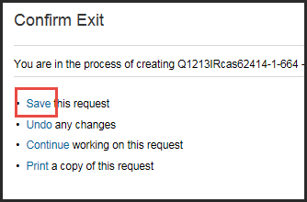

Submit Invoice
Once all exceptions are accepted the invoice can be submitted.
After all exceptions have been accepted, a message indicating The invoice is now reconciled. will appear in the upper left-hand corner.
Click Submit.

View Invoice Status
After submitting, the invoice moves on for Fiscal Approval. Follow the steps below to view the status of the approval.
Click View. | 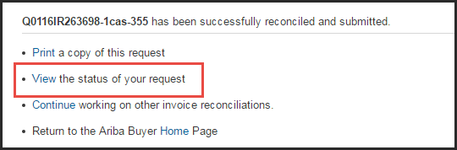
The IR document status will change to Approving. | 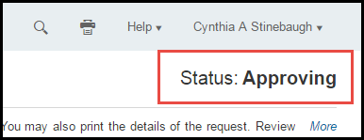
The Approval Workflow is displayed, showing a list of approvers at each level and noting at which approval step the invoice sits. | 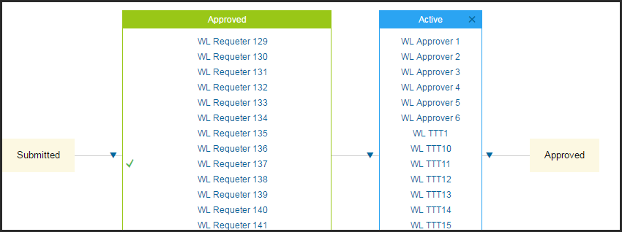
Once all approvals are obtained, the invoice will move to Paying status.

