
Textbook Management System
Updated 09/17/2024 post Grails 5 Upgrade
Chris Marheine

Table of Contents

Getting Started 2
Getting Started 2
Textbook Management Functionality 2
Dashboard Tab 2
Material Maintenance Tab 4
• Export Materials 4
• Cell A1 in the spreadsheet must say Campus:**(See NOTE above) 5
• Cell B1 in the spreadsheet must use the Campus abbreviation (PWL, CEC or TLF) **(See NOTE above) 5
• Cell C1 in the spreadsheet must say Term: **(See NOTE above) 5
• Cell D1 in the spreadsheet must say the term and year (ex. Spring 2015) **(See NOTE above) 5
o If a course is cross-listed, only the controlling course can enter the textbook information. If your course is not the controlling course, you should not enter any information. The Dashboard will show your course as still outstanding, but you should ignore this message. 6
o If a CRN has more than one textbook or supplemental material, add a row for each different item. 6
o If a professor offers several options for the same textbook or material, take one of these actions: 6
▪ List the information for one of these choices. Describe the remaining choices in the Notes and indicate that the student must pick one of the choices 6
▪ List each material’s information in a separate row. Put Optional in the Optional/Required column. In each of the Notes columns, tell the student that the textbook or material is required and he/she must pick one 6
o Save your file. Proceed to Batch Upload. Note: You do not have to be completely done entering information in order to upload what you have completed so far. 6
• Batch Upload 6
• View/Edit Materials 7
Help Documentation 15
• Chrome Settings 15
Cognos Reports 17
Cognos Reports 20

Getting Started
Open myPurdue, using the web browser of your choice
The link to the Purdue Textbook Mgmt tool can be found on the Academic Operations Hub card:
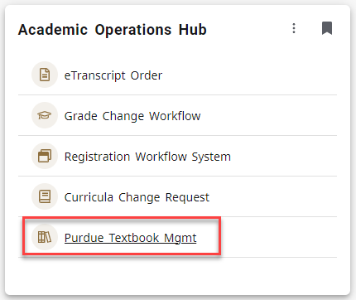
The system opens with the Dashboard page. The system also features the Maintenance tab.

Textbook Management Functionality

Dashboard Tab
- This tab will provide the statistics for each Textbook Coordinator’s department, indicating the percentage of gradable sections that have materials specified.
- Also, the Term and Campus selected on this tab will be the default (usually the current) term and campus on all subsequent tabs in the system. You can change each selection on any tab even though the default is set.
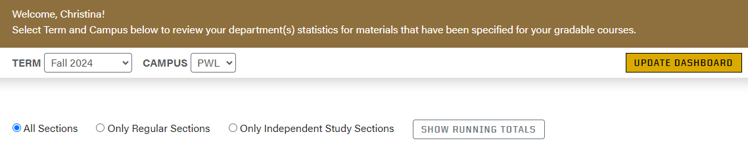
  - The information on the dashboard has the following features
    - Defaults to show “All Sections” (first radio button; as shown above)
    - Allows the user to toggle using the radio buttons to show “Only Regular Sections”, i.e. only gradable sections, not including independent study course, or show “Only Independent Study Sections”, i.e. exclude all sections except for independent study sections.
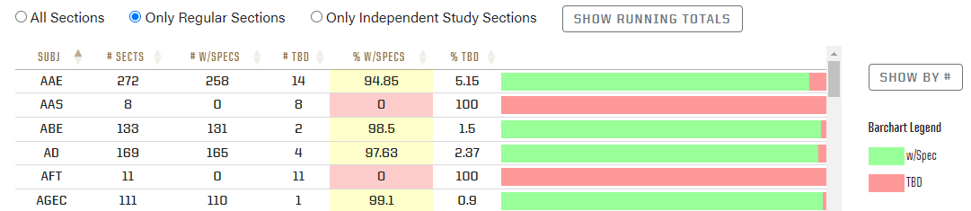
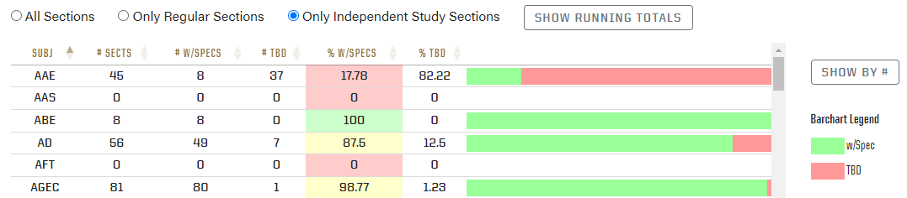
    - Is sortable by each column
    - By clicking on the “Show by #” button, the colored bar to the right will switch from % to the actual number of sections
Special Notes about the Dashboard:
The Dashboard is useful for tracking your textbook entry progress. However, there are some circumstances that will prevent you from showing 100% complete in the Dashboard. These circumstances are described as follows:
69800 and 69900 courses – At the beginning of each term, all 69800 and 69900 courses will be pre-populated with None (No materials required). These courses will be indicated as completed in the Dashboard.
Cross-listed courses – Only the textbook coordinator for the controlling subject for a cross-listed course should enter the textbook information for the course. This means the non-controlling subjects for this course will not show that this section is completed in the Dashboard.
Cancelled sections – If a section is cancelled, this section may continue to show as non-completed in the Dashboard.

Material Maintenance Tab
There are 3 options on this menu:
- The ability to Export currently defined material requirements for a specified term, campus and subject.
- The ability to Batch Upload an Excel file of material requirements for a specified term, campus and subject.
- The ability to add/view/edit materials for specified sections of a course for a given term, campus and subject using the View Materials option.
Each item is outlined more specifically below.
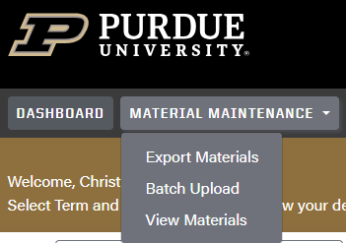
- Export Materials
  - Select Export Materials from the Material Maintenance tab
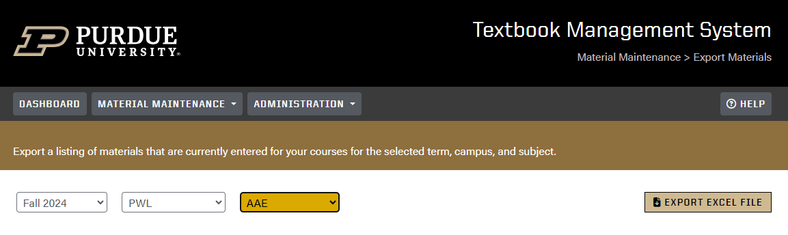
    - Select the desired term from the Term drop down menu
      - Only terms open for upload are available
    - Select the desired campus from the Campus drop down menu
      - Four campuses are available in the drop down: CEC (Continuing Education), PWL (Purdue West Lafayette), PIN (Indianapolis and W. Lafayette) and TLF (Lafayette Polytechnic)
    - Select the desired subject from the Subject drop down menu
      - Textbook Coordinators will only see their assigned subject areas in the drop-down menu
    - Click the EXPORT EXCEL FILE button
      - A new Excel file will open that will contain all gradable sections for the chosen subject and any existing material requirements. Note: Your department may choose not to print some gradable sections to the online Schedule of Classes. These sections will appear on your spreadsheet, but any information you enter for these sections will not appear in the Schedule of Classes.
      - If there are no requirements yet specified for the chosen campus, subject and term, the file will still export with only the header and rows for each gradable section. The Subject, Number, CRN and Instructor columns will be filled in. All of the columns headed Type through Notes will be blank.
      - NOTE: You may get a warning message when opening in Excel like the following. Select “Yes” to open the file:
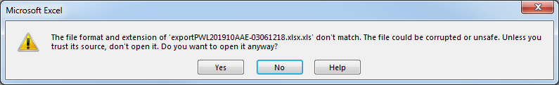
NOTE: Effective September 2024, the header looks different in the new version than it did in the old but the old format will work the same as the new format. Please continue to use the old format if you are using older files to prepare your upload for materials.
- Tips for Using the Exported Spreadsheet to Enter Textbook Information
    - Cell A1 in the spreadsheet must say Campus:**(See NOTE above)
    - Cell B1 in the spreadsheet must use the Campus abbreviation (PWL, CEC or TLF) **(See NOTE above)
    - Cell C1 in the spreadsheet must say Term: **(See NOTE above)
    - Cell D1 in the spreadsheet must say the term and year (ex. Spring 2015) **(See NOTE above)
- The spreadsheet name (see the lower left) must be Sheet1
- Column A Course Subject (these rows are prepopulated)
- Column B Course Number (5 digits; do not add more digits or delete digits)
- Column C CRN (5 digits; do not add more digits; these are drawn from the Banner system)
    - Replace the CRN with ALL when Columns E through N are the same for all of a course’s CRNs, then delete the remaining rows for that course
- Column D Instructor (last name, first name)
    - This information is for reference only. You do not need to change it if incorrect. This information is pulled from the master schedule of classes. If you are concerned about the name of the professor listed here, contact your schedule deputy.
- Column E Type (Textbook, Supplemental or None)
    - If Textbook is entered, an ISBN number must be entered in Column G, a title must be entered in Column F and either Required or Optional must be entered in Column L.
    - If Supplemental is entered, do NOT enter an ISBN number in Column G. A title must be entered in Column F and either Required or Optional must be entered in Column L.
    - If None is entered, “no course materials are required for this section” will display in the Schedule of Classes. Do not enter anything in Columns F through N.
    - If left blank, “to be determined; materials may be assigned at a later date” will display for this section in the online Schedule of Classes. Enter either textbook/supplement information or None as soon as the information is known.
- Column F Title
    - Textbook title or title/description of supplemental material
- Column G ISBN (13 characters that start with 978 or 10 characters that start with 0)
    - If after entering the ISBN you get an odd format like , enter ‘ before the number or enter a – between 978 and the rest of the number. (An alternate suggestion is to change the format for the entire ISBN column to Text.)
    - If using a ten-digit ISBN, enter ‘ before the ISBN number.
    - If the user receives an error message saying “One or more of the ISBN is a non-numeric character” when doing a Batch Upload, this means there is an issue with how the ISBN is expressed and the user should follow one of the steps above to fix the error.
- Column H Author (enter if known)
- Column I Edition (enter if known)
- Column J Year (if available)
- Column K Publisher (if available)
- Column L Required/Optional (one or the other must be entered for Textbook and Supplemental)
- Column M Good through Term (if available).
    - If an entry is made here, it must be expressed as the six-digit Banner Term Code (examples: the term code for Fall 2020 is 202110, the term code for Summer 2021 is 202130). If any other format is used, you will receive an error message when uploading.
- Column N Notes
    - Enter any additional information about the textbook or supplemental material that the students might find helpful. There is a limit of 255 characters.
  - If a course is cross-listed, only the controlling course can enter the textbook information. If your course is not the controlling course, you should not enter any information. The Dashboard will show your course as still outstanding, but you should ignore this message.
  - If a CRN has more than one textbook or supplemental material, add a row for each different item.
  - If a professor offers several options for the same textbook or material, take one of these actions:
    - List the information for one of these choices. Describe the remaining choices in the Notes and indicate that the student must pick one of the choices
    - List each material’s information in a separate row. Put Optional in the Optional/Required column. In each of the Notes columns, tell the student that the textbook or material is required and he/she must pick one
  - Save your file. Proceed to Batch Upload. Note: You do not have to be completely done entering information in order to upload what you have completed so far.
- Batch Upload
  - Select Batch Upload from the Material Maintenance tab
    - Select the Term and Campus
    - Browse for the file you wish to upload by clicking “Choose File” button.
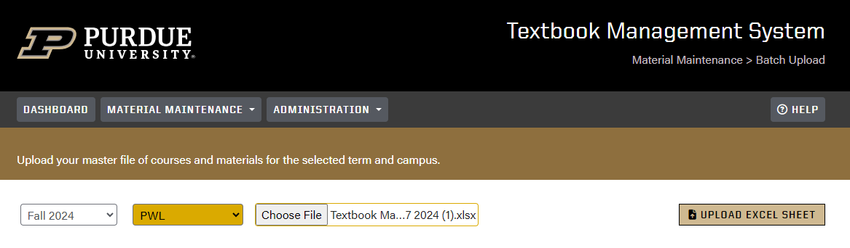
    - Once the file name is in the field, click the “UPLOAD EXCEL SHEET” button
      - There are a number of error conditions that can occur at this time
        - Campus and/or term in file do not match selected Campus and/or Term. The header record in your upload file must contain the same campus and term that you select in the TMS system during batch upload or you will receive this error message.
        - The filename of the file has too many characters
    - If there are no issues with the file itself, the materials will be uploaded successfully.
    - There are a number of transaction errors that can occur
        - Invalid CRN
        - One or more of the ISBN is a non-numeric character (See notes under Column G on page 6 for directions on how to fix this error.)
        - Missing subject
        - Invalid subject
        - Missing course number
        - Invalid course number
        - Missing CRN
        - Invalid ISBN
        - Invalid material type
        - Null material type
        - Missing ISBN
        - Missing title
        - Null required/optional field
        - Invalid value in required/optional field
        - Conflicting records for the same course, i.e. assign no materials to all CRNs in one entry and then assign a textbook to all CRNs in another entry
        - Duplicate material entry
        - Not authorized to add/edit/delete subject area
- View/Edit Materials
  - Go to the Material Maintenance tab, View Materials. This is where you can manage materials manually for a given term, campus, subject and course
    - Select the term, campus, subject and course and click “Search”
      - If there is more than 1 CRN for the selected subject and course, the drop down will populate with the list of gradable CRNs available. You do not have to select a CRN from the drop down if you want to apply the material to all of the CRNs.
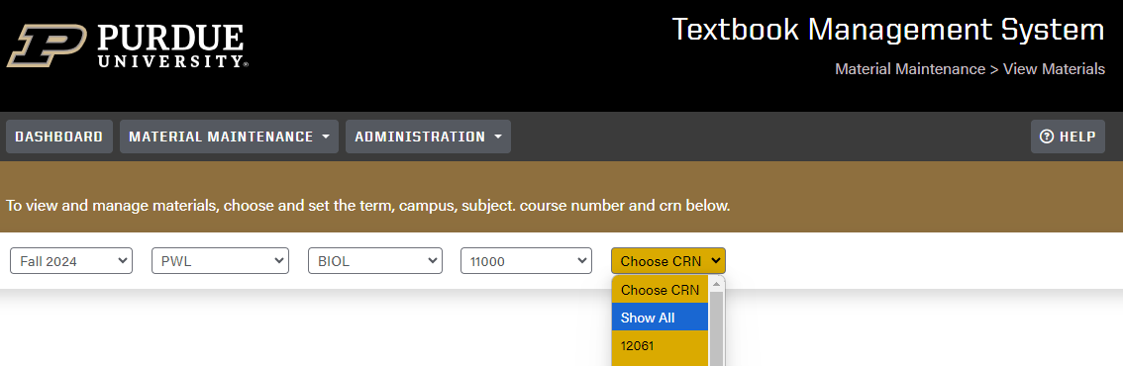
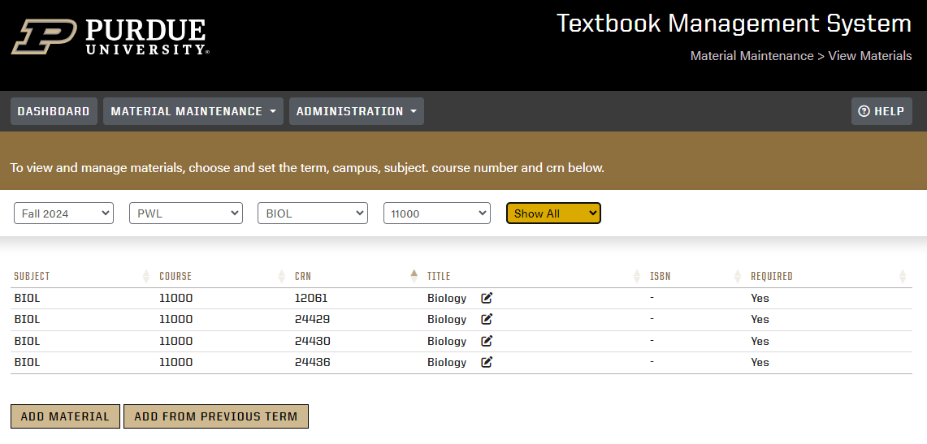
    - Select the action to be taken – add/edit
      - If a material exists, you will see it in the results section and you can select the edit icon to modify or delete it or you can click on Add Material to add another material to this course
      - You also have the option to add a new material by selecting the “Add Material” button
        - Selecting “Add Material” will open a window where you can enter the details of the material you wish to add
          - First select what you want to do
            - “I need to define a material”
              - This option tells the system that you would like to add materials to the selected course
            - “I need to state NO material”
              - This option tells the system that you want to explicitly indicate that there are no materials required for the selected course
          - To define a material:
            - Select the appropriate Type from the drop-down menu. The valid values are TEXT for textbook requirements and SUPP for any additional supplemental material requirements
            - If TEXT is chosen, enter a valid ISBN number. ISBN is required if TEXT is chosen
              - If you enter the ISBN number and click on “ISBN Lookup”, if it is a valid number, the details of the textbook will automatically populate. You have the ability to overwrite what is populated.
                - NOTE: The “ISBN Lookup” button will not assist you in finding a valid ISBN. Its only purpose is to find details of the provided, valid ISBN
                - If the ISBN entered is not valid, after clicking “ISBN Lookup”, a message will appear indicating such
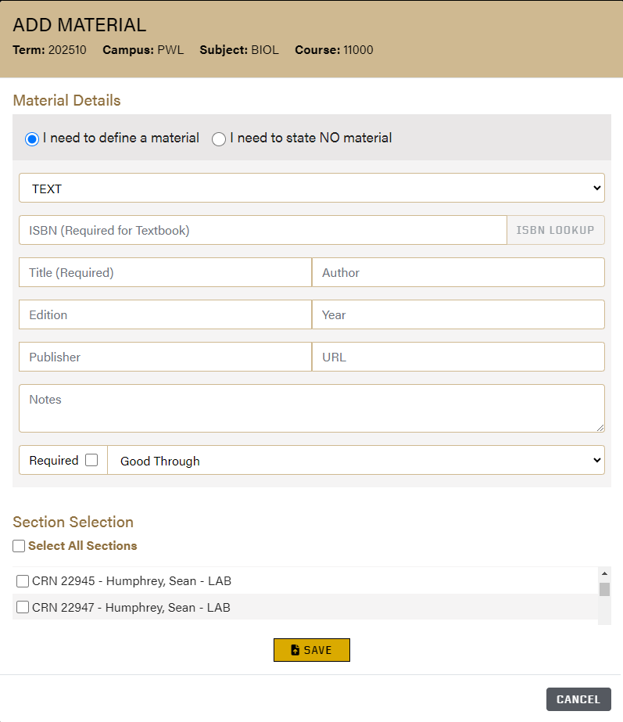
              - You may choose to enter all of the information manually as well but the ISBN data will not validate unless you click “ISBN Lookup”. If you’ve manually entered info and then select “ISBN Lookup”, the system will overwrite all information with the information found during the look up
          - At the bottom of this page you have the ability to add notes regarding the material, indicate whether the material is required and specify a valid good through term.
          - The Section Selection area is where you identify which specific CRN’s should have the specified material.
            - If the material applies to all sections, click the small box next to Select All Sections (Includes Future Sections) and click Save to apply the material requirements to all sections of the selected course
            - If you want to select which CRNs to apply the material specification to, uncheck the Select All Sections box and check the boxes next to only those CRN’s you wish to add the material to.
Add from Previous Term -- New Feature Starting January 27, 2020
The Textbook Management System was enhanced in January 2020 to allow users to select materials from a previous term in View Materials.

After selecting Term, Campus, Subject, Course and CRN, and clicking on Search, a button called Add from Previous Term will appear.
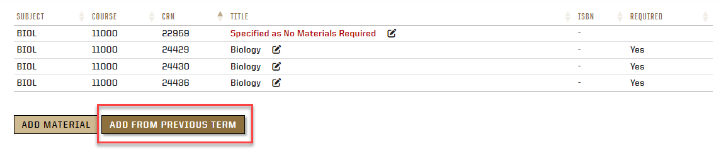
After clicking on Add from Previous Term, this box will appear:
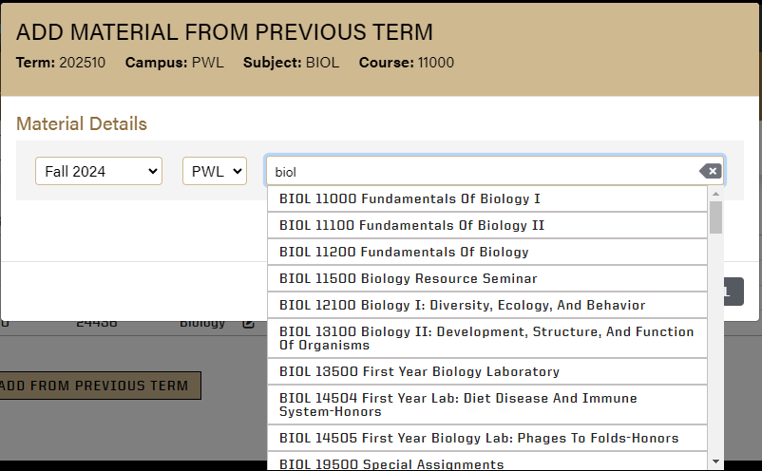

Start entering the course you wish to copy from in the course field. You’ll see the list of courses start to appear that you can select from.

The previous material will appear and will look similar to the example below.
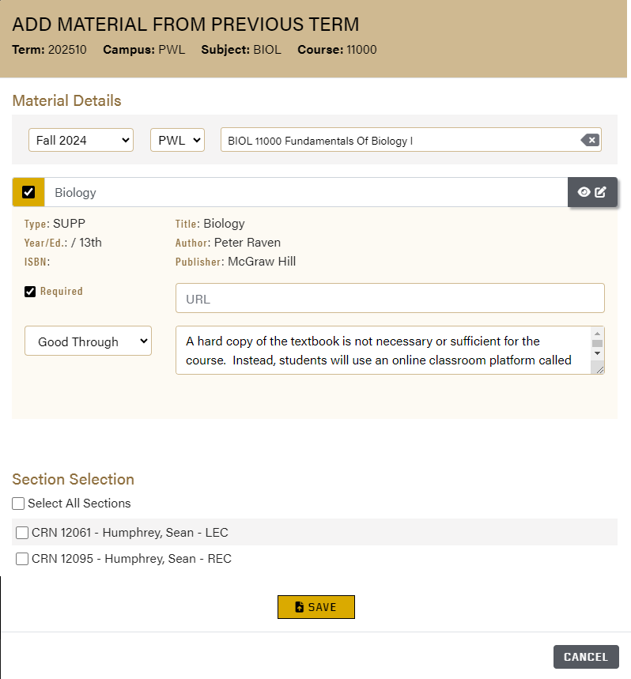

If this same material is being used again and is the only one that appears, the user can either check the box on the left side of the box.

If more than one item appears, and the user does not want them all entered, the user should click the box beside the item.

If more than one item appears, and the user wants to enter all of them, the user should click the gray box beside Select All.

Click on the Next button. A new box will appear that shows the textbook/material information the user has selected.

If the text or material is not being used by all of the sections, the user should click on the appropriate CRN or CRNs, then click on the Save button.

Printing the Add/Edit Materials screen

The Add/Edit Materials screen can be printed using your web browser. If you have print quality issues, try pressing Control+F5 to refresh your browser, then try to print the Add/Edit Materials screen.

Help Documentation
The Help link at the top of the page in the TMS system is a direct link to help documentation that can be accessed at any time within the application.
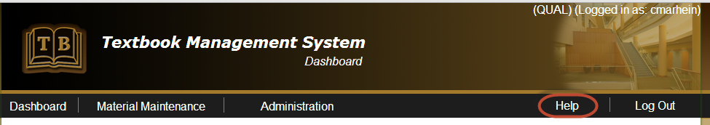
For users in Chrome, you may have to update your settings to allow the document to be accessible. Those instructions are below. Without completing these steps you can access the document by right clicking on the Help button in the application and choosing Save link as… and saving the document to a directory of your choice
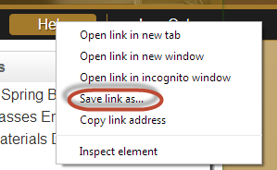
- Chrome Settings
  - Type “chrome://plugins” in the URL field after opening Chrome

  - Find Adobe Reader in the list of plug-ins and click Enable and check the Always allowed checkbox. Close Chrome and re-open it. The document should automatically open from this point forward
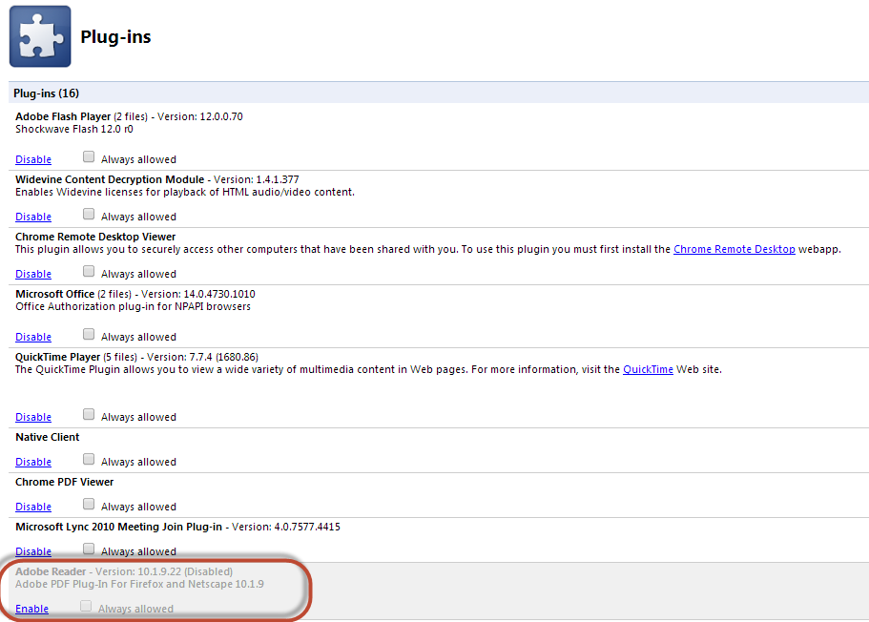

Cognos Reports
If a textbook coordinator has access to Cognos, two textbook-related reports are available. Instructions are as follows:
To obtain a list of CRNs With Materials Assigned:
Open Cognos.
Click on the Team Content folder on the left.
Click on Standard Content.
Click on Courses.
Click on Registration.
Click on Textbook Management.
Click on Course Materials Auditing.
You will get a selection screen.
At the top, click on the circle that says All CRNS with Materials Assigned.
Select your TERM:
Select your SUBJECT:
Click on Finish.
Your report will process and will eventually open. It shouldn’t take too long.
To obtain a list of CRNS Without Materials Assigned:
Open Cognos.
Click on the Team Content folder on the left.
Click on Standard Content.
Click on Courses.
Click on Registration.
Click on Textbook Management.
Click on Course Materials Auditing.
You will get a selection screen.
At the top, click on the circle that says All CRNS without Materials Assigned.
Select your TERM:
Select your SUBJECT:
Click on Finish.
Your report will process and will eventually open.
SPECIAL NOTE: This report will give you a listing of both gradable and non-gradable CRNs. Please disregard or remove the non-gradable CRNs from your final report. The Textbook Management System allows you to only enter textbook information for gradable sections. If you want to enter textbook materials for a non-gradable section, please send an email to janetm@purdue.edu. In the email, list the Subject, Course Number, and CRN of the non-gradable section you want to have added to the Textbook Management System.

