SIF Print User Document
- Login to myPurdue page.
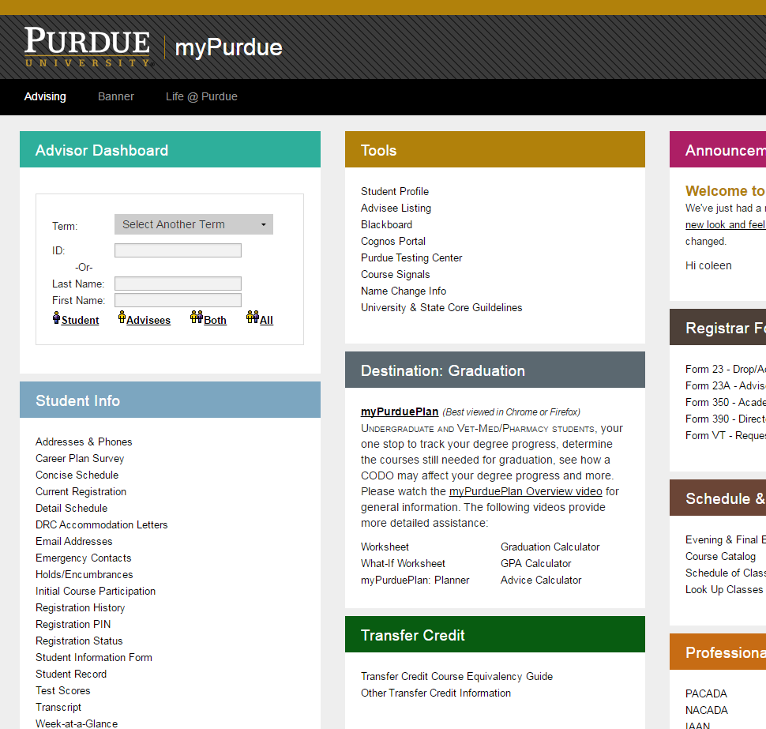
Website can also be accessed directly through the link https://www.purdue.edu/advisors/sif. Login to the site using CAS.
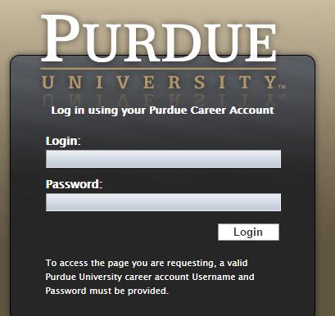
- Student List

List of all newly admitted students who has completed the SIF will be displayed when you login.

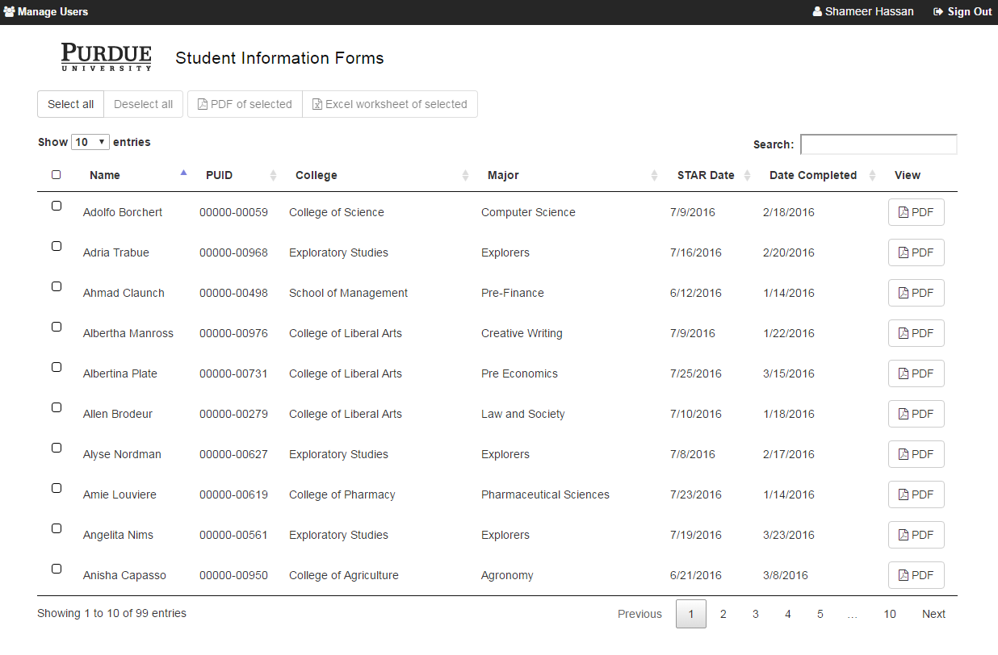

- Filter
To apply filter by college, type in the college name and if you want to further filter by major, continue typing major name.

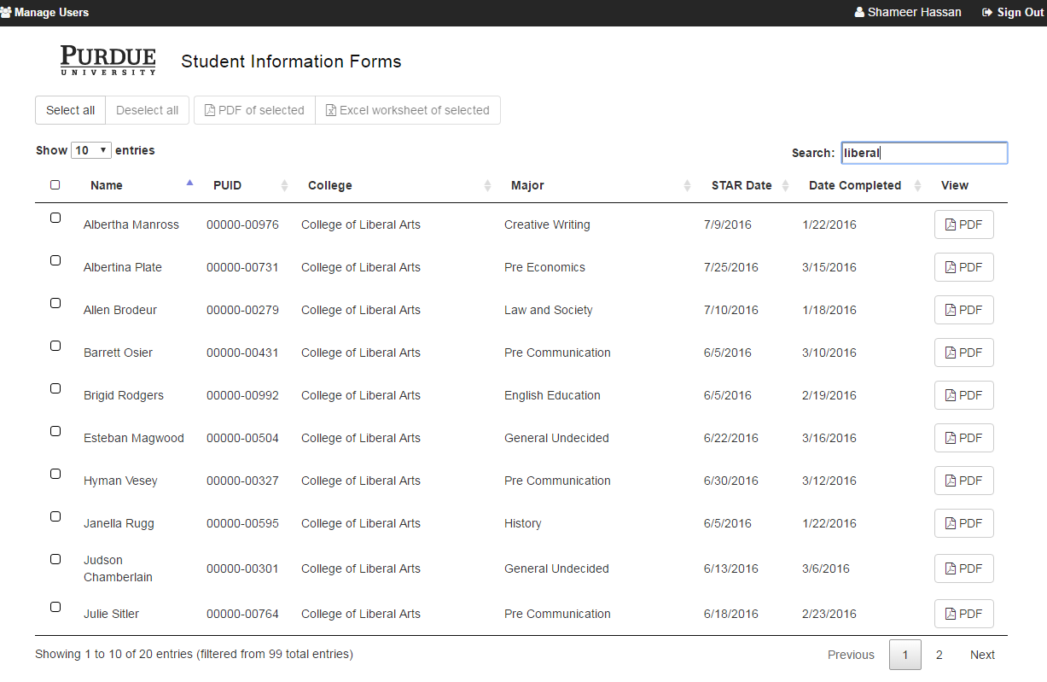
Filters can be entered here.

- View PDF
Individual PDF can be viewed or printed by clicking the 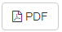button.

- Select all
Selects all the records that are available. If a filter is applied, the Select All will select only the records in the filtered group.

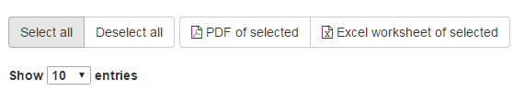
- Deselect all
Deselects the selection.

- Select all on the page:
The checkbox next to the Name will select records on the current page.
Number of Records displayed on page can be changed by changing the Show entries.

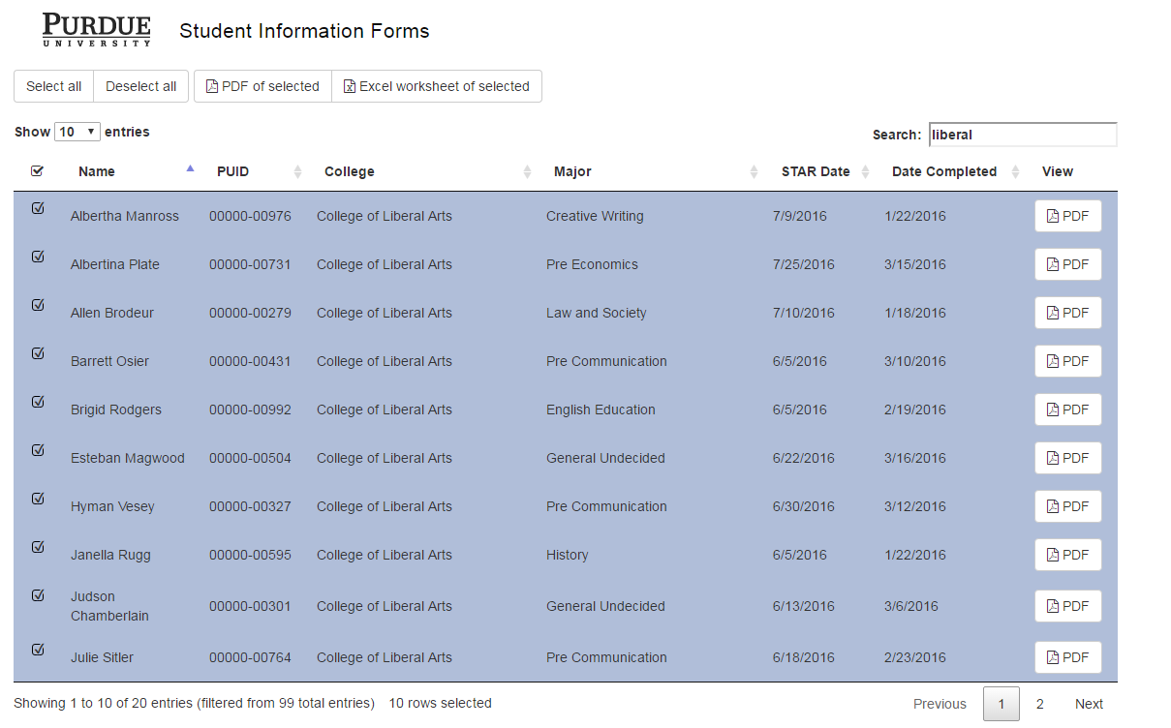
Click on this checkbox to select all the records on current page.
You can change the number of records displayed on the page by editing here.

- PDF of Selected
Will create a zip file with pdfs of the selected records. The pdfs are saved as individual files with PUID as the name. To print multiple files, extract the zip file, select the files in windows explorer and right click to print.
- Excel worksheet of selected
To print other labels, export the selected records to Excel using the button “Excel worksheet of selected”.

- Sort

By default, the records are sorted by Name. To sort, click on the column headers.
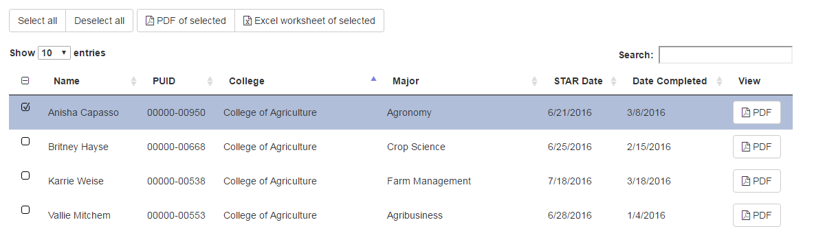
Click on the column header to Sort.
Blue arrow shows the sort order.

- Multiple Sort

To sort on multiple columns, use Shift key after the first sort.
For e.g., if you want to sort by College and then Major, sort College column first and use Shift and sort Major column.

