**Registrar/Advisor Gathering**

**Nov 8 2016 LWSN 1142**

**4:00 p.m. - 4:50 p.m.**

**Lesa’s Notes**

* **Update on myPurduePlan-Sandy**
  + Please use myPurduePlan issue log to submit inquires
    - Do not use email
    - Provide as much detail as possible including what block is being affected
  + Issues with catalog term, majors, minors in SFAREGS
    - myPurduePlan team cannot fix those issues. Please email Ryan Jones [rcjones@purdue.edu](mailto:rcjones@purdue.edu) or Nikki Zimmerman [nzimmerm@purdue.edu](mailto:nzimmerm@purdue.edu)
  + Programs vs Degree
    - See attachment for a sample of worksheet and plan
    - Will not affect existing Exceptions
    - More information to come as project progresses
    - Will be implemented Fall 2017
  + 0 credits with W or F grades
    - Should be corrected so W and F grades show up with 0 credits now
    - Vendor resolved the issue
  + Exception forms are now on myPurdue portal

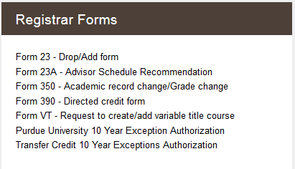

* **Reporting demo- Chris M.**
* **Change of Curricula** 
  + Major, minor, certificate, college change
  + Testing in November with some advisors from each college.
* Need help with event scheduling in Unitime, not sure where to go or what to do? Well come join us in a Unitime/Timetabling training. We will show you how to navigate the system from adding, modifying and even canceling an event. We’ll also show you some tips & tricks to make it a little easier.

[Untime training](http://www.purdue.edu/registrar/faculty/scheduling/unitime_training.html)

**Next meeting will be….**

|  |  |  |  |  |
| --- | --- | --- | --- | --- |
| Thurs | 8-Dec | 8:30 AM | 9:20 AM | MATH 175 (seats 180) |
| Thurs | 12- Jan | 10:00 AM | 10:50 AM | LSWN 1142 (seats 100) |
| Tues | 14-Feb | 8:15 AM | 9:15 AM | STEW 314 (seats 126) |
| Wed | 8-Mar | 3:30 PM | 4:30 PM | ARMS B 061 (seats 120) |
| Wed | 12-Apr | 10:30 AM | 11:30 AM | MATH 175 (seats 180_ |
| Mon | 8-May | 9:00 AM | 10:00 AM | ME 1130 (seats 120) |