**How to Waitlist….**

**From a student’s myPurdue portal, select Academic tab.

**Then click on Add or Drop Classes.

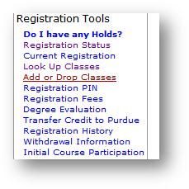

**Select appropriate semester and submit.

**Enter PIN if prompted.

**To determine if the class is eligible for waitlist….look at the WL Rem. (WL is not West Lafayette…but rather Wait List ☺ )

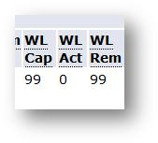

**Enter CRN to Waitlist and Submit Changes.

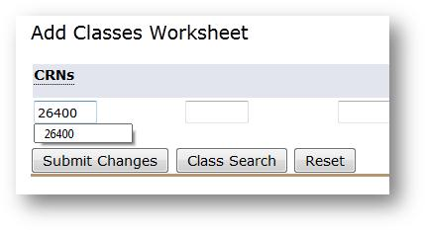

**When you get the following message, select Waitlist from the dropdown and submit changes.

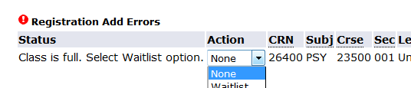

**Student now on Waitlist.

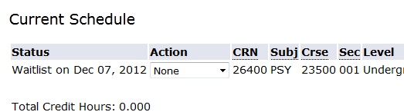

**Student can view Waitlist position from viewing schedule.

