How do I enable Turnitin Originality for a Brightspace assignment?
This article will overview how to enable originality checking for a Brightspace assignment.

Access the assignment
- Login to Brightspace and open the course where you would like to use Turnitin.

- From the course navigation bar, click Course Tools and select Assignments from the drop-down.

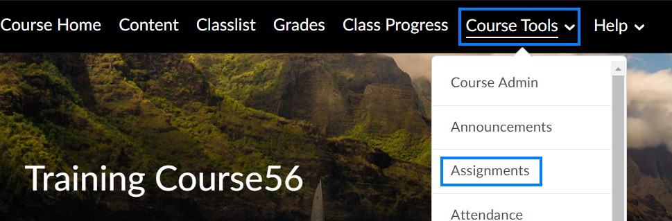

- Click New Assignment if the assignment has not yet been created. If the assignment has already been created, click the drop-down icon to the right of the assignment you will use Turnitin for and select Edit Assignment from the drop-down.

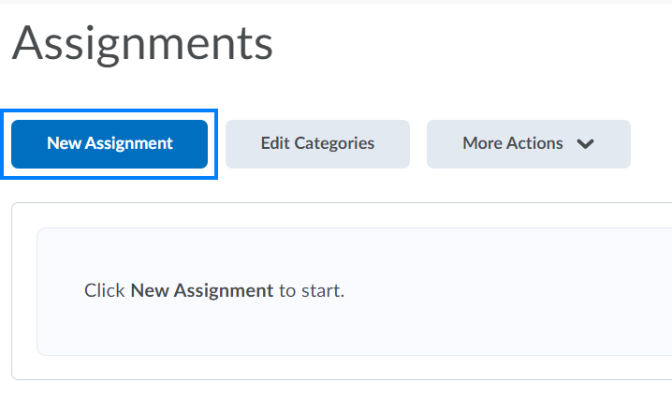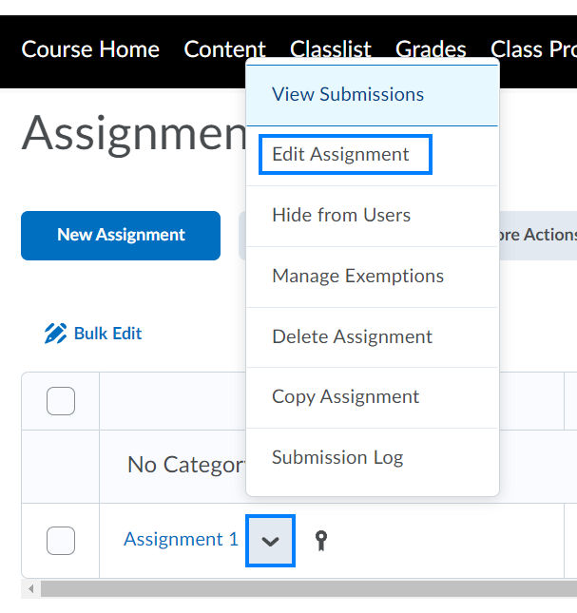

Establish the assignment settings
- From the Edit Assignment page, ensure the assignment has been named.

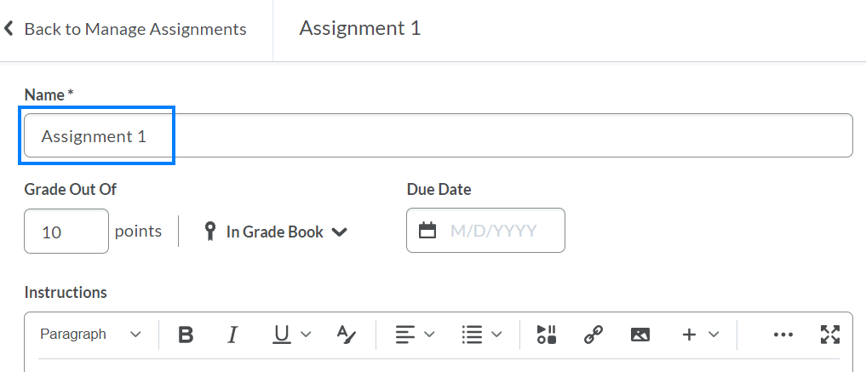

- Expand the Submission & Completion section on the right.

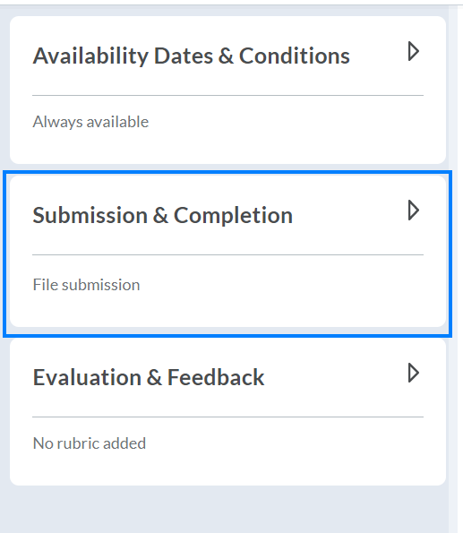

- Ensure the Submission Type is set to File Submission and the Files Allowed Per Submission is set to One File.

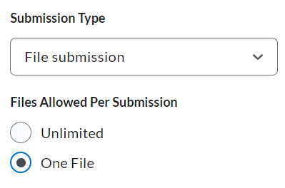

- Ensure the Allowable File Extensions is set to Compatible with Turnitin.

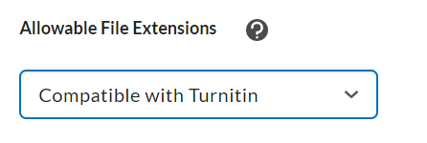

- Expand the Evaluation & Feedback section on the right.

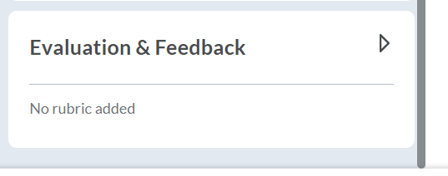

- Click Manage Turnitin.

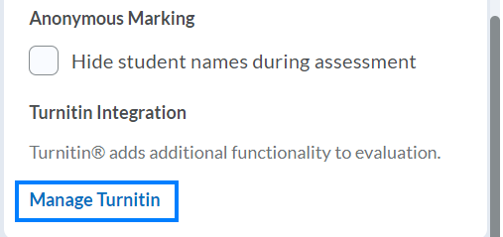

Establish the Turnitin settings
- Check the Enable Similarity Report for this folder option. This will enable Turnitin for this particular assignment.

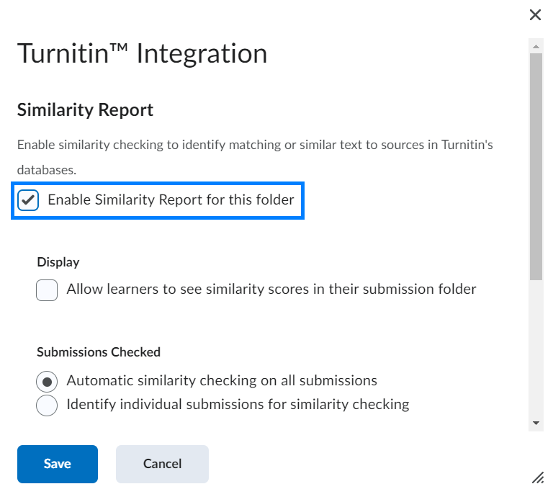

- If you would like to make the similarity score and report available to students, check the Allow learners to see similarity scores in their submission folder option.

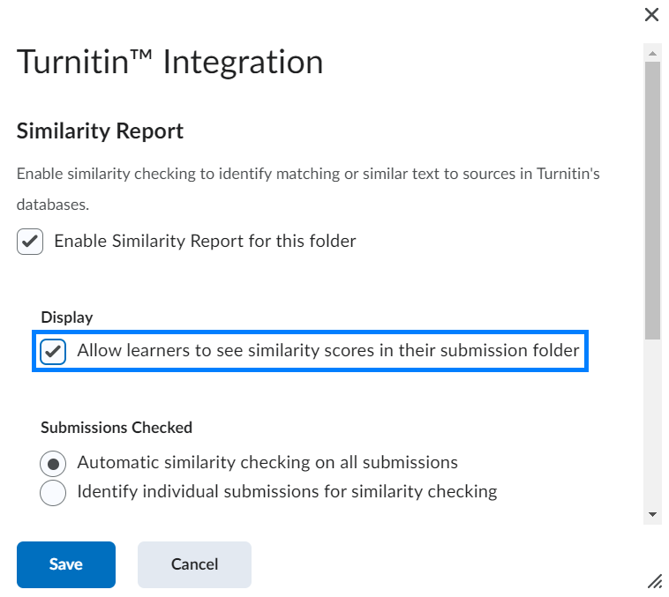

- If you would like to run Turnitin automatically for all student submissions, check the Automatic similarity checking on all submissions option. If you would like to run Turnitin only for specific student submissions, check the Identify individual submissions for similarity checking option.

PLEASE NOTE: We strongly encourage selecting the Automatic similarity checking on all submissions option. This checks all student submissions and helps avoid any potential conscious or unconscious biases.

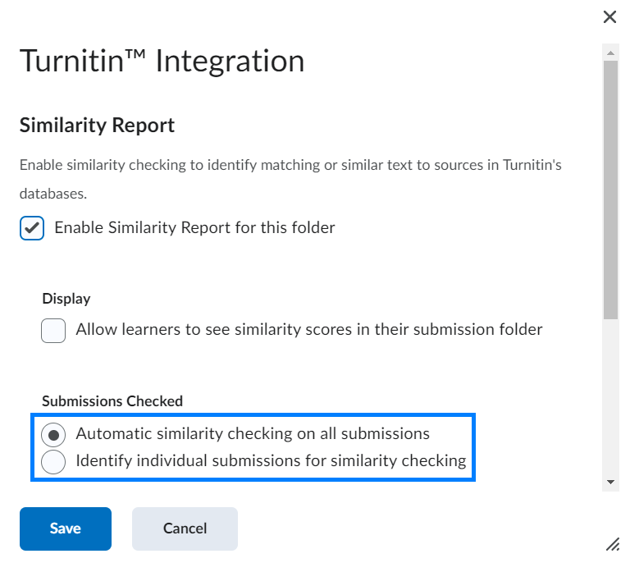

- Click More Options.

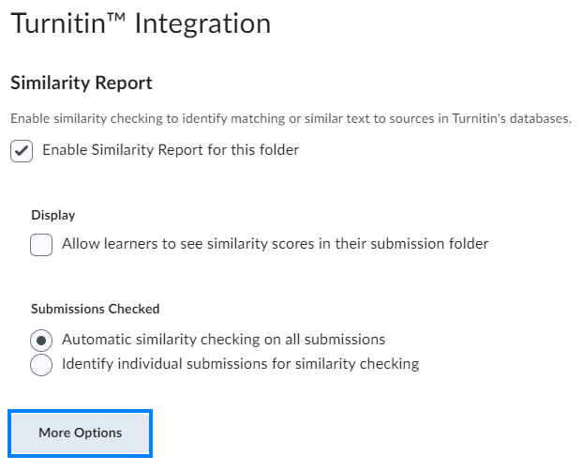

- Customize the Submission settings.

  - Standard paper repository – “Turnitin will store these submissions to the standard repository allowing them to be compared against by students from others institutions.”

  - Do not store the submitted papers – “Submissions will not be stored to any repository. These papers will not be used for any similarity comparison.”

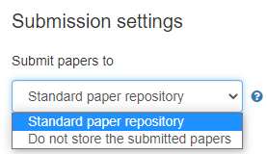

PLEASE NOTE: In instances where you are using Turnitin for drafts of assignments, we highly encourage you to select the Do not store the submitted papers option for all draft assignments and the Standard paper repository option for the final assignment.

- Scroll down to the Similarity Report section and establish when the Similarity Reports should be generated.

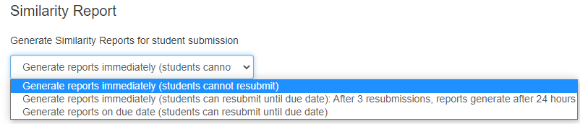

- Customize the remaining settings as desired and click Submit when finished.

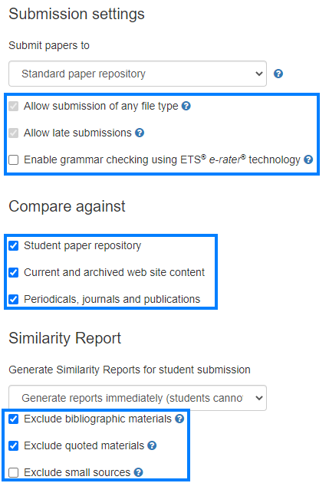

- Click Save to complete the Turnitin settings.

- Complete any remaining details of the assignment and then click Save and Close to save the assignment.

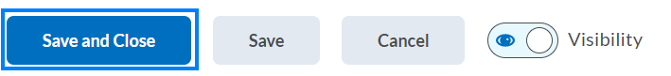

- When viewing student submissions, the Turnitin Similarity Report(s) will be available for you to review.

If you see an icon to the right of a student’s submission in place of the Similarity Report, click the Submit file to Turnitin icon.

