Complete a video assignment in Circuit
This article will overview how students can complete a video assignment in Circuit.

- Login to OneDrive. OneDrive is a cloud-based storage feature of Office 365 and is a university-supported tool.

- Click My files on the left and navigate to the location you will upload your video to.

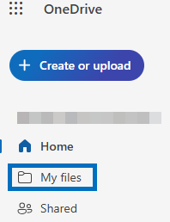

- Click the + Create or upload button at the top-left and select Files upload from the drop-down.

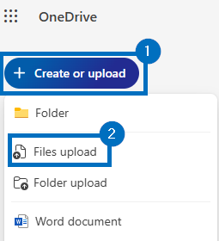

- Select the video to be uploaded and click Open. After the video has uploaded, hover over the file name, click the three horizontal dots, and select Copy Link from the drop-down.

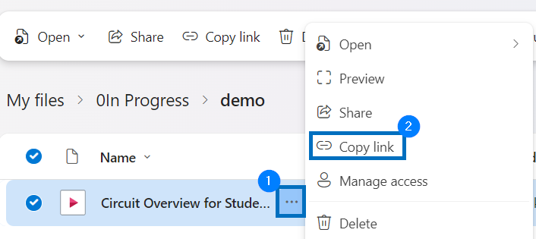

- On the pop-up, click Settings.

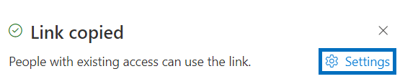

- Select to share the link with Anyone, select Can View, and click Apply.

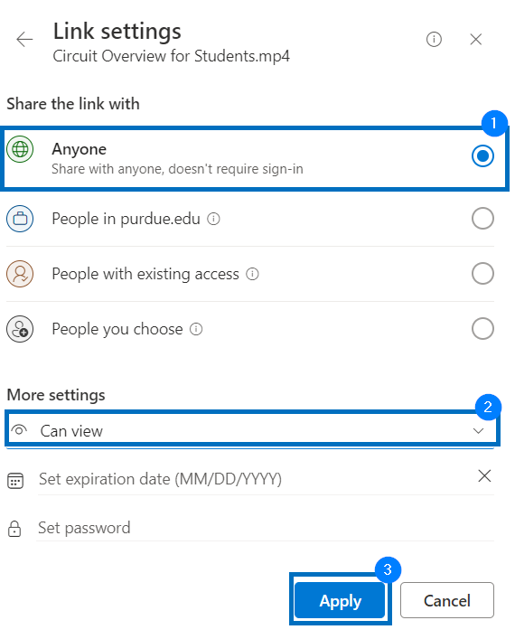

- The link will be copied to your clipboard. Open an incognito/private browsing window, paste the URL, and press Enter. If you can view the video without trouble, you are ready to submit this link to Circuit. If you are unable to view the video, repeat steps 4-6.

