

Student Guide

Contents
Access Circuit 2
Complete the Circuit Assignment 2
Content Submission 2
Calibrations 5
Peer Reviews 7
Self-Review 8
Scoring 8

Access Circuit

- Login to Brightspace and open the course where Circuit is being used.

- Click Content from the black course navigation bar.

- Locate and click the link to Circuit, or click the name of the specific Circuit assignment. How this appears will vary based on the link your instructor has added to the course.

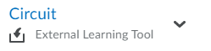

Complete the Circuit Assignment

Content Submission

PLEASE NOTE: It is extremely important to remain aware of the due dates for each phase of the Circuit assignment. If you miss any due date, you will be unable to proceed to the subsequent phases of the assignment and will receive an incomplete for all missed phases.

- In Circuit, click the name of the assignment you are working on.

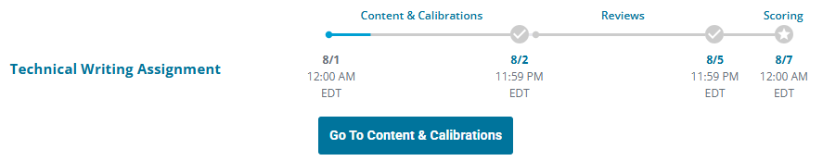

- Submit your assignment to Circuit in the required format. The screen you see will reflect your instructor’s selection of a text, file, or link submission.

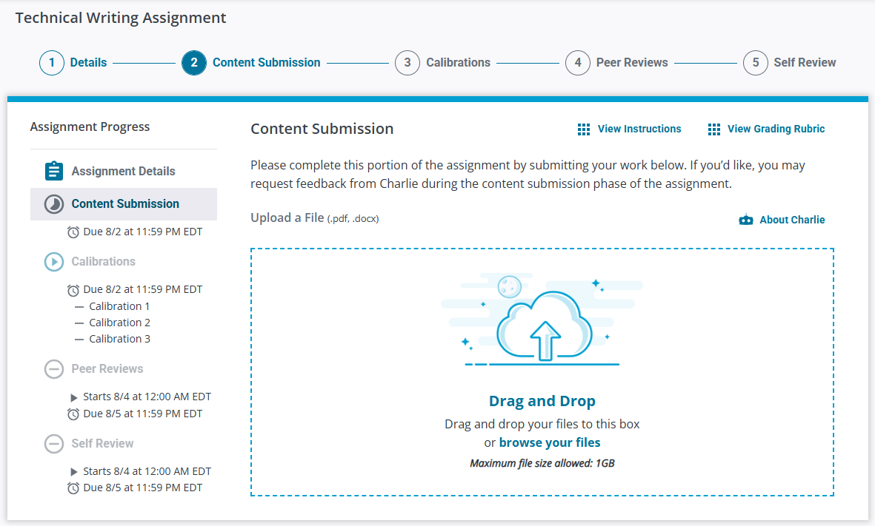

- Upon submitting, you will receive a confirmation message. The message and details about the next phase of the assignment will vary based on the settings chosen by your instructor. Review the details of the message and then click Got it. Thanks!

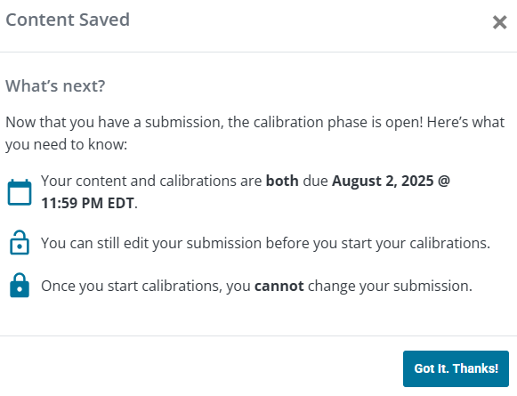

- If your instructor has enabled Charlie for the assignment, you can optionally request feedback on your submission. Charlie is an AI-powered writing assistant that provides, constructive feedback on .docx or .pdf submissions. Charlie’s ideas and suggestions are based solely on your submission and the assignment’s rubric.

You can revise your work, resubmit, and ask Charlie for feedback as many times as you would like. When you are happy with your submission, you can proceed to the next phase of the assignment.

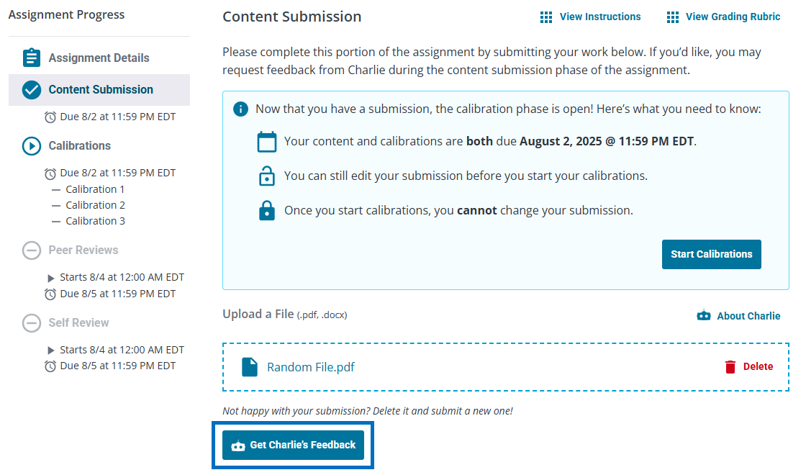

If your instructor has enabled Calibrations for your assignment, continue to the next section.
Otherwise, skip ahead to the Peer Review, Self-Review, or Scoring section
based on the next phase of the assignment.

Calibrations
In this phase, you will review three example submissions with the goal of evaluating each one similar to how your instructor did. You will have 3 chances per document to achieve a passing score before moving on to the next document.

PLEASE NOTE: Once you begin this phase, you can no longer edit your submission.

- Click Start Calibrations.

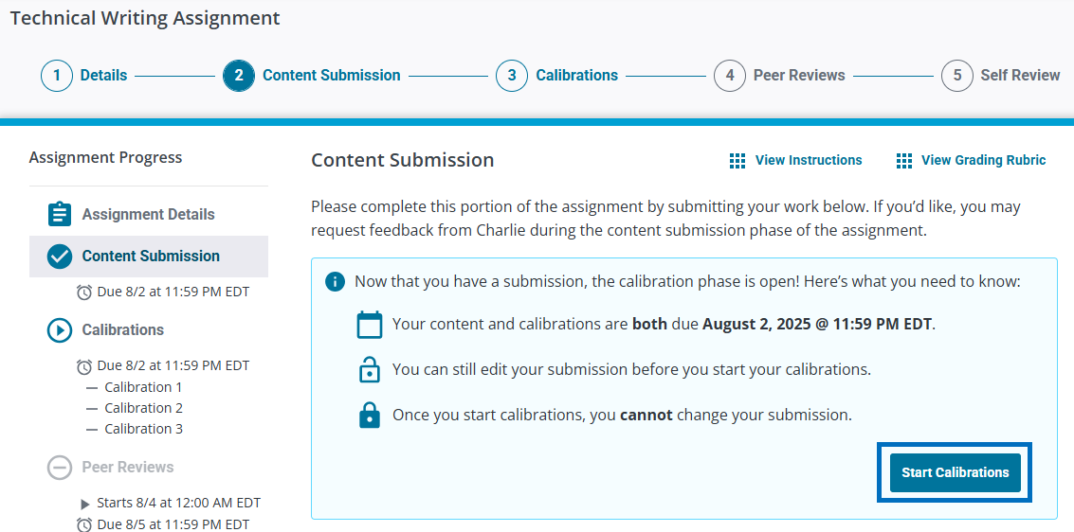

- Click Open Calibrations when you are ready to begin this phase of the assignment.

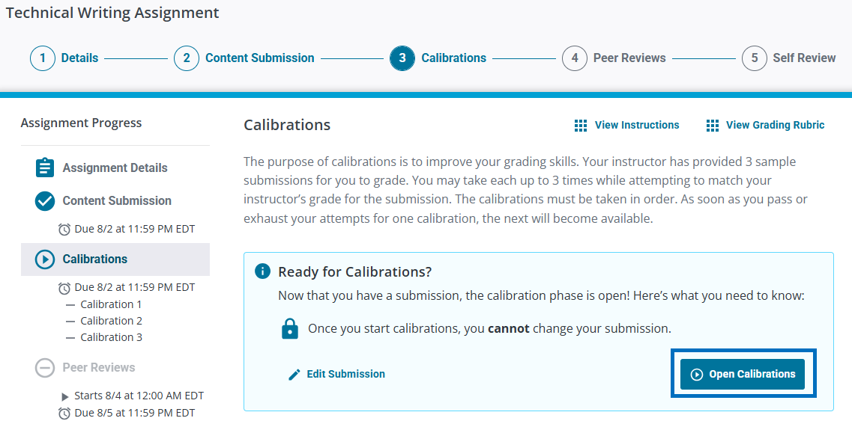

- Use the rubric (or numeric scale) on the right to review the example submission on the left. Click Submit Review when finished.

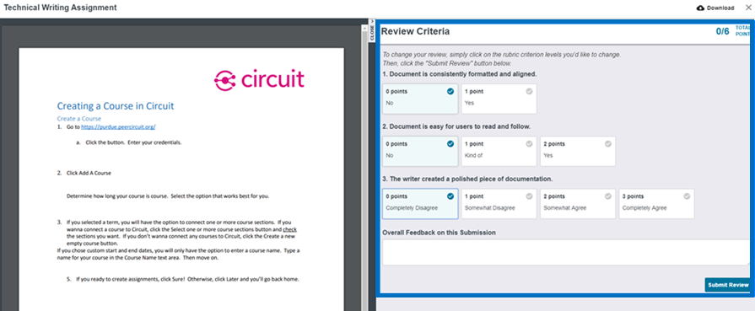

- Repeat this process until you have reviewed all three example submissions. This will need to be completed before the Calibrations phase due date.

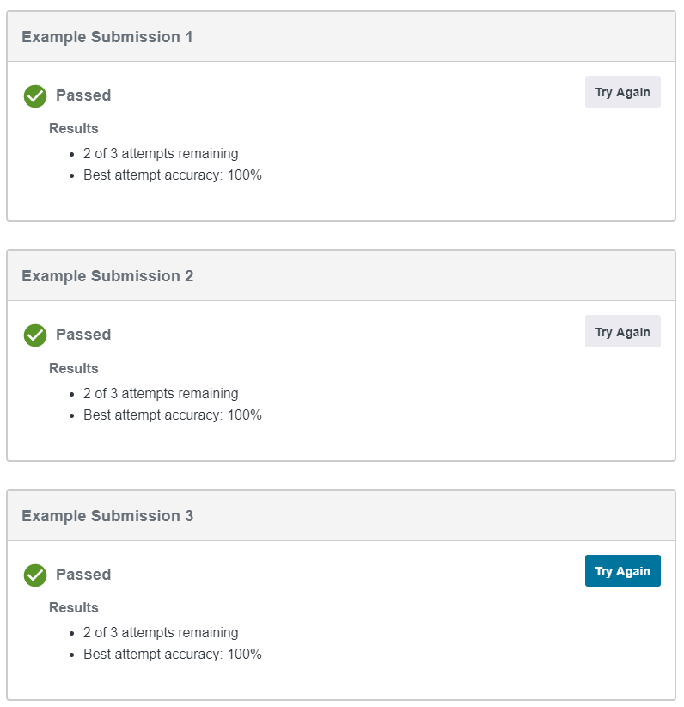

If your assignment includes a Peer Review phase, continue to the next section.
Otherwise, skip ahead to the Self-Review or Scoring section
based on the next phase of the assignment.

Peer Reviews
In this phase, you will review the work of three classmates using the established rubric or numeric scale. The peer review process in Circuit is anonymous.

- Use the rubric (or numeric scale) on the right to review your peer’s submission on the left. Click Submit Review when finished. Your instructor may require you to provide textual feedback on the submission before you have the option to submit your review.

- Repeat this process for your remaining two peers.

If your assignment includes a Self-Review phase, continue to the next section.
Otherwise, skip ahead to the Scoring section.

Self-Review
In this phase, you will review your own submission using the established rubric or numeric scale. Your goal is to review your submission as your peers would.

- Use the rubric (or numeric scale) on the right to review your submission on the left. Click Submit Review when finished.

Scoring
- Be sure to return to Circuit on or after the Scoring Date/Time. Your score and any feedback from your peers will be released in Circuit on the day and time set by your instructor.

