

Instructor Guide

Contents
Add the Circuit Integration to Your Brightspace Course 2
Create the Circuit Assignment 4
Instructions 4
Grading 6
Calibrations 9
Scheduling 10
Review and Activate 11
Instructor Review Phase 14
View Student Progress 14
Adjust Circuit Assignment Scores 15
Appendix 16
What are Calibrations? 16
What is a Late Permit and How Do I Use It? 16

Add the Circuit Integration to Your Brightspace Course

- Login to Brightspace and open the course in which you will be using Circuit.

- Click Content and navigate to (or create) the module where the link to Circuit should reside. This link will take you and your students to the homepage of the Circuit course.

- Click Existing Activities and select External Learning Tools from the drop-down.

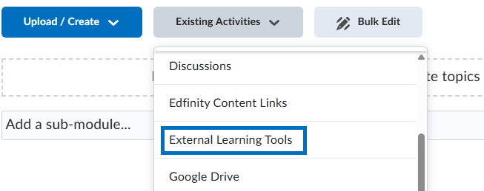

- Select Circuit from the list.

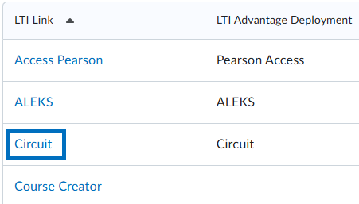

- Click the newly created Circuit link.

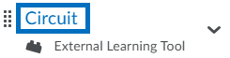

- Click Sure! to set up your Circuit course.

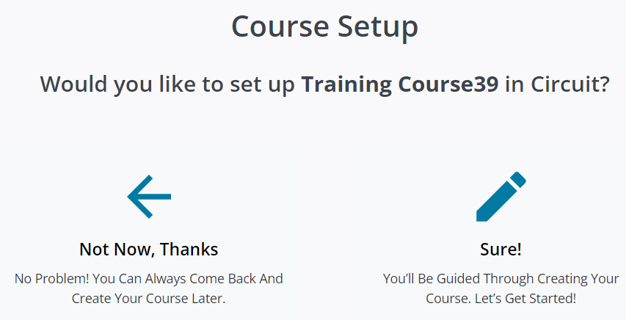

- The course name and dates will be auto-filled. Select if you would like the final Circuit scores to be pushed to the Brightspace gradebook automatically or manually. You can return at any time to modify your selection.

The Automatic option will push scores to Brightspace on the Score Date/Time you establish in the Circuit assignment.

The Manual option will enable you to choose when and/or if you would like to push scores to Brightspace after the assignment ends.

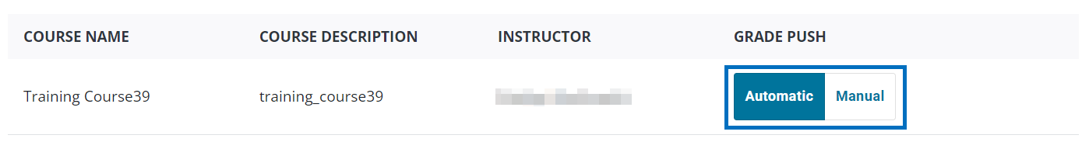

- Click Save.

Create the Circuit Assignment

Instructions

- Click Assignments at the top-right.

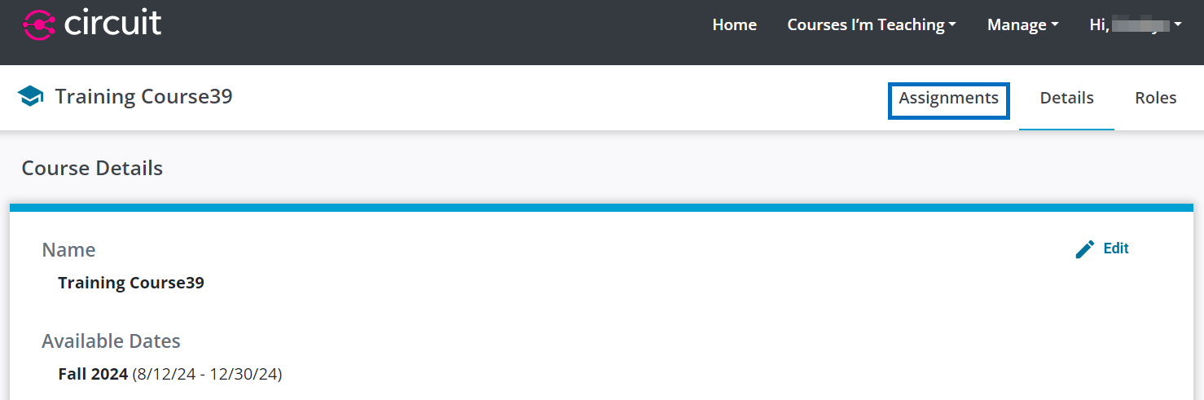

- Click New Assignment at the top-right.

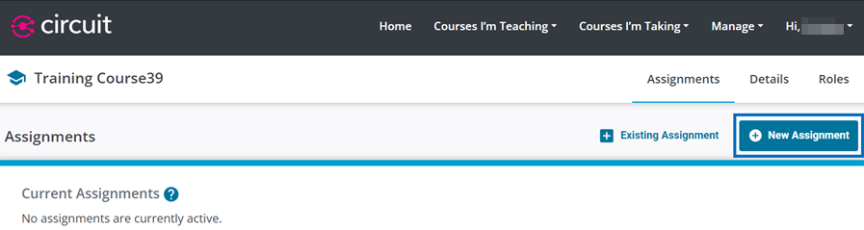

- Enter a name for the assignment.

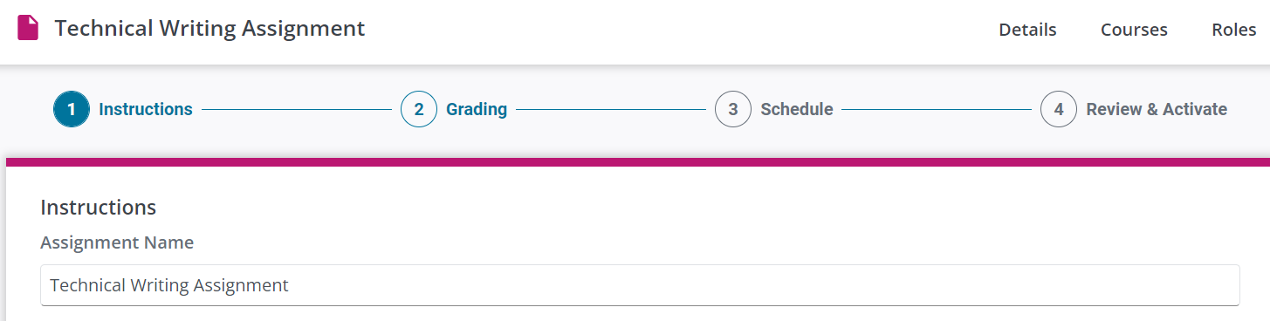

- Enter the assignment instructions.

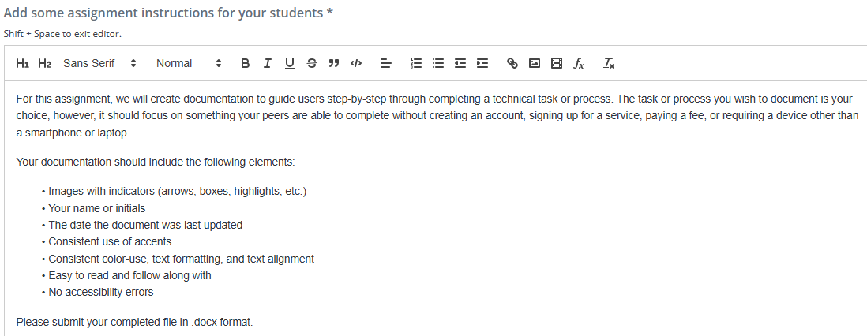

- Optionally, upload any supplemental files your students may need to reference to complete this assignment.

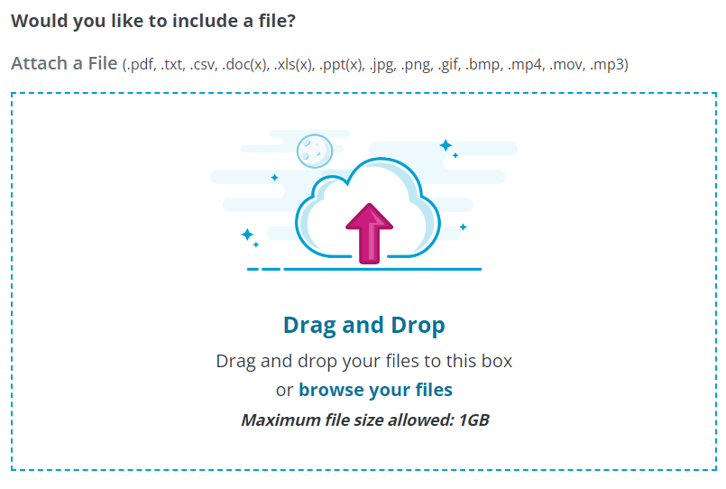

- Select the format you would like students to submit their work as in Circuit. Only one option can be selected.

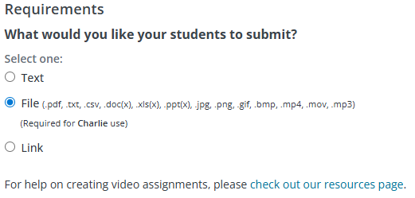

  - Text: Provides students with a multi-line textbox in which to type their work. The textbox editor supports basic formatting features, as well as, optional word count requirements.
  - File: Provides students the ability to select and upload, or drag and drop, a file from their computer. This option is required if you intend to enable Charlie.
  - Link: Provides a single-line text box for students to paste a web URL.

PLEASE NOTE: For video submissions, we strongly recommend having students upload their videos to a cloud-based storage platform (i.e. OneDrive), obtain a shareable link everyone can view, and submit that link to Circuit. Step-by-step instructions for students are available on the Circuit webpage.

- Click Save & Continue.

Grading

- Select the phase(s) you would like the Circuit Assignment to include.

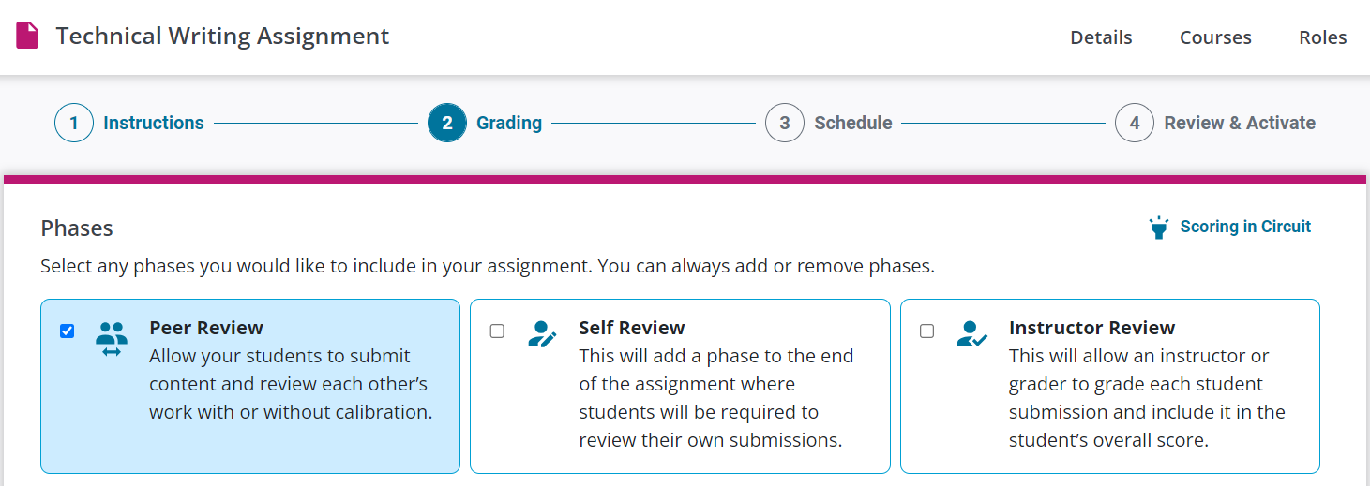

- If your assignment includes a Peer Review phase, select if you would like to include Calibrations. For more information on calibrations, click here.

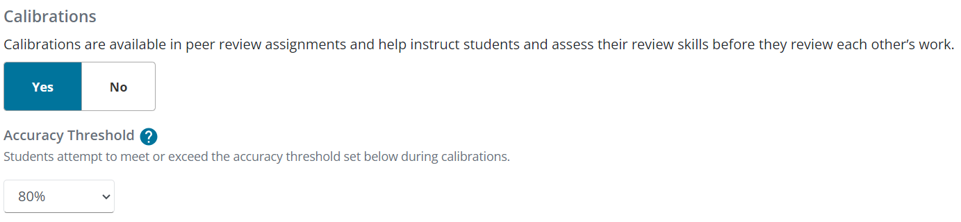

- Establish the weight and feedback requirements for each phase of the assignment. The fields you see will vary based on the phases you previously selected.

  - Content Quality: A student’s content quality score is based on the scores their 3 peers provide when reviewing the student’s submission.
  - Calibrations: A student’s calibration score is based on the accuracy of the student’s review of each calibration document in comparison to how you review each calibration document.
  - Peer Review: A student’s peer review score is based on how they reviewed their 3 assigned peers, in comparison to how others reviewed those same 3 peers.
  - Self Review: A student’s self-review score is based on how they review their own submission in comparison to how their 3 peers reviewed them.
  - Instructor Review: Your score for a student’s submission.

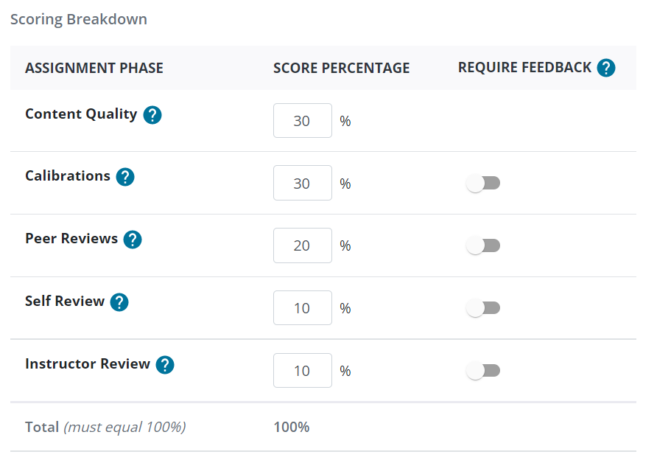

- If you previously selected to have students submit a File, you will have the option to enable Charlie. Charlie is an AI-powered writing assistant that provides students with personalized, constructive feedback on .docx or .pdf submissions. Charlie will not rewrite a student’s paper or tell them exactly what to change, but will offer ideas and suggestions solely based on the submission and the assignment’s rubric. When utilizing Charlie, it is important your rubric be as detailed as possible to provide Charlie context on the subject and criteria you are looking for.

Students can revise their work, resubmit, and ask Charlie for feedback as many times as they would like. Charlie will continue offering feedback - even on high-quality submissions - so it is up to the student to decide when they’re happy with the final version. The assignment then proceeds based on the phases and timeline you’ve selected.

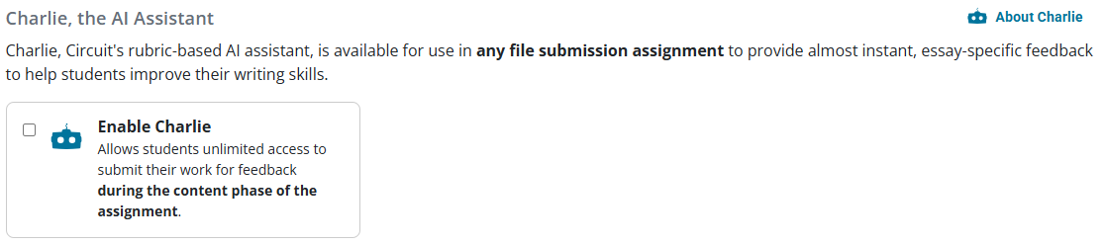
- Select whether the assignment will be assessed using a rubric or 10-point scale. When using a rubric, the point value for the entire Circuit assignment will be the sum of the highest rubric levels for each criterion. When using a 10-point scale, the point value for the entire Circuit assignment will be the highest point value on the scale.

A student’s score will be calculated based on the weights you previously established for each assignment phase. This score will be out of the assignment point value you establish with the rubric or 10-point scale.

PLEASE NOTE: We strongly encourage you to consider using the Rubric option. A rubric provides students with guidance in what you want them to look for when they review their peers. Rubrics also offer the authoring student direct feedback to help them understand where they can improve.

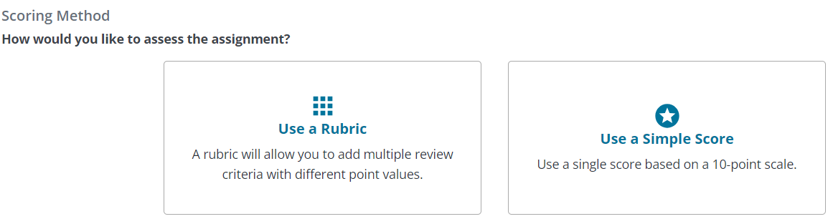

- Click Save & Continue.

Calibrations

This section only applies if you previously chose to include Calibrations in the assignment. If you did not, please skip to the Scheduling section.

You will need to have three examples prepared for this step – one high-quality example, one medium-quality example, and one low-quality example of the particular assignment.

- Click a quality level on the left and upload the corresponding example document on the right.

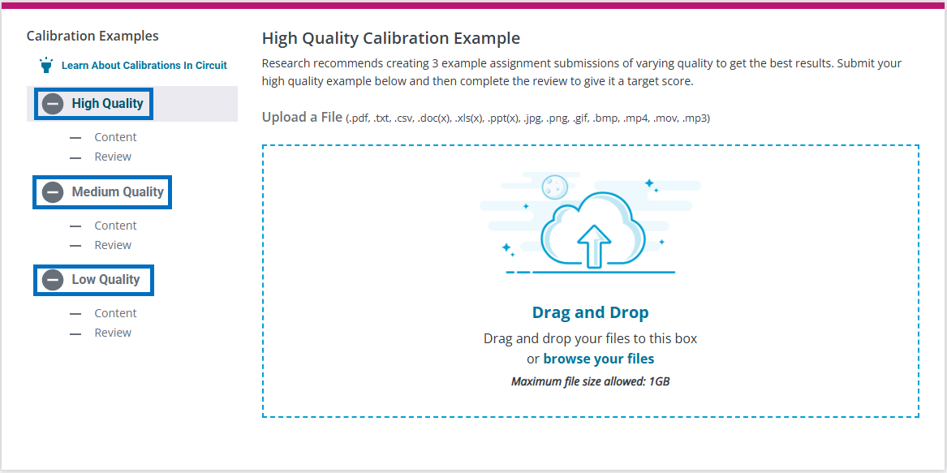

- Click Review.

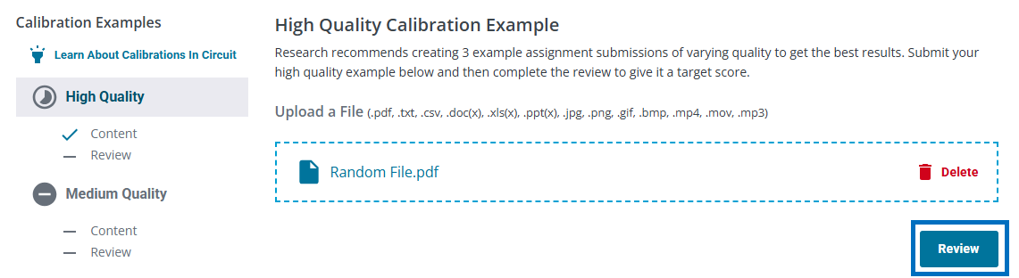

- In the Review screen, you will see scoring options based on your previous selection of rubric or simple scoring. Review the document the way you expect students to review the document. The student’s goal is to score the document within the accuracy threshold you previously established. When finished, click Submit Review.

- Repeat this process for the remaining two calibration examples. When finished, click Continue.

Scheduling

PLEASE NOTE: Phases of a Circuit assignment occur sequentially. Students must complete one phase in order to move on to the next. If a student misses a due date at any point, they will be unable to proceed to the subsequent phases and will receive an incomplete in Circuit for those missed phases - unless you use the late permit feature. For more information on the late permit feature, click here.

- You can elect to combine or separate the Content and Calibration Dates.

When combined, students must submit their content and complete the calibrations before the specified due date. Students will be able to revise their submission until they begin calibrations. Once they begin calibrations, their submission becomes “locked” and can no longer be changed.

When separated, students will have a start and due date for content followed by a separate start and due date for calibrations. The dates for each phase cannot overlap. Students can revise their submission until the Content phase ends.



- In the Start Date field, type the date or click the calendar icon to set the date.
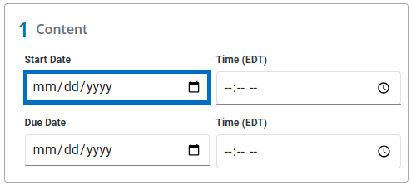

- In the Start Time field, type the time or click the clock icon to set the time.
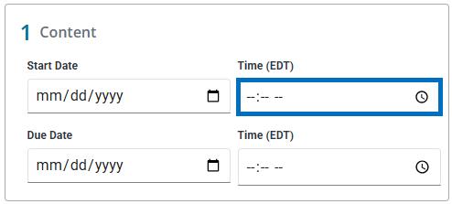

- Repeat the previous two steps for all other Start and Due dates listed. The Scoring Date refers to the date and time at which the assignment scores and feedback will be released to students in Circuit. If the Circuit course is set for automatic grade push, the scores will also be pushed to your Brightspace gradebook.

- Once all dates and times have been entered, click Save and then click Continue.

Review and Activate

- Review all components of the Circuit assignment. If you need to make a change, click the pencil icon to the right of the appropriate section. If everything appears correct, click Activate to make the assignment visible to students.

PLEASE NOTE: Do not click Activate until the assignment is finalized. When you click Activate, the rubric and many assignment settings become locked and cannot be modified.

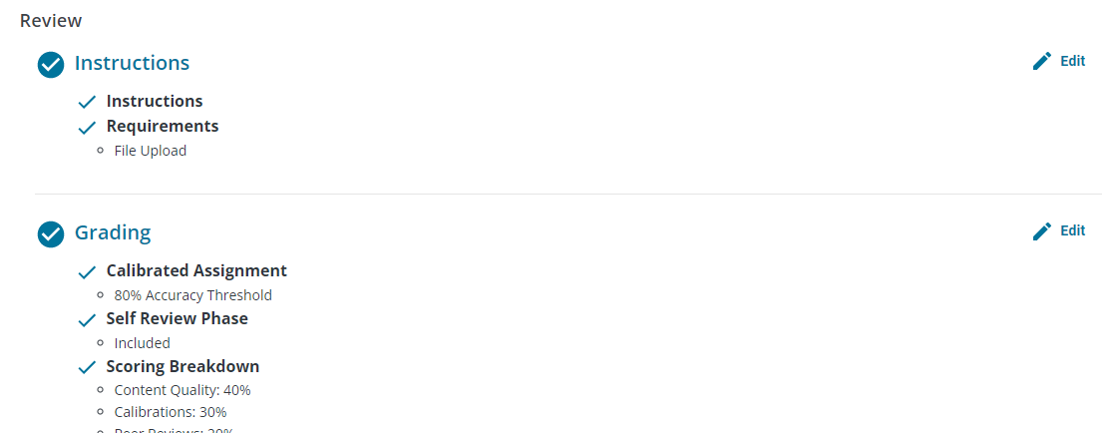

- Return to your Brightspace course and open the Content module where this assignment should reside.

- Click Existing Activities and select Circuit Assignment from the drop-down.

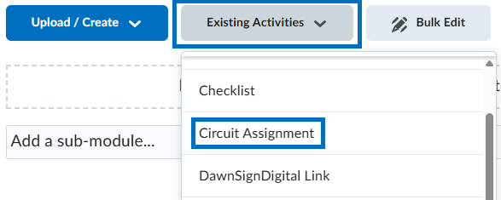

- Click the plus icon to the right of the assignment you would like to link to.

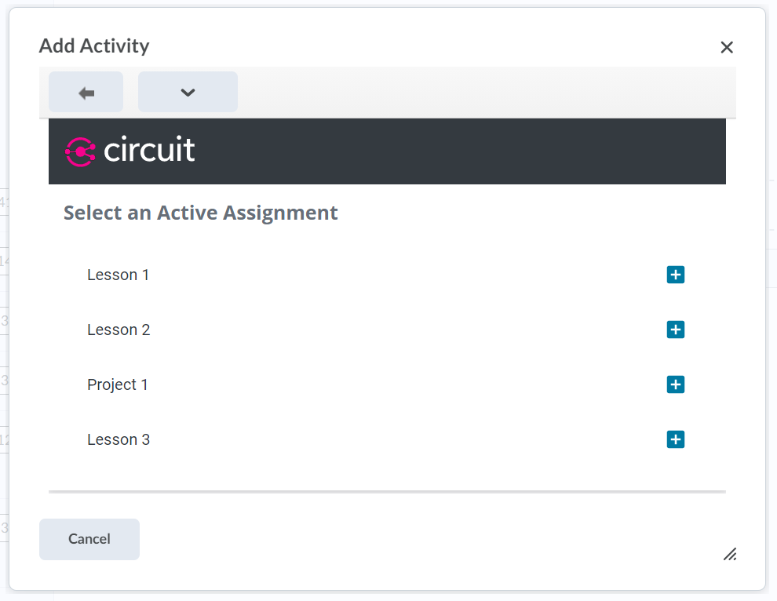

- Click Link Assignment.
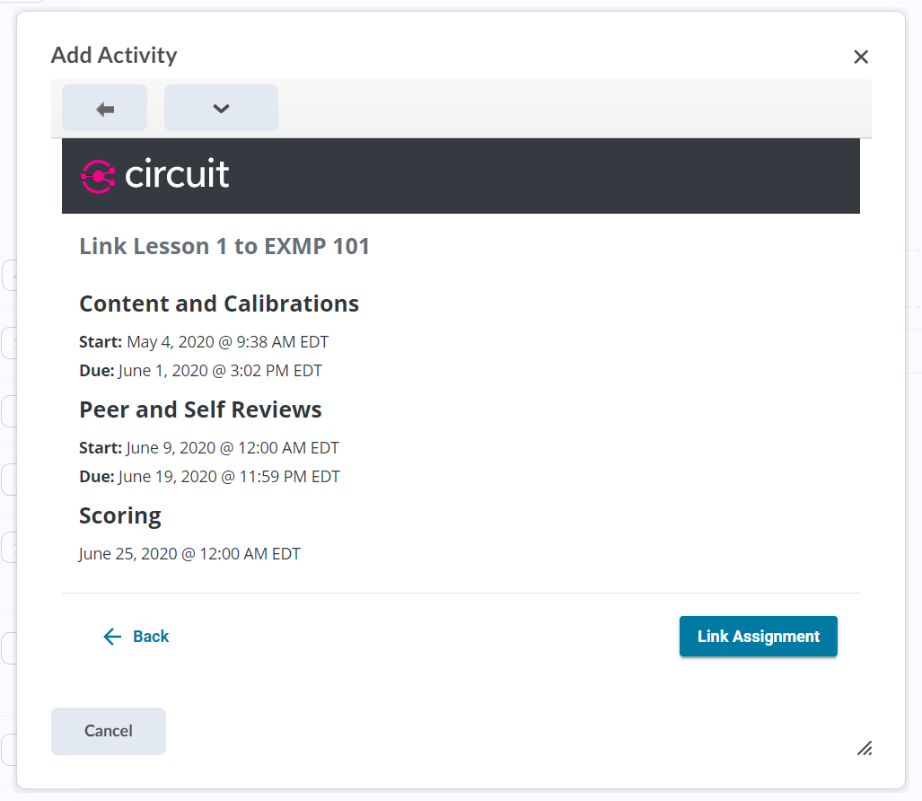
- Click the newly created Circuit assignment link in your course content. This will create a new grade item for the assignment in your gradebook.

- Click Grades from the course navigation bar.

- Click the drop-down to the right of the Circuit assignment grade item and select Edit.

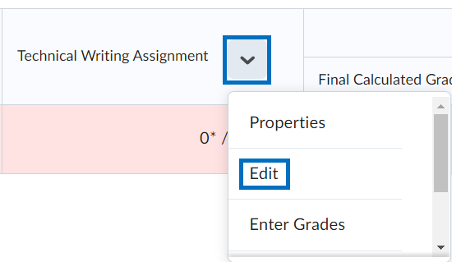

- Uncheck the Exclude from Final Grade Calculation option.

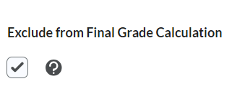

- Click Save and Close.

Instructor Review Phase

- If your assignment includes an instructor review phase, this will become available to you, TAs, and/or Graders after the start of the Peer Review phase. Click the name of the Circuit assignment.

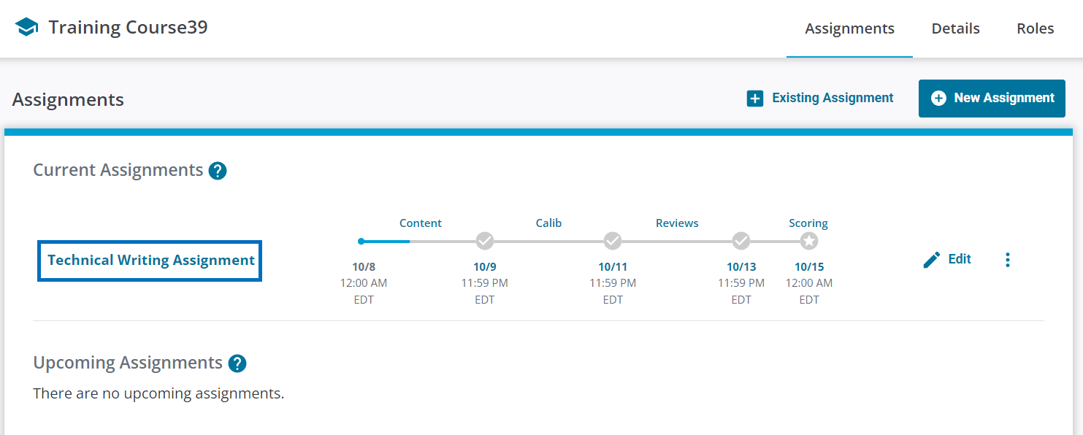

- Click Instructor Review on the left. Click the name of the student you would like to review on the right.

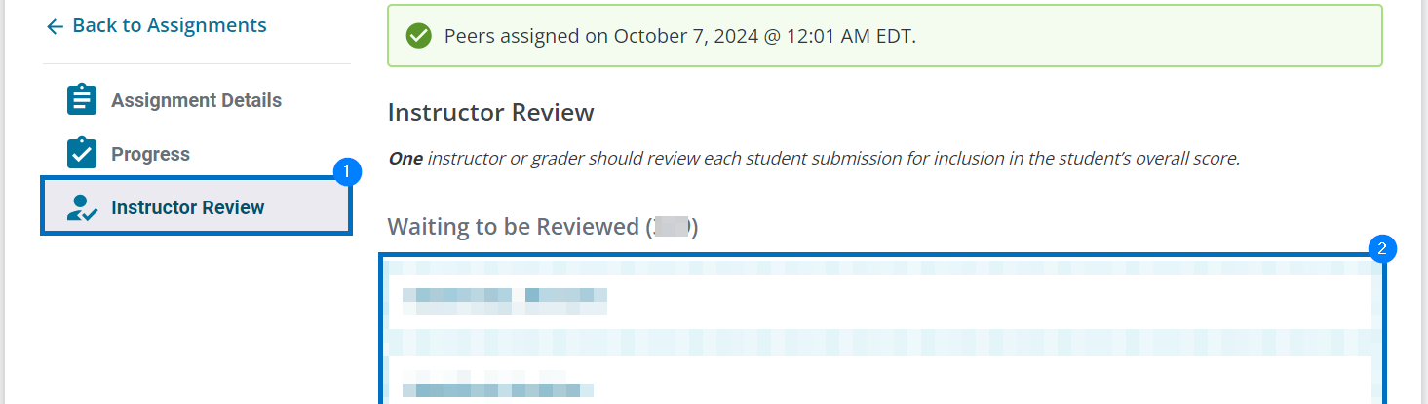

View Student Progress

- Students will receive email notifications throughout the Circuit assignment reminding them of upcoming dates related to the assignment. To view student progress at any time, click the name of the Circuit assignment.

Adjust Circuit Assignment Scores

- In Brightspace, click Grades and locate the grade column for the Circuit assignment.

- Click the drop-down icon to the right of the Circuit assignment name and select Enter Grades from the drop-down.

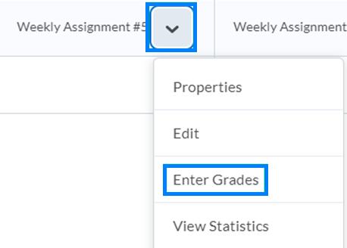

- Adjust student scores as needed. Optionally, add your rationale for the grade adjustment in the feedback box for student awareness.

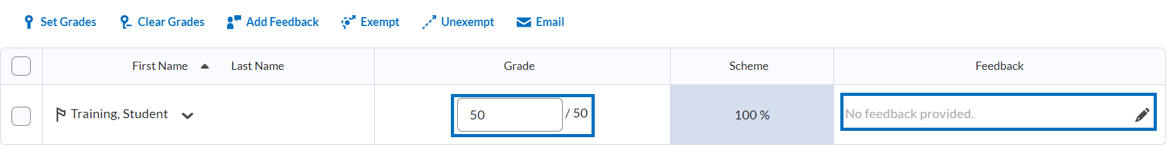

PLEASE NOTE: Grades for the Circuit assignment can only be modified in Brightspace. Grade changes made in the Brightspace gradebook will not be reflected in Circuit.

Appendix

What are Calibrations?

When calibrations are enabled, the instructor will upload 3 example assignment submissions - one high-quality, one medium-quality, and one low-quality. Using the assignment rubric, the instructor will then evaluate each example submission. The instructor establishes an accuracy threshold. This threshold determines how close students should score each example document in comparison to how the instructor scores each document.

During the Circuit assignment, students will review those same three documents. They will be randomized, so there is no indication to students which one is the high, medium, or low-quality example. Students will have three attempts per document to achieve a score within the accuracy threshold. If they do not achieve a passing score, they will advance to the next calibration document, but their calibration score will be lowered.

Benefits of a calibrated assignment include (1) providing students an opportunity to practice and develop their peer review skills on sample work prior to reviewing the work of their peers. (2) A student’s performance during the calibration phase generates their calibration score. Circuit uses that score to distribute students into peer groups that contain one student with a high calibration score, one student with a medium calibration score, and one student with a lower calibration score. The higher a student’s calibration score, the more weight their evaluation will hold when they review their peers. To return the Grading section, click here.

What is a Late Permit and How Do I Use It?

The late permit feature can only be used when gaps of time are left between phases of a Circuit assignment, and the Start Date/Time of the subsequent phase has not yet passed. During this gap of time, you can grant individual students a late permit for the previous phase of the assignment. To grant a late permit:

- Click the name of the Circuit assignment.

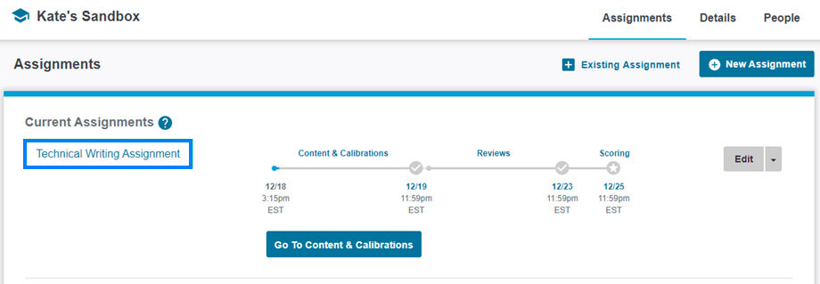

- Click Progress on the left and locate the student you would like to grant a late permit to. Click the Late Permit/timer icon to the left of their name and check the box for the phase you would like to grant a late permit for.

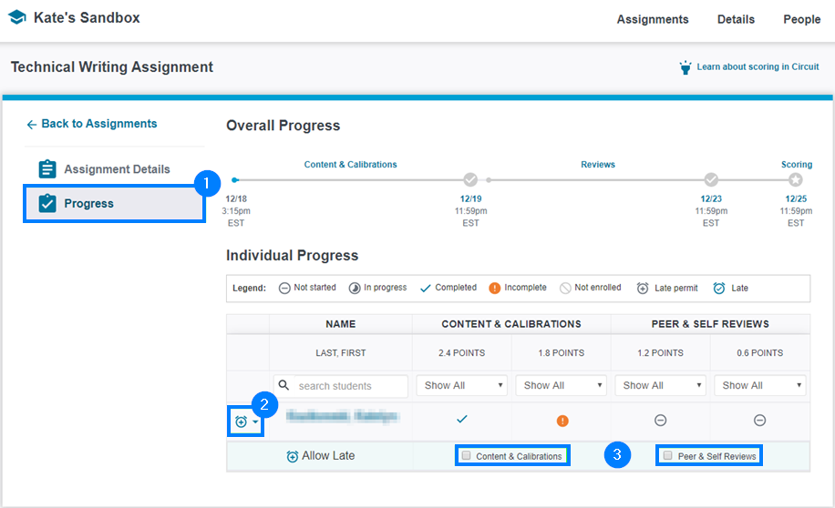

- The student now has until the start of the next phase to complete their work in the previous phase. To return to the scheduling section, click here.

