Video Assignments in Circuit

Instructors
Due to the various video file formats that exist and the variations in how each web browser displays (or does not display) certain media formats, we recommend students upload their videos to a platform, such as OneDrive, obtain a link viewable to others, and submit that link in Circuit. This provides a more consistent viewing experience for students during the peer review phase of the assignment as it relies on the chosen platform’s media player instead of the browser’s media player.

As you setup the Circuit assignment, select the Text option if students need to submit additional information with the video or Link if students are submitting only a video.

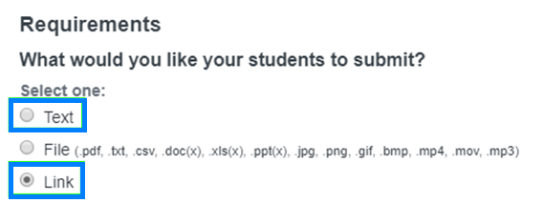

Students
OneDrive is a cloud-based storage feature of Office 365 and is a university-supported tool.

- Login to Office 365

- Click OneDrive.

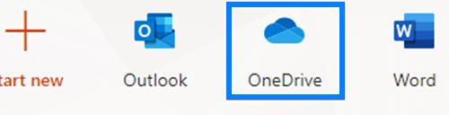

- Click Upload and select Files from the drop-down. Select and open the video file you intend to submit in Circuit.

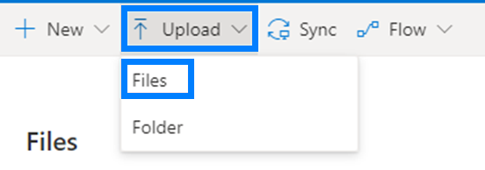

- After the video has uploaded, hover over the file name, click the 3 vertical dots, and select Copy Link from the drop-down.

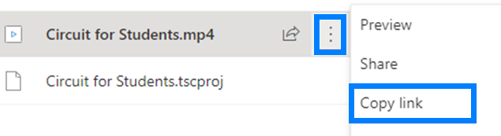

- On the pop-up, click Anyone with the link can edit.

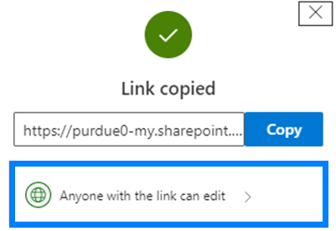

- Uncheck Allow Editing and click Apply.

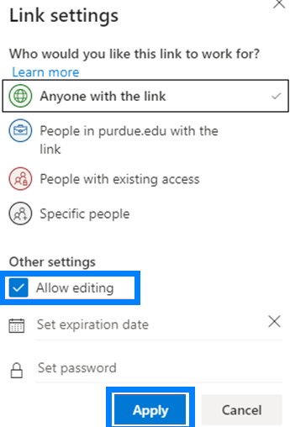

- Copy this link and paste it into an incognito/private browsing window to ensure it will work for others. If you are able to view the video without trouble, you are ready to submit it in Circuit.

