Use Circuit Outside of Brightspace

Create A Course
- Open a web browser and navigate to https://purdue.peercircuit.org/.
- Click Log in with your Purdue Career Account and enter your Purdue Career Account credentials.

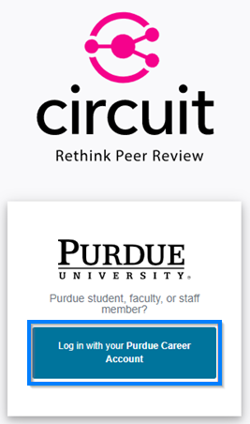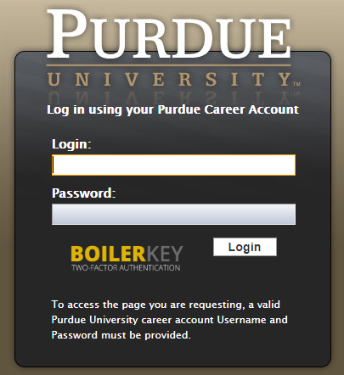

- Click the Add A Course button.

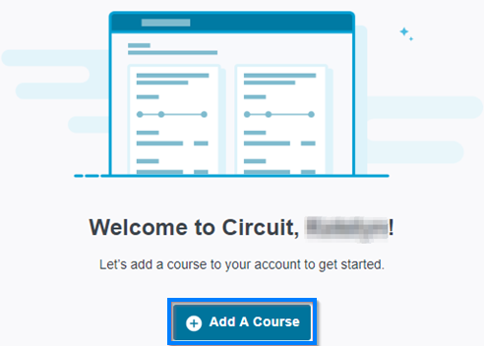

- Enter the name and timeframe for your Circuit course.

  - If you would like the course to be available for the duration of a semester, click Select a semester term and choose the appropriate term from the drop-down.

  - If you would like to customize the start and end dates for the course, click Set custom start and end dates and enter the appropriate dates.

PLEASE NOTE: If you would like to set up your course with roster sync, you must use the Select a semester term option. This will enable you to choose which course(s) you would like to connect and it will sync your roster nightly to update with any students who have added or dropped your course.

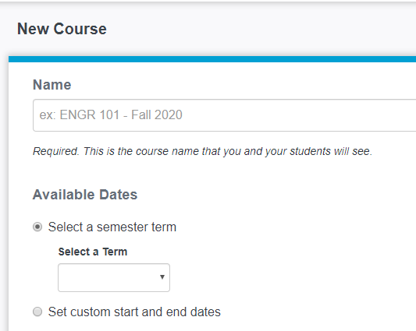
You will also have the option to Save And Add Instructors if you would like to sync course sections taught by other instructors or add co-instructors.
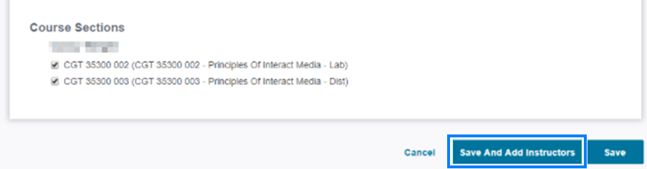

- When you are ready to create an assignment, click Assignments.

- Then click New Assignment.

Add, Modify, or Review Circuit Course Enrollment
- To add, modify, or review enrollments for courses, click People near the top-right.

- To add a student or another instructor to the Circuit course, enter their Purdue Career Account username or PUID into the text box. After doing so, you may add additional people on subsequent lines of the textbox.

In the Access Level drop-down, choose the appropriate role for the individual(s). If you are adding a teaching assistant who should have the ability to modify Circuit assignments and grade student work, select Instructor. If you are adding an assistant who will only be reviewing student grades and performance, select Grader. Then click Add.

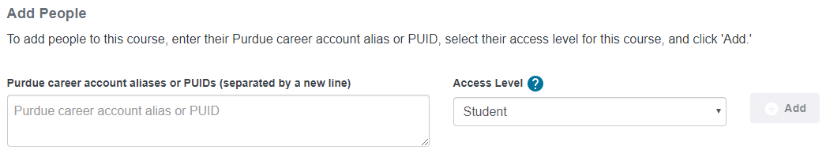

- If you added an individual manually, you will have the option to remove them from the course.

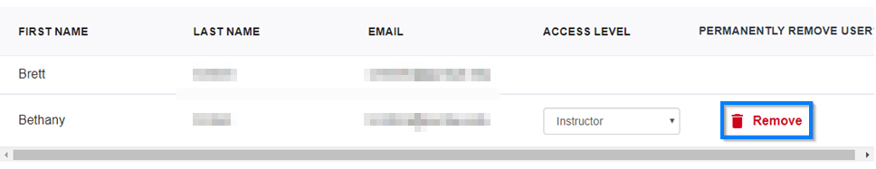

- If you have connected your Circuit course to a course section, you will see the list of students in the Automatically Added Students area. Your roster will sync nightly, however, if you wish to sync your roster on-demand, click Sync Roster near the top-right.

