

Contents
Tips 2
Access Simple Syllabus 4
Edit Your Syllabus 4
Visibility and Privacy Settings 4
Add a Syllabus Component 5
Remove a Syllabus Component 6
Reset a Component 8
Preview Your Student-Facing Syllabus 9
Submit Your Syllabus 10
View Your Public-Facing Syllabus 11
Copy Syllabus Content 11
Automatic Importation Of Syllabus Content 12

Purdue Simple Syllabus Tool Support Webpage
Purdue Syllabus Guidelines Webpage

Tips

- Only the instructor(s) of record can “edit and submit” the course syllabus. Students and anyone enrolled in the Brightspace course via the Enrollment Manager tool (i.e. Instructor, TA, Grader, Course Builder, SI Tutor, or Read Only Course Copy) will be able to “view” the course syllabus once it has been submitted by the instructor(s) of record.

- Simple Syllabus is used only for academic courses. When clicking Syllabus from the course navigation bar within a DEV or noncredit course, you will receive a message that the section could not be located. This is accurate and expected behavior.

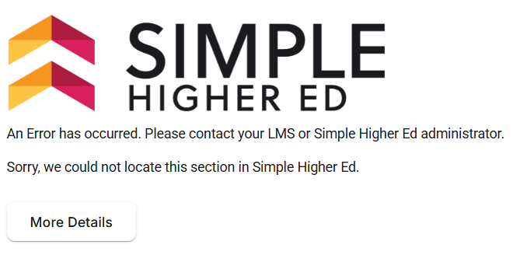

- The text editor in Simple Syllabus supports keyboard shortcuts for functions like copy, paste, undo, and redo. [Enter] (PC) / [Return] (Mac) creates a new paragraph. [Shift + Enter] (PC) / [Shift + Return] (Mac) creates a single line break.

- After making changes to a content component, your information will be automatically saved - indicated with “saved” text appearing near the visibility and privacy sliders. For components with a pencil/edit icon, click Save when you are finished. You are free to work, leave, and return to your syllabus as desired. Do not “submit” your syllabus until it is finalized.

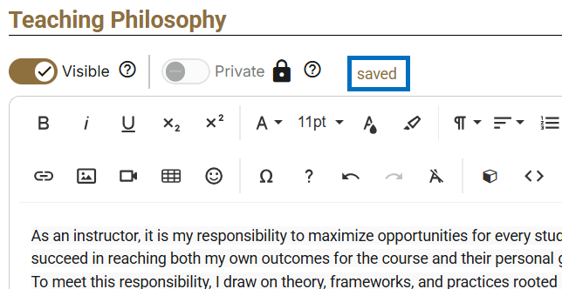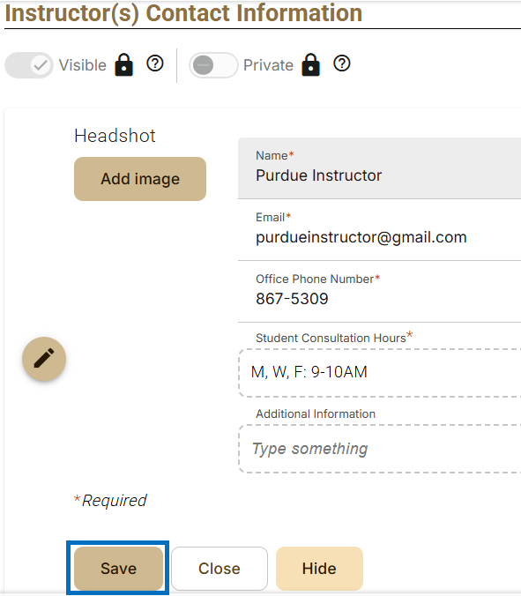

- Several components of your syllabus are required by the university and must be completed before you can submit. These will be visually indicated with “Required” text and a border outlining the component.

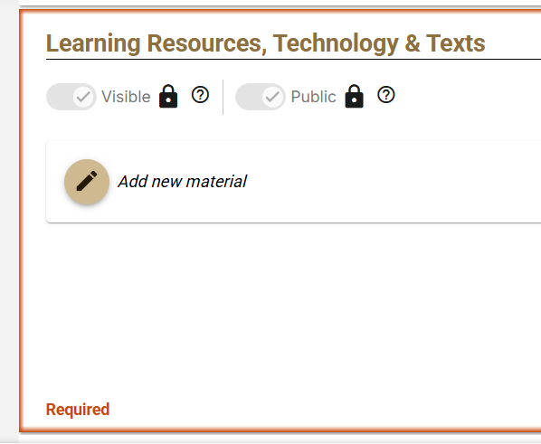

- An accessibility checker will review the accessibility of your content as you work. Any detected issues will be indicated by the accessibility check icon and will need to be corrected before the syllabus can be submitted.

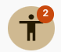

- The Submit button “publishes” your syllabus. It will automatically create a public view and a student view of your syllabus based on the visibility and privacy settings established for each component. Once submitted, no further action is required. You can return at any time to make revisions and re-submit.

Access Simple Syllabus

- Navigate to Brightspace and login using your Purdue credentials.

- Open a Brightspace course.

- Click Syllabus from the course navigation bar.

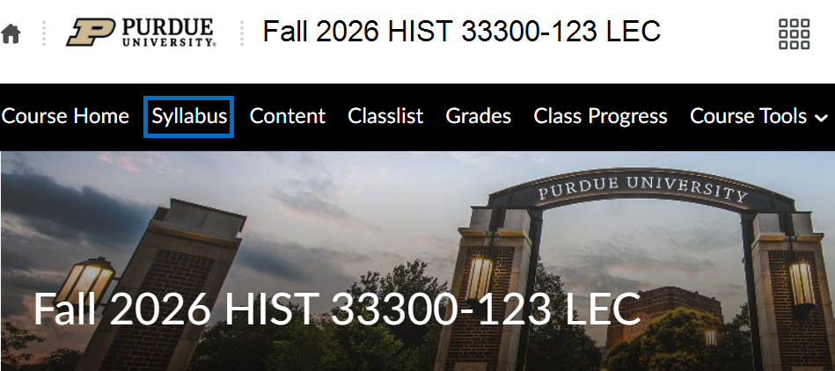

Edit Your Syllabus

Visibility and Privacy Settings

Visibility and privacy toggles are used to control the audience for each component of your syllabus.

- Visible/Invisible: Controls whether a component is included (Visible) in a published version of your syllabus, or hidden and visible only to you in the editor (Invisible).

- Public/Private: Controls whether the syllabus component is visible to both your students and the general public (Public), or visible only to your students and those with assigned access (Private). Several default components of the syllabus will be pre-designated as Public to comply with Indiana state law. All other default components will be marked Private.

- A lock icon indicates a setting established by the university that cannot be changed.

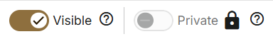

Add a Syllabus Component

The default syllabus template contains sections the university believes may be useful to you and your students. To add additional components to your syllabus:

- Click +Add from the menu. Alternatively, scroll to the bottom and click Add new component.

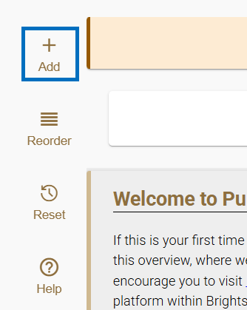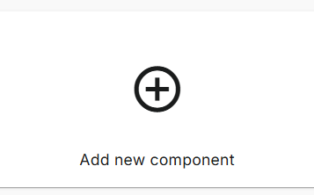

- Enter a Name for the component. Then click Save.

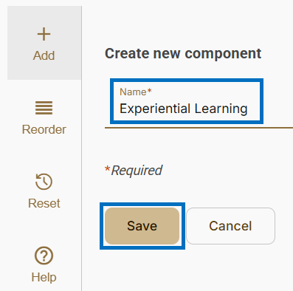

- Customize the component settings as desired:

  - Display Name: Use this checkbox to determine if the name of this component should be displayed in your published syllabus.

  - Visibility and Privacy: Use these toggles to establish the audience for this component. For more information, see Visibility and Privacy Settings.

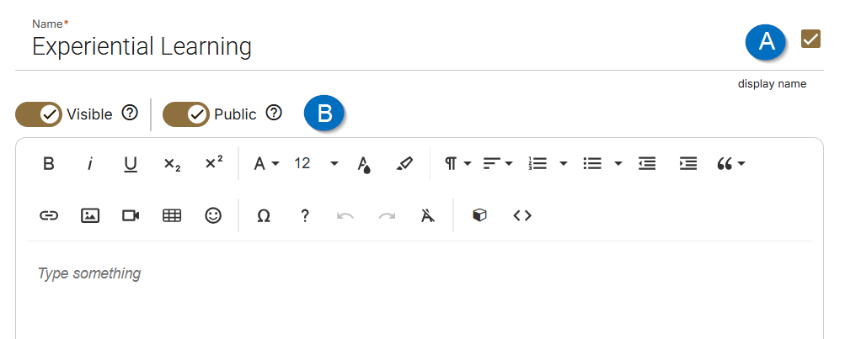

Remove a Syllabus Component

The default syllabus template contains sections the university believes may be useful to you and your students. To remove a component from your syllabus:

- Toggle the visibility slider to Invisible. Alternatively, leave the text field blank.



Reorder Syllabus Components

The template is laid out in an order that prioritizes information specific to your course and your students. To modify the order in which syllabus components are displayed:

- Click Reorder from the menu.

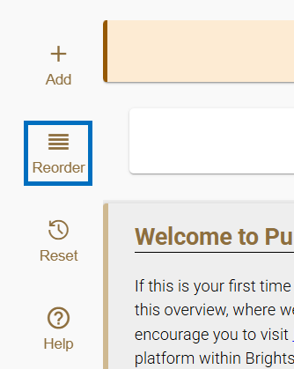

- Click the up/down arrows on each component to reposition in your desired order. Alternatively, click and drag components to your desired order.

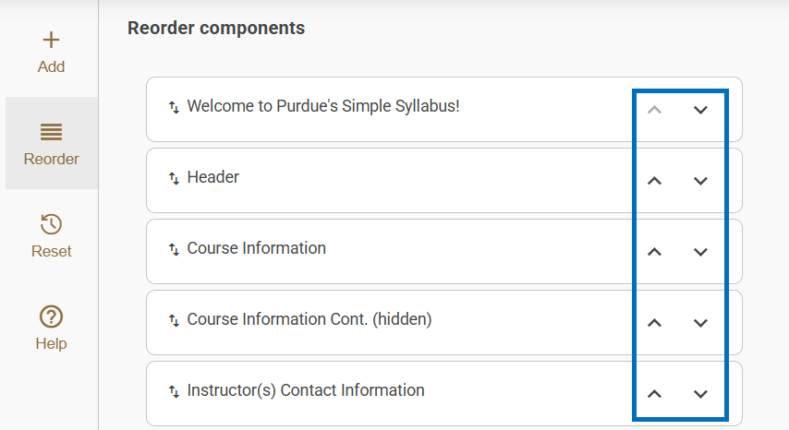

Reset a Component

To reset a component back to the university’s default state:

- Click Reset from the menu.

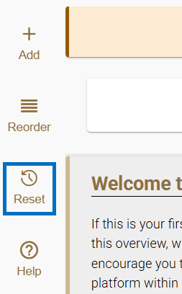

- Select the component(s) to be reset. Then click Next.

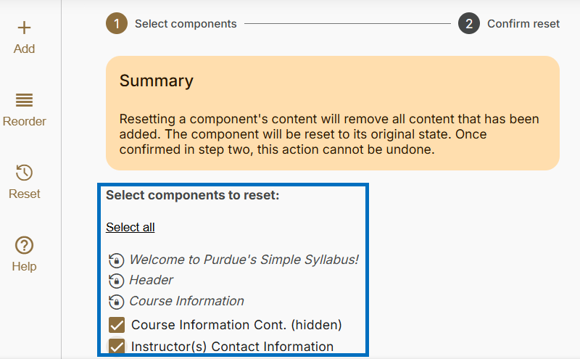

- Click Reset.

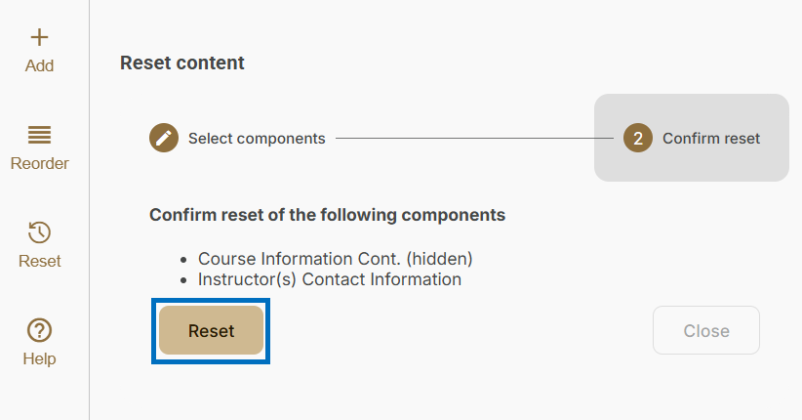

- Click Close when finished.

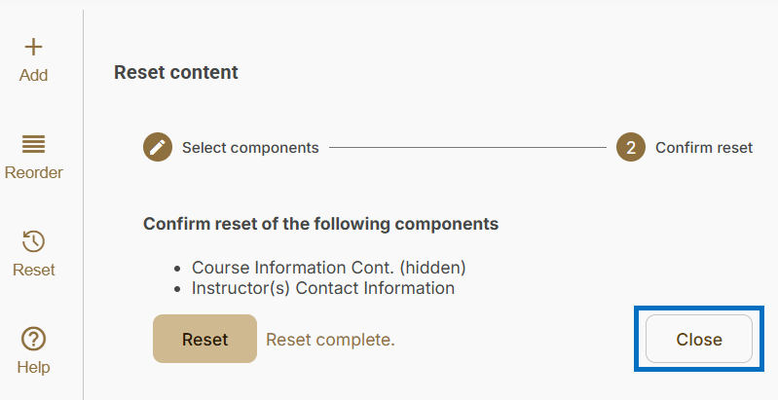

Preview Your Student-Facing Syllabus

To preview your syllabus as students will see it:

- Click Preview.

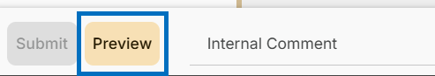

- This will open the syllabus preview in a second tab. When you have finished reviewing it, close the tab to return to the syllabus editor.

Submit Your Syllabus

Submitting your syllabus simultaneously creates a student view and a public view of your syllabus. The visibility and privacy sliders establish the audience for each component. Once submitted, no further action is required. The student-facing view will be made available in Brightspace. The public-facing view will be made available on Purdue’s Simple Syllabus website. You can return at any time throughout the semester to make changes and re-submit your syllabus. In order to submit your syllabus, you must:

- Complete all syllabus components marked required.

- Resolve any issues detected by the accessibility checker.

- Click Submit.

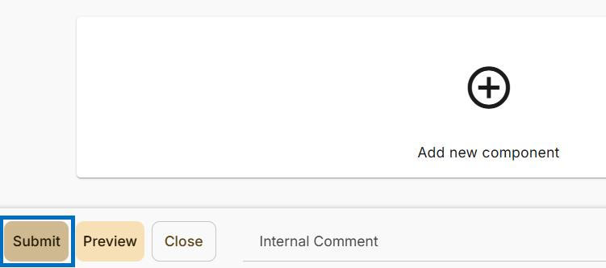

View Your Public-Facing Syllabus

Once you have submitted your syllabus, to view it as the public sees it:

- Navigate to Purdue’s Simple Syllabus website.

- At the top-right, ensure you are NOT logged in. If you are currently logged in, click your name and select Logout from the drop-down.

- Search for your course.

Copy Syllabus Content

Once you have submitted a syllabus, it becomes part of your repository. At any time, you can choose to copy all content into another course syllabus. To copy all content from another syllabus:

- Open the course syllabus you would like to copy content into.

- Click Replace with a different syllabus? at the top

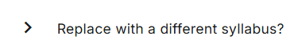

- Select the course you would like to copy from.

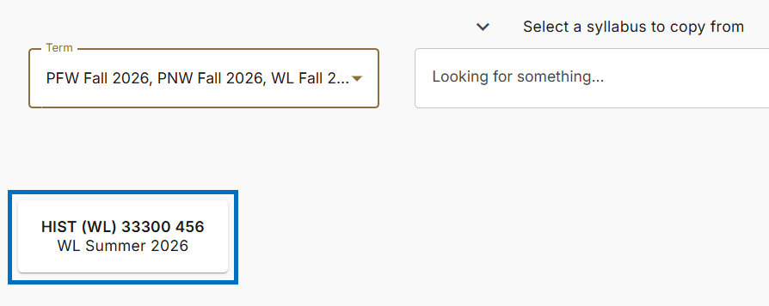

- The contents will import.



Automatic Importation Of Syllabus Content

Simple Syllabus will automatically import your most recent syllabus for a course offering. For example, in Fall 2026 you teach HIST 333. In Spring 2027, you teach the course again. When you edit your Spring 2027 HIST 333 syllabus, the contents of your Fall 2026 HIST 333 syllabus will be imported automatically. You have 3 options:

- Update the imported content to reflect the current semester.

- Select a different syllabus to import. See Copy Syllabus Content.

- Reset the syllabus to clear all content and restart with a blank version of the university’s template. See Reset a Component.

