Edit Mechanical Captions for Kaltura Media via Brightspace

Beginning summer term 2024, all new video uploads to Kaltura will be submitted for automatic captioning via automatic speech recognition. This update should save faculty time and make their content more accessible. With that in mind, the auto-generated captions do not guarantee compliance. Captions should always be reviewed and edited following the instructions below:

Edit Captions
- When the captions are finished processing, you can edit the captions for accuracy. To do so, click the name of the video, click Actions beneath the video player, and select Edit from the drop-down.

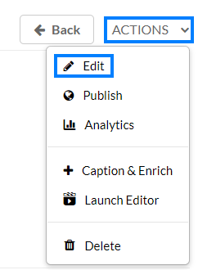

- Click the Captions tab beneath the video player.

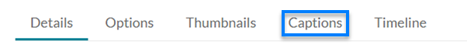
- Click the Edit Captions button.

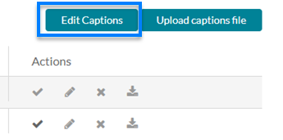

- A list of the caption bubbles will load along with the option to play the video. Click into any bubbles where there are inaccuracies, correct the text, and click Save when you have finished making corrections.

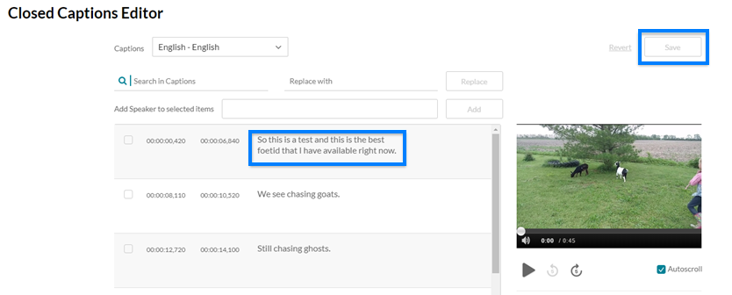

- The changes made to the captions will process in the background and the captioning file will update when complete.

