Request Mechanical Captions for Kaltura Media via Brightspace

Professional captions are created by a third-party vendor using a human who watches the video and transcribes the audio. Professional captions take 2-5 days to be completed, have a high level of accuracy, and an associated cost per minute.

Mechanical captions can be created automatically by a computer using machine learning algorithms. Mechanical captions are free and have a quick turnaround time but have a significantly lower level of accuracy. PLEASE NOTE: The accuracy of mechanical transcription does not meet accessibility standards. You will need to edit your captions for accuracy. The steps to request and edit mechanically generated captions can be found below.

Request Captions
- Open your Brightspace course, click Course Tools from the course navigation bar, and select Kaltura My Media from the drop-down.

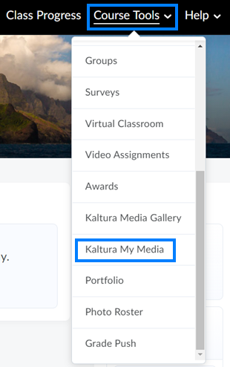

- Click the name of the video you would like to caption.

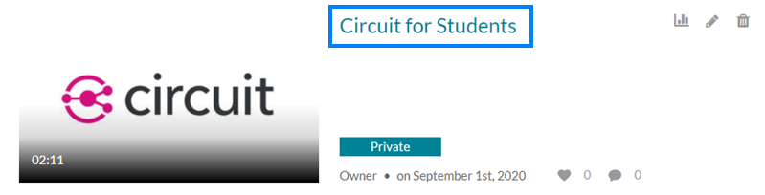

- Click Actions beneath the video and select Caption & Enrich from the drop-down.

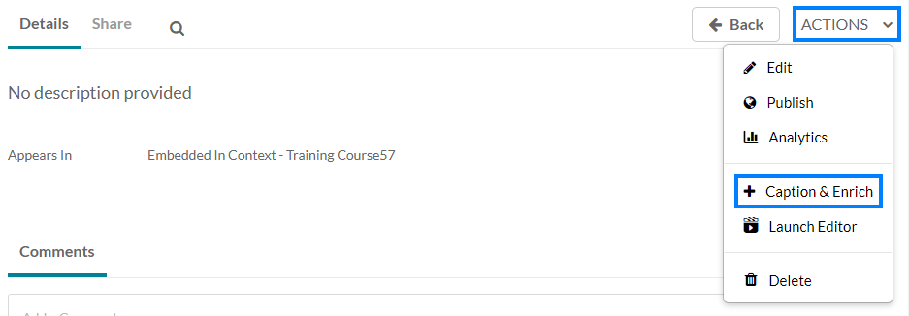

- Select the language that was being spoken in the video and click Submit. This will submit a request for mechanical captions for your video.

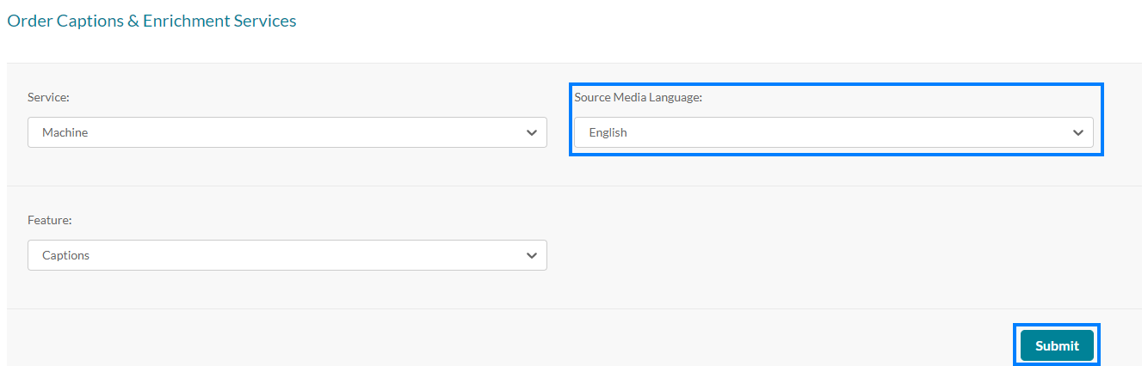

Edit Captions
- When the captions are finished processing, you can edit the captions for accuracy. To do so, click the name of the video, click Actions beneath the video player, and select Edit from the drop-down.

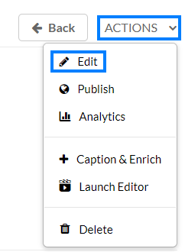

- Click the Captions tab beneath the video player.

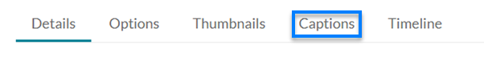
- Click the Edit Captions button.

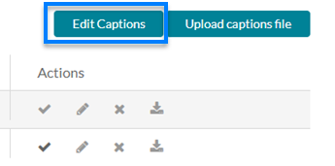

- A list of the caption bubbles will load along with the option to play the video. Click into any bubbles where there are inaccuracies, correct the text, and click Save when you have finished making corrections.

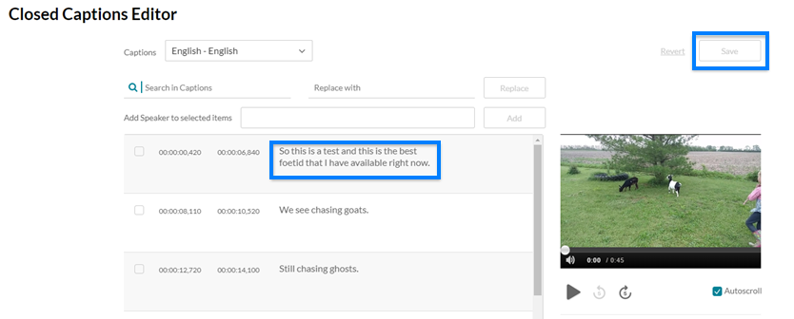

- The changes made to the captions will process in the background and the captioning file will update when complete.

