Obtain the Link to a Kaltura Video

PLEASE NOTE: Students are unable to obtain links to their Kaltura Media, via Brightspace or via the steps outlined below.

- Navigate to https://mediaspace.itap.purdue.edu/, login, click your name near the top-right, and select My Media from the drop-down.

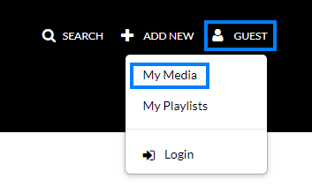

- Click the title of the video you would like to obtain a link to.

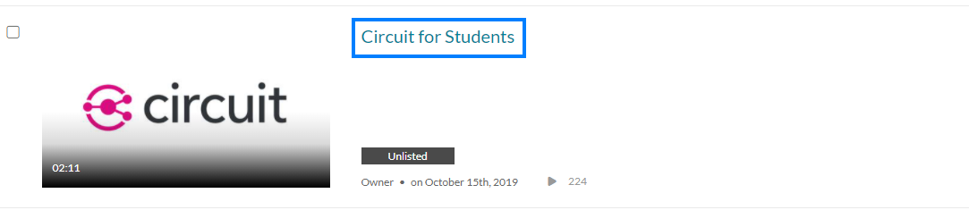

- Click Actions beneath the video and select Publish from the drop-down.

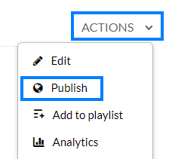

- Select Unlisted under publishing status and click Save.

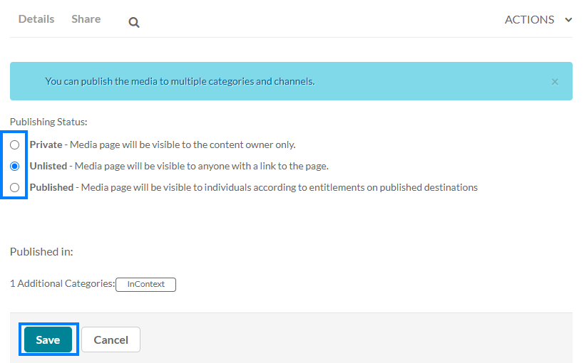

- Click the Share tab beneath the video to obtain the link you can share with others.

