Obtain the Link to a Kaltura Video

PLEASE NOTE: Students are unable to obtain links to their Kaltura Media.

- Navigate to Mediaspace, click Guest at the top-right, and select Login from the drop-down.

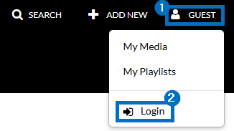

- Click your name at the top-right and select My Media from the drop-down.

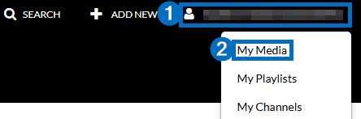

- Click the Pencil/Edit icon to the right of the video you would like to obtain a link to.

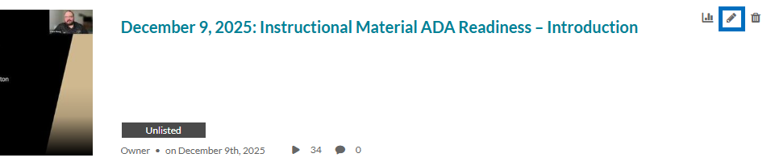

- Click the Publish tab, select Unlisted, and click Save.

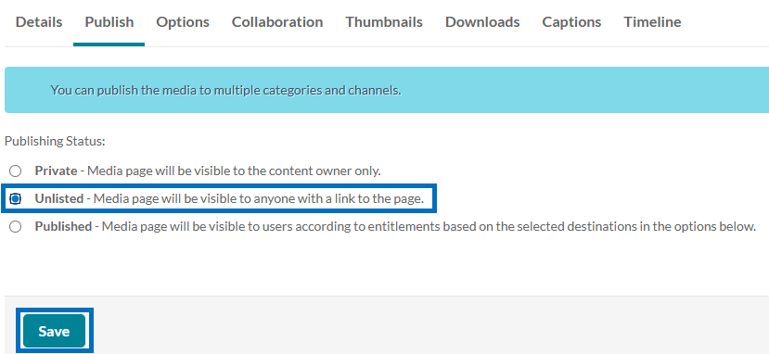

- Click < Back to Media Page at the top-left.

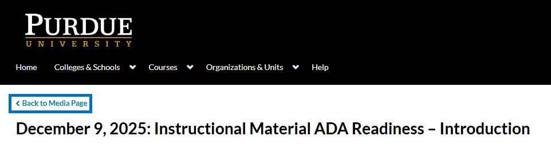

- Click Share and then copy the Link to Media Page.

