Create a Video Using Kaltura Capture via Mediaspace

Install the Recording Client

- Navigate to Mediaspace, click Guest at the top-right, and select Login from the drop-down.

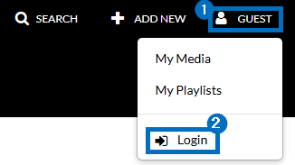

- Click +Add New at the top-right and select Kaltura Capture from the drop-down.

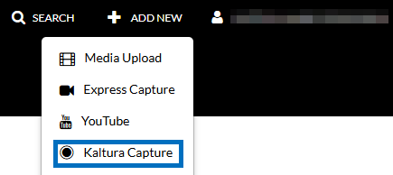

- If Kaltura Capture has not yet been installed on your device, click the appropriate download. When the download completes, open/run the installation file.

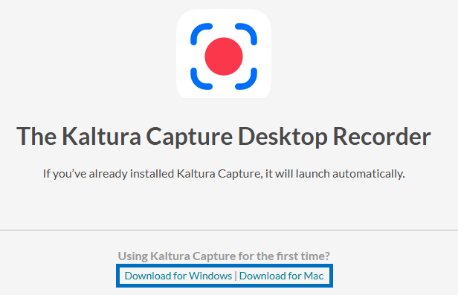
- When the installation is complete, repeat steps 1 and 2. You will see a Kaltura Capture icon load and the recording controls appear when finished.

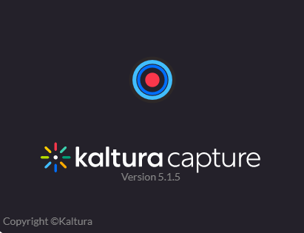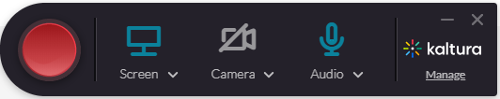

Record Using Kaltura Capture

- You can select to include any combination of screen, camera, and audio in your recording by clicking directly on the source icons. Active sources will appear in blue; inactive sources will appear greyed out with a line through it. You can click the drop-down icons for each source to select which input you would like to use.

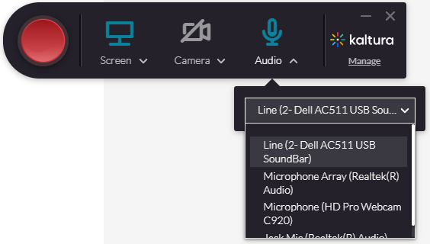
- When ready to begin recording, click the red record button. A countdown timer will display and the recording will start after the countdown completes.

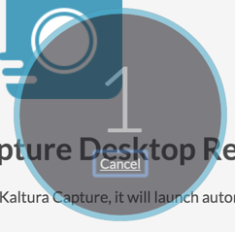

  - Click Stop to end the recording.


  - Click Pause to pause the recording and resume the same recording when ready.


  - Click Cancel to discard the recording and start over.
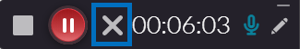
  - A timer will show the elapsed time of the recording on the controls.
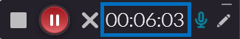

  - Click the Edit/Pencil icon for screen annotation tools.


- When you stop the recording, a screen will appear where you can preview the recording and enter a name, description, and tags for the recording as you would like it to appear in Kaltura. Click Save & Upload when finished. The recording will upload and appear in your Kaltura My Media list when finished.

