Add an Additional Instructor or TA to a Kaltura Video via Mediaspace

- Navigate to Mediaspace, click Guest at the top-right, and select Login from the drop-down.

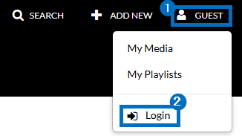

- Click your name at the top-right and select My Media from the drop-down.

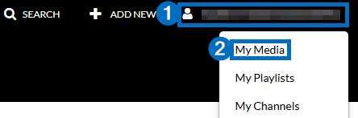

- Click the Edit/Pencil icon to the right of the video you are editing captions for.

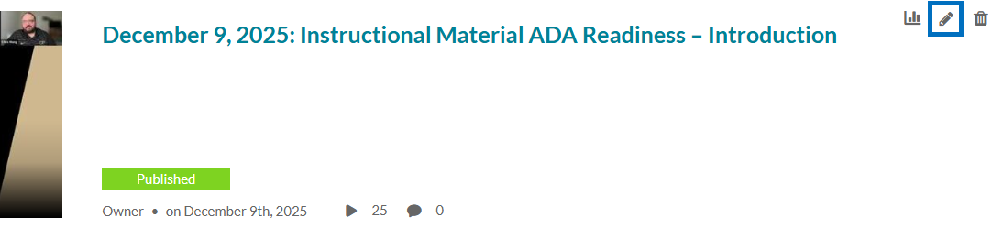

- Click the Collaboration tab and then click + Add Collaborator.

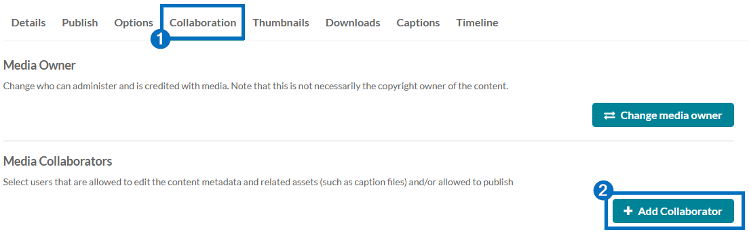
- Enter the name or username of the individual you would like to add and select the appropriate option from the drop-down that appears. Select the desired permission level(s) this individual should have. Then click Add.

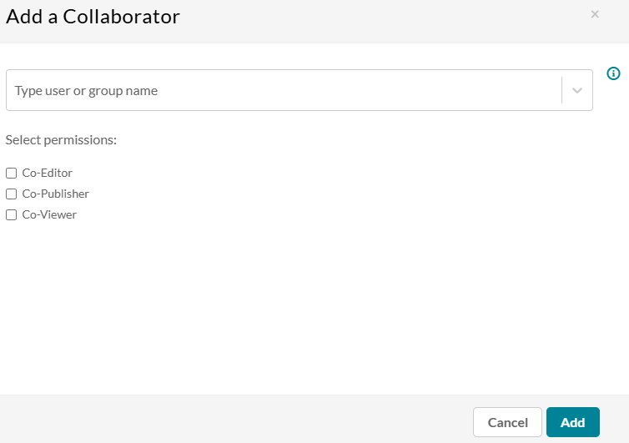

  - Co-Editor: Can edit this media's details and metadata, trim media, replace media, edit captions, edit chapters, and edit slides. Co-editors can't delete media or add new co-editors and co-publishers. Co-editors can see the analytics page for the media they co-edit.

  - Co-Publisher: Can publish this media to their entitled Categories or Channels.

  - Co-Viewer: Can only view this media and doesn't have editing or publishing permissions.
Kaltura Source

