Access Viewer Analytics via Mediaspace

- Navigate to Mediaspace, click Guest at the top-right, and select Login from the drop-down.

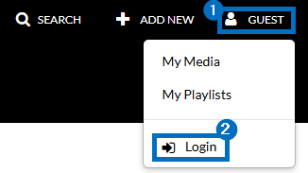

- Click your name at the top-right and select My Media from the drop-down.

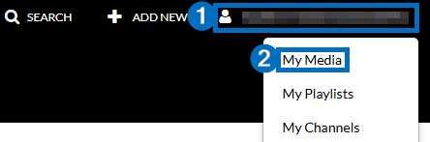

- Locate the video for which you would like to see viewer statistics. Click the View Analytics icon to the right of the video.



- Click View Engagement Per User beneath the line graph.

