Use Kaltura for Video Assignments

Learners may use Kaltura to upload videos to their assignments or discussions in Brightspace. Kaltura allows you to upload your videos securely so that it may be seen only by your instructor, or only by your instructor and classmates.

Videos uploaded via Kaltura to an assignment are only viewable by your instructor; videos uploaded to a discussion can be watched by anyone with access to that discussion forum.

- Login to D2L Brightspace and open the course you would like to submit your video to.

- If you are submitting a video to an assignment, click on the name of the assignment in the appropriate module. Alternatively, click Course Tools and select Assignments from the drop-down to locate the assignment.
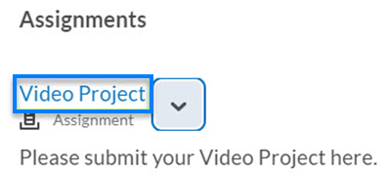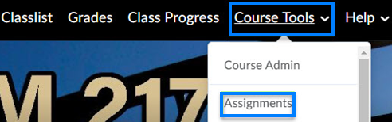
- If you are submitting a video to a discussion, click on the name of the discussion in the appropriate course module. Alternatively, click Course Tools and select Discussions from the drop-down to locate the discussion.
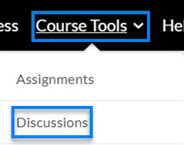

- In the submission area, click the Insert Stuff button near the center of text box menu.

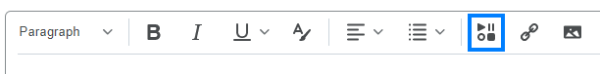

- Click Add Kaltura Media.
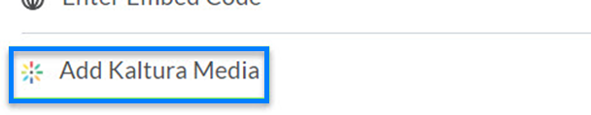

- Click +Add New near the top-right side of the screen and select Media Upload from the drop-down.
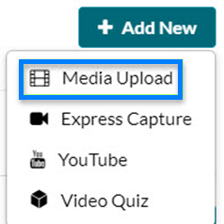

- Drag and drop the video file from your computer into the pop-up window or click +Choose a file to upload to search for the file. You may need to scroll in the pop-up window to see all available options. Your video will then upload.
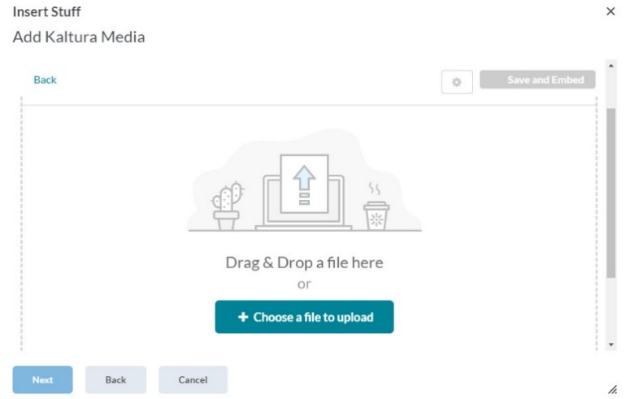

- If the screen changes and you cannot see the upload options, refresh the screen and click on the Add Stuff icon again. Your video will have uploaded.
- Your video will process in Kaltura. Allow a few minutes for the video to be converted by Kaltura. Click the Refresh icon at the upper right of the Add Kaltura Media screen to check video conversion progress.

- Once the video is ready, click the </>Embed button to the right of your video.
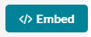
- You can preview the video if you would like. Click Insert to add the video to the assignment or discussion.
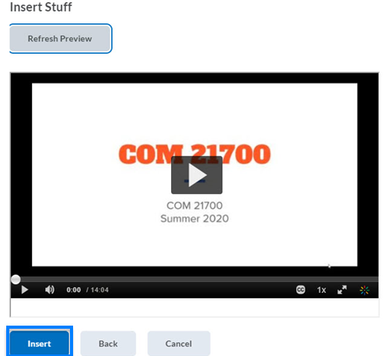
- The video is added to the submission window. You may choose to add text or other content at this time. When you are finished, click Submit.
