Setting up the iClicker Software with Brightspace Integration

Getting Started: Contact itap@purdue.edu to obtain the necessary software to run iClickers.
*Please note, a new copy of the software will need to be obtained in order for it to integrate with Brightspace.

- Once you receive the new iClicker software, be sure to store the file in a place where it will be accessible to you during your class. The software must be running during the session.
- Open the downloaded file. You may have to ‘unzip’ or ‘extract’ the files.
- From the files, select the iclicker.exe. Double click the file to open. NOTE: If you receive a software update message do not do the update – click “Not Now”.
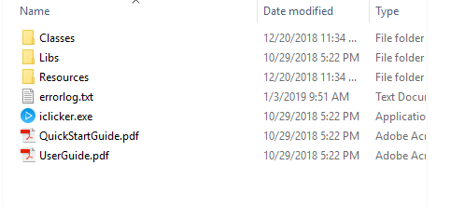

- The main iClicker screen will appear. Select Create to set-up a new course for the semester.
- On the following screen, enter your course title. You may want to indicate the semester and/or section in the title. When you are finished, click Create.
Your course will now appear in the main iClicker screen. If you will have multiple courses and/or sections, repeat the above steps to create separate courses.

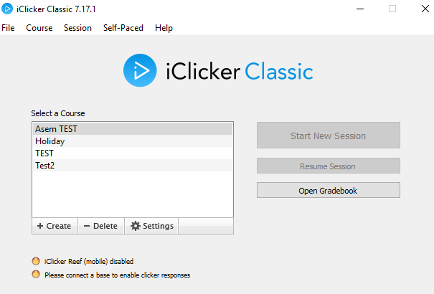

Linking Your Course with Brightspace:
- Using your default web browser, log into Brightspace using your Purdue career account and Boilerkey.
- Open the iClicker software.
- Once you have the iClicker software running, click on the course so it is highlighted. Then click on Settings.
- Select the Gradebook tab at the top of the screen.
- Click on Select Course.
- A new window will appear indicating that you will log into D2L using D2L credentials. Be sure the box near the bottom of the screen is checked.
- Click Log In to continue. NOTE: If a list of classes appear and you do not see the Log In button, click Logout and you will be taken to the login screen where you can now click on the Log In button (as shown in the image below).

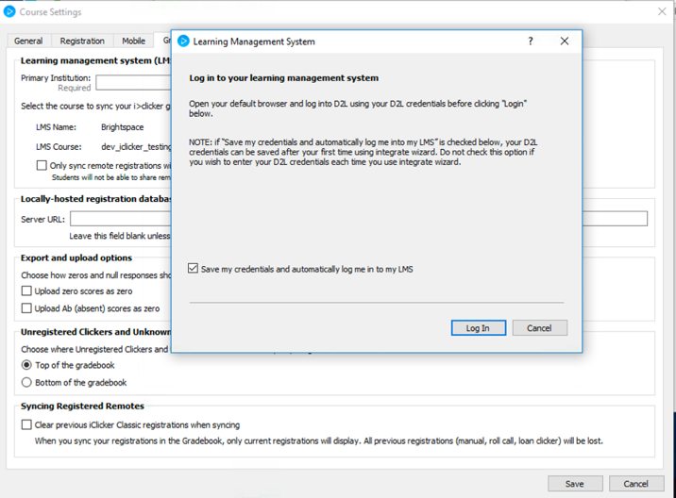

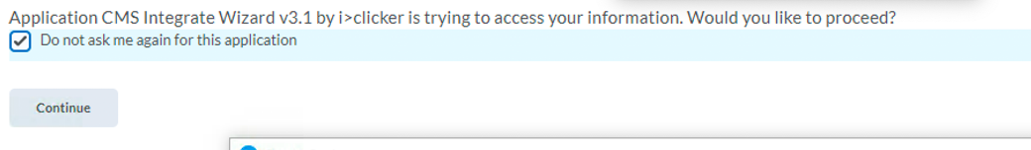
- Your web browser will then prompt you with a message asking if you would like to proceed. Be sure to check the box next to “do not ask me again for this application”. Click Continue.

- A pop-up window will appear with your available courses. Select the appropriate course. Click Select to continue. You course is now linked to the iClicker software.
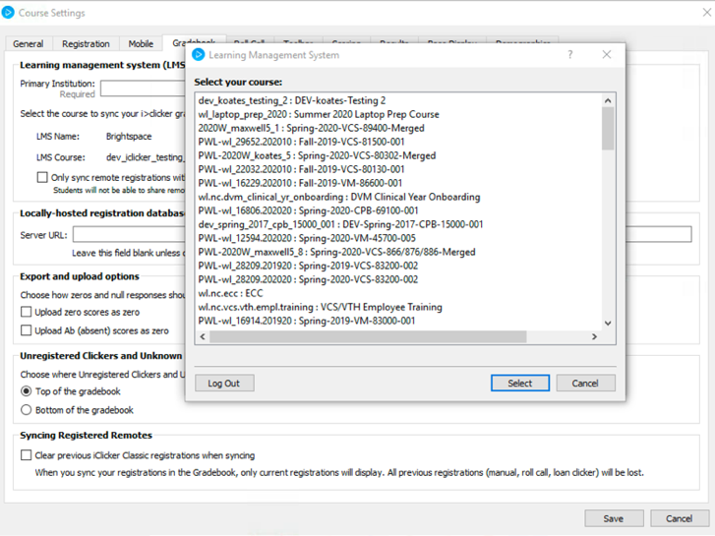

Note: You may receive a pop-window and/or a message in your web browser similar to the ones below. If you encounter these, you can disregard.
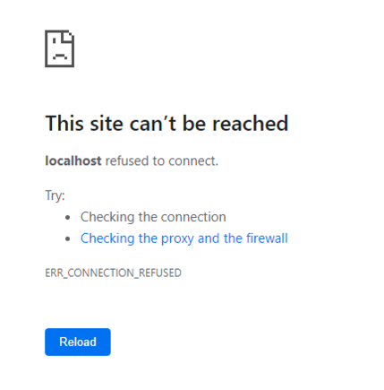
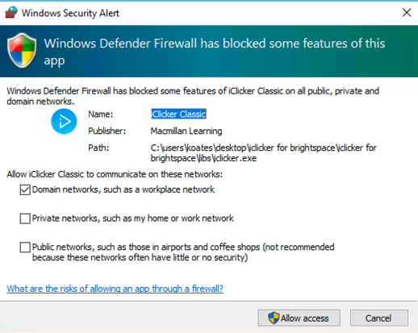

Syncing Your iClicker Course with your Brightspace Roster:
- Open the iClicker software.
- Select and highlight the desired course.
- Click on Open Gradebook.
- From the top of the screen, click on Sync Roster.
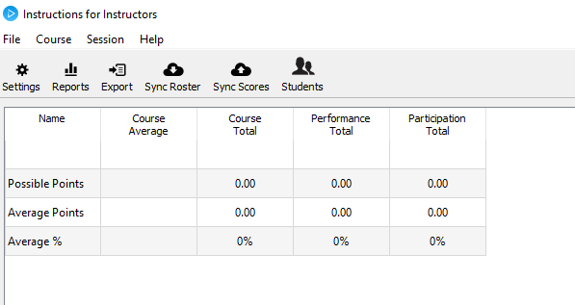

- Once the screen confirms that the roster was downloaded, click Close.
- Your students will now appear under the name column.

Note: If students have not registered their clickers in your Brightspace course (see document on Creating Student iClicker Registration Link in Brightspace), their names may not appear. Be sure to sync the roster again before uploading grades for the first time. Please make sure your students are aware that they must register their own device. If their iClicker is registered under another student account, it will not correspond to the correct student.
You can close the window when you are finished.

Scoring Settings in iClicker:

- Open the iClicker Software.
- Select and highlight the desired course.
- Click on Settings.
- Select Scoring tab near the top of the screen.
- Change the settings according to how you would like student responses to be evaluated by the system.
  - If your points will vary between class sessions, you will need to alter the session scoring settings. See next section for instructions. If you would like assistance with this section, please contact tlt@purdue.edu.
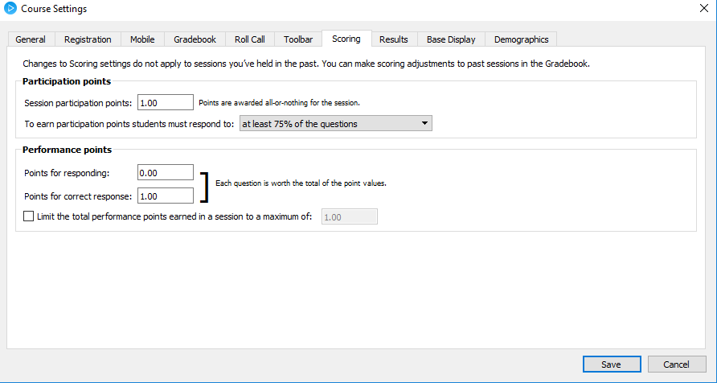
- When you are finished, click Save.

Grading individual iClicker Sessions:

- Open the iClicker software.
- Select and highlight the desired course.
- Click on Open Gradebook button.
- Click the blue View button located below the session title and date.
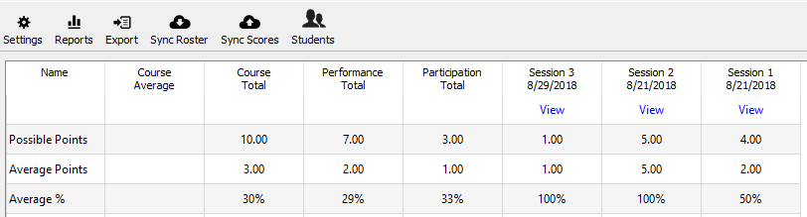

- On the following screen, screen captures of the session questions will be displayed. Click on each picture and check the box next to the correct answer. If a question is invalid, you can delete it using the button in the upper, right-hand corner of the screen.
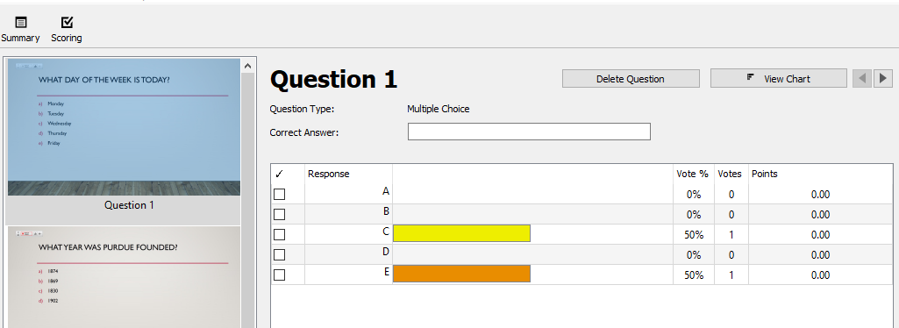

- To alter the points scored for the session, click the scoring icon in the upper, left-hand corner of the screen.

- From the options displayed, select which features fit the course.
  - Participation points are earned when students answer a certain number of session questions.
  - Performance points are earned when students answer correctly. This section also allows for students to earn points for responding.
  - A maximum number of performance points can also be set for a session.
- When you are finished, click Done.
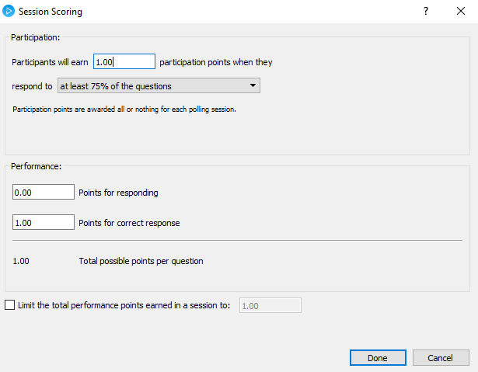

Preparing iClicker Questions:
As you prepare your class lectures, you can directly incorporate your iClicker questions into your PowerPoint. Be sure that your question can be answered by the iClickers. Multiple choice questions (A-E) are most common and highly recommended, but there are also numeric and alphanumeric response options as well. Impromptu questions do not have to be prepared for in advanced within your instructional presentation. The iClicker polling can be opened and closed as many times as you would like. Each time an iClicker poll is started, the software takes a screen shot of what is on the screen, therefore capturing the iClicker question you have incorporated into your PowerPoint slide deck.

Using iClickers in Your Classroom
Note: To use iClickers in your class, you must have a base, student iClickers, and iClicker software. You must set up your course prior to your class session. See previous steps if you have not completed course set up.
- On the room computer, log in and open the iClicker software that you used to prepare your course.
- Check for a base and make sure it is plugged into the computer you are using.
  - If you are using laptop, the base must be plugged in directly to your laptop.
- Click Start New Session on the main screen.
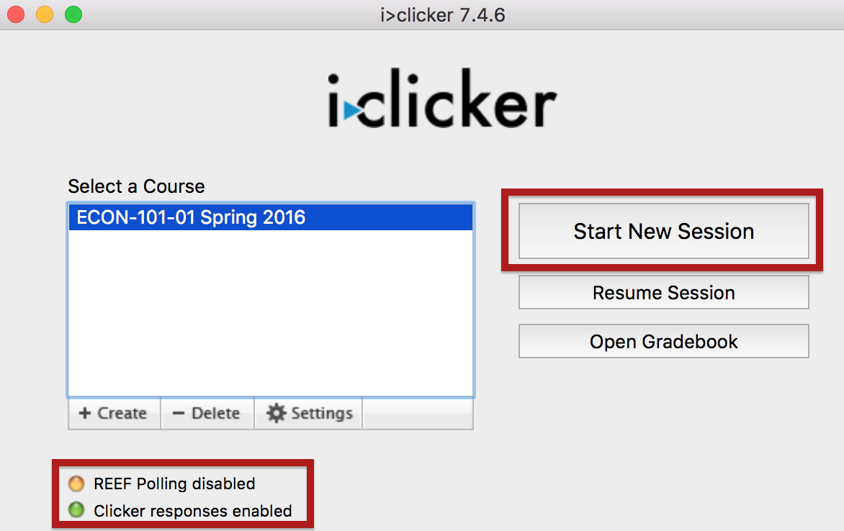

- The tool bar will appear. This item can be dragged to the corner of the screen until you are ready to open the polling.


- Bring up your presentation.
- When you are ready for students to respond, click the green “Multiple Choice” button on the tool bar.
  - The tool bar will now display a timer and response count.
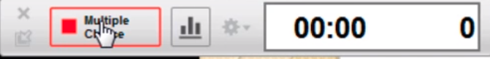

- When you are ready to close the poll, click the red “Multiple Choice” stop button.
  - If your class has multiple questions in the session, you can start and stop the response ability as many times as you would like.

- If you would like to review the responses with the students, click on the graph icon on the tool bar.
  - You can toggle between different question responses by using the drop down menu near the top of the pop up window.
  - Be sure you closed polling before opening the graph to show students. If polling is still open, students will change their answers based upon what they see, skewing the results.
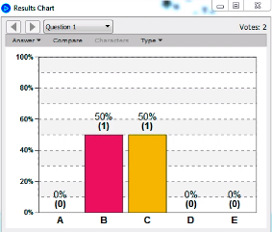

- When you are finished using iClicker, close your session by clicking the ‘X’ on the tool bar.
  - If you accidentally close the tool bar, you can open it again using the Resume Session button or Start New Session button.

Uploading Scores to Brightspace
If the roster has not been synced to the software, you must do so prior to uploading scores. Please see the ‘Syncing Roster’ section for directions. If your points will vary between class sessions, you will need to alter the session scoring settings.
- Open the iClicker software and click Open Gradebook.
- Sync roster if necessary using the icon near the top of the window. This is recommended during the first few weeks of the course.
- If you would like to alter points for a specific session, do so by click the ‘View’ under the corresponding session. See previous section for specific directions.
- Once you are ready, click the ‘Sync Scores’ icon near the top of the window.
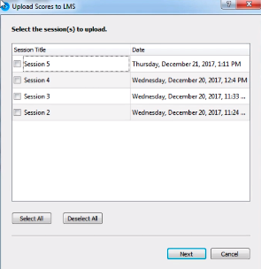
- On the following pop up window, select which sessions you would like to upload by checking the box next to the session title.
- Click Next to continue.

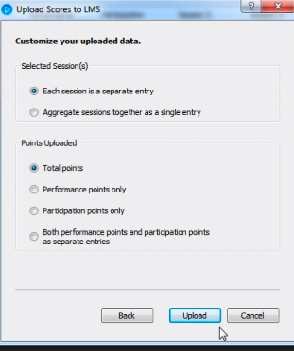
- From the following options, choose which items best fit your course.
- Click Upload to continue.
- When the scores have uploaded successfully, click Close.
- A corresponding grade column will now appear in the Brightspace course.

Additional Options

Instructor Remote:
Instructor remotes are available to instructors free of charge. These can be obtained by contacting itap@purdue.edu (Limit 1 instructor remote per course). The instructor remote acts like a traditional slide advancer, but it also allows you to control the opening and closing of polling during your class session. The remote also has a red laser pointer. Simple instructions for using the instructor remote are located on the back of the device.

iClicker Bases:
If your classroom does not have a base, please contact itap@purdue.edu and a base will be installed in the classroom for you at no charge.

iClicker Reef:
At this time, the iClicker Reef application is not supported at Purdue. In order to use the iClicker software, students must purchase a hand-held iClicker remote.

