Grant a Late Permit to a Student

Overview Of Late Permits
Phases of a Circuit assignment occur sequentially. Students must complete one phase of the assignment in order to move on to the next. If they miss a due date at any point in time, they will be unable to proceed to the subsequent phases of the assignment and will receive an incomplete for those missed phases - unless you are using late permits.

The late permit feature is available only when gaps of time are left between phases. During this time frame, you can grant individual students a late permit for the preceding phase of the assignment.

For example, Jacob Smith did not complete his calibrations by the due date (1/16/2020 at 11:59PM). He emailed you on 1/17/2020 at 9:00AM stating there was a power outage and he was unable to complete his last two calibrations. Because the Reviews phase has not yet begun, you are able to grant Jacob a late permit if you would like. With a late permit, he would have until 1/17/2020 at 12:00PM to complete the remaining calibrations.

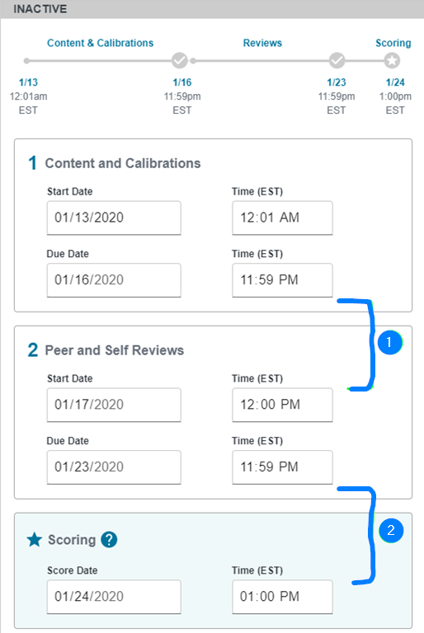

Grant A Late Permit
- To grant a late permit, click the name of the Circuit assignment.

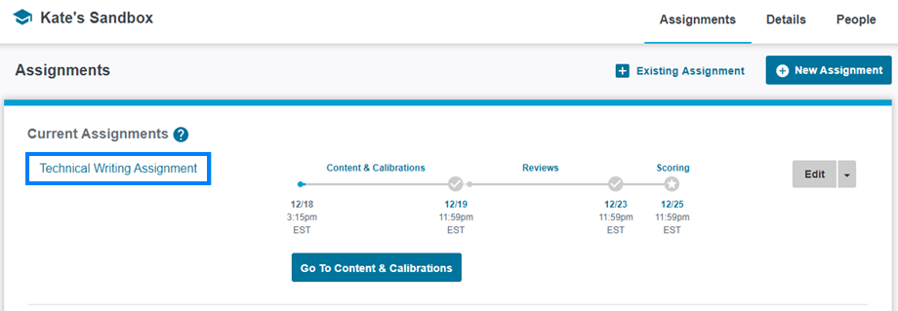

- Click Progress, locate the student you would like to grant a late permit to, click the Late permit icon to the left of their name, and check the box for the phase you would like to grant a late permit for.

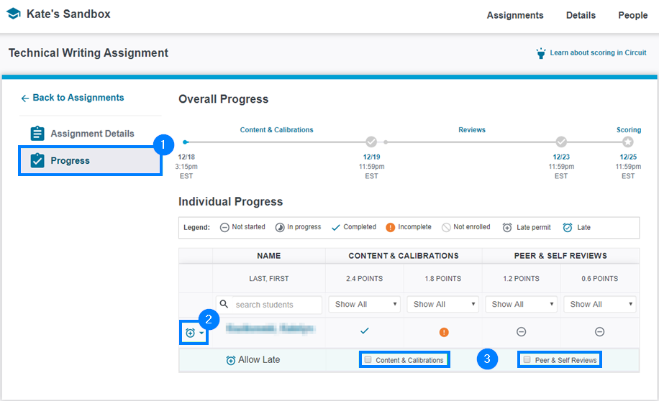

- The student now has until the next phase begins to complete their assignment.

