Getting Started with Snagit

Snagit enables you to create high-quality screen captures from your computer. Captures can be in the form of images or videos. Annotations such as highlights, arrows, text, blurs, and more can be added.

Installing Snagit

- Navigate to the Snagit IL webpage and click Download Snagit Software.

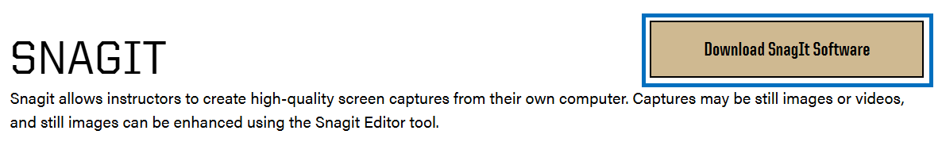

- Click Sign in with Purdue Credentials.

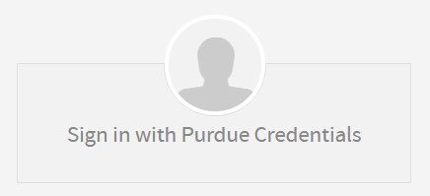

- Choose the Snagit for Personally Owned Computers or Snagit for University Owned Computers based on the device you are using.


- Review the product information for installation information based on the version of the software you selected to install.

- Select your operating system, select the number of machines you intend to install this software on, and click Add to cart.

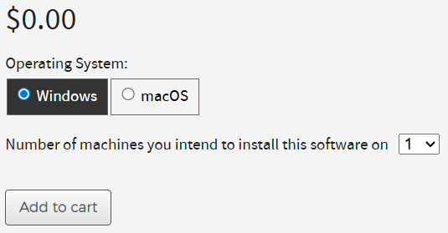

- Click Checkout and proceed through the checkout process. At the end, you will be provided with the installation package and license key information.

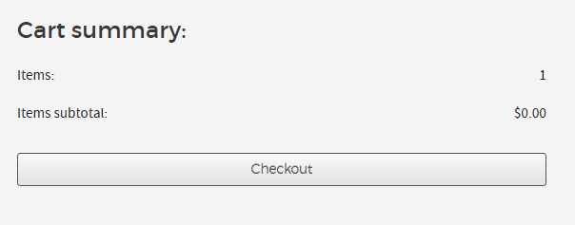

Using Snagit
Snagit tutorials are available here.

