Enable Turnitin for a Brightspace Assignment

Turnitin Originality works by comparing text in files submitted to a Brightspace assignment with Turnitin’s database of previously submitted papers, published research papers, and numerous internet resources. This produces a report highlighting any similarities detected between the student’s current submission and the database of existing resources. Turnitin can be enabled for any “File Submission” assignment in Brightspace.

Brightspace Assignment Settings
- Login to Brightspace and open the course where you would like to use Turnitin.

- From the course navigation bar, click Course Tools and select Assignments from the drop-down.

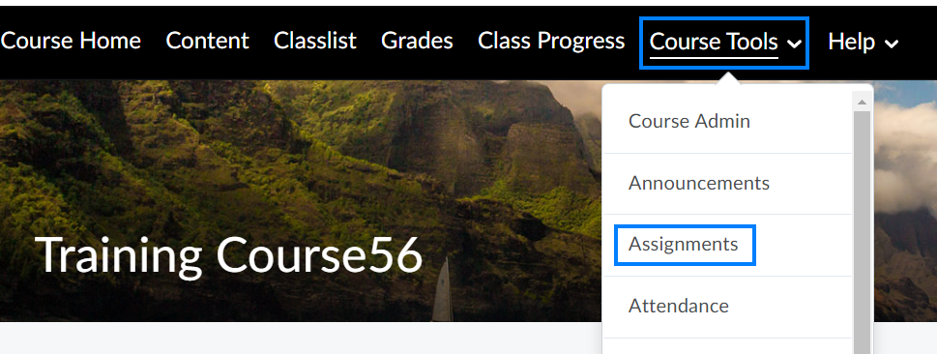

- Click New Assignment if the assignment has not yet been created. If the assignment already exists, click the drop-down icon to the right of the assignment you will use Turnitin for and select Edit Assignment from the drop-down.

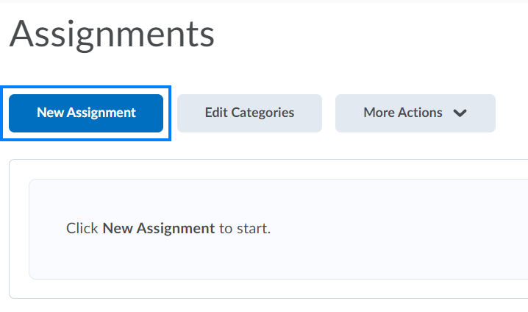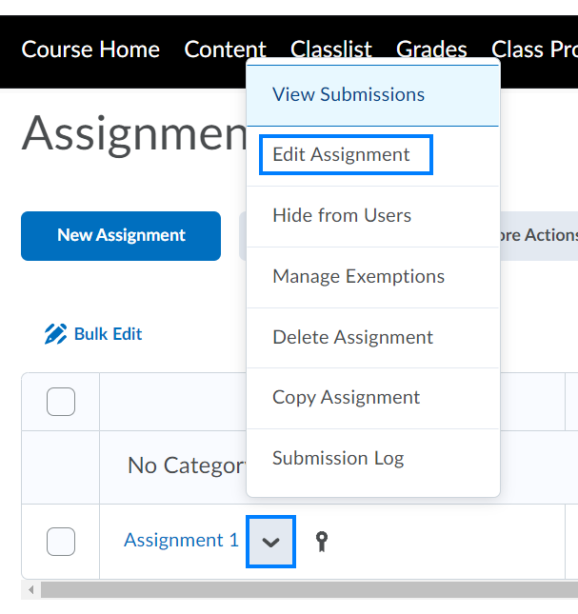
- From the Edit Assignment page, ensure the assignment has been named.

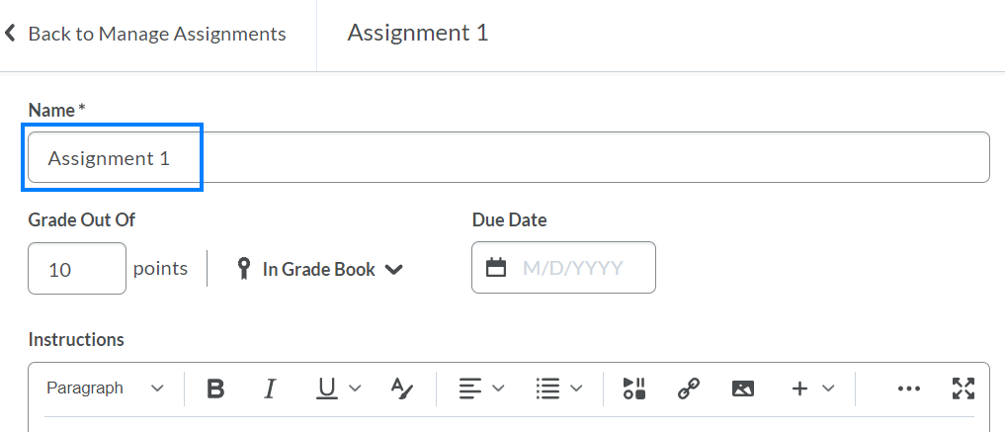

- Expand the Submission and Completion section on the right.

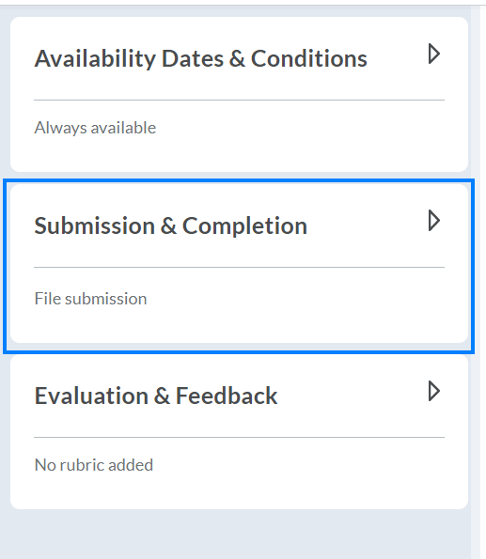

- Ensure the Submission Type is set to File Submission and the Files Allowed Per Submission is set to One File.

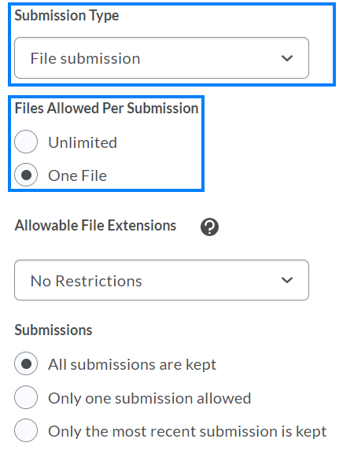

PLEASE NOTE: Turnitin can be used on individual or group assignments. A list of file types supported by Turnitin is available here.

- Expand the Evaluation & Feedback section on the right.

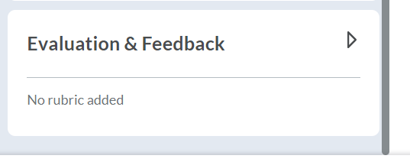

- Click Manage Turnitin.

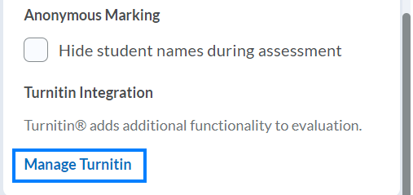

Turnitin Settings
- Check the Enable Originality Check for this folder option. This will enable Turnitin for this particular assignment.

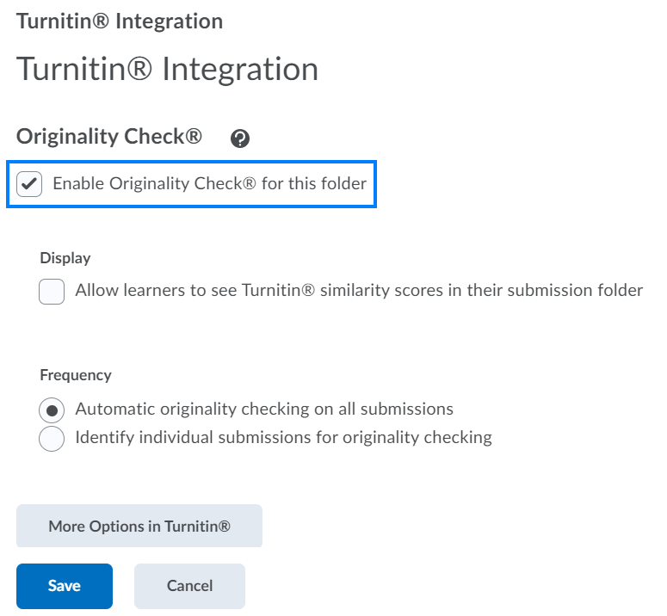

- If you would like to make the similarity score and report available to students, check the Allow learner to see Turnitin similarity scores in their submission folder option. This will allow students the opportunity to see and better understand their score.

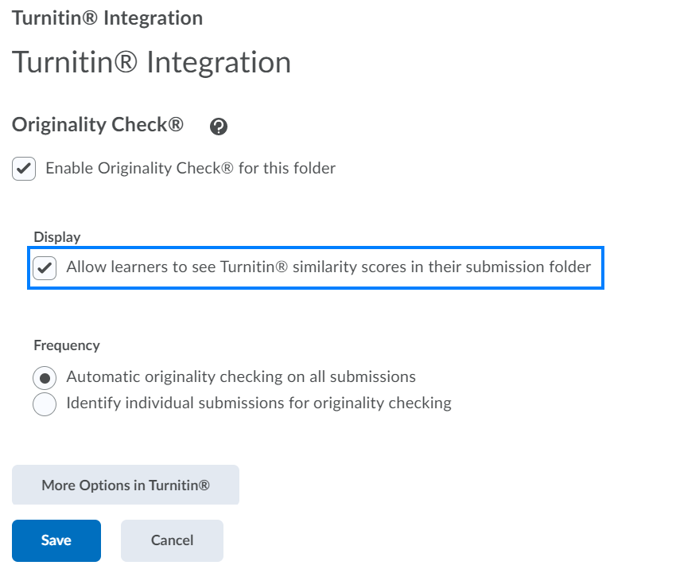
- If you would like to run Turnitin automatically for all student submissions, check the Automatic originality checking on all submissions option. If you would like to run Turnitin only for specific student submissions, check the Identify individual submissions for originality checking option.

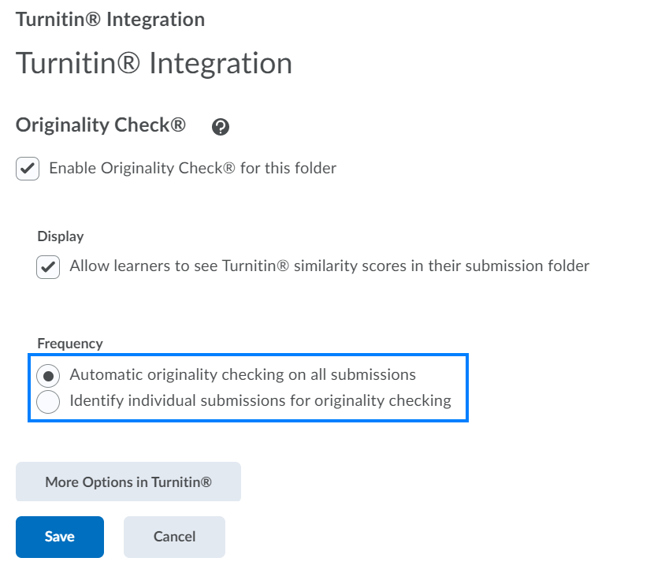

PLEASE NOTE: We strongly encourage selecting the Automatic originality checking on all submissions option. This checks all student submissions and helps avoid any potential conscious or unconscious biases.

- Click the More Options in Turnitin button.

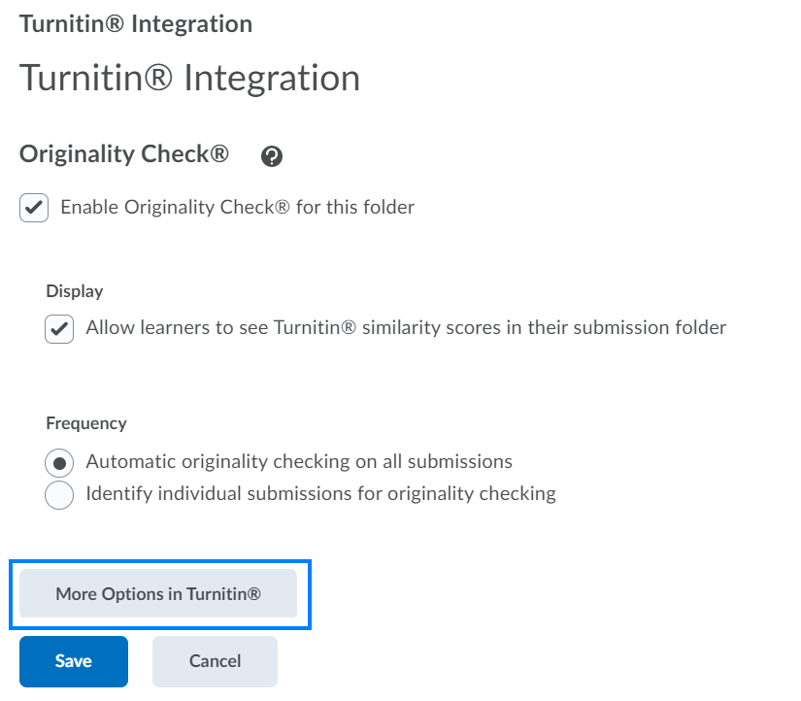
- Customize the Submission settings.

  - Standard paper repository – “Turnitin will store these submissions to the standard repository allowing them to be compared against by students from others institutions.”

  - Do not store the submitted papers – “Submissions will not be stored to any repository. These papers will not be used for any similarity comparison.”
(Turnitin Resource)

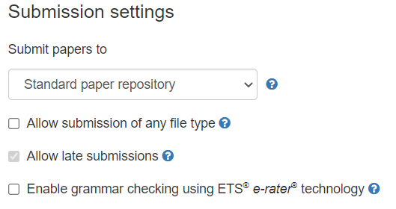

PLEASE NOTE: In instances where you are using Turnitin for drafts of assignments, we highly encourage you to select the Do not store the submitted papers option for the draft assignments and the Submit papers to option for the final assignment.

- Customize the remaining settings as desired and click Submit when finished.

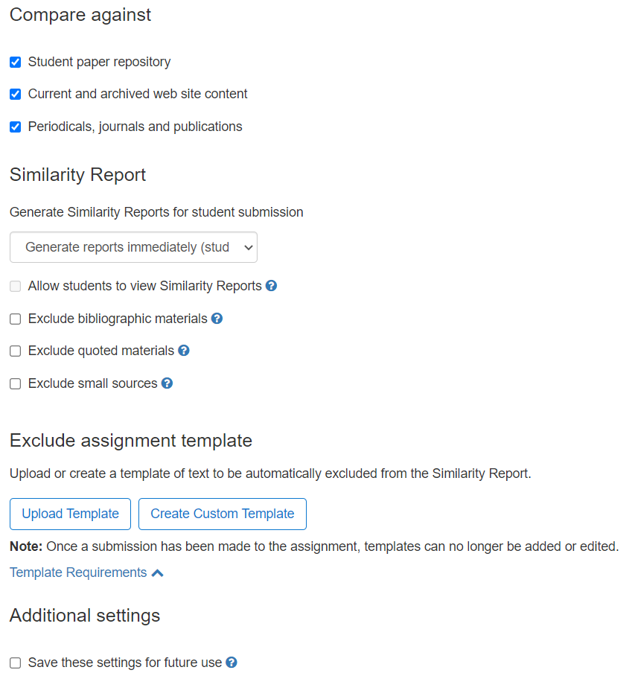
- Click Save to complete the Turnitin settings.

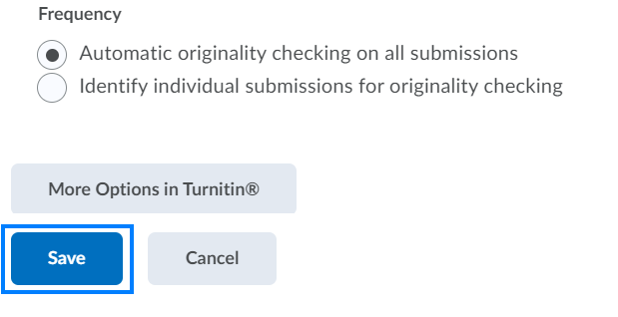

- Complete any remaining details of the assignment and then click Save and Close to save the assignment. The Turnitin enabled icon will appear to the right of the assignment.

