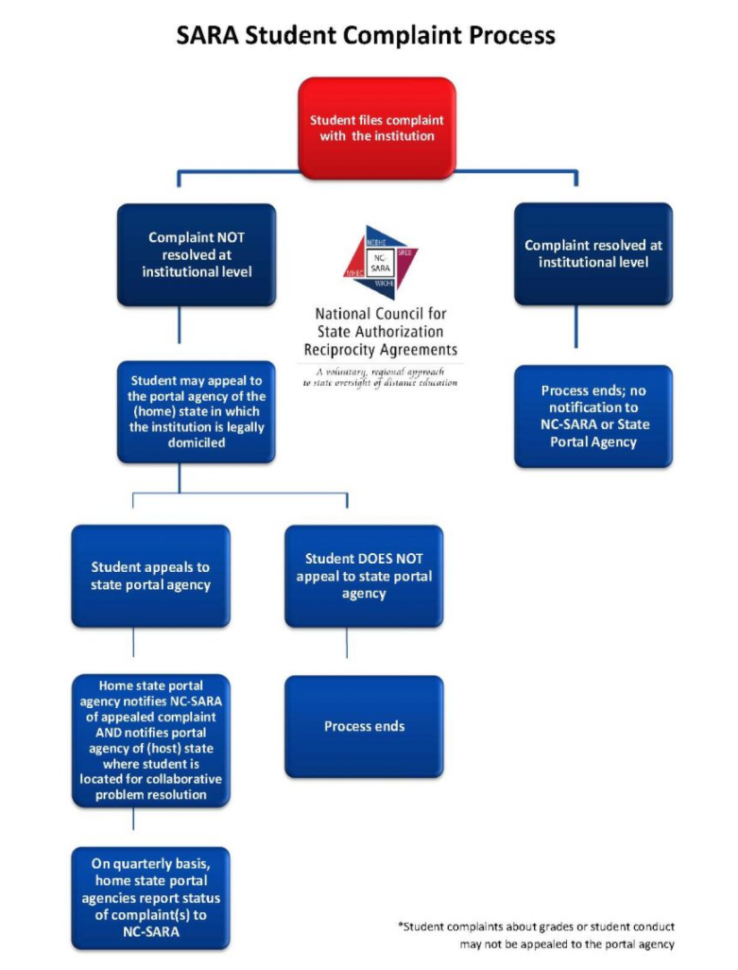

http://www.nc-sara.org/content/sara-complaint-process