Download a Kaltura Video via Brightspace

- Open your Brightspace course, click Course Tools, and select Kaltura My Media from the drop-down.

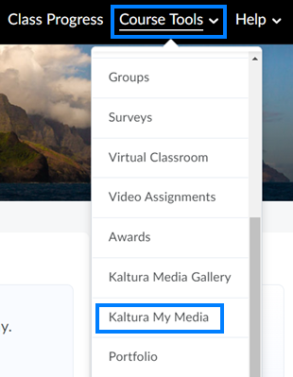

- Click the Pencil/Edit icon to the right of the video you would like to download.

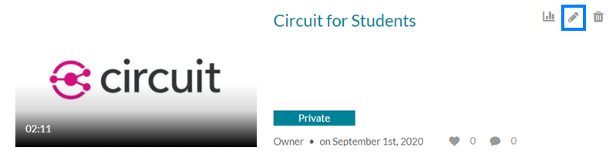

- Click the Download icon and near the bottom-right of the video player to download the video.

