Create a Video Using Kaltura Capture

Description
Kaltura Capture is a quick way for you to record anything you can show on your computer screen including things like PowerPoint presentations, websites, and applications while allowing you to record your voice while you are recording. To install and use Kaltura Capture, use the following steps:

Install the Recording Client
- Login to Brightspace at https://purdue.brightspace.com and enter one of your courses.

- Click on Course Tools and select Kaltura My Media from the drop-down.

- Click the Add New button near the top-right and select Kaltura Capture.

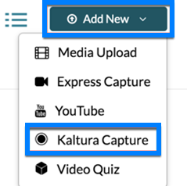

- A screen will load which allows you to download the recording client for Windows or Mac. Download and open/run the installation file that you need for your system.

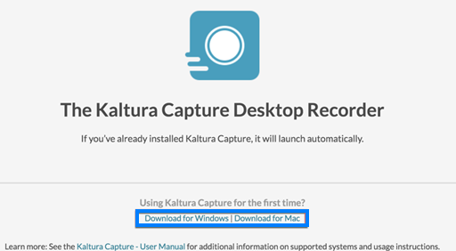

- When the install completes, you will see a shortcut appear on your desktop, but the client still needs to be configured. Once again, click Course Tools, select Kaltura My Media from the drop-down, click Add New near the top-right, and select Kaltura Capture from the drop-down. Rather than downloading the installation file, wait a moment for the client to configure and launch automatically. You will see a Kaltura Capture icon loading icon appear and the recording controls will appear when configuration is complete.

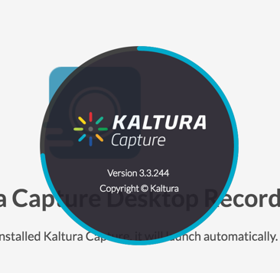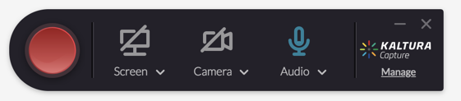

Record Using Kaltura Capture
- You can select multiple combinations of screen, webcam, and microphone using the source buttons on the recording controls. Clicking on the Screen, Camera, or Audio icons will enable or disable the sources. Active sources will appear in blue and if you have multiple inputs to select from for a given source, those can be selected from on the drop-downs beneath each the source buttons.

- When you have selected your sources, click the red record button. A countdown timer will display and the recording will start after the countdown. A timer will show the elapsed time of the recording on the controls.

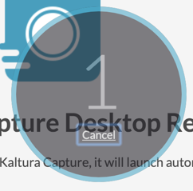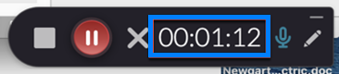

- When finished, click the stop button and confirm that you do want to stop.

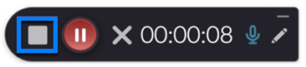
- A screen will load where you can preview the recording and enter a name, description, etc. for the video. Click the Save & Upload button when complete.

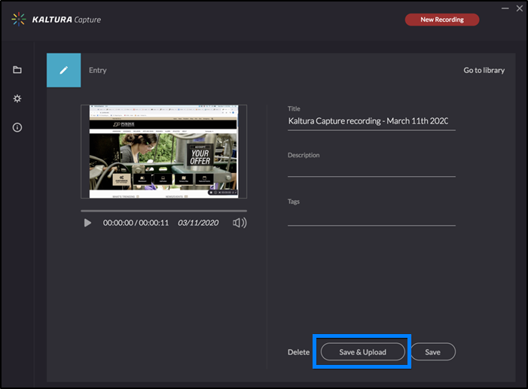

- The recording will then begin to upload and will appear in your local library. When the upload completes, it will appear in your Kaltura My Media list when it finishes processing.

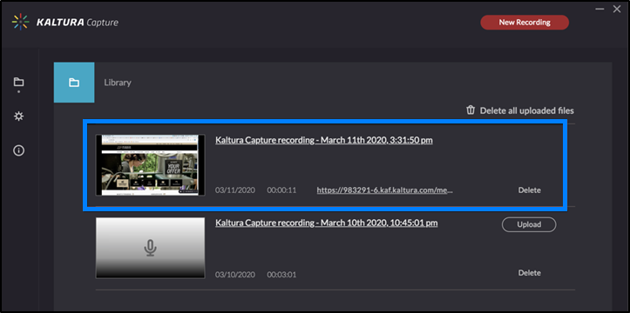

Insert the Recording into Your Brightspace Course
- Open the course module where you would like to insert your recorded video. Click Existing Activities and select Add Kaltura Media from the drop-down.

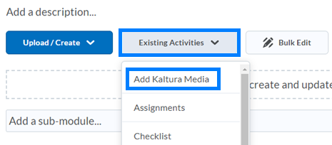

- Locate the video you would like to insert and click </> Embed.

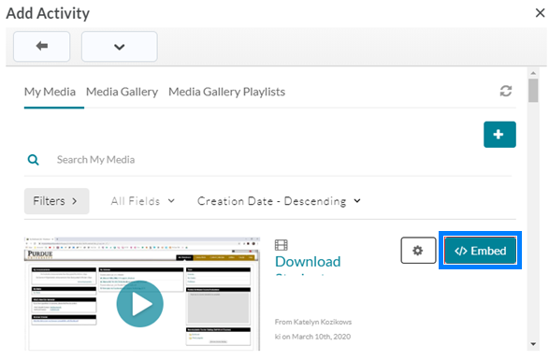

Alternatively, from any textbox location where you see the Insert Stuff button, you can insert your video.

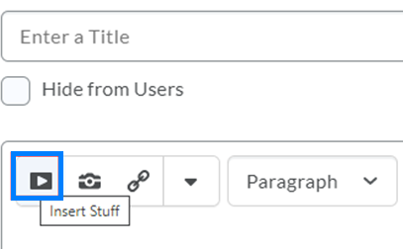

Your videos can also be added to the Kaltura Media Gallery under Course Tools by going to the Media Gallery, clicking the Add Media button, selecting your video, and clicking Publish.

