Create a Standard Peer Review Assignment

Create An Assignment
- To create an assignment in your Circuit course, click New Assignment.

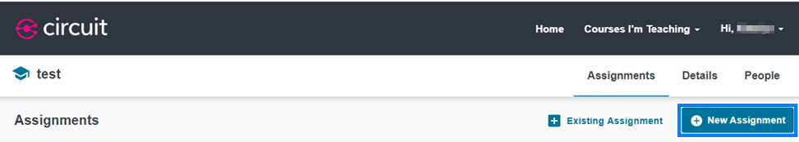

- Enter the name of your assignment. Then click Next.

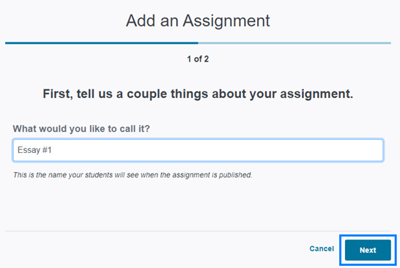

- For a non-calibrated peer review assignment, click the Standard option. Then click Save & Continue.
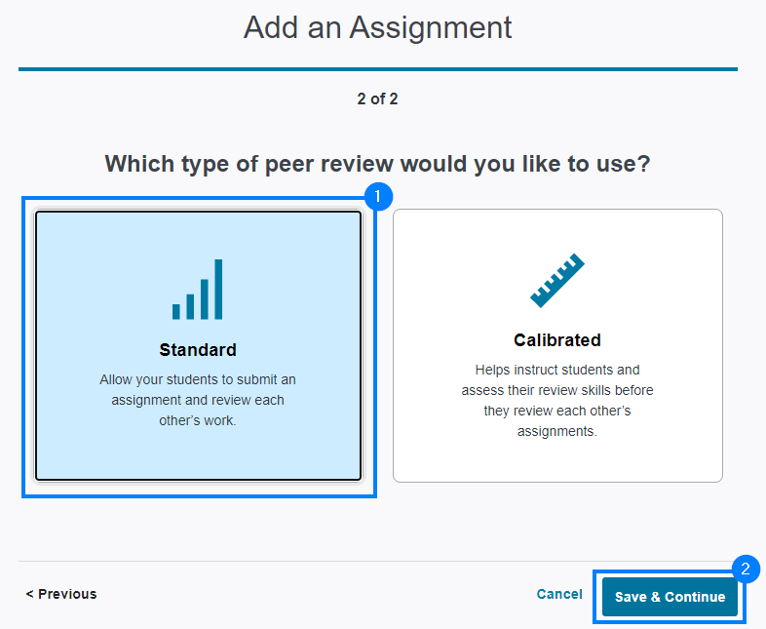
- On the Instructions screen, enter the assignment instructions for your students.
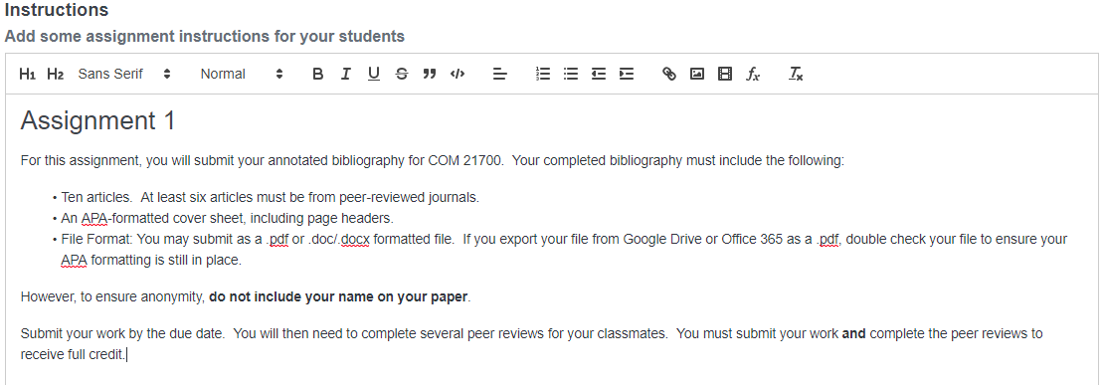

- You have the option to attach supplemental files students may need to read, listen to, or view to help them complete the assignment. To attach files, click and drag or click browse your files to upload one or more files from your computer to Circuit.

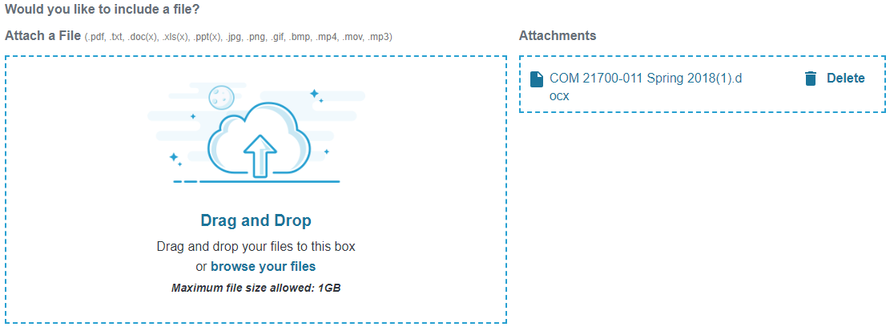

- Specify what you would like students to submit in Circuit. Students are able to submit text, a file, or a web link. Select the appropriate option and click Save & Continue near the bottom right of the screen.

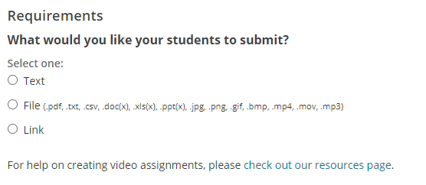

PLEASE NOTE: If you wish to include a minimum or maximum word count as part of the assignment, you must select the Text submission type.

Grading Options
- On the Grading screen, select whether the assignment should include a Self-Review Phase where students review their own work. This phase will occur after students have completed their peer reviews.

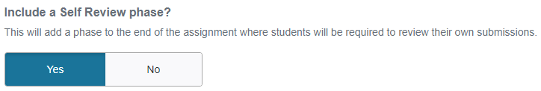

- Next, you can determine the weight, grading method, and feedback requirements for each stage of the assignment:

- Content Quality: It is an average of scores (calibrated or not) received from peers on a student’s submitted work.
- Peer Review: This score is based on the similarity of a student’s review of 3 assigned peers in comparison to how others reviewed those same peers.
- Self Review: The student’s score is based on how closely their review matches the mean scores given by their peers.
Adjust the default score percentages if desired. Choose whether you will be using a standard or participatory grading method for each phase. With standard grading, student scores are determined using the descriptions above. With participation grading, students receive points based on their completion of the phase. Toggle the Require Feedback option on if you would like to require students to provide written feedback as part of their review.
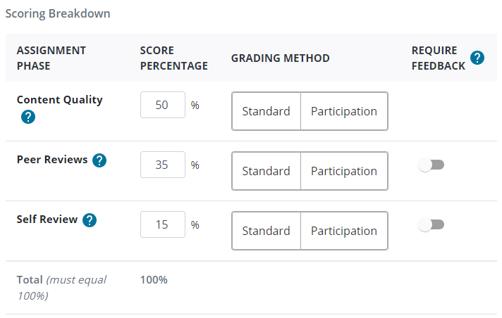

- Lastly, decide if the assignment will use a rubric or a simple score.

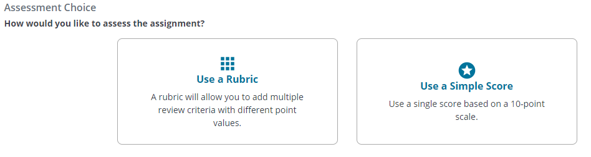

  - If you choose to use a rubric, click Use a Rubric and then click Create a Rubric. A rubric template will open on the screen. Create the rubric and click Save Rubric when you are finished.

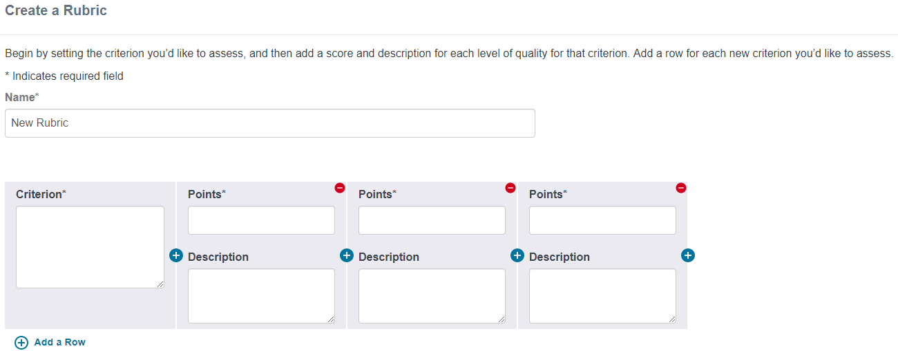

  - If you choose to use a simple score, click Use a Simple Score to open the simple score option. Enter the number of points possible and click Save & Continue. The number you entered will be broken into 10 equal increments to create the scale.

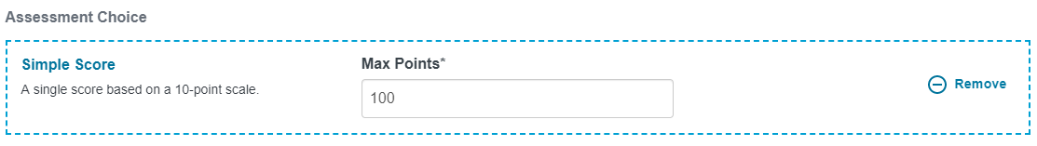

Scheduling
PLEASE NOTE: Phases of the assignment occur sequentially. Students must complete one phase of the assignment in order to move on to the next. If they miss a due date at any point in time, they will be unable to proceed to the subsequent phases and will receive an incomplete in Circuit for those missed phases - unless you are using the late permit feature.

- During the Content phase, students must submit their work. In the Start Date field, click the dd to type the start date or click the calendar icon to set the date.
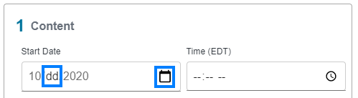

- In the Start Time field, click the -- to type the time or click the clock icon to set the time.
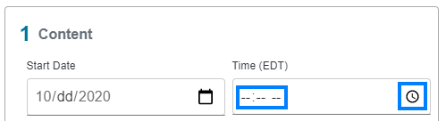

- Repeat the previous two steps for all other Start and Due dates listed. Leave gaps of time between phases if you would like the ability to grant late permits to students. Late permits enable students to continue in the assignment despite having missed a due date and time. They can be granted only when the next phase has not yet begun. The Scoring Date refers to the date the assignment will be scored by Circuit and released to students. Once all dates and times have been entered, click Save and then click Save & Continue.

- You will now have the option to activate the assignment. On the Review and Activate screen, review the Instructions, Grading, and Schedule portions of the assignment. If you need to make a change, click the pencil icon to the right of the given section. If all options are correct, click Activate to make the assignment visible to students.

- You will return to the Assignments screen and see your new assignment listed as a current or upcoming assignment based on the start date of the assignment.

