Create a Calibrated Peer Review Assignment

Create An Assignment
- To create an assignment in your Circuit course, click New Assignment.

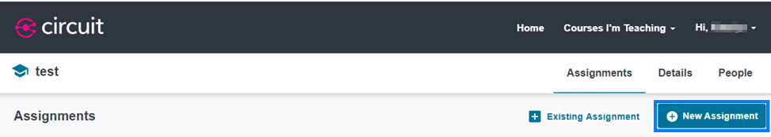

- Enter the name of your assignment. Then click Next.

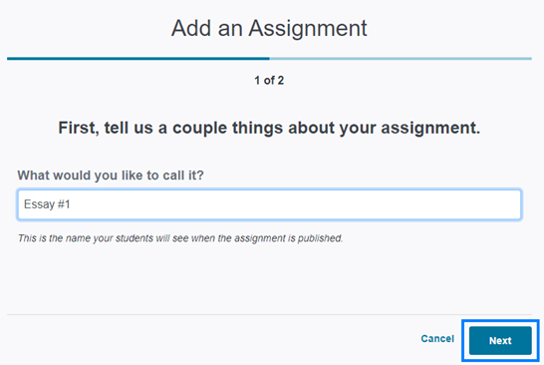

- For a calibrated peer review assignment, click the Calibrated option. Then click Save & Continue.

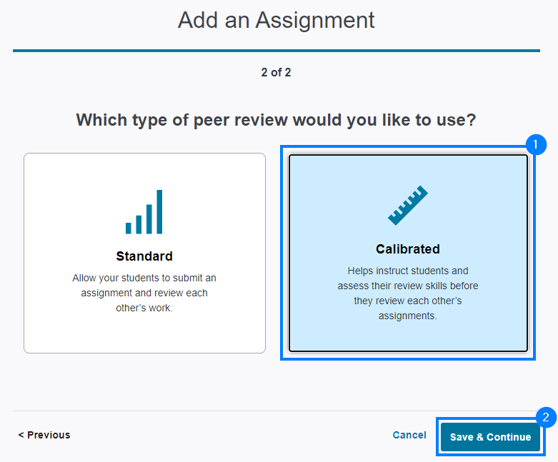

- On the Instructions screen, enter the assignment instructions for your students.
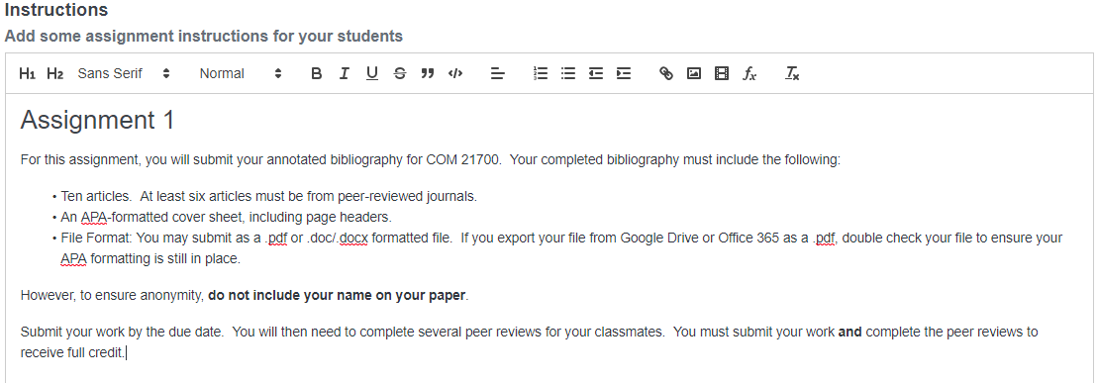

- You have the option to attach supplemental files students may need to read, listen to, or view to help them complete the assignment. To attach files, click and drag or click browse your files to upload one or more files from your computer to Circuit.

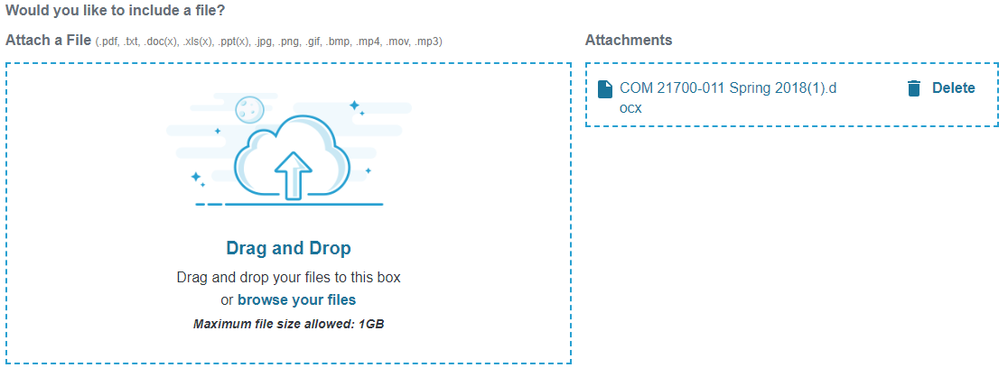

- Specify what you would like students to submit in Circuit. Students are able to submit text, a file, or a web link. Select the appropriate option and click Save & Continue near the bottom right of the screen.

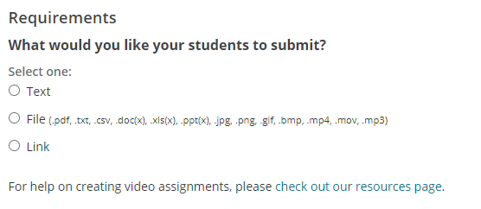

PLEASE NOTE: If you wish to include a minimum or maximum word count as part of the assignment, you must select the Text submission type.

Grading Options
- On the Grading screen, select whether the assignment should include a Self-Review Phase where students review their own work. This phase will occur after students have completed their peer reviews.

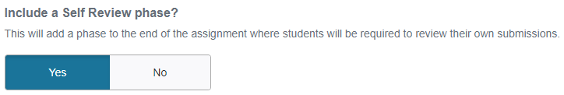

- The Accuracy Threshold is the threshold students attempt to meet when reviewing calibrations. During the calibration setup process, you will upload and evaluate three sample submissions (high, medium, and low quality). Students attempt to evaluate these documents just as you did. The threshold determines how close the student’s review needs to be to your review of each document in order to pass.
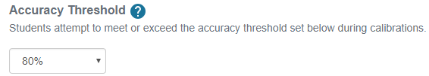

- Next, you can determine the weight and feedback requirements for each stage of the assignment:

- Content Quality: It is an average of scores (calibrated or not) received from peers on a student’s submitted work.
- Peer Review: This score is based on the similarity of a student’s review of 3 assigned peers in comparison to how others reviewed those same peers.
- Self Review: The student’s score is based on how closely their review matches the mean scores given by their peers.

Adjust the default score percentages if desired. Toggle the Require Feedback option on if you would like to require students to provide written feedback as part of their review.

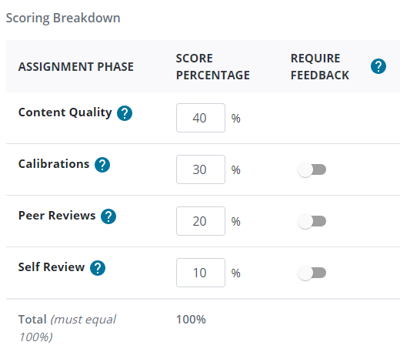

- Lastly, decide if the assignment will use a rubric or a simple score.

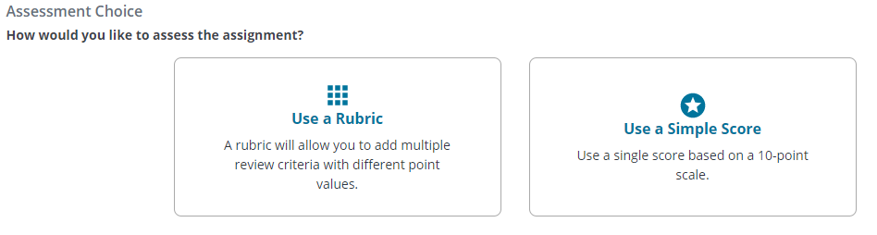

  - If you choose to use a rubric, click Use a Rubric and then click Create a Rubric. A rubric template will open on the screen. Create the rubric and click Save Rubric when you are finished.

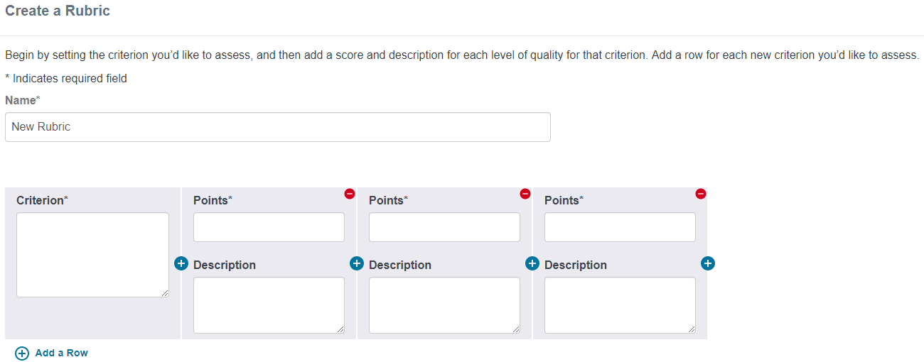
  - If you choose to use a simple score, click Use a Simple Score to open the simple score option. Enter the number of points possible and click Save & Continue. The number you entered will be broken into 10 equal increments to create the scale.

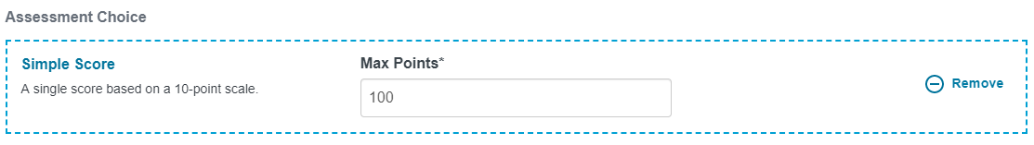

Calibration Setup
- In this next step, you will set the calibrations for the assignment. You will need to have three examples prepared for this portion – a ‘high quality’ example, a ‘medium quality’ example, and a ‘low quality’ example. Click a quality level on the left and upload the corresponding example document.
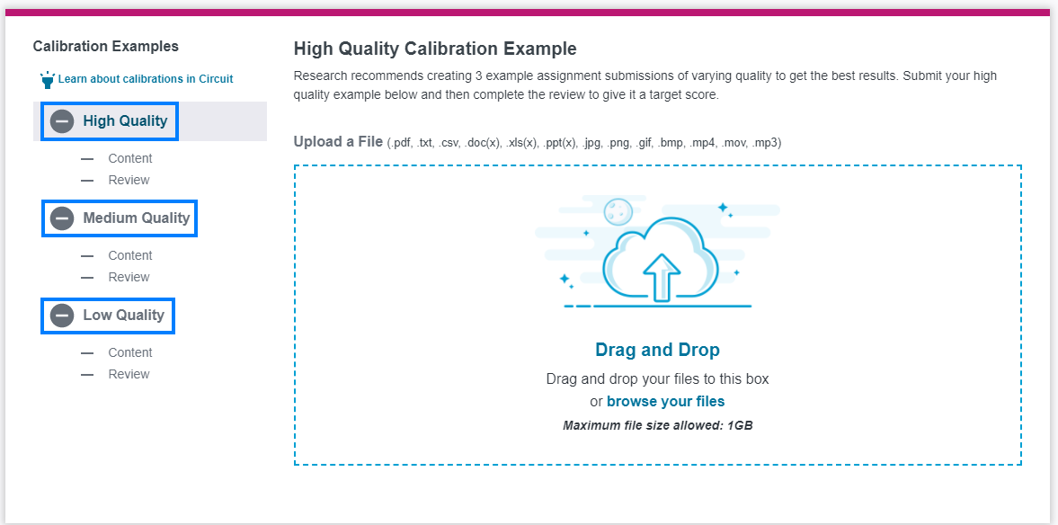

- Once uploaded, click Review.

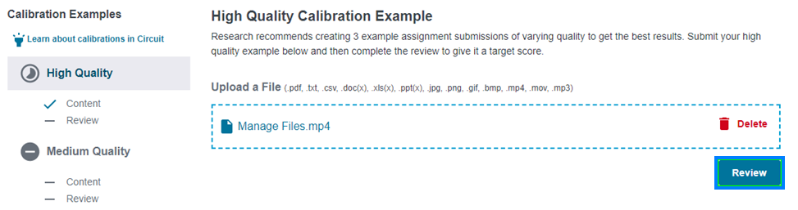

- In the Review Criteria screen, you will see scoring options based on if you chose to use a rubric or simple scoring:

  - If you created a rubric, select the criterion levels appropriate for the quality of the example you selected and add any appropriate feedback.
  - If you chose a simple score, select the score appropriate for the quality of the example you selected and add any appropriate feedback.
When finished, click Submit Review.

- Repeat this process for the remaining two calibration examples. When finished, click Continue to proceed to the scheduling section.

Scheduling
PLEASE NOTE: Phases of the assignment occur sequentially. Students must complete one phase of the assignment in order to move on to the next. If they miss a due date at any point in time, they will be unable to proceed to the subsequent phases and will receive an incomplete in Circuit for those missed phases - unless you are using the late permit feature.

- You can elect to Combine the Content and Calibration Dates. This means students must submit their content and have completed their calibrations before the specified due date. Students will be able to revise their submission until they begin calibrations.

If this option is turned off, students will have a start and due date for Content followed by a separate start and due date for Calibrations. The dates for each phase cannot overlap.

- In the Start Date field, click the dd to type the start date or click the calendar icon to set the date.
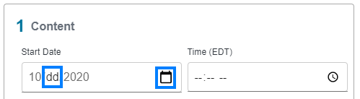

- In the Start Time field, click the -- to type the time or click the clock icon to set the time.
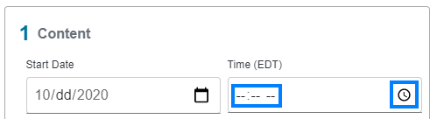

- Repeat the previous two steps for all other Start and Due dates listed. Leave gaps of time between phases if you would like the ability to grant late permits to students. Late permits enable students to continue in the assignment despite having missed a due date and time. They can only be granted when next phase of the assignment has not yet begun. The Scoring Date refers to the date the assignment will be scored by Circuit and released to students. Once all dates and times have been entered, click Save and then click Save & Continue.

- You will now have the option to activate the assignment. On the Review and Activate screen, review the Instructions, Grading, and Schedule portions of the assignment. If you need to make a change, click the pencil icon to the right of the given section. If all options are correct, click Activate to make the assignment visible to students.

- You will return to the Assignments screen and see your new assignment listed as a current or upcoming assignment based on the start date of the assignment.

