Circuit Guide for Students

Access Circuit
- From within the Brightspace course where Circuit is being used, navigate to Content and then locate and click the link to Circuit or to a Circuit assignment. This will vary based on the link your instructor has inserted.

Content Submission
PLEASE NOTE: It is very important to remain aware of the due dates for each phase of the Circuit assignment. If you miss any due date, you will be unable to proceed to the subsequent phases of the assignment and will receive an incomplete in Circuit for any missed phases.

- Locate and click the name of the assignment you would like to work on.

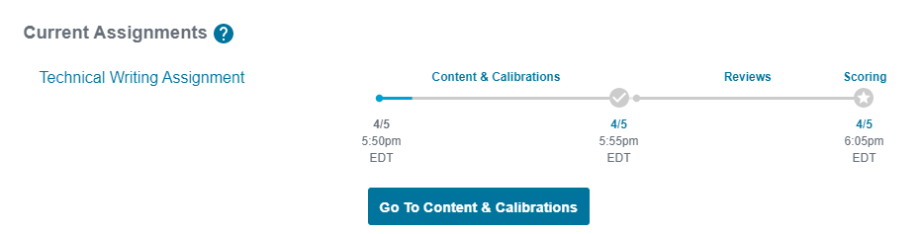

- Submit your assignment in the required format. This will be a text submission, file upload, or web link based upon the settings chosen by your instructor.

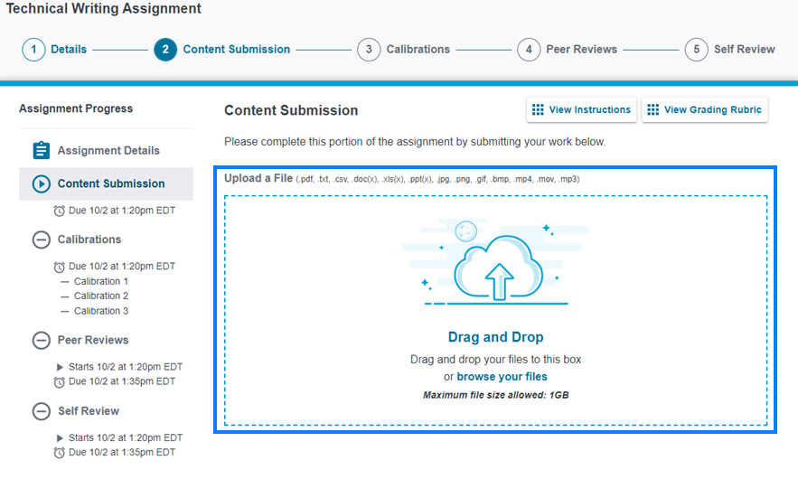
- You will receive a confirmation message after submitting your assignment. Depending on how the assignment has been setup, the next phase will be either the calibration phase or the peer review phase. You have until the Content Submission due date to revise your submission or until you begin calibrations, if applicable. Click Got it. Thanks!

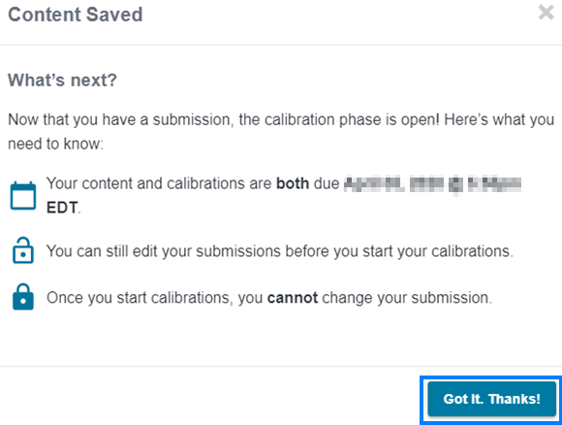

If your assignment includes a Calibrations phase, continue to the next section.
Otherwise, skip ahead to the Peer Review section.

Calibrations
- Click Open Calibrations when you are ready to begin this phase of the assignment.

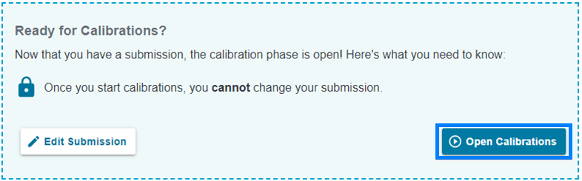

- Use the rubric (or numeric scale) on the right to review the example submission on the left. Click Submit Review when finished.

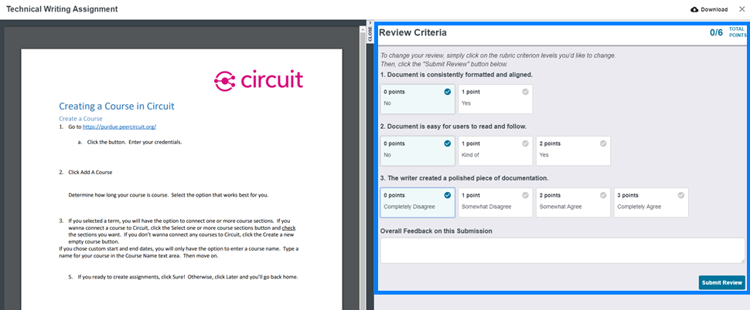

- Repeat this process until you have reviewed and received passing scores on all three example submissions. This will need to be completed before the Calibrations phase due date.

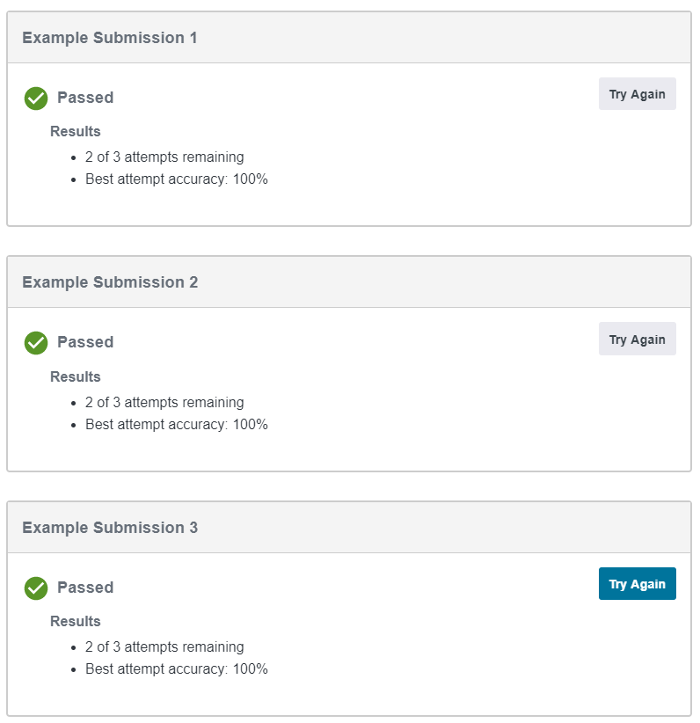

Peer Review
- When the Peer Review phase opens, you will be assigned three peers to review. The peer review process in Circuit is anonymous. Use the rubric (or numeric scale) on the right to review your peer’s submission on the left. Click Submit Review when finished.

- Repeat this process for your remaining two peers.

If your assignment includes a Self-Review phase, continue to the next section.
Otherwise, skip ahead to the Scoring section.

Self-Review
- Use the rubric (or numeric scale) on the right to review your submission on the left. Click Submit Review when finished.

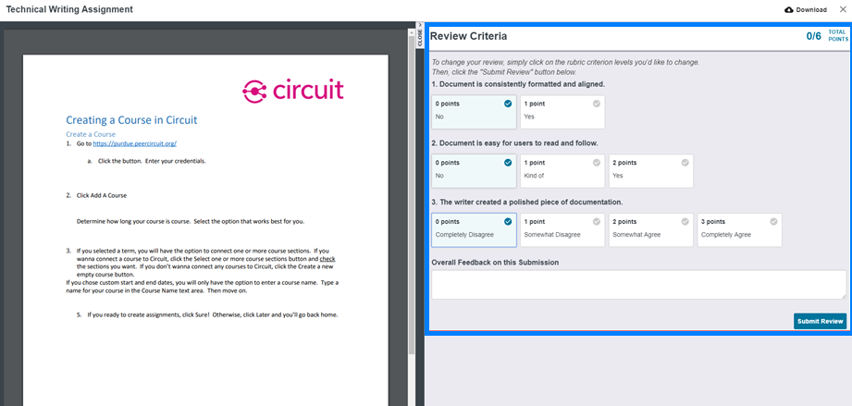

Scoring
- Be sure to check back. Your score and any feedback from your peers will be released in Circuit on the day and time set by your instructor.

