Circuit Integration with Brightspace

Add an LTI Link to a Circuit Course
- Log in to Brightspace and open the course in which you will be using Circuit.

- Click Content and navigate to the module location where the link to Circuit should reside.

- Click Existing Activities and select External Learning Tools from the drop-down.

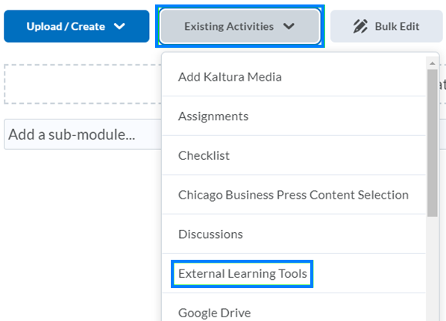

- Select Circuit from the list of options.

- Click the newly created Circuit link and set up your Circuit course. Your course name and dates, if set, will be auto-filled.

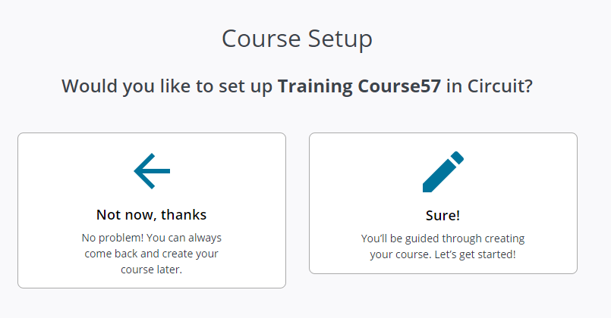

Add an LTI Link to a Circuit Assignment
It is also possible to create an LTI link to Circuit that goes directly to an assignment. This can be helpful for adding multiple links to different assignments in their appropriate location within your course content.

- Log in to Brightspace and open the course in which you will be using Circuit.
- Click Content and navigate to the module location where the link to Circuit should reside.
- Click Existing Activities and select Circuit Assignment from the drop-down.

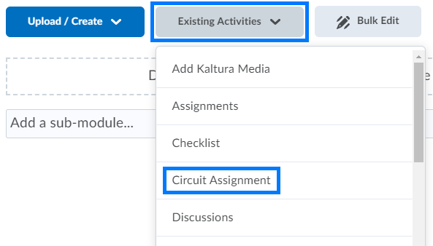

- Set up your Circuit course. Your course name and dates, if set, will be auto-filled. This is only required for the first link.
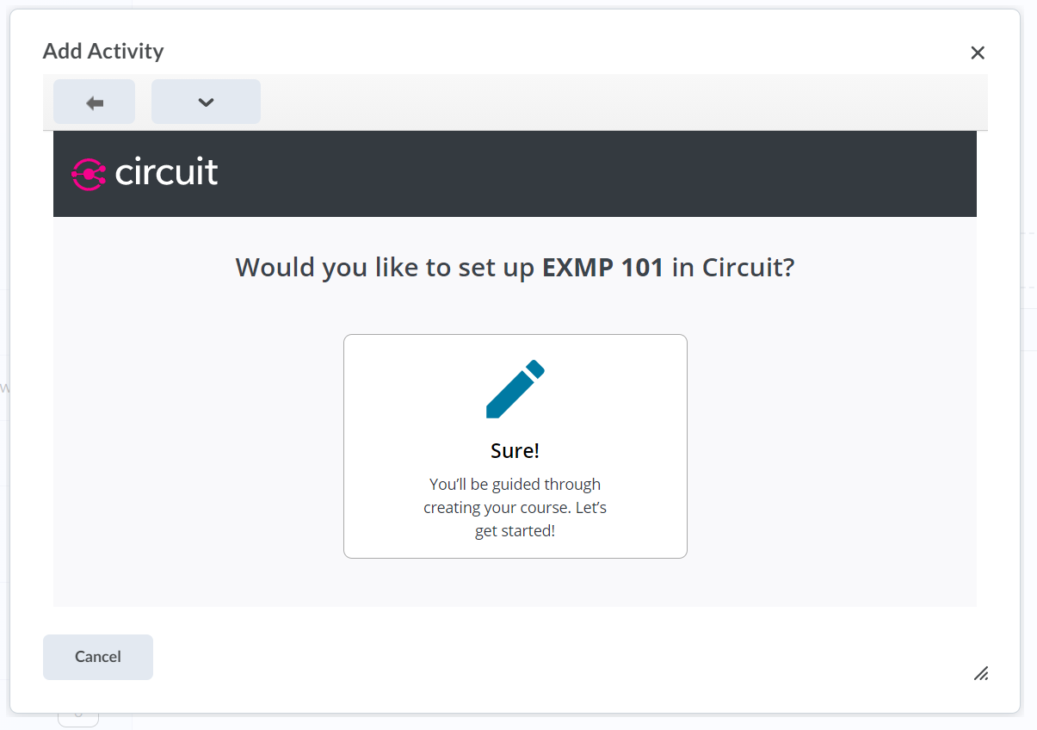
- Click the link in the text to go to your new course in Circuit and create some assignments.
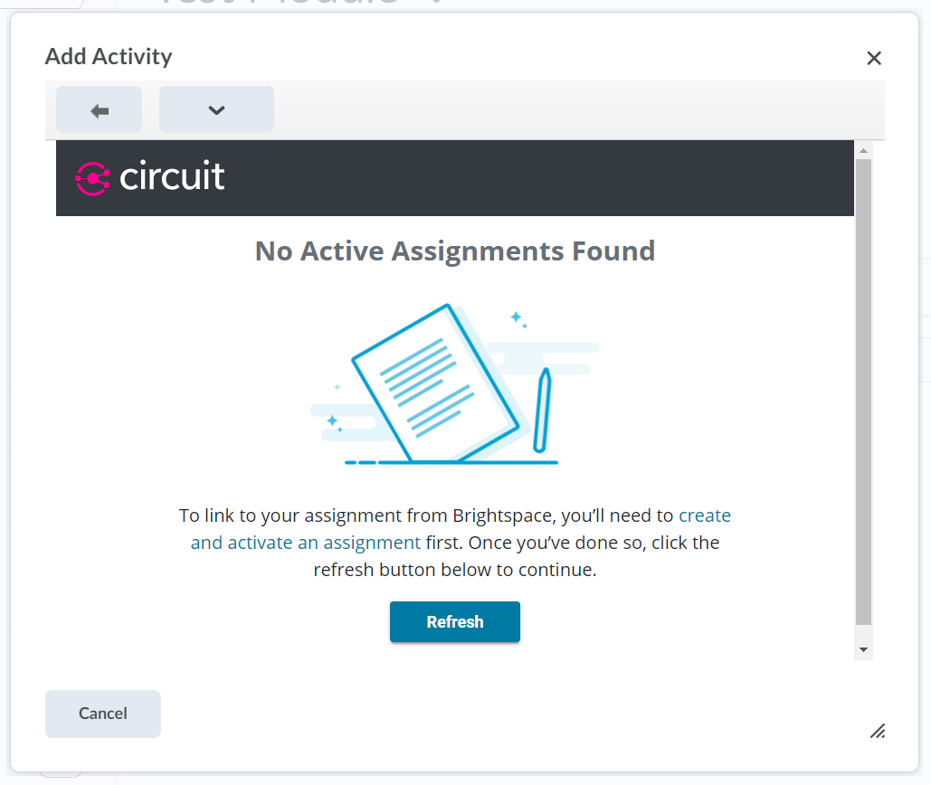
- Create a new assignment or Attach an existing assignment to your Circuit course.
  - You can create all the assignments you plan to link to Brightspace at this point. If you would like more information on creating an assignment in Circuit check out this guide.
- Return to your Brightspace tab and click on the Refresh button in the window.
- Select the assignment you would like to use for this link.
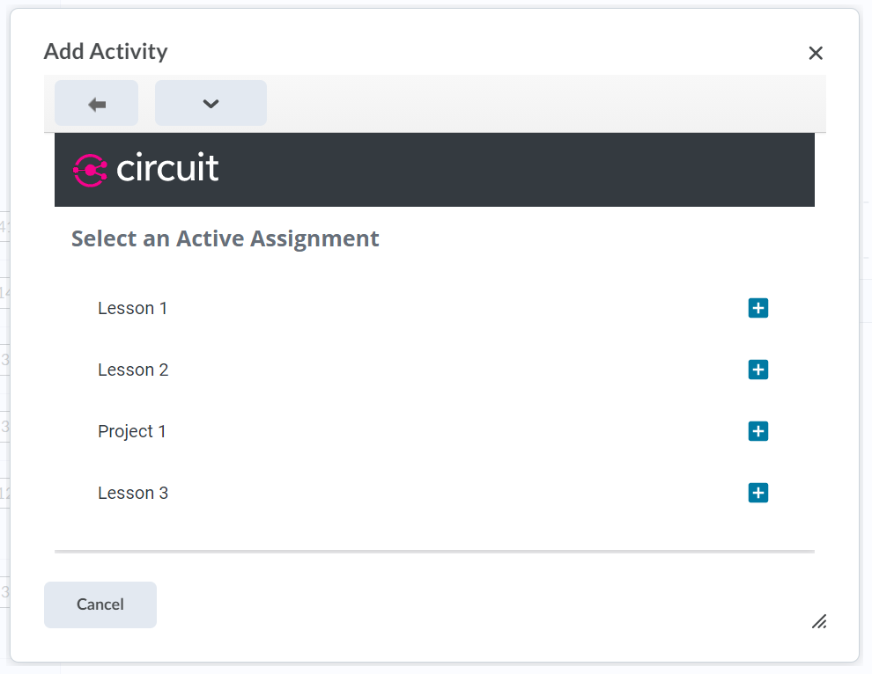
- Confirm the dates for the assignment are correct, and then select Link Assignment
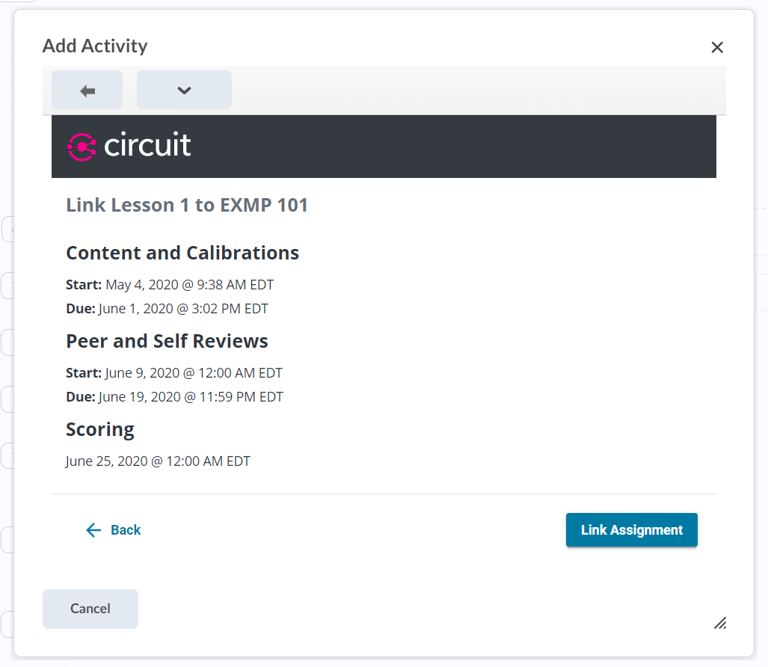
- Click on the newly created link in your course content. This will create the related line item for the assignment in your gradebook.
  - The availability times of assignments in Circuit and this link in your course content are independent. Students can still go directly to the Circuit website and see open assignments even if they are hidden in Brightspace.

Link to an Existing Grade Item
If you’ve already created grade items in your grade book for these assignments, it is possible to create the LTI link and then link it to your existing grade item.
- Create the LTI assignment link following the steps above including launching the link.
- Return to your Brightspace tab which will now be showing details for your external link.
- Under Activity Details on right side, click on your assignment name to open the grade item list and select your existing grade item.
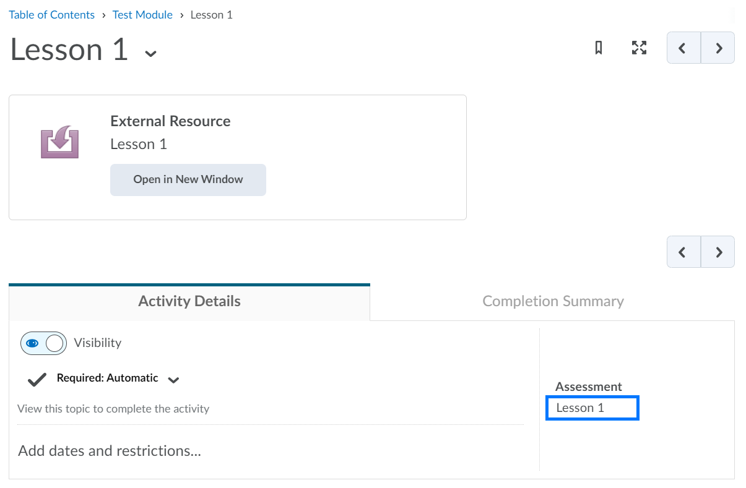
- Delete the unwanted grade item from your gradebook.
- Launch your Circuit link one more time.

Roster Sync
Circuit will automatically sync instructors, graders, and students from your Brightspace course shortly after your Circuit course is created.

PLEASE NOTE: If someone is not in your Brightspace course, you can manually add them to your Circuit course through the People tab near the top-right of your Circuit course. Manually added users will automatically become synced shortly after they are added to your Brightspace course at a later time.

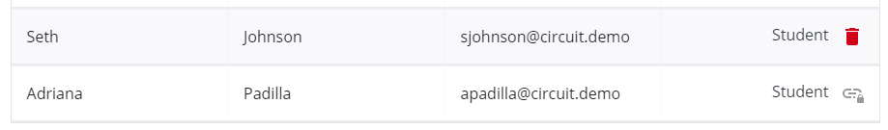

View Student Submissions
- From Circuit, click the name of the Circuit assignment.

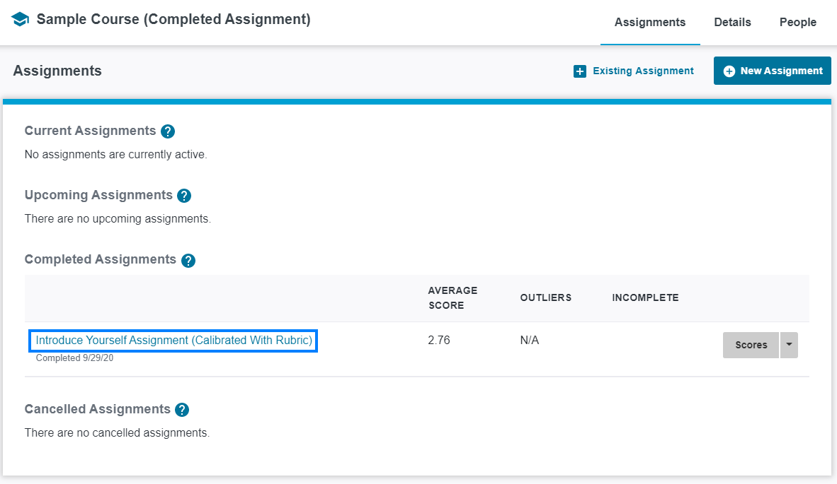

- From the Scores tab, click the name of a student.

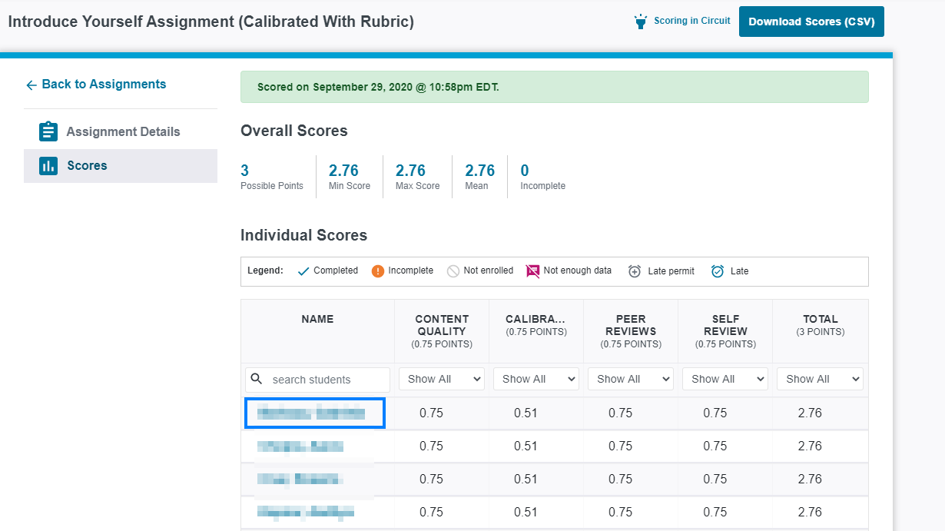

From here you will find details on the student’s score, their submission, the feedback they received, the feedback they provided others, as well as calibrations and self-reviews (if applicable).

Grade Push
When creating your course or editing it at a later time, you will have the option to push grades manually or automatically. If you choose to push grades manually, you will find a button on the scores page of completed assignments to push grades. If you choose to push grades automatically, the scores will be pushed to Brightspace when the assignment is scored. In either instance, a new grade item will be created in Brightspace with the same name as the assignment in Circuit.

PLEASE NOTE: Students who were added manually will not have their scores pushed to Brightspace.

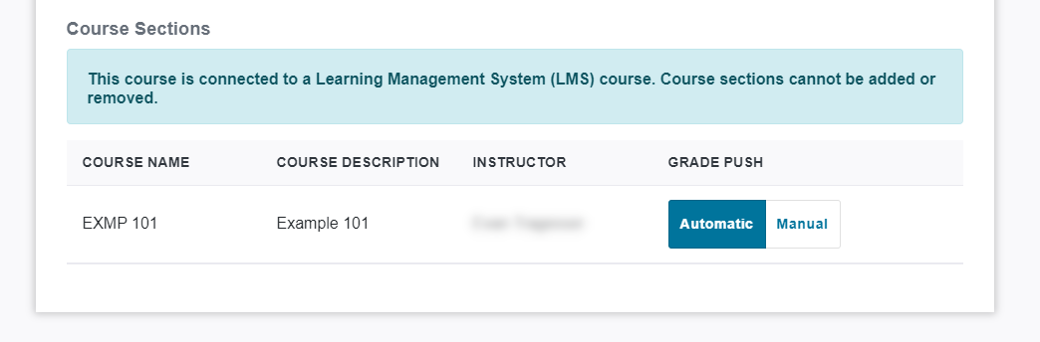

Edit Circuit Scores Pushed To Brightspace
- In Brightspace, click Grades and locate the grade column for the Circuit assignment.

- Click the drop-down icon to the right of the Circuit assignment name and select Enter Grades from the drop-down.

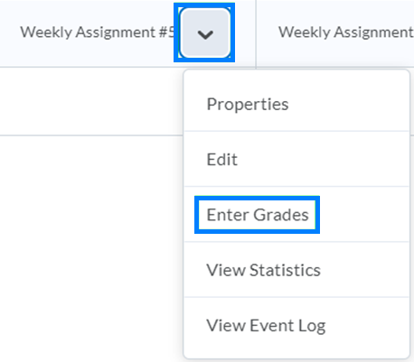

PLEASE NOTE: Grade changes made in Brightspace will not be reflected on the Circuit scores page.

Include Circuit Scores in Brightspace Final Grade Calculation
When grades are pushed to Brightspace they are, by default, not included in the final grade calculation.

- In Brightspace, click Grades and locate the grade column for the Circuit assignment

- Click the drop-down icon to the right of the Circuit assignment name and select Edit from the drop-down.

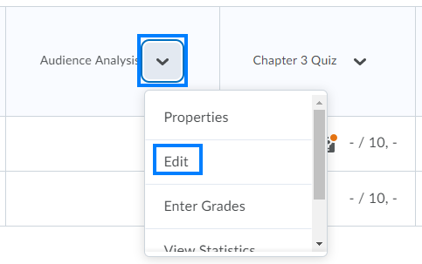

- Scroll down and uncheck the Exclude from Final Grade Calculation option.

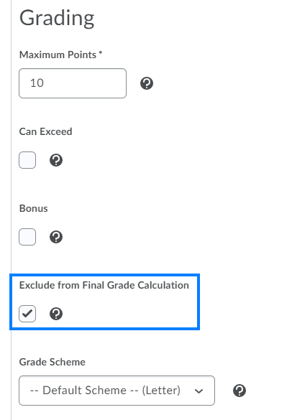

- Click Save and Close.

