Student: Use Kaltura for Video Discussions

- From within a Brightspace course, locate and open the discussion you are submitting to.

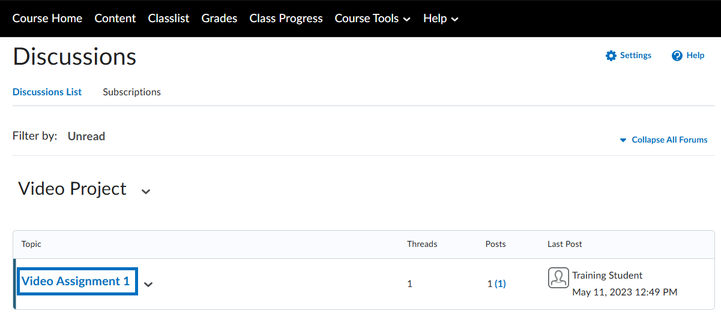

- Click Start a New Thread.

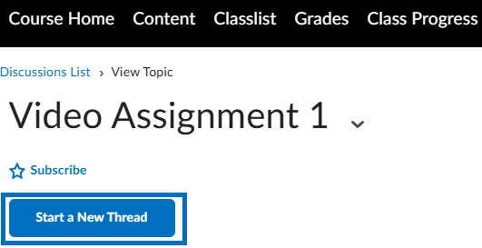

- In the Post box, click the Insert Stuff button from the menu.

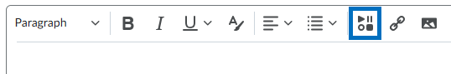

- From the list of options, select Add Kaltura Media – LTI 1.3 Insert Stuff.

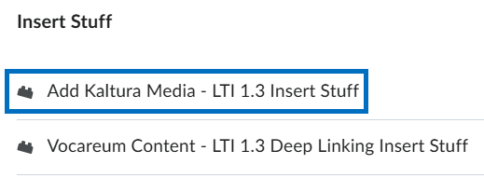

- Click + Add New at the top-right and select Media Upload from the drop-down.

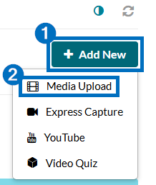

- Drag and drop the video file from your computer into the pop-up window, or click + Choose a file to upload.

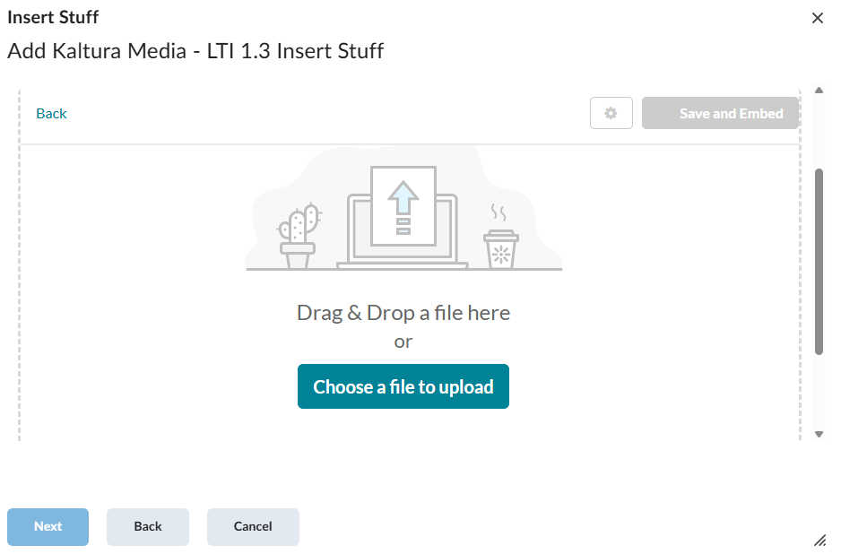
- You can rename the file and/or add a description as desired. When the file upload is complete, click </> Save and Embed at the top-right.

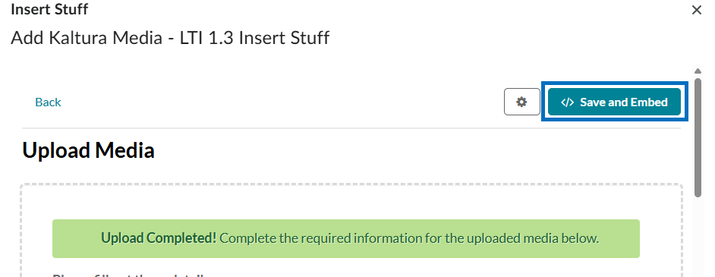

- Your video will process in Kaltura. It may take a few minutes before the preview is available. When you are ready, click Insert.

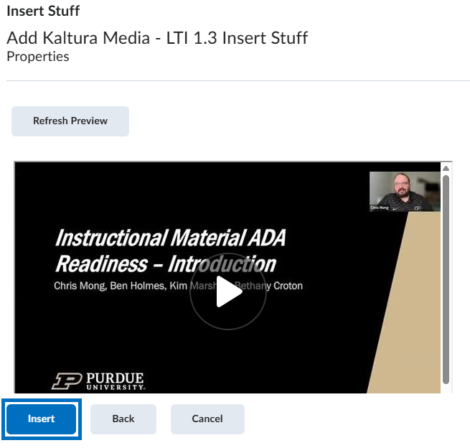

- This will add your video to the text box. When ready, click Post to submit the thread.

