Edit Mechanical Captions for Kaltura Media via Brightspace

Beginning Summer 2024, videos uploaded to Kaltura are automatically captioned via automatic speech recognition. Auto-generated captions do not guarantee compliance with WCAG 2.1AA standards and should always be reviewed following the steps below.

Access Captions

- From within a Brightspace course, click Course Tools and select Kaltura My Media – 1.3 from the drop-down.

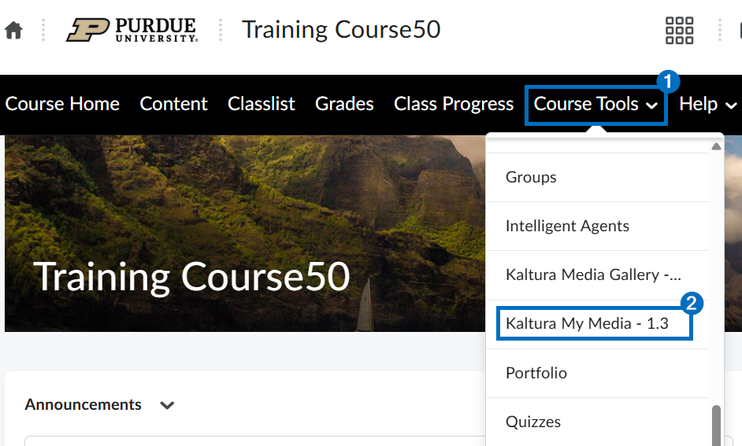

- Click the Edit/Pencil icon to the right of the video.

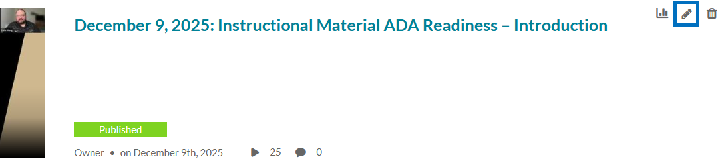

- Click the Captions tab.

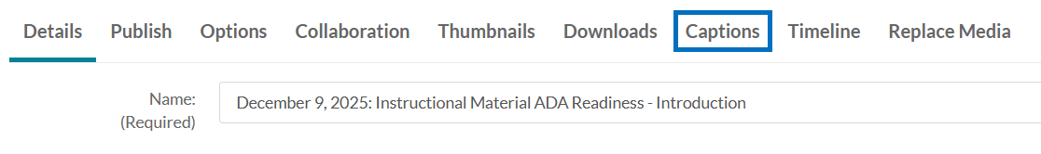

Edit Captions

- Click Edit Captions.

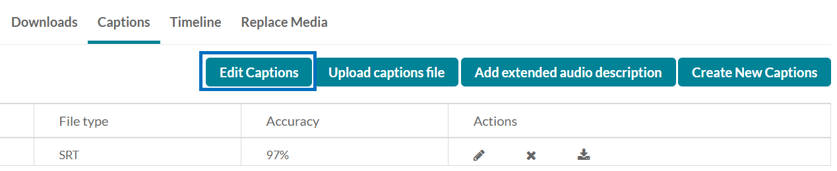

PLEASE NOTE: If you cannot select Edit Captions and do not see any caption files listed, please see the Request Mechanical Captions section.

- Captions will appear on the left where you can click into and edit the text. The video will appear on the right where you can play and pause the content. When you have finished editing the captions, click Save at the top-right and then click Back.

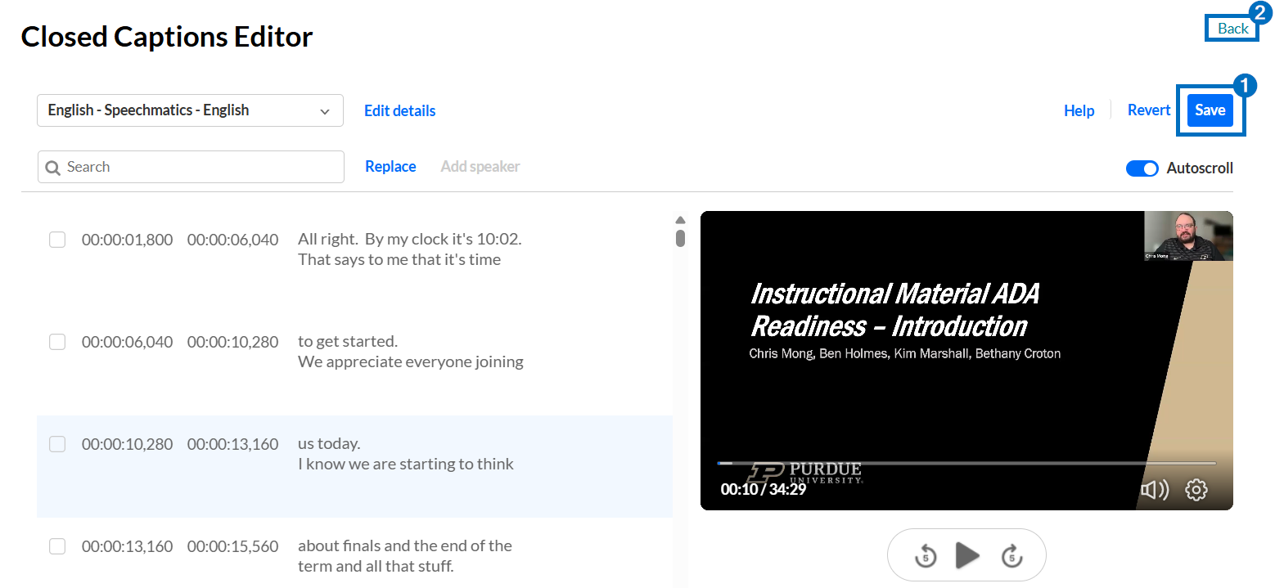

Request Mechanical Captions
This section only applies if captions were not available to edit.

- From within a Brightspace course, click Course Tools and select Kaltura My Media – 1.3 from the drop-down.

- Locate and click the title of the video you are requesting captions for.

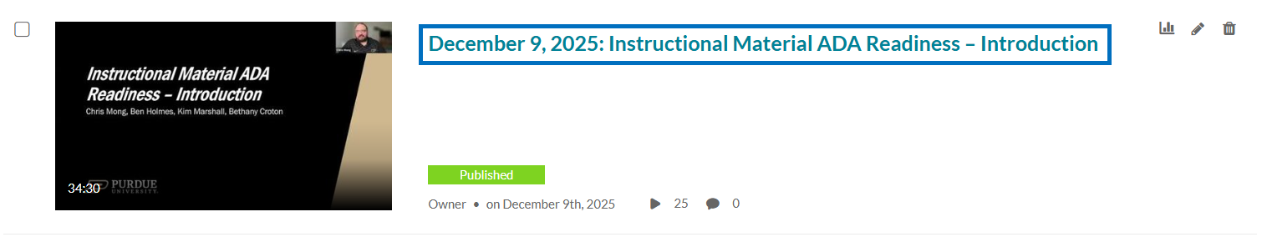

- Click Actions and select Caption & Enrich.

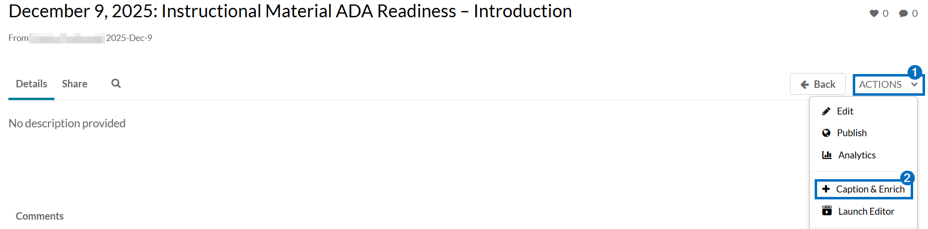

- Click + Order.

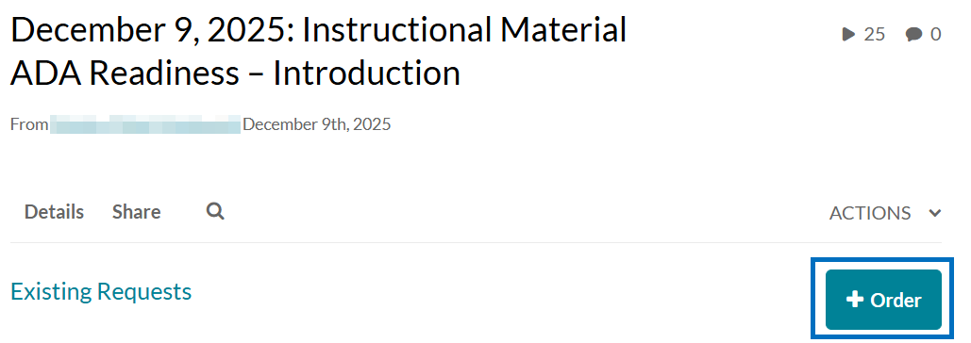

- Click Submit. Your request for mechanical captions will process. When they are ready, return to the Access Captions section.

