Download a Copy of Your Kaltura Video via Brightspace

- From within a Brightspace course, click Course Tools and select Kaltura My Media – 1.3 from the drop-down.

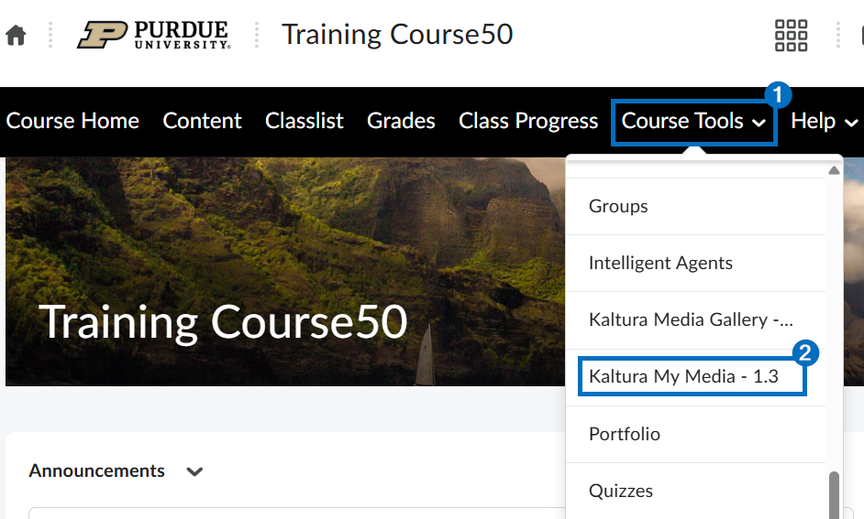

- Click the Edit/Pencil icon to the right of the video.

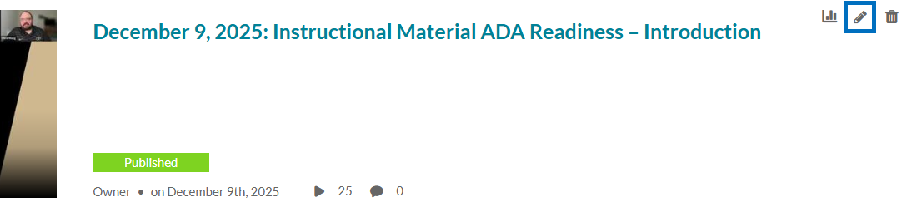

- Click the Play icon to begin the video. Click the Pause icon to pause the video.

- At the top-right of the video player, click the Download icon.

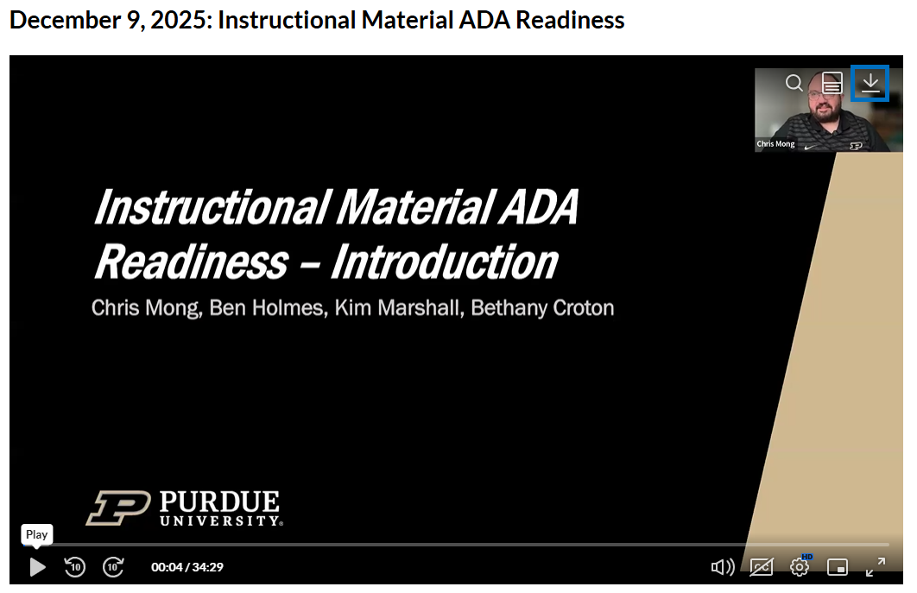

- Click the Download icon to the right of the .mp4 file.

