Add an Existing Kaltura Video to Your Brightspace Course

- From within your Brightspace course, click Content.



- Open the module where the video will reside, or click Add a module on the left to create a new one.



- Click Existing Activities and select Add Kaltura Media - LTI 1.3.

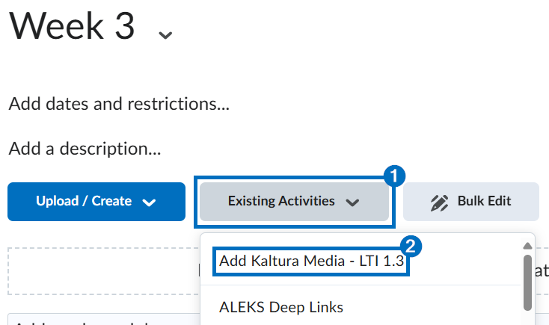

- Click Embed to the right of the video.

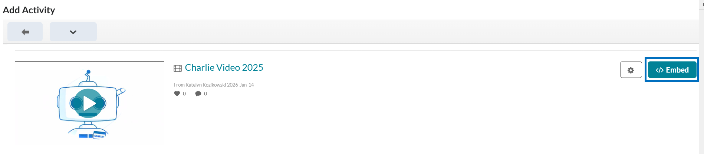

- The video will appear at the bottom of the content module.

