Add an Additional Instructor or TA to a Kaltura Video via Brightspace

- Open your Brightspace course, click Course Tools from the course navigation bar, and select Kaltura My Media from the drop-down.

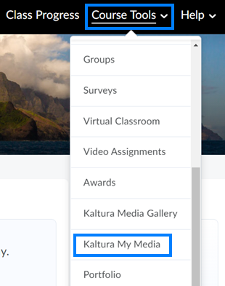

- Click the Pencil/Edit icon to the right of the video you would like to give someone else access to.

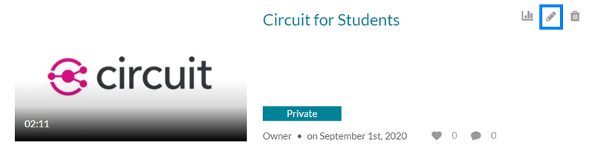

- Click the Collaboration tab and click the Add Collaborator button.

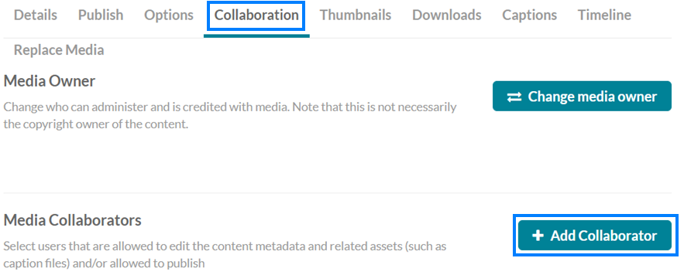
- Search the username of the individual you would like to add. Check the permission level(s) you would like to grant this person and then click Add.

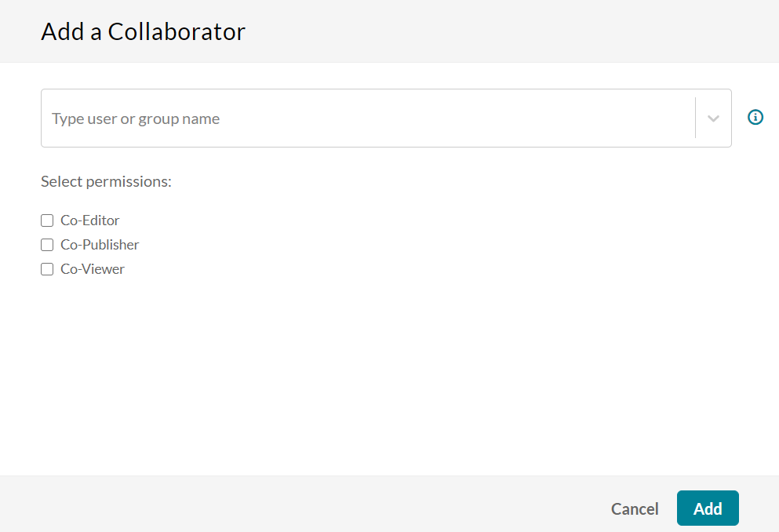

  - “Co-Editors: can edit the entry's details and metadata, trim media, replace media, edit captions, edit chapters and edit slides. Co-editors cannot delete media or add new co-editors and co-publishers. Co-editors can see the analytics page for the media they co-edit.

  - Co-Publishers: can publish media to their entitled Categories or Channels. This option must be enabled by your KMS administrator for this tab to display. Group support may be enabled for the Media Collaboration features. When enabled, you can select groups that may be assigned as co-editors/publishers for an entry.

  - Co-Viewers: are only able to view media and do not have editing permissions, nor are they allowed to view unlisted entries, unless they are also co-publishers or co-editors of that entry.”

Kaltura Source

