Access Viewer Analytics via Brightspace

- Login to D2L Brightspace and open one of your Brightspace courses.

- From the course navigation bar, click Course Tools and select Kaltura My Media from the drop-down.

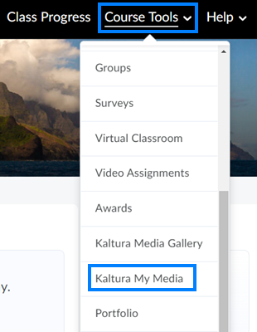

- Locate the video for which you would like to see viewer statistics. Click the View Analytics icon to the right of the video.

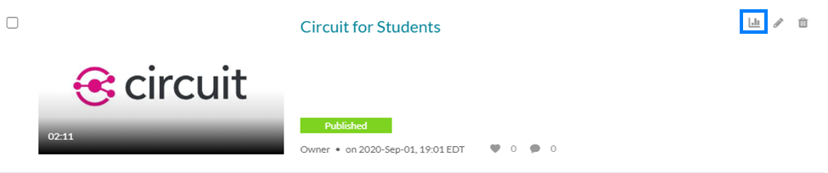

- Click View Engagement Per User beneath the line graph.

