Adding Kaltura Media to a Content Module

- Open your Brightspace course and click Content from the course navigation bar.

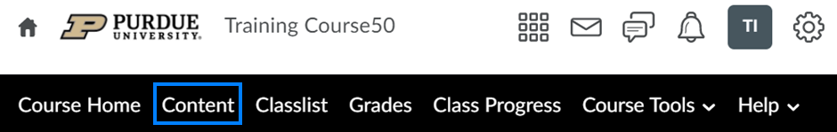

- Open an existing module or create a new module.

- Click the Existing Activities menu and select Add Kaltura Media from the drop-down.

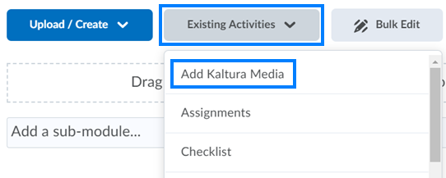

- From the window that appears, click Embed to the right of the video you would like to add to the module. This will insert the video at the bottom of the module.

