Add a Local Video to Brightspace

- Open your Brightspace course and click Content from the course navigation bar.

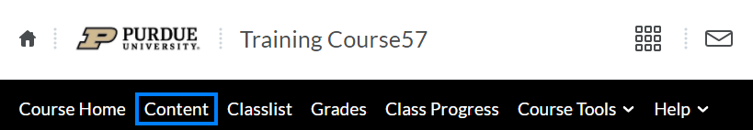

- Open an existing module where the video should reside, or create a new module using the Add a module text box.

- Click Existing Activities and select Add Kaltura Media from the drop-down.

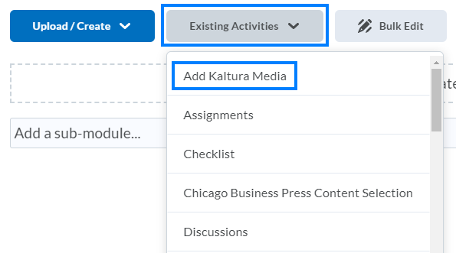

- Click the + icon near the top-right and select Media Upload from the drop-down.

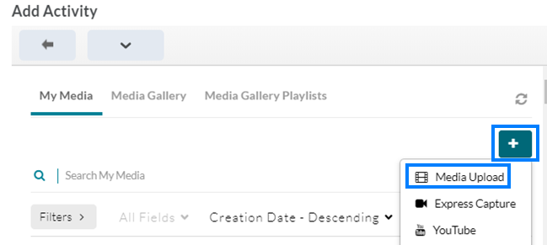

- Click Choose a file to upload and locate the video you would like to upload.

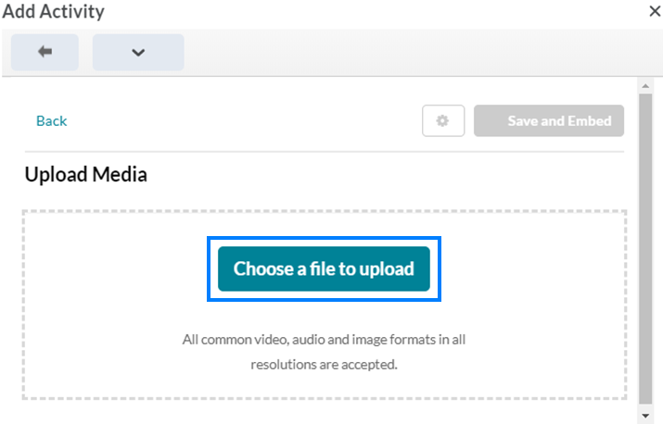

- After the upload finishes, click Save and Embed near the top-right.

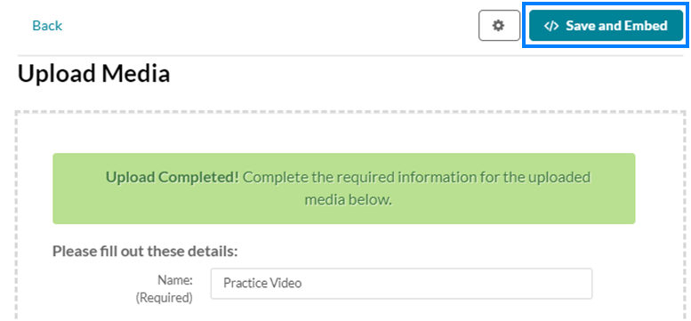

- This will add the video to the bottom of the content within the module you have selected.

