Data Cookbook User Profile Customization Guide

Navigating to your User Profile

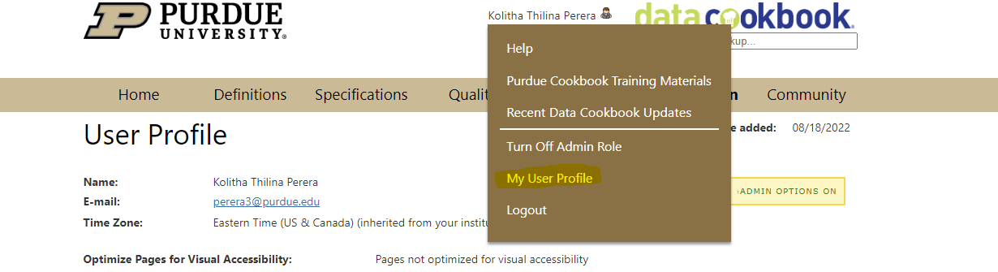

- To navigate to your user profile click on your name at the top of the data cookbook page after logging in and click on my user profile.

Changing Notification Frequency
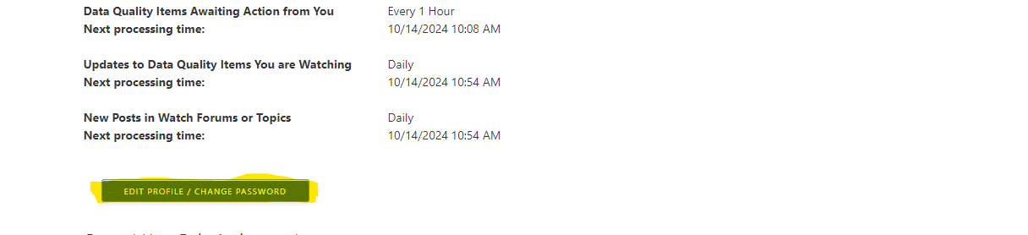

- From the user profile page, to edit notification frequency click on the button labeled “Edit Profile / Change Password.” IMPORTANT: Do NOT change your data cookbook production password as it is tied to your career account.

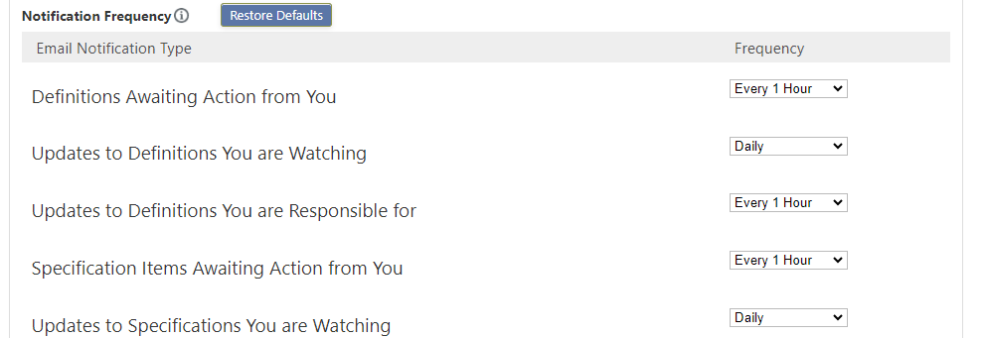

- After clicking this button, scroll down to the section labeled “Notification frequency.” From here you can adjust the frequency of notifications for different objects and various other categories. Note: A recent Cookbook update adds a notification frequency titled “immediate digest” this sends a singular email every 3 minutes with all notifications of a single type.

How to Save Objects to Your Watchlist
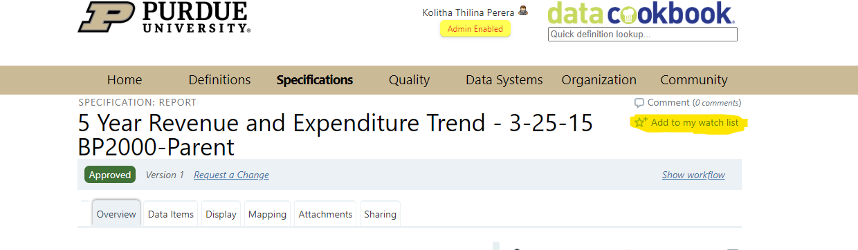

- To save objects to your watchlist, first search for your object by looking up the definition, specification, collection etc. and clicking on “Add to my watch list” in the upper right-hand corner of the page as shown above.

How to Find Objects on Your Watchlist

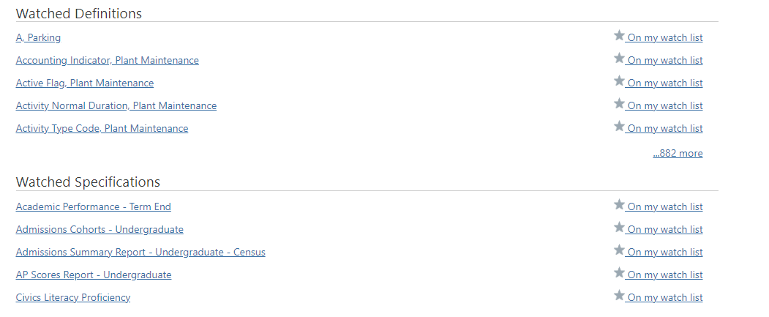

- To find objects that you are currently watching, navigate back to your user profile page and scroll until you reach the sections beginning with the word “Watched.” Here, you will have linked all of the objects of each type that are currently on your watchlist.

How to Unwatch Objects on Your Watchlist

- There are two ways to unwatch objects that you are currently watching. First, if you want to unwatch all objects of a certain type, in this case, quality issues, you can click the unwatch all button at the bottom of your watchlist for the object type that you want to unwatch.

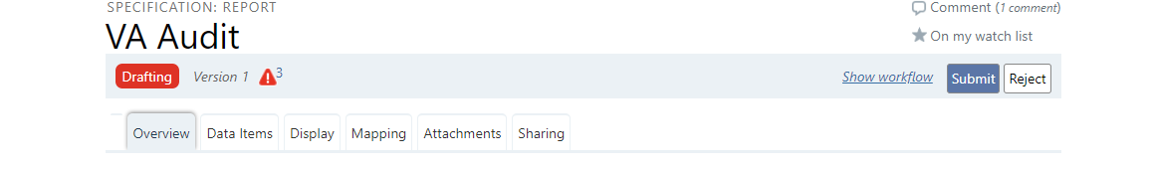

- Secondarily, you can click on the object links on your watchlist or look up the object you want to unwatch on Cookbook and click the text labeled “On my watch list” to remove it from your watchlist.

