Data Cookbook: Short Version for Specification Approvers

idata@purdue.edu

12/15/2024

Table of Contents
Specification/Collection Paragraph Standards 2
Workflows of Specifications and Collections 2
Finding Specifications and Collections Ready for Review 3
Searching in List of Specifications/Collections 4
Editing and Approving Specifications/Collections 5
Editing 5
Approval of Workflow 5
Checking Tags 6
Checking Keywords 7

This document is a short version of our complete specifications standards document, for the approvers of specifications/collections. Please see the complete documentation of Creators Specifications - Standards (https://www.purdue.edu/idata/data-governance/data-cookbook/cookbook-training.php).

Specification/Collection Paragraph Standards

- Specifications may contain three paragraphs. Not all three are required. Complete sentences are to be used.
  - Paragraph 1 – purpose
  - Paragraph 2 – description
  - Paragraph 3 – additional information (optional)

Workflows of Specifications and Collections

- Specifications move from “Drafting” to “Functional Area Review” to “Final Review” and “Approved” stages. Once specifications are drafted and the functional area review is complete, they move to the report/dashboard owner for a “Final Review” for accuracy, completeness, and adherence to standards.

- Additional edits can be made OR the spec it sent back to “Drafting” for the original creator to make edits. A comment box appears when a specification moves from one stage to another. If the specification is sent back to drafting, the Reviewer/Approver is able to add verbiage about the edits needed.

- Once the functional area owner considers it complete, they click the “Approve” button.

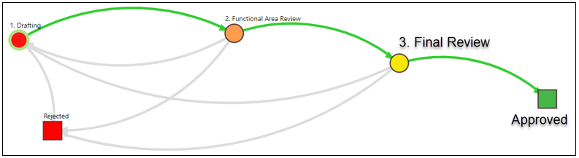
- Collections move from “Proposing” to “Under Development” (Functional Area Review), to “Final Review” and “Approved” stages.

- Once collections are drafted and the functional area review (“Under Development” stage) is complete, they move to the collection owner for a “Final Review” for accuracy, completeness, and adherence to standards.

- Additional edits can be made OR the collection sent back to “Proposing” for the original creator to make edits. A comment box appears when a collection moves from one stage to another. If the collection is sent back to “Proposing,” the Reviewer/Approver is able to add verbiage about the edits needed.

- Once the collection owner considers it complete, they click the “Approve” button.

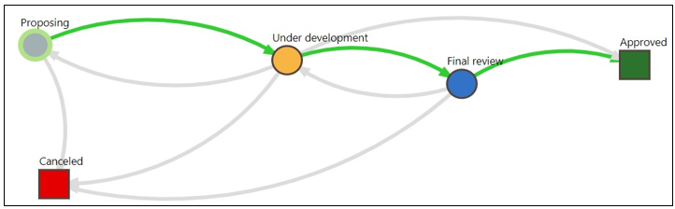

Finding Specifications and Collections Ready for Review

- If you received an email message that a specification/collection is ready to review, use the link embedded in the email. Automated email notices from Data Cookbook are sometimes routed to spam filters. Please be sure to check your spam filter for any trapped emails.

- Click on the “Specifications” tab and then use the “Search” box, if you know the specification name. For Collections click “Browse Collections” under the “Specifications” tab and then use the search box.

- Recommended: Go to the Specification/Collection Approval Queue and use the filters by following the instructions below:

- Hover over the Specifications tab and select Specification Queue/Collection Queue:
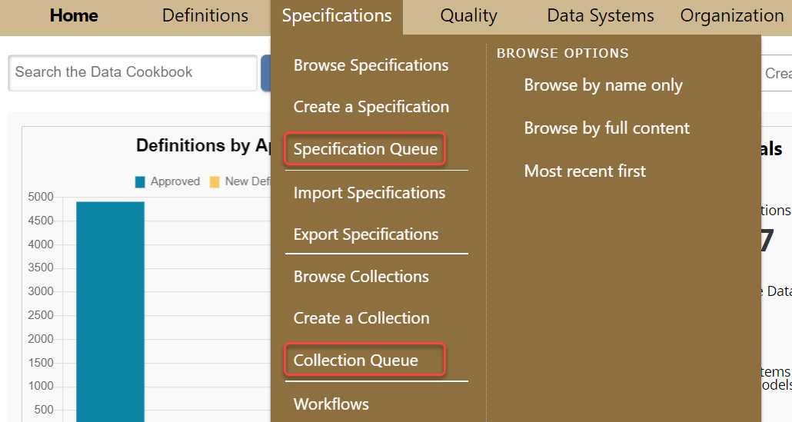

- Then, you can narrow down the specifications/collections by using the filters under the Specification Approval Queue/Collection Approval Queue. See the instructions below.

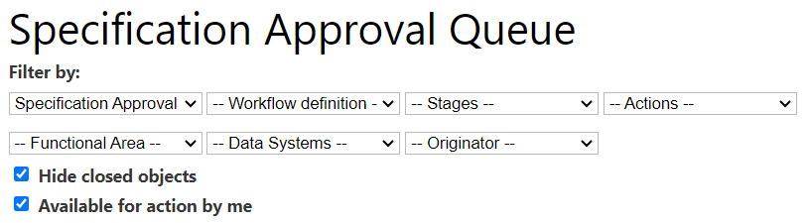
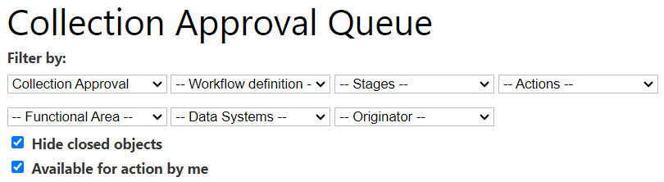

Searching in List of Specifications/Collections

- For specifications, choose the “Specification Approval” from the Workflow type dropdown menu. And then it will open up a functional area filter where you can filter by the Functional Area to narrow the search. By clicking on the Name field or any of the columns, you can sort the specifications by name.

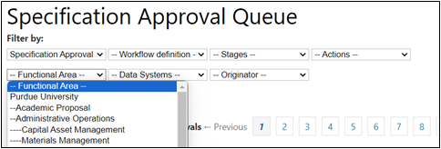

- For collections, you can choose the name of the person who drafted the collection in the Originator drop down menu. By clicking on the Name field or any of the columns, you can sort the collections by name.

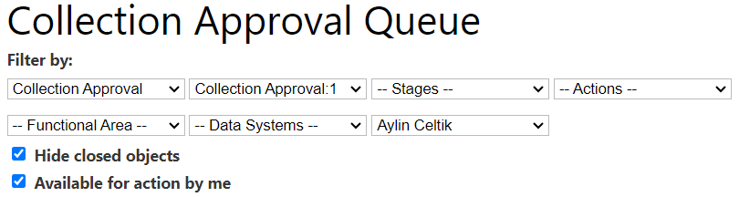

Editing and Approving Specifications/Collections

Editing

- Once you have narrowed down your selection, under the “Name” column, click on the name of the specification/collection you wish to edit/update/approve. This will open the specification/collection window. The Report/Dashboard/Collection Owner begins a final review for accuracy, completeness and adherence to standards. If you need to edit the specification/collection, click on the “Edit” button.

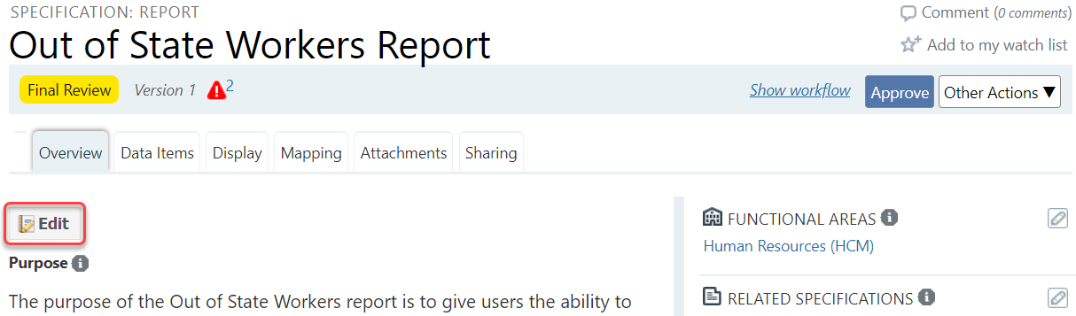
- Once the specification/collection has been edited and the changes are ready to be saved, click the “Save” button at the bottom of the page to save the work.

Approval of Workflow

- Specifications: Options include “Approve,” “Back to Drafting” and “Reject.”
  - Click “Approve” if you believe the spec is accurate, complete and adheres to standards
  - Click “Back to Drafting” if you believe the spec needs editing before it is approved. Please make sure you add a comment that explains why it needs more work. A comment box will open up when you click that button.
  - It is not recommended to reject specifications. If the specification is no longer needed, contact idata@purdue.edu to delete the specification.

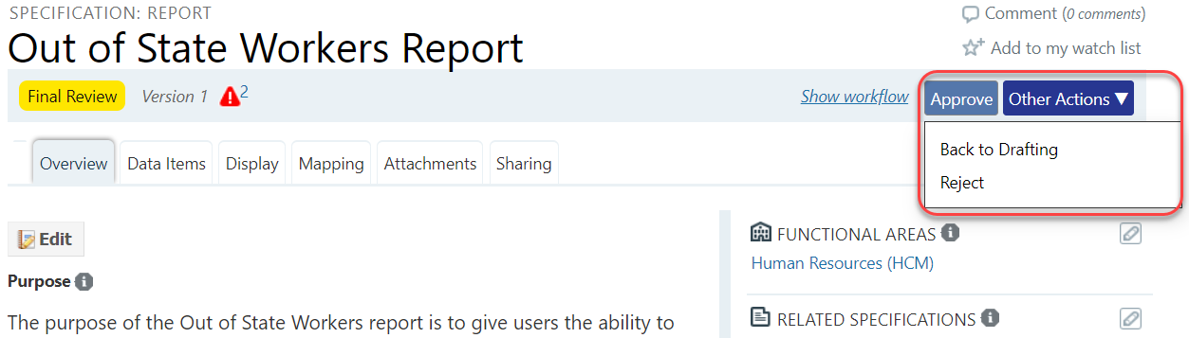

- Collections: Options include “Approve,” “Cancel,” and “Send back to development.”
  - Click “Approve” if you believe the collection is accurate, complete and adheres to standards.
  - Click “Send back to development” if you believe the collection needs editing before it is approved. Please make sure you add a comment that explains why it needs more work. A comment box will open up when you click that button.
  - Clicking “Reject” is not recommended. If the collection is no longer needed, contact idata@purdue.edu to delete the collection.
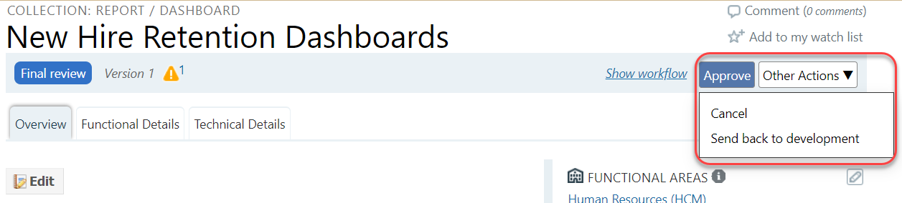
- Tip: If you have a larger number of specs/collections in your approval queue, it would be better if you opened each spec/collection in another tab from your queue page, then approved that spec/collection and closed that tab. Your approval queue will stay the same in the first tab, so you can open the second spec/collection in your queue in another tab. This way you do not need to wait your queue to be loaded every time you approve a spec/collection, and you will approve them faster. You can refresh your approval queue page from time to time.

Checking Tags

- A tag is used to quickly group specifications together for ease in searching (they are used as a filter on the browse page). They may be shared by multiple specifications. Currently, “Data Digest Dashboard,” “Equity Task Force Dashboard,” “Management Dashboard,” and “Covid-19” tags are in use for specifications.

- Example

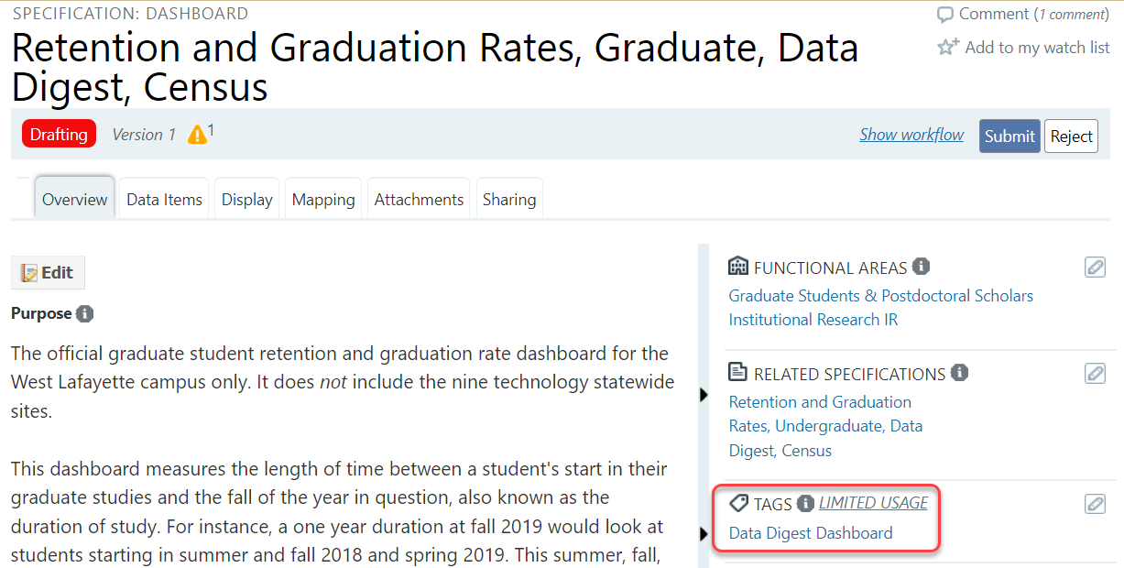

Checking Keywords

- Keywords can be used as part of the specification description to allow specification search. The following format should be used: “Keywords: synonym1, synonym2, etc.”

- Example

