Data Cookbook: Short Version for Definition Approvers

idata@purdue.edu

2/10/2025

Table of Contents
Definition Paragraph Standards 2
Workflow of Definitions 2
Finding Definitions Ready for Review 3
Definition Queue 3
Searching in List of Definitions 3
Editing and Approving Definitions 4
Editing 4
Approval of Workflow 4
Checking Tags 5
Checking Keywords 5

This document is a short version of our complete definitions standards document, for the approvers of definitions. Please see the complete documentation of Creators of Definitions - Standards
(https://www.purdue.edu/idata/data-governance/data-cookbook/cookbook-training.php).

Definition Paragraph Standards

- Definitions may contain six paragraphs. Not all six are required. Complete sentences are to be used.
  - Paragraph 1 – business definition, understandable, no jargon
  - Paragraph 2 – sample of valid values or reference to list of values (optional)
  - Paragraph 3 – context, cautions, standard uses or misuses
  - Paragraph 4 – links to other related definitions
  - Paragraph 5 – keywords (other words someone might search on for this element)
  - Paragraph 6 – security, permissions (if applicable)
- For Finance, Human Resources (HCM), Administrative Operations, and Research (GM), refer to Appendix B for the standards, used for SAP Data Marts only.

Workflow of Definitions

- Definitions move from “Drafting” to “Functional Area Review” to “Final Review” and “Approved” stages.

- Once definitions are drafted and the functional area review is complete, they move to the functional data owner for a “Final Review” for accuracy, completeness, and adherence to standards.

- Additional edits can be made OR the definition sent back to “Drafting” for the original creator to make edits. A comment box appears when a definition moves from one stage to another. If the definition is sent back to drafting the Reviewer/Approver is able to add verbiage about the edits needed.

- Once the functional data owner considers it complete, s/he hits the “Approve” button.

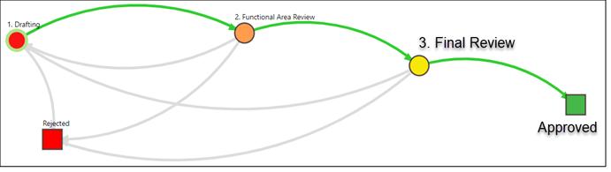

Finding Definitions Ready for Review
There are three ways to locate definitions that are ready for review:

- If you received an email message that a definition is ready to review, use the link embedded in the email. Automated email notices from Data Cookbook are sometimes routed to spam filters. Please be sure to check your spam filter for any trapped emails.
- Click on the “Definitions” tab and then use the “Search” box, if you know the definition name.
- Recommended: Go to the Definition Approval Queue and use the filters by following the instructions below.

Definition Queue

- Hover over the Definitions tab and select Definition Queue:

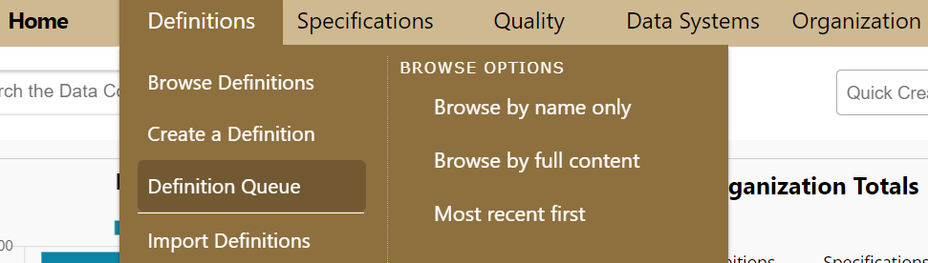

- You can narrow down the definitions by using the filters under the Definition Approval Queue. See the instructions below.

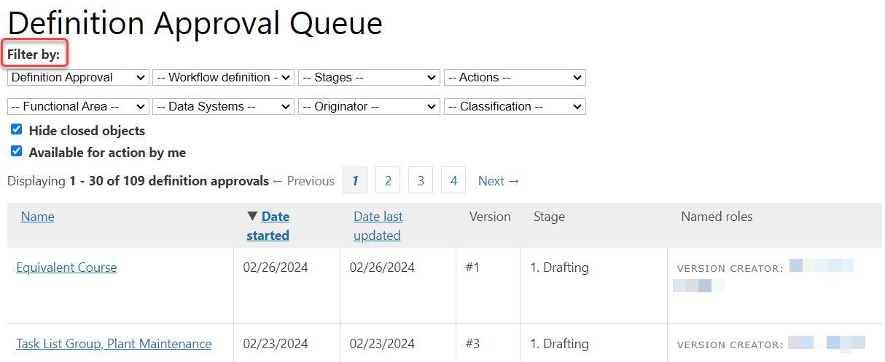

Searching in List of Definitions

- The top row of the search are cascading prompts. You must select a value in the first dropdown - Workflow type – which will be prepopulated as Definition Approval. Then populate the next search box - Workflow definition, etc.

Editing and Approving Definitions

Editing

- Once you have narrowed down your selection, under the “Name” column, click on the name of the definition you wish to edit/update/approve. This will open the Definition window. The Functional Data Owner begins a final review for accuracy, completeness and adherence to standards. If you need to edit the definition, click the edit button. If no edits are needed, click the Approve button – for more information please see the next section.

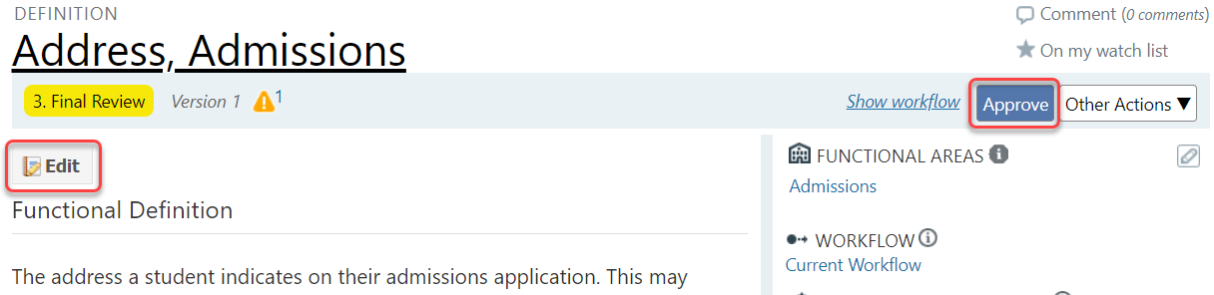
- Once the definition has been edited and the changes are ready to be saved, click the “Update” button at the bottom of the page to save the work.

Approval of Workflow

- Options include “Approve,” “Back to Drafting” and “Reject:”
  - Click “Approve” if you believe the definition is accurate, complete, and adheres to standards.
  - Click “Back to Drafting,” if you believe the definition needs editing before it is approved. Please make sure you add a comment that explains why it needs more work. A comment box will open up when you click “Back to Drafting.”
  - It is not recommended to reject definitions. If the definition is no longer needed, contact idata@purdue.edu to delete the definition.

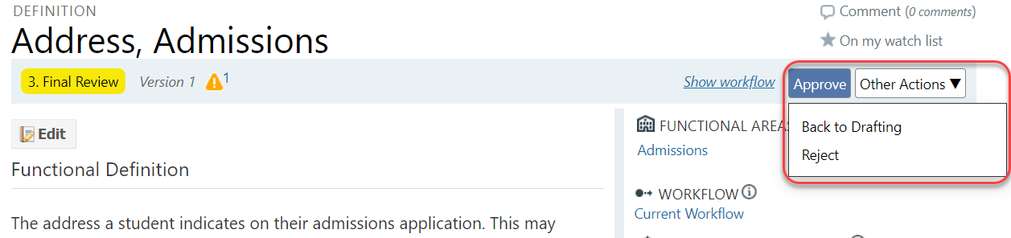
- Tip: If you have a larger number of definitions in your approval queue, it would be better if you open each definition in another tab from your queue page, then approve that definition and close that tab. Your definition approval queue will stay the same in the first tab, so you can open the second definition in your queue in another tab. This way you do not need to wait for your queue to be loaded every time you approve a definition, and you will approve your definitions faster. You can refresh your approval queue page from time to time.

Checking Tags

- A tag is used to quickly group definitions together for ease in searching (they are used as a filter on the browse page). They may be shared by multiple definitions.

- Example:

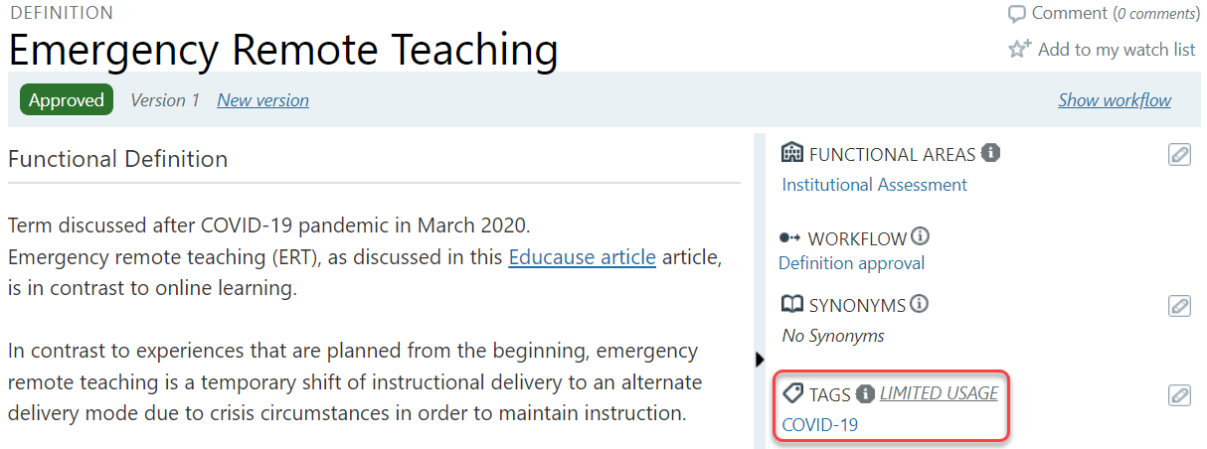

Checking Keywords

- Keywords can be used as part of the Functional Definition to allow definition search. The following format should be used: “Keywords: synonym1, synonym2, etc.”

- Examples:

