Data Cookbook: Getting Started

idata@purdue.edu

7/7/2025

Table of Contents
Audience 2
Getting Started 3
Accessing Data Cookbook 3
Creating your Account 3
Current Functionality 3
Cautions 4
Purdue Community Resource 5
Your Input is Appreciated 5
Portals to Data Cookbook from Cognos and Tableau 7
Portal from Cognos Standard Reports 7
Portal from Tableau Dashboards 7
Searching for Metadata 10
Home Page vs. Browse vs. Quick Definition Lookup 10
Home Page Search 10
Browse Definitions or Browse Specifications Search 11
Quick Definition Lookup 12
Browse Definitions 13
Workflow Status of Definition 14
Versions 15
Browse Specifications 17
Cognos Reports & Dashboards & Dimensions 17
Workflow Status of Specification 17
Filters 19
Collections 20
Workflow Status of Collection 21
Tags 22
Additional Informational 23

Audience

- New Data Cookbook users

- This guide includes basic navigation and listing of current functionalities of Data Cookbook. Data Cookbook is the authoritative source of metadata for data fields, as well as standard report and dashboard specifications. All Cognos folders labeled “Standard,” as well as Management Dashboards and Data Digest dashboards are documented in Data Cookbook. New and updated metadata is constantly being added to the system.

- All official reporting and decision-making should be using definitions that have been approved by data owners. These approved definitions will be transparent, as well as accessible via Cognos and Tableau. They will be available for comment from any Data Cookbook user.

Getting Started

Accessing Data Cookbook

- Launch Data Cookbook at https://purdue.datacookbook.com

- Data Cookbook is also available at Purdue OneCampus portal (https://one.purdue.edu/). Search the portal using keywords “cookbook,” “data,” “governance,” or “metadata.”

- You can also locate Data Cookbook by internet search of “Purdue Data Cookbook.”

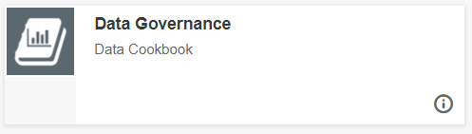

Creating your Account

- Using your Purdue Career Account login, create an account, accepting the information provided. The account is automatically created upon login.

Current Functionality

- Purdue Data Cookbook contains thousands of definitions and specifications across multiple functional areas. Some subject areas are more complete than others, and work continues. The functional areas include:
  - Academic Agreements
  - Academic Proposal
  - Administrative Operations
    - Capital Asset Management
    - Materials Management
    - Parking
    - Plant Maintenance
    - Space Administration
  - BICC
  - Elements
  - Ethics and Compliance (VPEC)
  - Faculty Affairs
  - Finance
  - Human Resources (HCM)
  - Institutional Assessment
  - Institutional Research IR
  - Purdue for Life
  - Purdue Online
  - Research (GM)
  - Student
    - Admissions
    - Bursar
    - Courses
    - Financial Aid
    - Graduate Students & Postdoctoral Scholars
    - Slate Graduate
  - Student Life
  - Teaching & Learning
    - Center for Career Opportunities (CCO)
    - Center for Instructional Excellence (CIE)
    - Office of Experiential Education
    - Student Success Programs
    - Undergraduate Academic Advising
  - Transact

- As of January 2019, the Cognos metadata from standard reports for Admissions, Bursar and Student areas were converted into Data Cookbook, and are no longer updated in Cognos. In 2021, Cognos metadata for standard SAP reports was imported into Data Cookbook. It includes the areas of Administrative Operations, Finance, Human Resources and Research (Grants Management). Upon completion of the conversion, the Cognos metadata functionality will be retired.

Cautions

- Data Cookbook is cloud-based so response times may vary.

- Log out of Data Cookbook AND close browser window when finished.

Purdue Community Resource

Your Input is Appreciated

- Data Cookbook is the authoritative source of Purdue metadata for data fields, standard reports and dashboard specifications. Definitions and report/dashboard specifications make information available in writing. The functional data owners make every effort to ensure definitions are current and correct. However, your help is needed. Having an involved community with different perspectives adds to the quality of the content.

- If you see a definition or specification that can be clarified, improved or updated, please add a comment. Anyone can propose a change at any time by using the comment box displayed at the bottom of each definition and specification. Your comment routes to the data owner(s) for that functional area. The owner has expertise in the subject area and will review the comment and take appropriate action. Please note that comments are tracked in the space below the comment box and are visible to all users.

- Click in the text box to highlight the comment area. Type your comment and then click “Add Comment.”

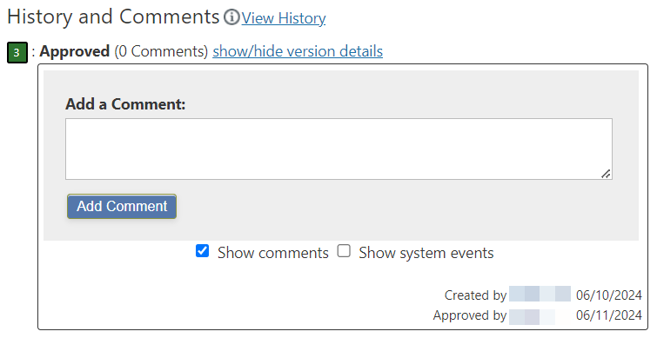
Example:
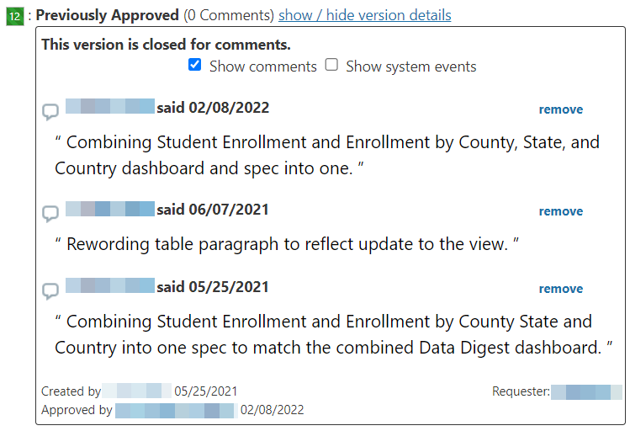

THANK YOU for your part in making Data Cookbook a more valuable resource.

Portals to Data Cookbook from Cognos and Tableau

- For ease of access, there are portals from both Cognos and Tableau to Data Cookbook. Clicking them provides information from the specification in Cookbook, including Purpose, Description, Owner, and links to Related Definitions. If more detail is needed, there is a “View Details” link directly into Data Cookbook for all of the detailed information.

Portal from Cognos Standard Reports

- The portal has been implemented in several standard reports and is now part of Student Reporting Governance committee report approval process. Work continues.

- Content > Team Content > Standard Content

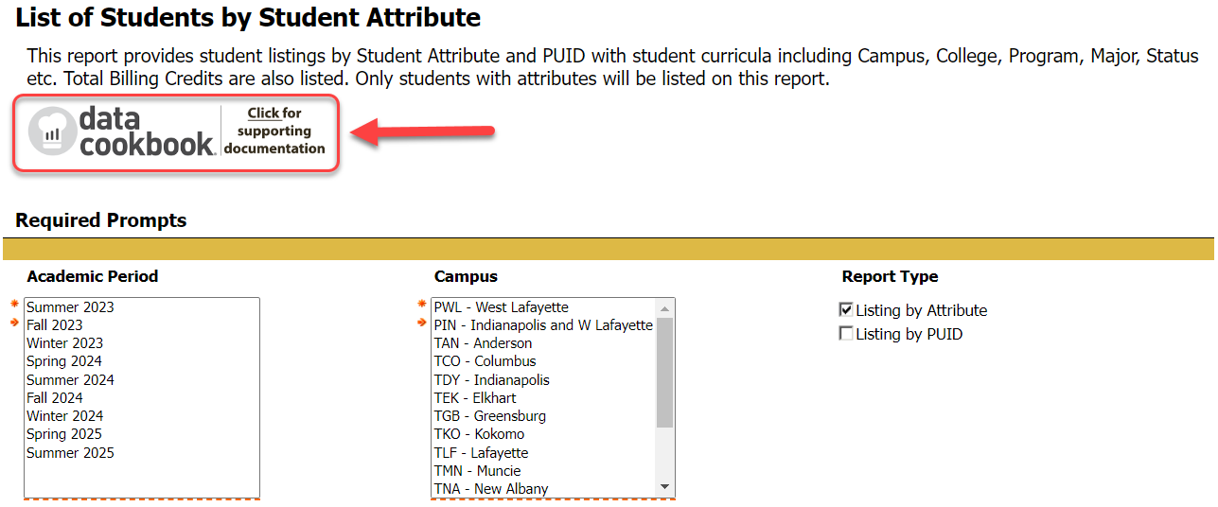

Portal from Tableau Dashboards

- The portal from Tableau to Data Cookbook has been implemented in several of the Data Digest dashboards and work continues. It is located next to the Help button on the top of the dashboard.
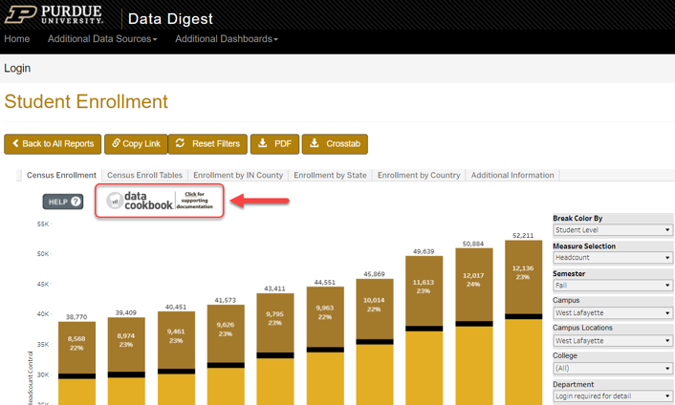

- Clicking the “data cookbook” logo from both Cognos standard reports and Tableau dashboards opens summary information including Purpose, Description, Owner, and Related Definitions.

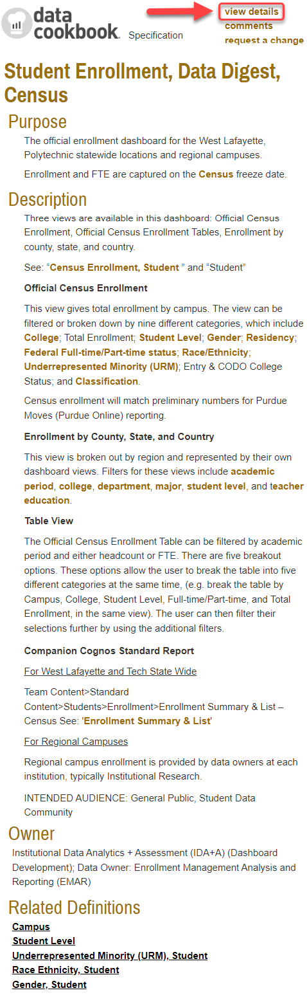

- “View Details” link leads directly into Data Cookbook.

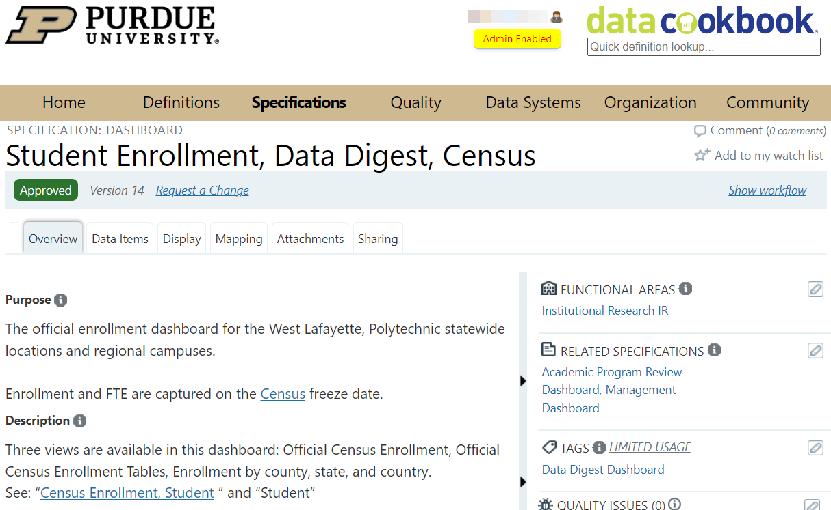

Searching for Metadata

Home Page vs. Browse vs. Quick Definition Lookup

- The table below shows three ways to locate definitions or specifications. Please note the important differences in results between the methods.

Search Method | Returns | Status
1. Home Page | Definitions, Specifications and Data Systems | APPROVED only
2. Definitions/Browse Definitions;  Specifications/Browse Specifications | Definitions or Specifications | In any status
3. Quick Definition Lookup (top right) | Definitions | In any status

- Searching from the Home page only returns Approved definitions. Searching from Definitions/Browse Definitions or Specifications/Browse Specifications returns all definitions in any status (Draft, Functional Area Review, Final Review, and Approved).

- With many definitions and specifications being created at this time, the recommendation is to search using Definitions/Browse Definitions or Specifications/Browse Specifications and be aware of definition status.

- A definition in draft or pending status may be incomplete, but it can provide basic information to help you continue with your work.

Home Page Search

- A search box is available on the Home page. In this example, the word “application” is the search term. It will return any definition or specification with “application” anywhere in the definition, title, or keyword list.

- The Home Page Search only returns Approved definitions/specifications.

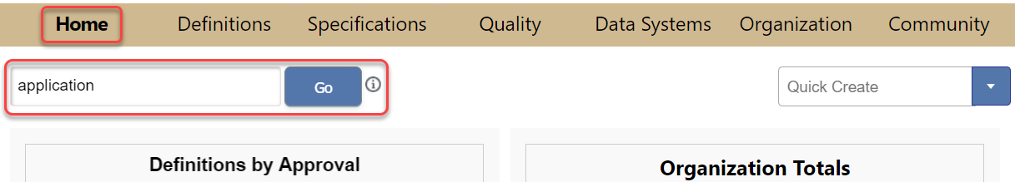
- The results of the “application” search show Definitions, Specifications, and Data Systems that contain the word “application.”

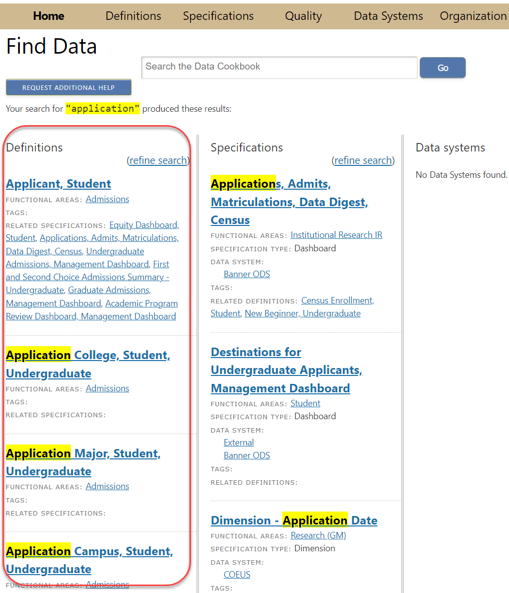
- The full search returned 20 Definitions with “application” in the title or description. Click on any Definition to view the complete entry.

- Remember, these are Approved Definitions. Searches from the Home tab omit Definitions in draft or review status. Use Browse Definitions (next) to see Definitions in any status.

Browse Definitions or Browse Specifications Search

- Click on the Definitions tab and select Browse Definitions, or Specifications tab and select Browse Specifications.

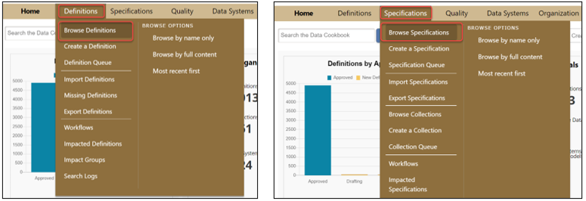

Quick Definition Lookup

- Searches using the “data cookbook” icon (top right corner) will return all definitions, including those from other institutions within the Data Cookbook community.

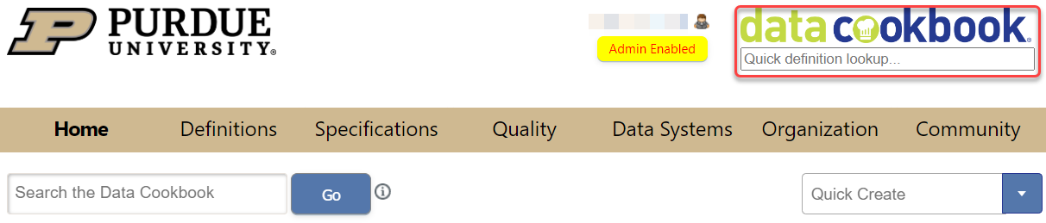

Browse Definitions

- Hover on the “Definitions” tab and select “Browse Definitions.”

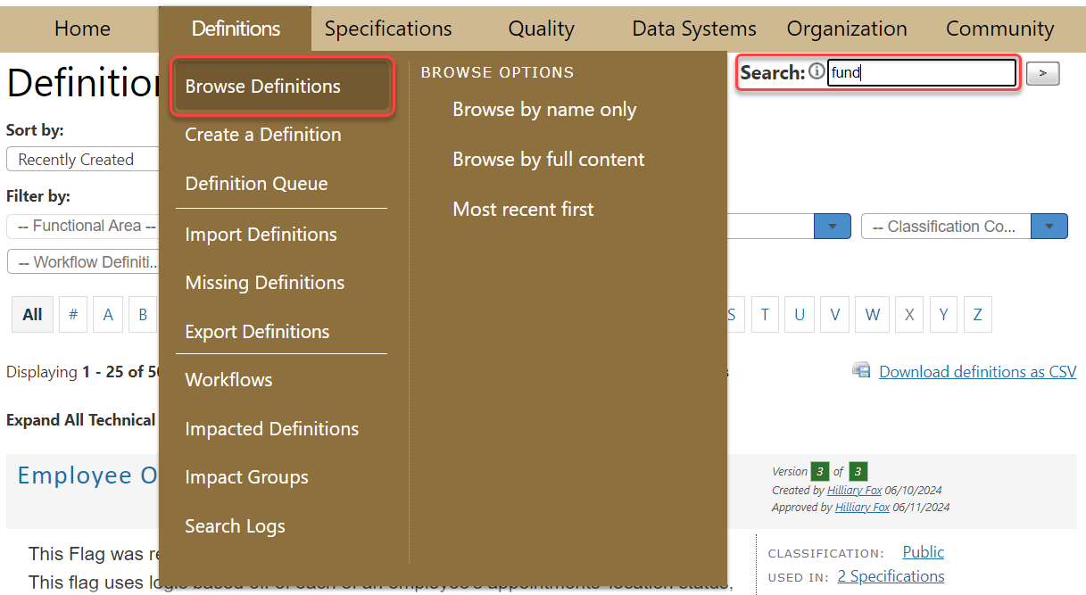

- The initial screen begins an alphabetical list of all (thousands) definitions in the Purdue Cookbook system. It cuts across functional areas. For example, “fund” search returns definitions from Finance, Research, and Financial Aid functional areas. You can scroll through the entire list or use the filters to narrow the search.

- The default is to show Name Only. You can change this using the Display filter to view Full Content of the Definition (name plus first three lines of the definition).

  - Default View:

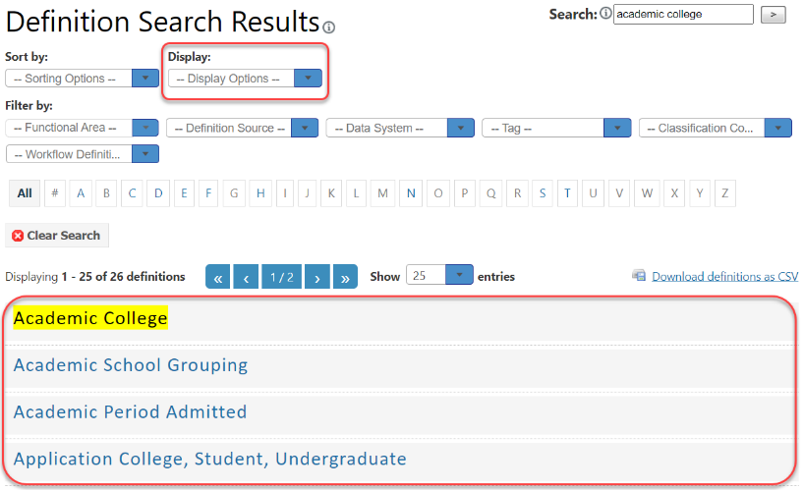

  - Full Content View:

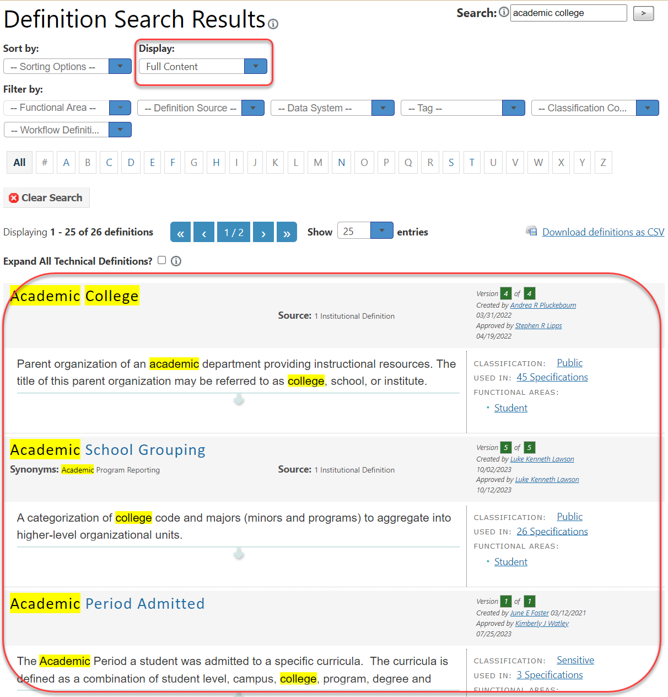

Workflow Status of Definition

- The Browse option shows definitions (or specifications) in any step of the review process. It is recommended over a Search from the Home Page due to the number of definitions and specifications currently being created.

- The steps in the approval process are:

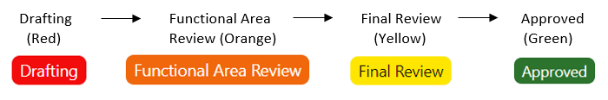

- The Browse option shows all definitions, including those in drafting status or under review. The status is shown on the right side of the screen in full content display.

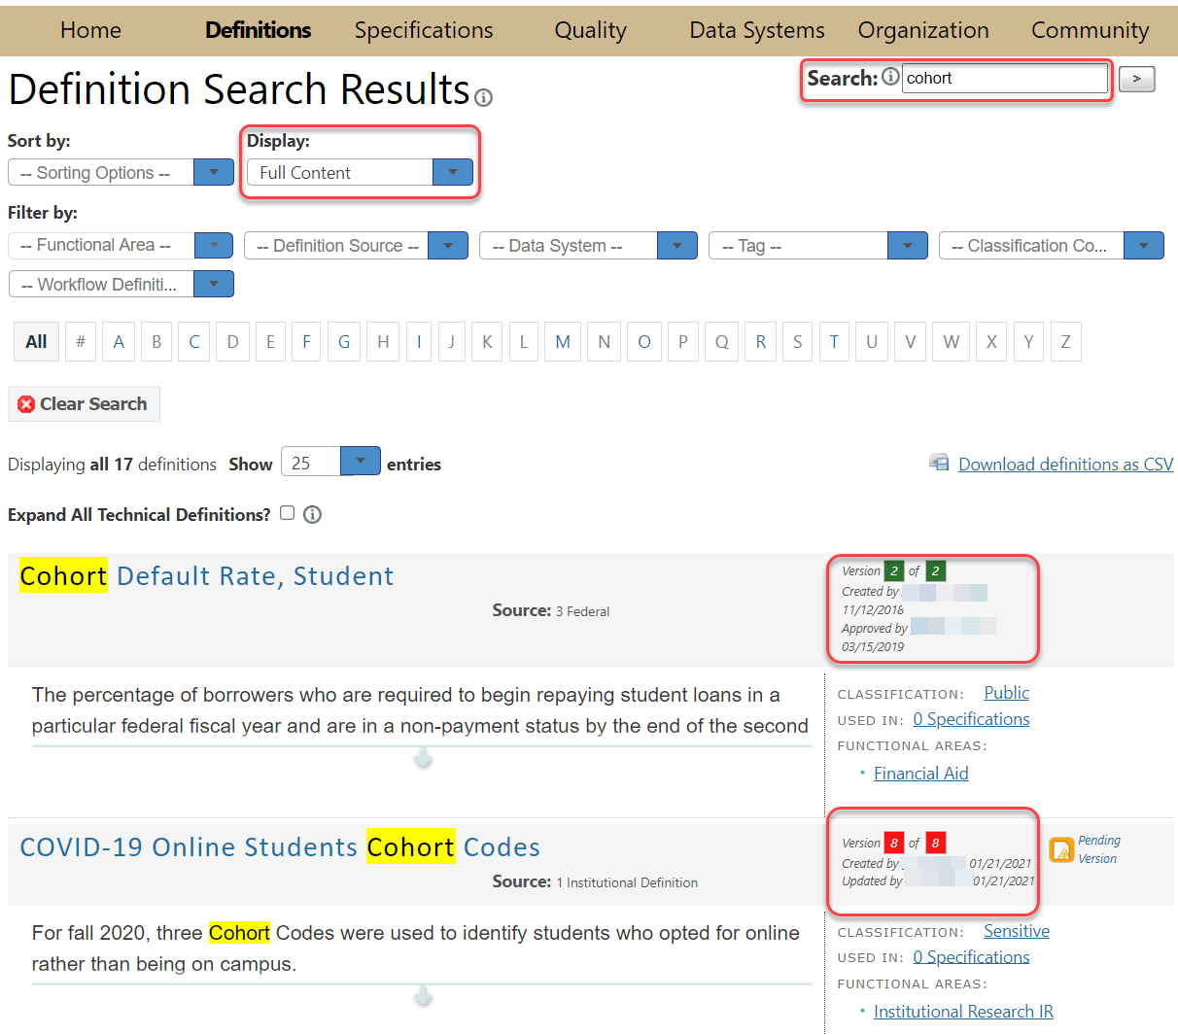
- In Definition view, status is displayed at the top left.

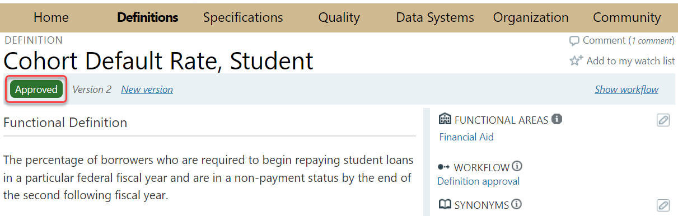

Versions

- Definitions can have multiple versions. Additional versions may include clarifications, additional verbiage, and new information. Comments added by anyone using Data Cookbook are reviewed and often lead to a new, better version.
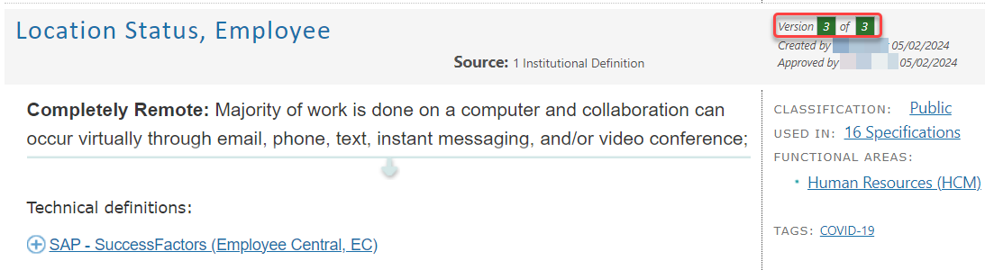
- Versions can all be in Approved Status or there can be an Approved version along with one still being reviewed.

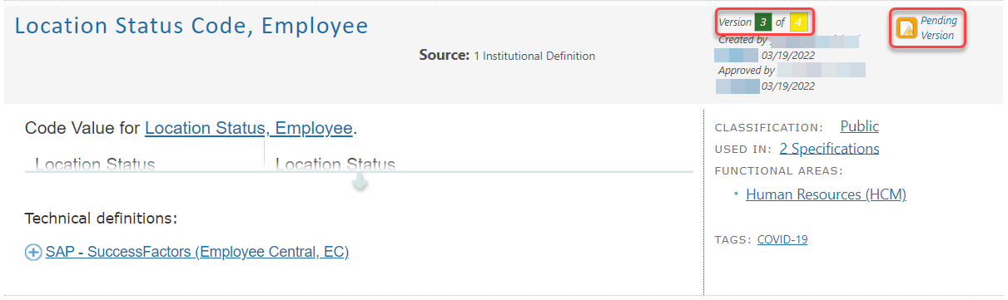

Browse Specifications

Cognos Reports & Dashboards & Dimensions

- Search results on “degree” keyword:

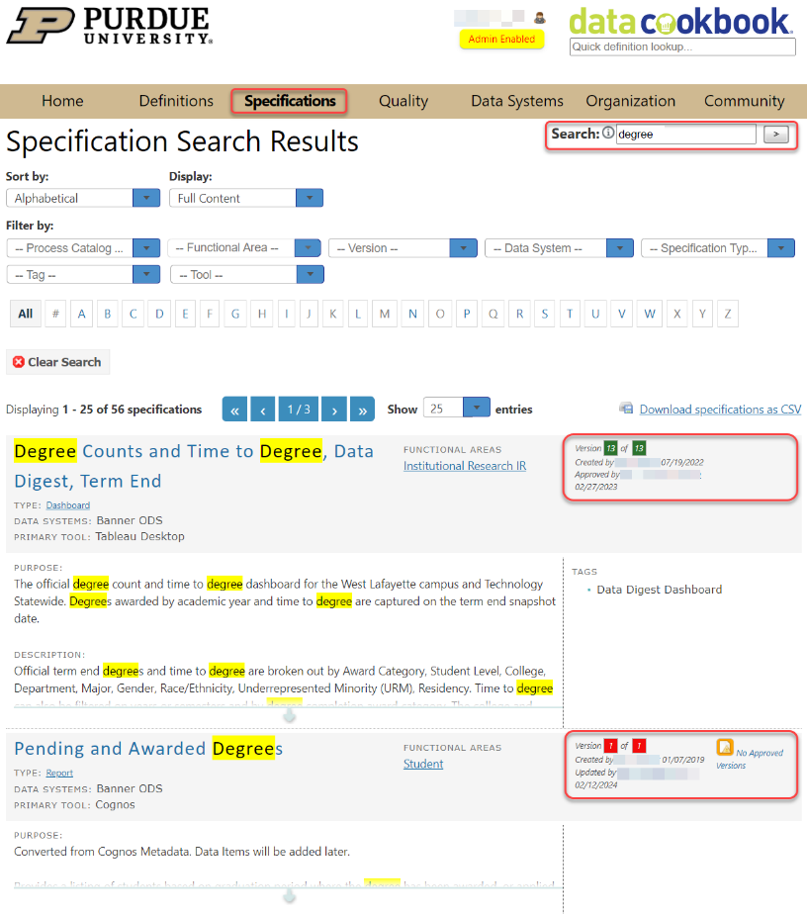

Workflow Status of Specification

- Specification workflow is same as the definition workflow.

- In Specification view, Specification status is displayed at the top left. Specifications (report or dashboard) also may have multiple versions.
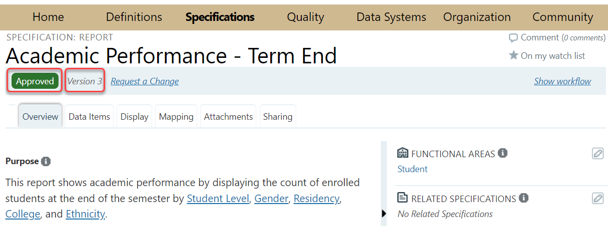

Filters

- Cookbook provides several filters to limit the scope of your search. The filters can quickly reduce the number of results, making it easier to locate a specific definition/specification/collection or group of definitions/specifications/collections.

- Filtering by Functional Area is a good way to limit the options on the screen and make it easier to find what you need. If you know what area is (or might be) responsible for activities related to your search term, click that area.

- Filtering by Tag is another option. For example, you can see all Data Digest or Management Dashboard related specifications. Please see the “Tags” section for more information about tags.

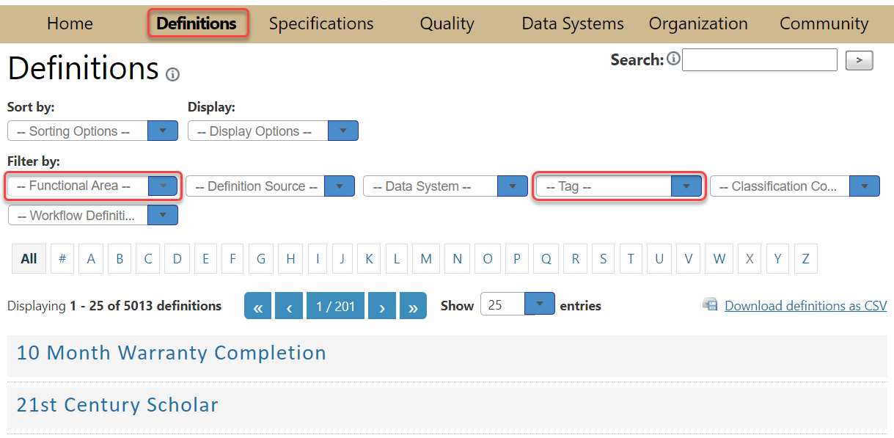

Collections

- Collections are used to group related Specifications in Data Cookbook and are used to document database stars. For example, we can group all academic proposals under one collection in Data Cookbook. To search for Collections, hit Browse Collections under the Specifications tab.

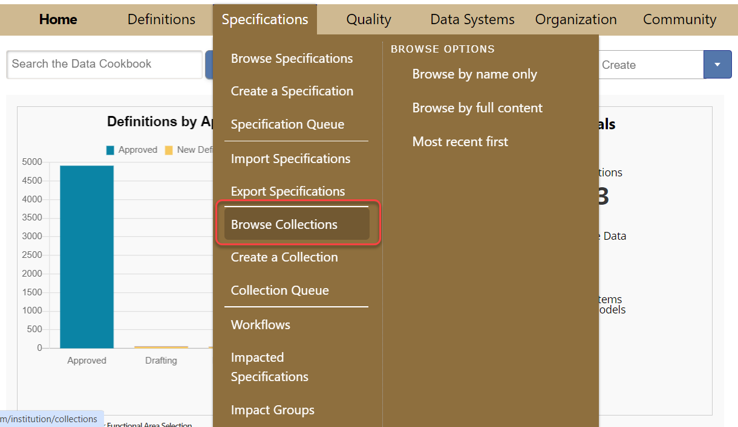
- You can filter Collections by functional area, collection type, data system, tool, and/or tag

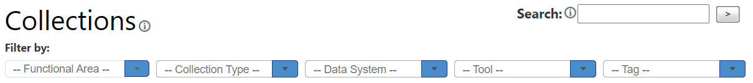
- When you open a collection, you can see the Purpose and Description of the collection, as well as Related Specifications in this collection on the side bar.
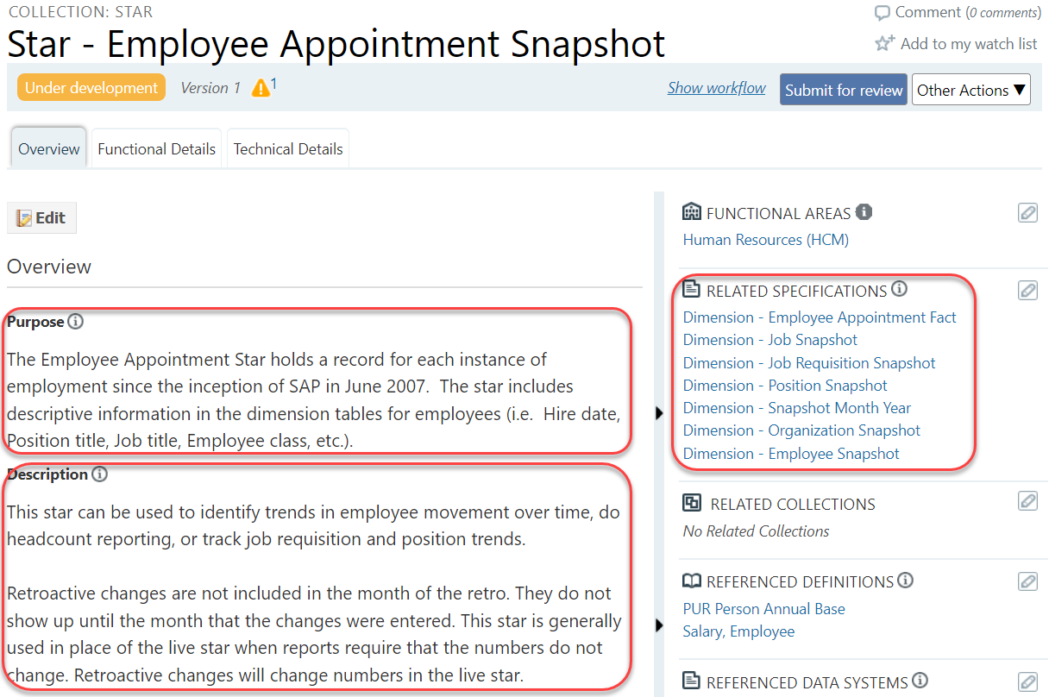

Workflow Status of Collection

- Clicking the “Show Workflow” link will open a section with the collection’s workflow status chart. The current status will be highlighted:

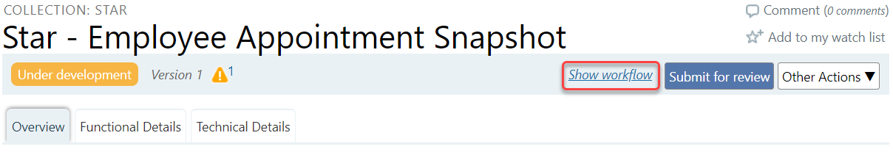
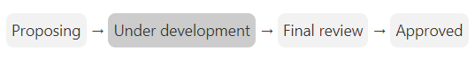

Tags

- Tags are searchable words or phrases. They are used as a filter on the browse page and they may be shared by multiple definitions and specifications. Tag filter is also used on specifications to easily identify Data Digest, Management Dashboard, or COVID-19 related specifications.

- For example, hit Browse Definitions or Specifications or Collections and from the Tag filter choose “Data Digest Dashboard” to see all related definitions/specifications/collections with that tag.

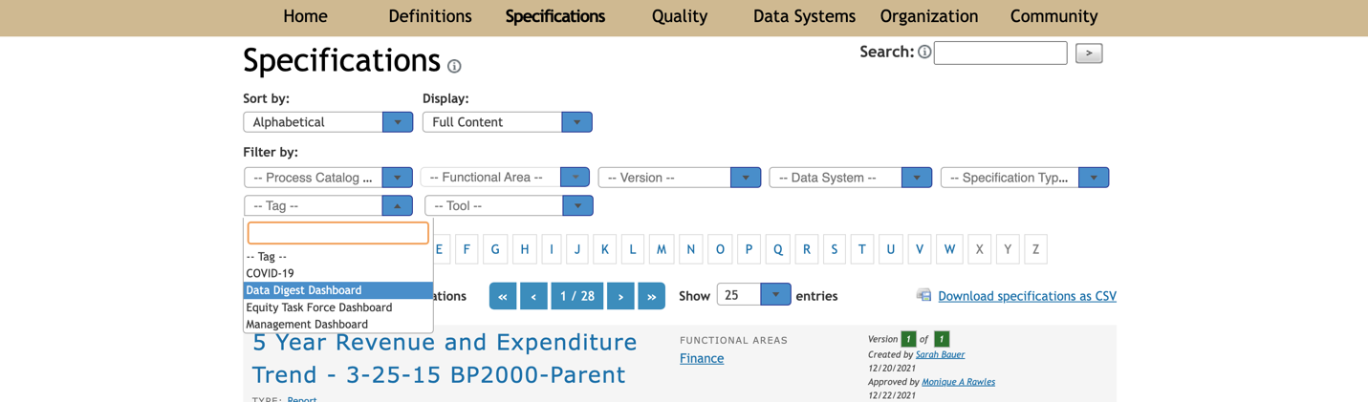

- Results:

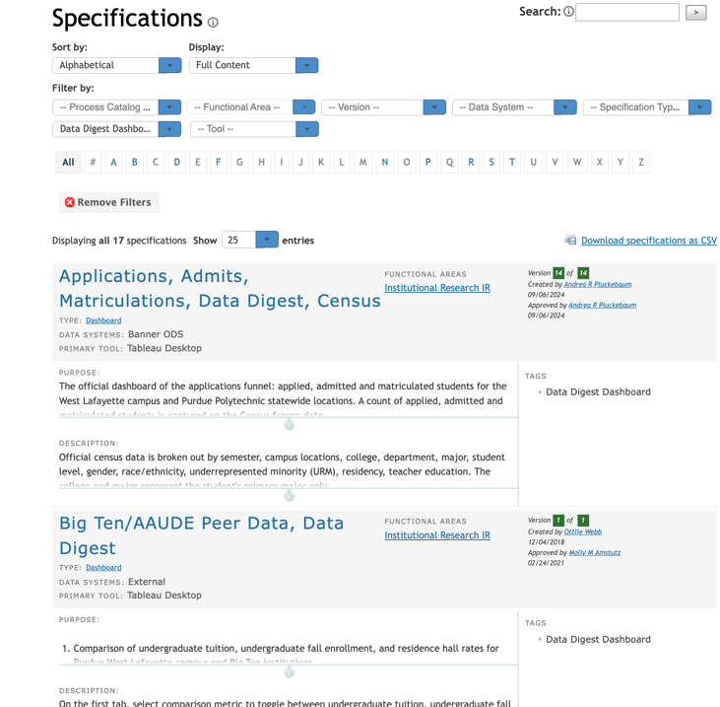

Additional Informational

- The Community tab provides additional information and resources compiled from Data Cookbook users at other higher education institutions. Community resources also include information from agencies such as Common Data Set, IPEDS and National Student Clearinghouse.

