Data Cookbook: Creators of Specifications - Standards

idata@purdue.edu

7/25/2025

Table of Contents
Audience 2
Creating New Specifications 3
Overview Tab 4
Specification Form 4
Step 1: Name (Required) 5
Step 2: Specification Type 6
Step 3: Functional Areas (Required) 6
Step 4: Purpose (Required) 6
Step 5: Description (Required) 7
Step 6: Additional Information (Optional) 7
Step 7: Save 8
Step 8: Tools (Required) 8
Step 9: Source Data System (Required) 9
Step 10: Owner (Required) 9
Step 11: Access Details (Required) 9
Step 12: Add Attachments 10
Save & Submit Specification 10
Sidebar Fields 11
Functional Areas 11
Related Specifications 12
Tags 13
Quality Issues (Currently Not Implemented) 13
Related Collections 14
Milestones (Currently Not Implemented) 14
Additional Tabs 15
Data Items Tab 15
Display Tab (Optional) 15
Mapping Tab (Currently Not Implemented) 16
Attachments Tab (Optional) 16
Sharing Tab (Currently Not Recommended) 17
New Specification Workflow 18
Specification approval process workflow 18
Editing/Approving Specification 18
Creating New Version of Specification 19
Adding a Pop-Up Window to Dashboards and Reports 21
Adding a Pop-Up Window to a Tableau Dashboard 21
Example Final Product: 23
Adding a Pop-Up Window to a Cognos Report 23

Audience

- Those who draft, edit, review, and/or approve specifications and collection content in Data Cookbook.

- Functional data owners review and approve the specifications and collections ensuring accuracy, completeness and adherence to the standards.

- Please be aware that as specification and collection creators, reviewers, and approvers, you have a role in the Workflow functionality and will receive emails from Data Cookbook as part of the process. Emails may be caught in the Spam folder, so you may need to Release and Add them to Safelist the first time.

Creating New Specifications

- A specification is a Data Cookbook term for information for a particular dashboard, dimension, glossary, or report.

- Specification templates define the structure of a specification through the tabs that are presented to the user when they create a new specification. A specification template has Overview, Data Items, Display, Mapping, Attachments, and Sharing tabs.

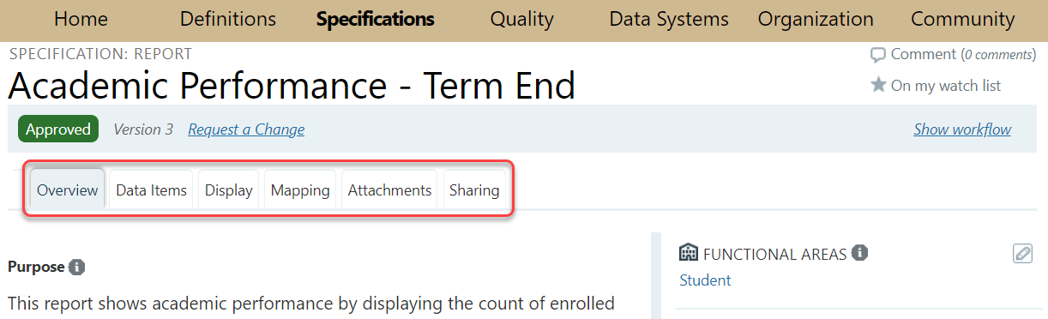

Overview Tab

Specification Form

- To create a new specification, hover over the “Specifications” tab and click on “Create a Specification” option.

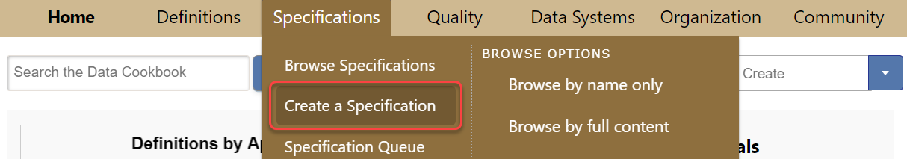
- A new page with specification template will open.
  - Required entries are marked with red asterisks (*).
  - Hovering over information icons () displays detailed explanations of information needed
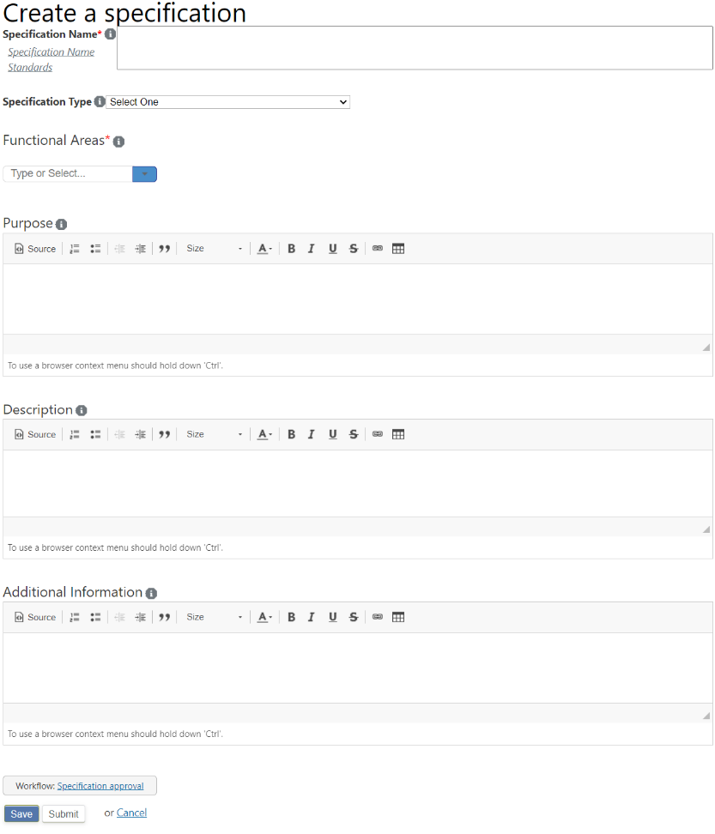

Step 1: Name (Required)

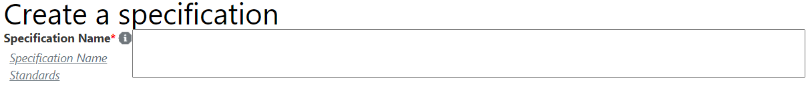
- A specification name should match or be similar to the report/dashboard name used for the standard Cognos report, Data Digest Dashboard or Management Dashboard. Reports and dashboards should go through a standard review and governance approval process prior to adding the metadata to Cookbook.

- Because Data Cookbook is an enterprise solution, the specification name should be in the format Name, Functional Area.

- Specification Name Standards:
  - Use Title Case - capitalize first letter of each word, with exception of short words (e.g., a, the, by, for).
  - Omit "A", "An", and "The" from the beginning of the name.
  - Avoid numbers and special characters, e.g., &, #, etc. (common abbreviations are allowed).
  - Delete leading and trailing white spaces (it can occur when cutting and pasting from other sources). Data Cookbook will treat "Grade Roster" and "Grade Roster<trailing space>" and “<leading space>Grade Roster” as different specs.
  - Because Cognos standard reports and Data Digest dashboards may contain some of the same information, you may need to crosswalk the name of the approved standard Cognos report with the Data Digest name.

- Examples
  - “Student Enrollment, Census”
  - “Articulation Agreement, Academic Agreements”
  - “Action Plan, SEDR”

- For Database Stars, use the following format: Dimension - <Table Name>, Functional Area
  - Example: “Dimension – CIP, PDW Student”

Step 2: Specification Type

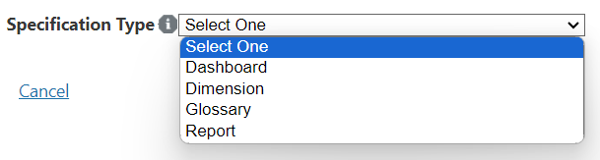
- Select from the drop-down list. If another type is needed, contact: idata@purdue.edu

Step 3: Functional Areas (Required)

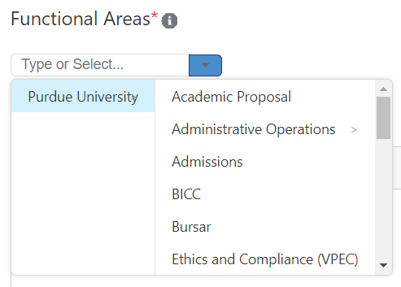
- Select a functional area from the drop-down box.

Step 4: Purpose (Required)

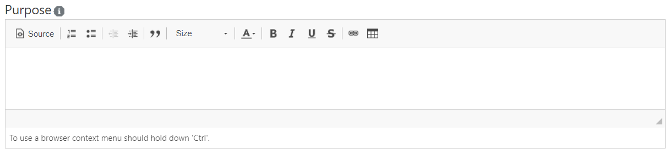
- This field is a very brief statement of the purpose of the specification indicating how it meets the University or unit’s need for the information. It should be written in understandable language for the Purdue community audience.

Step 5: Description (Required)

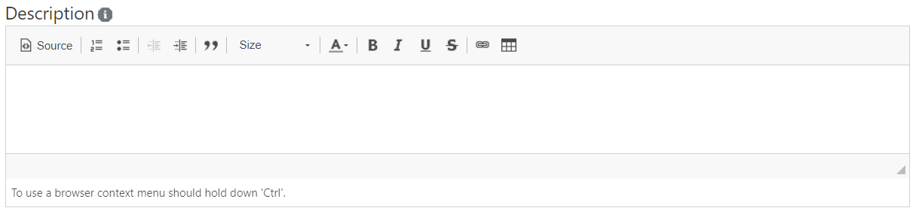
- This is a more detailed explanation including filters, parameters, etc. used in the report. It should describe what questions the dashboard or report answers. Include details about how information is calculated, when to use this object versus a different one, limitations, and the intended audience (e.g., executive decision-making, general public, transactional auditing).

- This field should be used when a more detailed description will help the end user.

- If no additional information is needed, write “N/A” in the field.

Step 6: Additional Information (Optional)

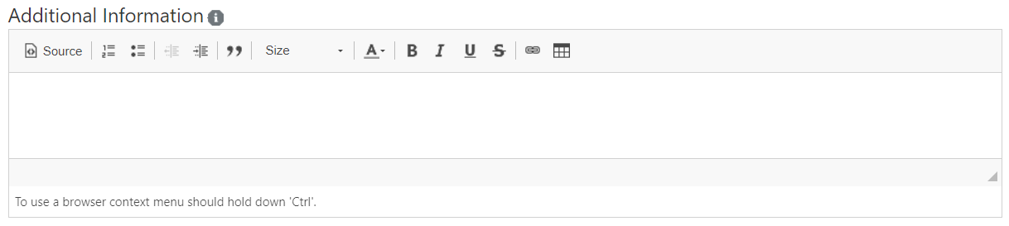
- This section should detail any caveats and/or cautions for the report/dashboard that the user might need to know. This information should include anything in the help text of dashboards.

- Example: “College of Health and Human Sciences did not exist prior to Spring 2011, but has been coded to be filled in through the past as if it had always existed.”

Step 7: Save
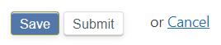
- Once the form entry is complete, click the "Save" button to save information entered in the form. You can edit the information and save it again any time before submitting it.

Step 8: Tools (Required)
- Once you have saved the form, click on “Edit.” A new section will appear between the Description and Additional Information sections in the specification form. You can enter additional information here, starting with the Primary Tool.

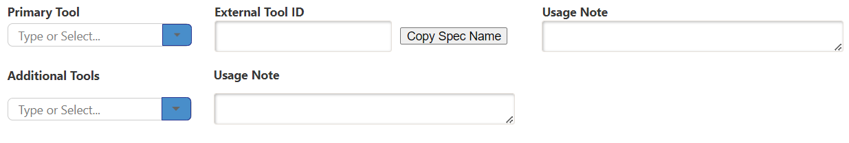
- Primary Tool - Choose the system or program that is used to generate the report or dashboard from the drop-down menu.

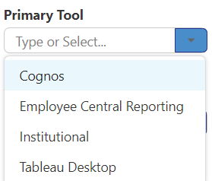

- External Tool ID/Usage Note – Not currently implemented

- Additional Tools/Usage Note - Not currently implemented

Step 9: Source Data System (Required)
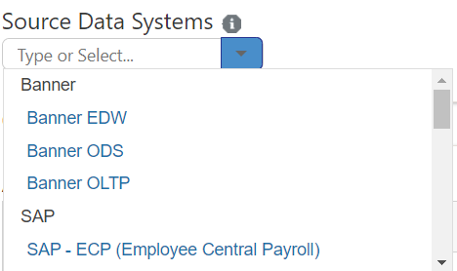

- Choose the data system from which the data in the report or dashboard is generated from the drop-down menu. May select more than one if needed. Options include Banner, SAP, and other systems such as Transact System.

- If another source data system is needed, send an email to idata@purdue.edu

Step 10: Owner (Required)

- Office responsible for the report/dashboard. If known by an acronym, begin with that and spell out full name.

- Use the same owner name in the same format for all of your specifications to be consistent.
  - Example: “IDA+A – Institutional Data Analytics and Assessment”

Step 11: Access Details (Required)

- Include any information re: access, specific roles required to access this spec and how to request the role.

- Example: “Because Data Digest dashboards are available to the public, and small cell sizes can occur when filters are used, access to department and major level is limited to Purdue faculty and staff only. To request access to department and major, send email to idata@purdue.edu

Step 12: Add Attachments

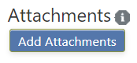

- If there are any documents that provide more information about a report or dashboard, they can be added here (also via the specification’s Attachments Tab). Clicking the “Add Attachments” will open a pop-up window. You can attach a file or a URL. Make your selections and click “Attach File.”

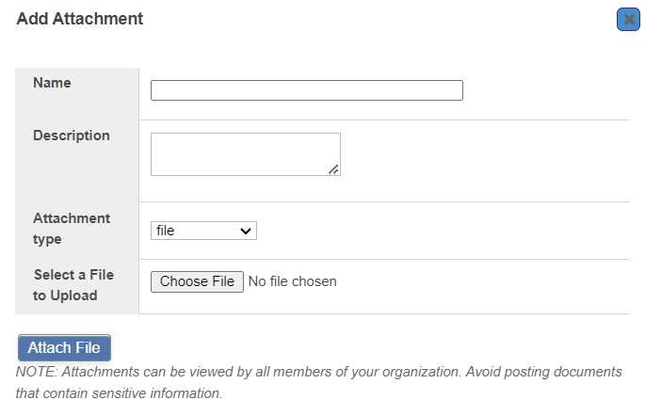
- Note: If you are attaching a file that is hosted on a website, be mindful that such items might go out of date. For that reason, attaching a URL in the Description is preferable to attaching a file. Maintenance of attachments, including making sure they are up to date, is the duty of the Functional Area.

Save & Submit Specification

- Once the new specification is complete, click the "Save" button to save information entered in the form. You can edit the information and save it again any time before submitting the form.

- Click the "Submit" button after the draft is complete. Once submitted, the review process of the specification approval workflow begins.

Sidebar Fields

- There are additional fields located on the right-hand sidebar of a specification page. These fields can be edited regardless of the workflow status (e.g. you can add related specs, tags, etc. even if the spec is in the approved stage).

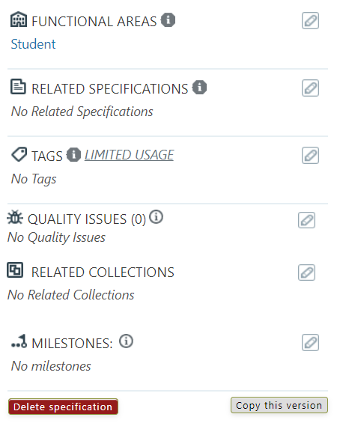

Functional Areas

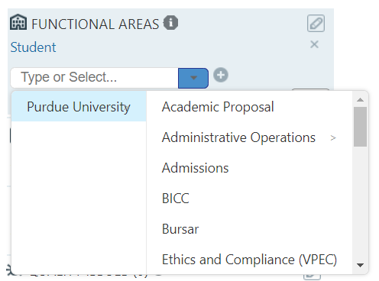

- This section was already populated with one or multiple functional areas in the process of creating the specification.

Related Specifications

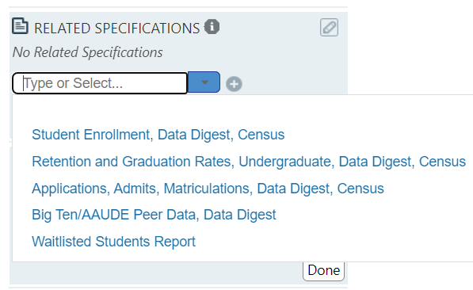
- Any specifications related to the current specification can be listed here. If the current specification is linked on another specification, the other specification will automatically be listed as a related specification.

- Editors can relate other specifications to in-progress or approved specifications. Related specifications should be listed if similar data/information is provided in another dashboard or report.

- To list related specifications, click the pencil icon on the right-hand corner, choose the spec from the drop-down menu, click the “+” sign next to the drop-down menu and then click “Done” button. You will see the selected spec listed above the drop-down menu.

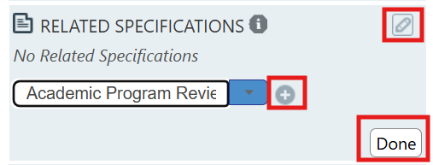

Tags

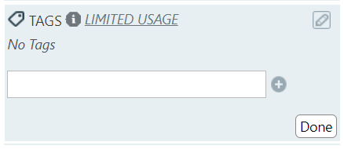
- Tags are filters used to group objects in Data Cookbook. We are currently using Data Digest Dashboard, Management Dashboard, Equity Task Force Dashboard, Covid-19, and PDW Student tags.

- To add a tag, click the pencil icon on the right-hand corner, type the tag (example: type Data Digest Dashboard), click the “+” sign next to it and then click the “Done” button.
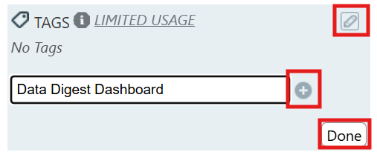

- To remove a tag, click the “X” button next to the tag below the pencil sign.
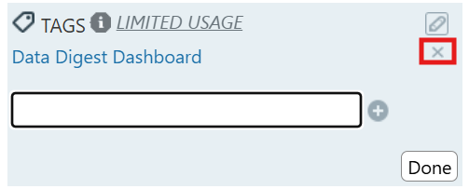

- If you would like to use a new tag, email idata@purdue.edu.

Quality Issues (Currently Not Implemented)

Related Collections

- If the specification is part of a collection, indicate so by selecting the collection from the drop-down menu, click the “+” button and click “Done.” If the specification is added to a collection, the Related Collections field populates automatically in the specification.

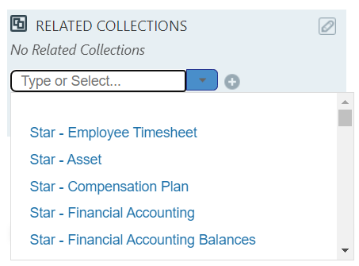

Milestones (Currently Not Implemented)

Additional Tabs

Data Items Tab

- Use this tab to document the data items (fields) used for a report or dashboard; these can be definitions or labels. Many are the Cookbook definition name itself; however, if a different label is used on the report/dashboard, document it here. That way it is clear to the data community what definition is being used in the report/dashboard.

- If the item is an existing definition, click on the “Existing Definition” and choose from the drop-down menu. If it is a new definition, create the definition by clicking on the “New Definition” button. If you have a large number of data items to add to the spec, contact idata@purdue.edu for assistance with an import.

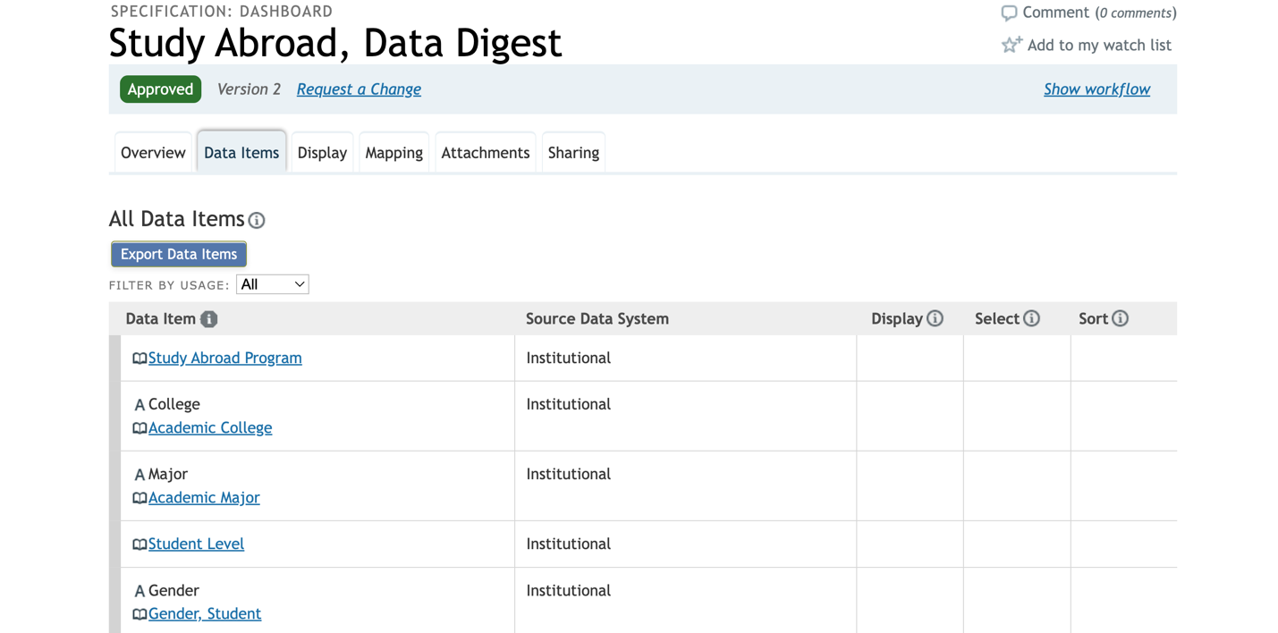

- After an existing definition has been added as a data item, the spec will appear as a “Related Specification” on the definition.

Display Tab (Optional)

- Use this tab to add additional information about the definitions or labels on the data items tab or to display additional notes, if needed, about the data items for the spec. Click the arrows to expand the “Items on Display” section.

- You can change the Display Mode by clicking on the Change Display Mode link. Options on this page change based on the selected display mode. Choices are "Image mock-up with pin drop," "sample attachment," and "full text description.”

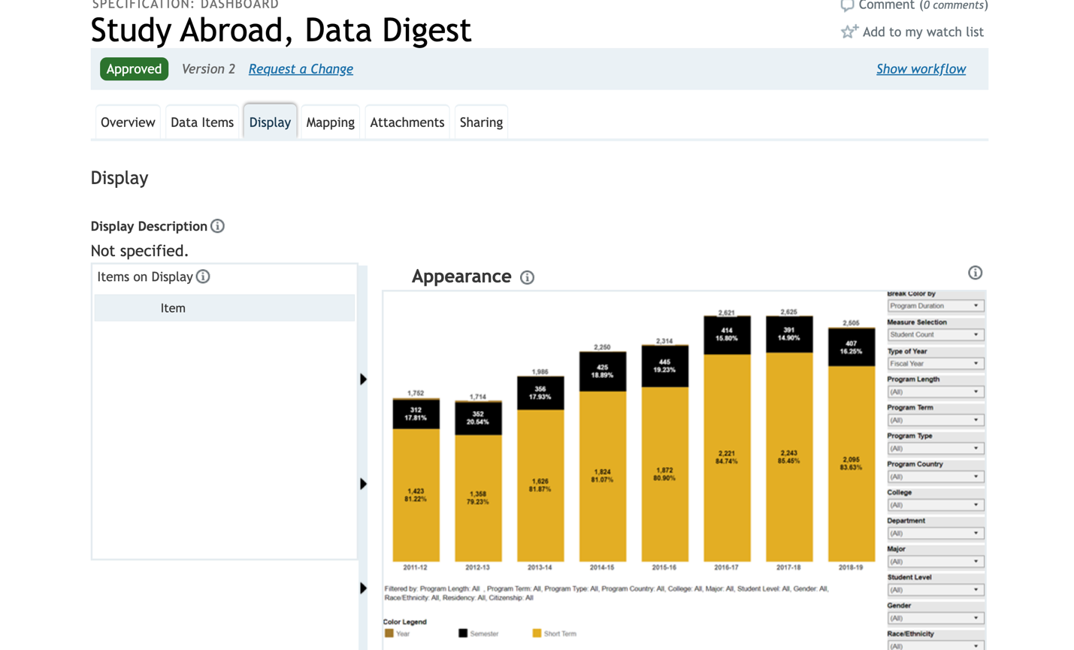
- Choose “Image mock-up with pin drop” option to add an image of the dashboard. To add an image of the desired report, click Add image and select a photo to upload. You can load any type of graphic file, such as a PNG, JPEG, GIF, or TFF. The optimal file size is 643px wide; wider files will display, but require horizontal scrolling to view the full image. The image you upload is also saved as an attachment (available from the Attachments tab). You can load only one photo. If you load a different image, the attached file is replaced.

- Choose “Full text description” option if you need a text area for including a description of the display. You can also add information about the header and footer of the report/dashboard.

Mapping Tab (Currently Not Implemented)

Attachments Tab (Optional)

- If there is a document that provides more information about a report or dashboard, it can be included as an attachment by uploading it to this tab.

- If you added an image of a dashboard in the “Display” tab, it will be also saved as an attachment in this tab.

- Note: If you are attaching a file that is hosted on a website, be mindful that such items might go out of date. For that reason, providing a URL is preferable to attaching a file. Enter the URL in the Description field of the pop-up window (do not attach the URL).

- Maintenance of attachments, including making sure they are up to date, is the duty of the Functional Area.

Sharing Tab (Currently Not Recommended)

New Specification Workflow

Data Cookbook specifications are routed through a workflow which allows the functional area to draft, review, and approve.

Specification approval process workflow
- In the Drafting stage, the specification creator writes the draft. They can invite additional collaborator(s).
- Once submitted, the Functional Area Review stage starts, and the reviewer(s) will be tasked with reviewing the specification. They will have the option of sending it for a final review, cancelling it, or sending it back to drafting.
- In the Final Review, the final reviewer(s) will have the option of approving it, cancelling it, or sending it back to draft.
- It is not recommended to cancel specifications. If the specification is no longer needed, contact idata@purdue.edu to delete the specifications.
- Users with the approval role are able to draft specifications and bypass the functional area review stage and move the object to final review.
- If the current workflow does not meet the needs of your area, contact idata@purdue.edu to explore the possibility of developing a customized solution.

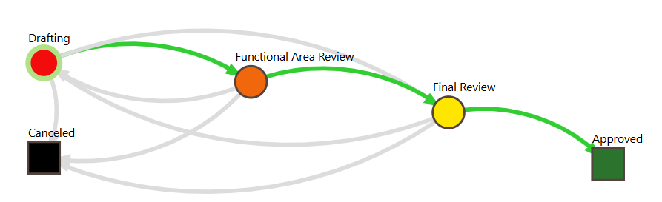

Editing/Approving Specification

- Use the “Edit” button to update the specification and “Save” button at the bottom of the page to save changes.

- If the specification is in the “Drafting” stage: Once you are done editing, you can click the “Submit” button to send it to the “Functional Area Review” stage in the Workflow.

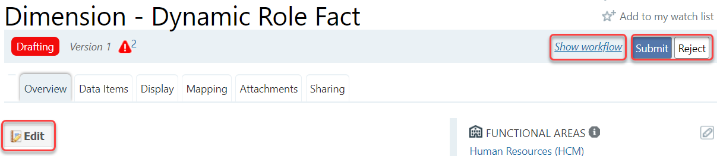

- If the specification is in the “Functional Area Review” stage: Once you are done editing, you can click the “Review Complete” button to send it to the “Final Review” in the workflow for an approver to review. If you think specification needs more work, click “Back to Drafting.”

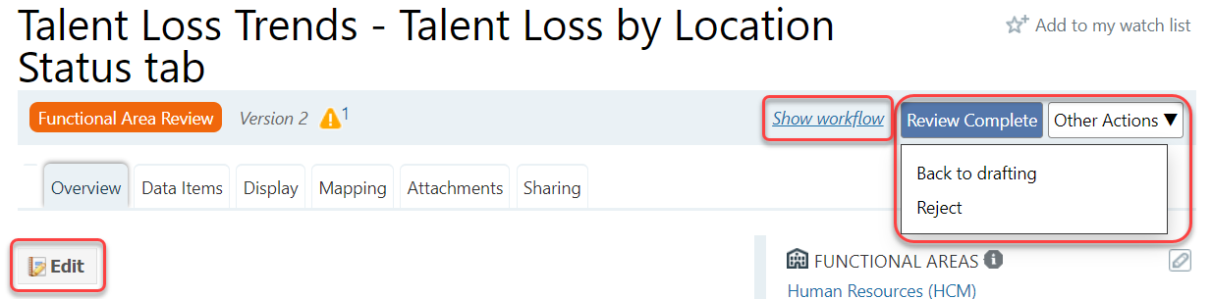
- If the specification is in the “Final Review” stage: Once you are done editing, click the “Approve” button to approve the specification. If you think specification needs more work, click “Back to Drafting.”

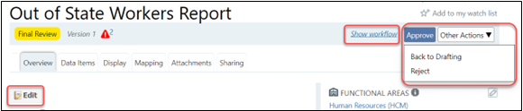

Creating New Version of Specification

- To create a new version of specification, click the “Request a Change” button as shown in the picture below. This is for making edits on approved specifications.

df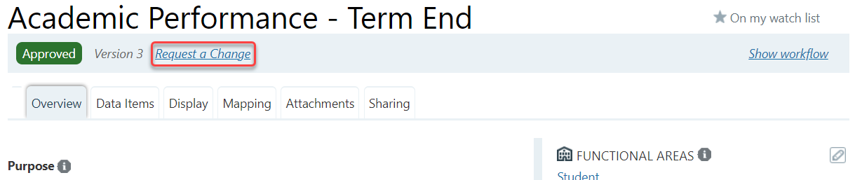
- This will open up a request change form where you can describe the nature of the change or include a comment which will be visible in the history and comments section of the specification. The form is optional but can be used to document why a change is being made.
- Click the Submit button at the end of the form to create a new version of the specification. The new version of the spec will be in “Drafting” and you can see the version number next to the Functional Area Review label.

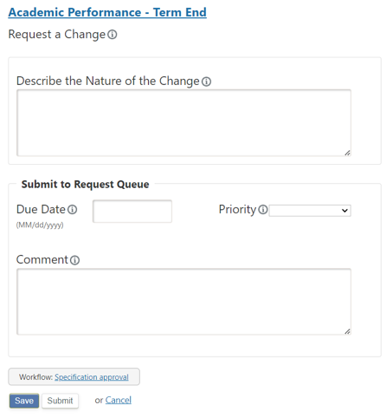

- Note: Data Cookbook has a Collections feature which allows you to group related specifications (dashboard, report or dimension) and manage this group through the Data Cookbook functionality of workflows. For example, we can use collections to group a set of related dashboards or reports so that users can easily find them. Collections are also used to document database stars.

- If you would like to create a collection, please email idata@purdue.edu for more information.

Adding a Pop-Up Window to Dashboards and Reports

- Cognos and Tableau can include a code in their reports and dashboards to allow a consumer to view the approved specification details stored in Data Cookbook. This provides end users with the metadata included in the report or dashboard.

- For example, a Cognos report author might include a button object on the report to allow the person running the report to click the button and see the detailed information from Data Cookbook displayed within the Cognos application in the form of a pop-up or portal window. To add the code to a report or dashboard you must have an approved specification.

- The unique code that is assigned by the Data Cookbook is at the end of the URL of the specification in the Data Cookbook.

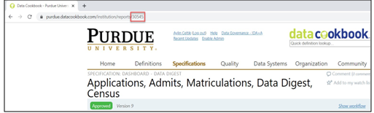

Adding a Pop-Up Window to a Tableau Dashboard

- Go to the following website to download and save the Data Cookbook image into your computer: Data Cookbook imagehttps://www.purdue.edu/bicc/external/images/cookbook.png (https://www.purdue.edu/bicc/external/images/cookbook.png).

- Right click on the image that opened up in a browser, click “Save image as…” and save it somewhere in your computer.

- On the dashboard tab, go to the bottom left to the objects panel. Hover over the image icon and drag it to the top of the dashboard and drop it on top of the dashboard.

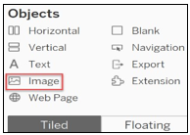

- The “Edit Image Object” box will open. If it doesn’t open, click on the down arrow on the right of the image box to get the dropdown menu and select “Edit Image.”

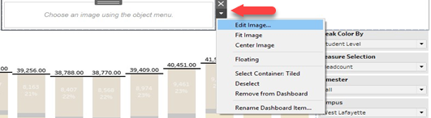
- The “Edit Image Object” box is where you will choose the image and place the target URL for the specification portal pop-up.

- Click on “Choose” button and navigate to where you have the image stored to select it.

- Check the “Fit image” and “Center image” boxes if they are not already selected.

- Copy the URL for the specification using the portal pop-up syntax and place it in the “Target URL” box.

- Click OK.

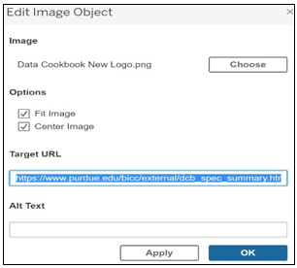
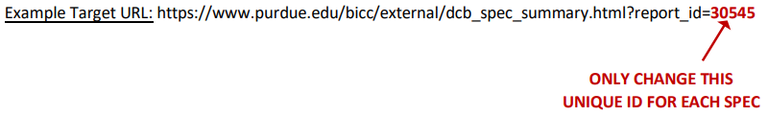

Example Final Product:

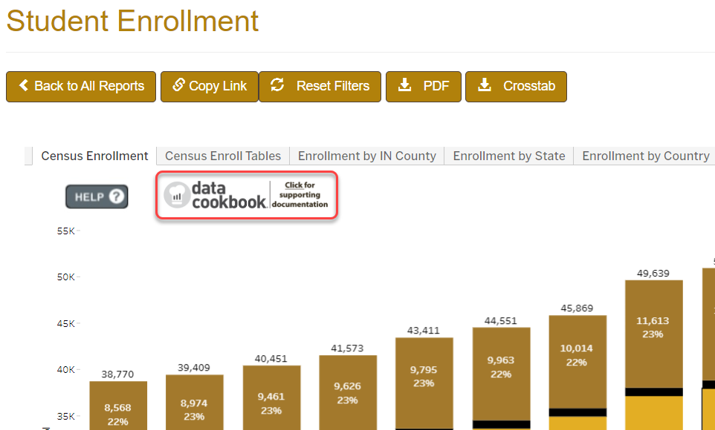

Adding a Pop-Up Window to a Cognos Report

- In Standard Report template, on the Prompts page, double click the <HTML item>.

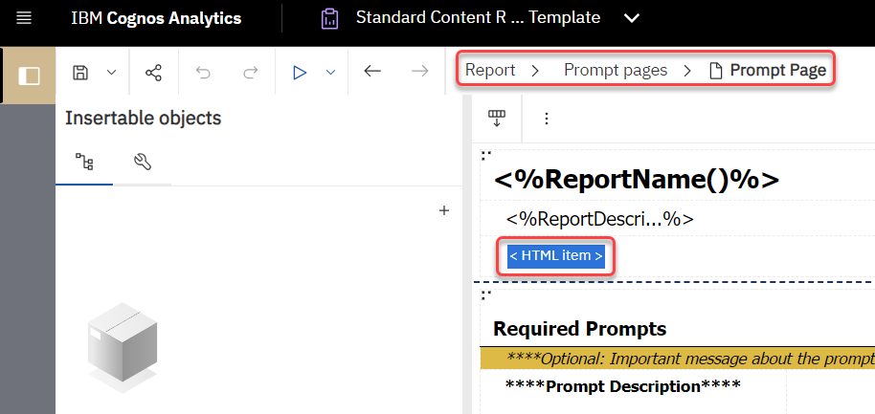
- A window will pop-up, containing a generic HTML. Replace the 99999 code with your specification’s code and click OK.

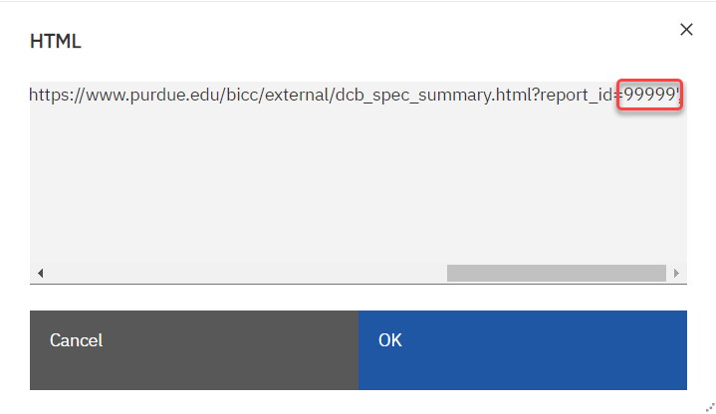

- The Cognos report will now have a link to the detailed information from Data Cookbook in the form of a pop-up or portal window.
