Data Cookbook: Creators of Definitions - Standards

idata@purdue.edu

7/17/2025

Table of Contents
Creating New Definition 2
Step 1: Name (Required) 3
Step 2: Functional Definition (Required) 4
Step 3: Source of Definition 6
Step 4: Classification (Required) 6
Step 5: Responsible Office (Required) 7
Step 6: Technical Table Name (Available for select systems) 7
Step 7: Technical Field Name (Available for select systems) 8
Step 8: Data Type (Available for select systems) 8
Step 9: Security Level (Available for select systems) 8
Step 10: SCD Type (Available for select systems) 8
Step 11: Inactive 9
Step 12: Technical Definition (Available for select systems) 9
Step 13: Tags (Limited Usage) 10
Step 15: Functional Areas (Required) 10
Save & Submit Definition 10
Importing Definitions 11
New Definition Workflow 12
Definition approval process workflow 12
Adding/Removing Collaborator 13
Add a Collaborator 13
Remove a Collaborator 14
Sidebar Fields 15
Synonyms 15
Attachments 15
Related Specifications & Collections 16
Related Quality Rules 17
Quality Issues 17
Community Sharing 17
Functional Area Review of Definition 18
Options to Find Definition(s) Ready for Review 18
Editing Definitions 19
Final Review and Approval of Workflow 21
New Version of Definition 22

Creating New Definition

- To create a new definition, hover over the “Definitions” tab and click on “Create a Definition” option:

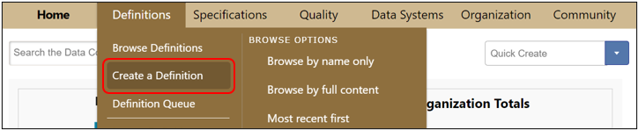
- A new page with the definition template will open.
- Required entries are marked with red asterisks (*).
- Hovering over information icons () displays detailed explanations of information needed.

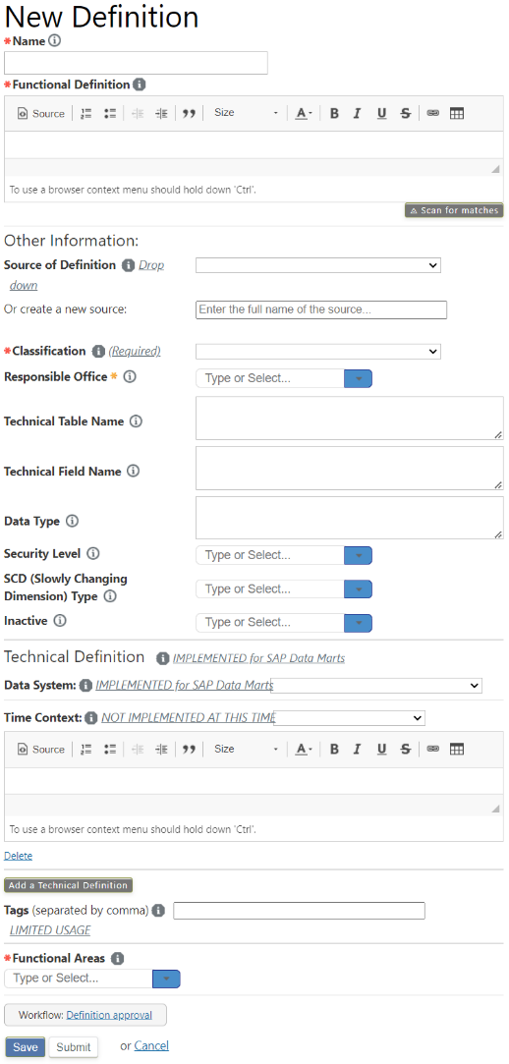

Step 1: Name (Required)

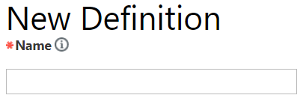
- A definition name is a word or phrase representing a data element. The name should be exactly as it is used in our organization, so that anyone looking for the definition can locate it. It can be a field or group of concatenated fields in a database, a derived field, a calculation (e.g., Grade Point Average), or a management metric (e.g., Retention Rate).

- Definition names should adhere to the following 2-part naming convention, separated by commas:
  - Data Element
  - Functional Area- Subject area within Data Cookbook; it should be added if doing so delineates how different functional areas use similar data elements.

- Examples:
  - Employee, Human Resources
  - Credit Hours, Student
  - Deferred Admission, Graduate Slate

Name Standards
- Avoid abbreviations
- Capitalize the first letter of each word, except short words (e.g., a, the, by, for, etc.)
- Make names descriptive of the definition
- Omit "A", "An", and "The" from the beginning of the name
- Avoid numbers and special symbols
- Parentheses can be used
- Do not use underscores, hyphens, dashes, ampersands - these characters may be ignored in Cookbook search and can turn into garbled text when exported
- Delete leading and trailing white spaces (can occur when cutting and pasting from other sources) - Data Cookbook will treat "Tuition Revenue" and "Tuition Revenue<space>" as different definitions
- For SAP Master Data definition naming standards, refer to “Master Data Definition Naming Standards” in the Appendix

Step 2: Functional Definition (Required)

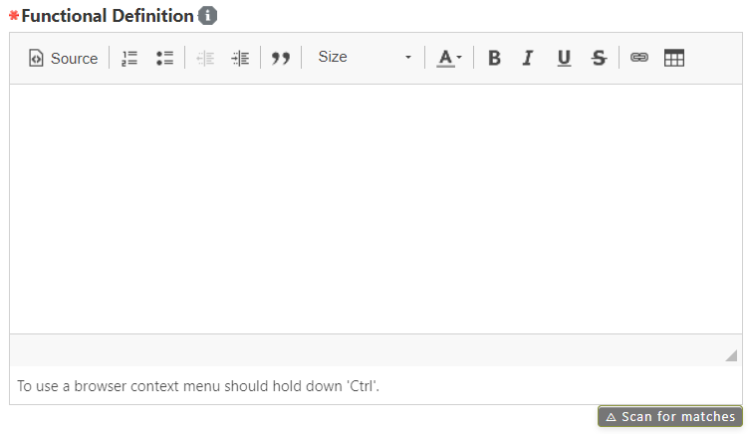
- The functional definition is the business use of the data element. It should provide uniqueness within a functional area, links to related definitions, examples or values, as well as context that would enable understanding for a person who is unfamiliar with the data.

Functional Definition Standards:
- Use complete sentences and standard grammar
- Be concise, precise and specific
- Use business, not technical language
- Words such as university, fall, spring should be lowercase
- Be as exhaustively descriptive as seems relevant
- Avoid emotive language, including persuasion
- Be candid, not sensational
- Avoid circular references
- Limited use of abbreviations is recommended. Define a term once and include the abbreviation in parentheses immediately after. For example, “Capacity Utilization Level (CUL)” or “Full-time Equivalent (FTE).”
- Parentheses can be used
- If copy/pasting from Excel, be aware of forced line breaks (when ALT+Enter is used in a cell instead of Excel wrap text function) - this creates a hard-line break in Cookbook and will cause the definition to split into multiple lines and cells when exported to CSV. It is best to turn off the Wrap Text function and copy the text from the Formula Bar.
- Special symbols may be used in a definition but must be preceded by the name of the symbol followed by the symbol in parentheses. For example, “Percentage of the difference between 100 percent (%) Occupancy…”
- Avoid using jargon and highly technical details. Those are included in the technical definition.
- The first time you refer to a related definition, hyperlink to that definition. Use double brackets around the related definition. For example, Graduation Rate [[Retention Rate, Student]] or Academic Year, Student [[Academic Period, Student]].
- Deviation from these standards is allowed if doing so adds to the ease or accuracy of understanding.
- To link to a website outside of Data Cookbook, use the hyper link button in the Functional Definition text box. When the hyper link button is clicked, a new menu will open, allowing the user to enter the display text and paste the URL. Click OK to save the link.

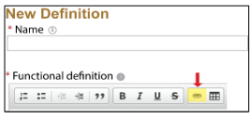
To create a functional definition, follow the steps below. Note: Definitions may contain some or all of the following elements.

- Business definition, understandable, no jargon (required):
  - Concise business explanation of the element, written in common language, for someone unfamiliar with the element. For example, the definition for “Academic Period” would appear as follows: Period of time during which formal instruction occurs.

- Context, cautions, standard uses or misuses:
  - Additional information, such as cautions, context, common misinterpretations, historical changes in values or use, how it can be sorted or grouped. If the term created has the same base term but a different term modifier or organization from another definition, refer to the similar term in the paragraph. Include the hyperlink to a similar term.

- See also: include links to other related or relevant definitions:
  - For similar definitions that were not referenced in previous paragraphs, include links here. Also include information regarding other related data elements.

- Keywords:
  - Consider what other keywords someone less familiar with the topic might use to search for this element. Including these in the functional definition will allow a search to identify it as a match. Use this format: “Keywords: synonym1, synonym2, etc.”
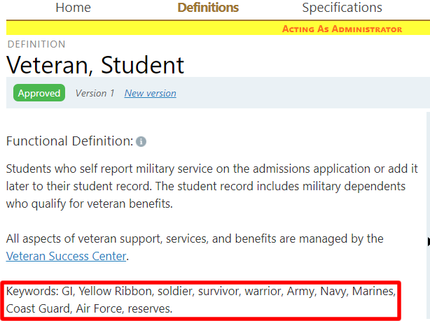

Step 3: Source of Definition

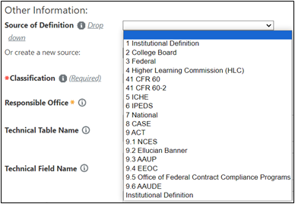

- Source of the definition will be “Institutional Definition,” in most cases, indicating it is a Purdue definition. Other options are external sources of definitions such as ICHE or IPEDS.

- Choose one of the sources from the drop-down menu, do not create a new source by using the text box. If additional external sources are needed in the drop-down, contact idata@purdue.edu.

Step 4: Classification (Required)
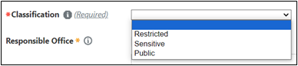

- Under the University’s Data Classification and Governance Policy, Purdue University data will be reviewed on a periodic basis and classified to its use, sensitivity and importance to the University and in compliance with federal and/or state laws.

- The three levels of data classification are: Public, Sensitive, and Restricted:
  - Public Information: Open to the general public: defined as information with no existing local, national or international legal restrictions on access. Example: Course Catalog.
  - Sensitive Information: Access must be guarded due to proprietary, ethical or privacy considerations. This classification applies even though there may not be a civil statute requiring this protection. Example: Birth Date, Ethnicity.
  - Restricted Information: Legally protected by state or federal statutes, policies or regulations. This level also represents information that is not legally protected, but for which the information owner has opted to restrict access. Example: Student’s academic records (protected by FERPA), SSN.

- Additional information can be found at:
  - Data Classification and Handling Procedures (https://www.purdue.edu/securepurdue/data-handling/index.php)

Step 5: Responsible Office (Required)

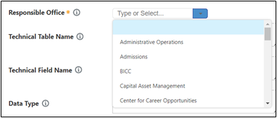

- Office to contact for additional information. If additional offices are needed in the drop-down, contact: idata@purdue.edu.

Step 6: Technical Table Name (Available for select systems)

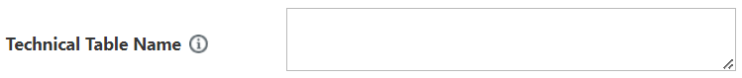
- The name of the table in the Data System that the field originates in. This field is required for SAP Data Mart definitions and may be available for other Data Systems. It will be used for the new Purdue Data Warehouse (PDW).

Step 7: Technical Field Name (Available for select systems)
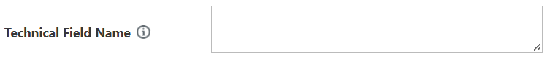
- Technical name in the Data System of the field. This field is required for SAP Data Mart definitions and may be available for other Data Systems. It will be used for the new Purdue Data Warehouse (PDW).

Step 8: Data Type (Available for select systems)

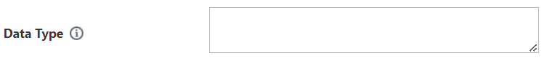
- Indicates the format of the data and string length (if applicable). Examples include VARCHAR, DATE, or NUMBER. This field is required for SAP Data Mart definitions and may be available for other Data Systems. It will be used for the new Purdue Data Warehouse (PDW).

Step 9: Security Level (Available for select systems)

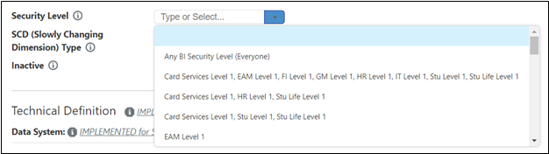

- Indicates the Purdue Defined Security Role Required to Access this field in Cognos. This field is required for SAP Data Mart definitions and may be available for other Data Systems. It will be used for the new Purdue Data Warehouse (PDW).

Step 10: SCD Type (Available for select systems)

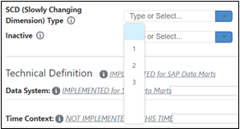

- SCD (Slowly Changing Dimension) Type (Available for select systems)
  - Type 1 – Old value overwritten
  - Type 2 – New additional record is created in order to maintain history
  - Type 3 – Old and new values stored in a single record to maintain history \

Step 11: Inactive

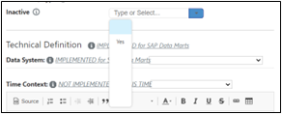

- Inactive Flag: Used to indicate archived content. Please choose “Yes” from the drop-down menu if the definition is no longer populated.

Step 12: Technical Definition (Available for select systems)

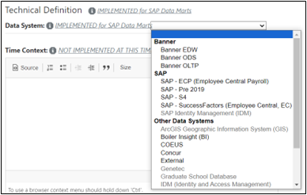

- The need for Technical Definitions are case based. For example, they are currently used for documenting Purdue Data Warehouse fields.

- Choose a data system from the dropdown menu. If the data system isn’t listed, contact idata@purdue.edu.

- Time Context is not currently implemented. Leave this field blank.
- The technical definition should include information about where the data item can be located in Cognos or the warehouse. This field cannot be blank, if there is no technical definition, type “N/A” in the field to clear the error.
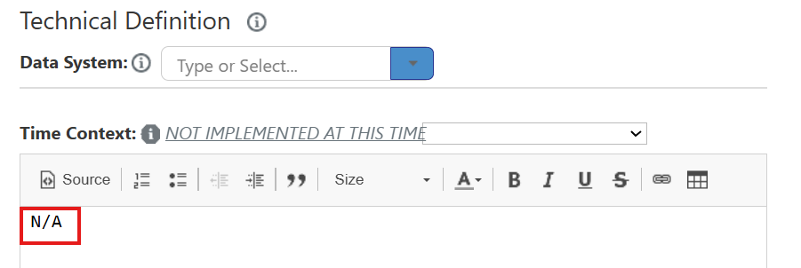

Step 13: Tags (Limited Usage)

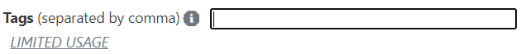
- A tag is used to quickly group definitions or specifications together for ease in searching. They are used as a filter on the browse page. They may be shared by multiple definitions. For example, hit the Definitions tab and from the Tag filter choose “COVID-19” to see all Covid-19 related definitions with “Covid-19” tag.

- Contact idata@purdue.edu to request new tags.

Step 15: Functional Areas (Required)

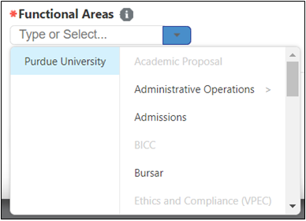

- Functional subject area(s) of the data element. If additional functional areas are needed or unsure of which functional area to use, contact idata@purdue.edu.

Save & Submit Definition

- Once the new definition is complete, click the "Save" button to save information entered in the form. You can edit the information and save it again any time before submitting the form.

- Click the "Submit" button after the draft is complete. Once submitted, the review process of the definition approval workflow starts.

Importing Definitions

- If you have a large set of definitions you need to import, please contact idata@purdue.edu for assistance.

New Definition Workflow

Data Cookbook definitions are routed through a workflow which allows the functional area to draft, review, and approve.

Definition approval process workflow
- In the Drafting stage, the definition creator writes the draft. They can invite additional collaborator(s).
- Once submitted, the Functional Area Review stage starts, and the reviewer(s) will be tasked with reviewing the definition. They will have the option of sending it for a final review, rejecting it, or sending it back to draft.
- In the Final Review, the final reviewer(s) will have the option of approving it, rejecting it, or sending it back to draft.
- It is not recommended to reject definitions. If the definition is no longer needed, contact idata@purdue.edu to delete the definition.
- If the current workflow does not meet the needs of your area, contact idata@purdue.edu to explore the possibility of developing a customized solution.
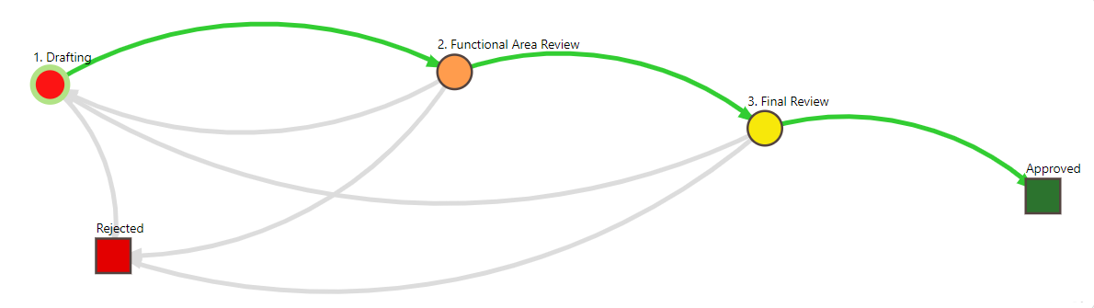

Adding/Removing Collaborator

- A collaborator is an additional user who is added to a definition to assist with reviewing or revision. A collaborator may be added at the Drafting, Functional Area Review, or Final Review steps in workflow.

- When adding a collaborator in the workflow, it is for that definition only. You will need to add the collaborator to each definition as needed.

Add a Collaborator
- On the Edit definition window, click on Show Workflow

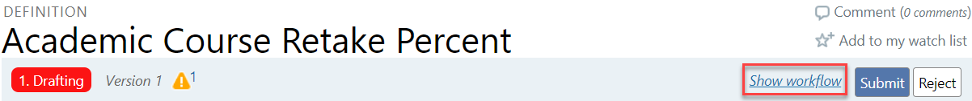
- With the Definition Workflow expanded, click on icon next to Collaborators
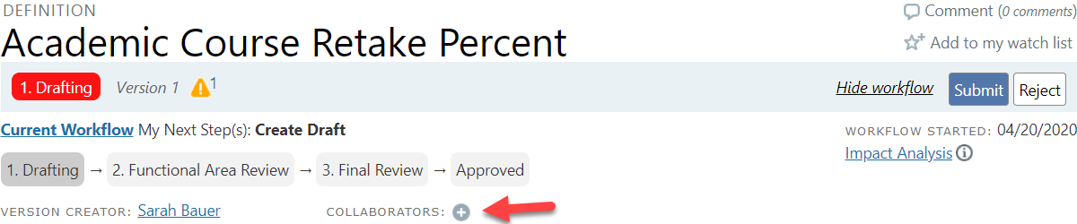
- Select a collaborator and their role

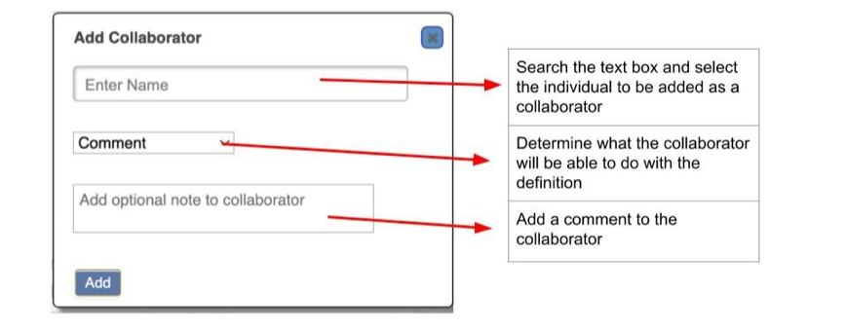
- A Collaborator can be designated to conduct one of the three activities:
  - Comment – the collaborator is able to provide comments on the definition
  - Edit – the collaborator is able to edit the definition
  - Delegate User Role – the collaborator has the same role as the editor

Remove a Collaborator
- Click on Show Workflow to open workflow

- Click on the collaborator’s name, under Collaborators, you want to remove.

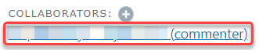
- A window will open - click on “Remove Collaborator.”

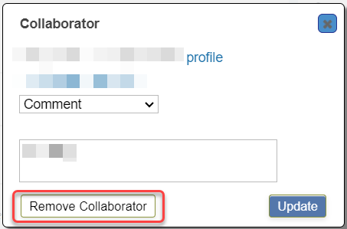

Sidebar Fields

- There are additional fields located on the right-hand sidebar of a definition page, where definition creator can provide information that has not yet been covered in the definition template.

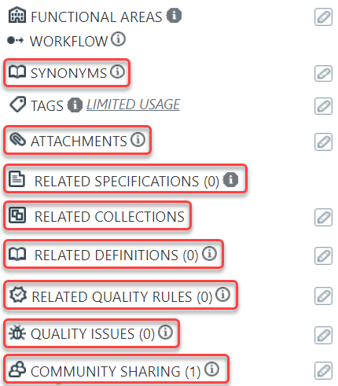

Synonyms

- Synonyms should not be utilized. Once a synonym is created, it cannot be used as a Definition Name later. The same functionality is met by using “Keywords” in the definition. Any word in the Definition Name or anywhere in the functional definition will be found when a search is done. If there is a need for either of these, please contact idata@purdue.edu.

Attachments

- If there is a document that provides more information about a definition, it can be added as an attachment. However, if the document is available on a website, it is recommended to add a link to the document in the definition. This allows for better version control.

- To add an attachment, click the pencil icon on the right-hand side of the box shown below a follow the instructions.
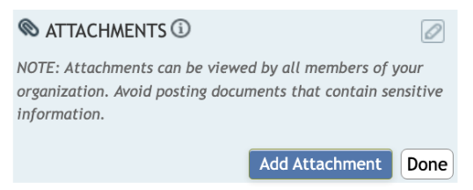 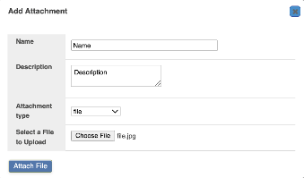 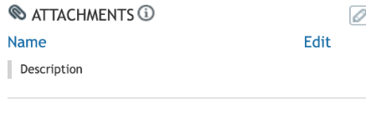

- Note: Attachments cannot be added to the Approved definitions. If a definition is Approved, a new version must be created, and the attachment added to it.

Related Specifications & Collections

- Relationships between Data Cookbook objects can help users understand the purpose of an object or how the object is used. If a definition is included in a specification’s data items, the specification will automatically be listed under Related Specifications on the Definition.

- To manually add a Related Specification or Collection, click the pencil icon next to “Related Specifications” or “Related Collections” and begin typing to locate the object. Click the object name, then click the “+” button. Click “done” to save the relationship.

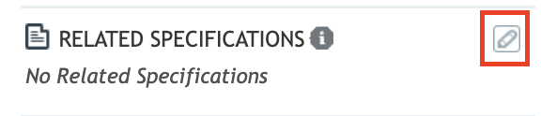
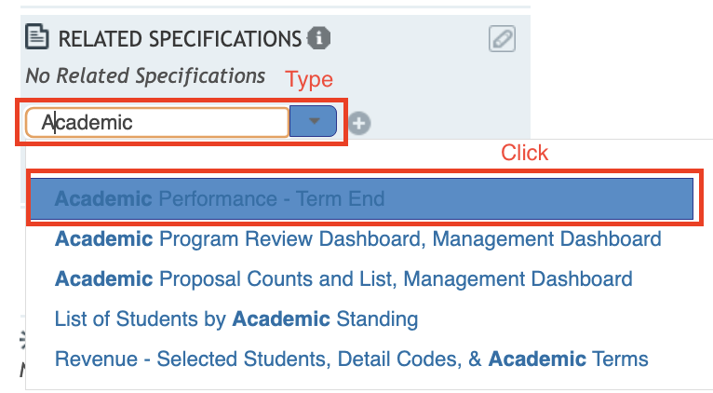
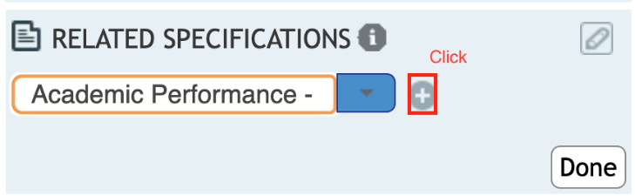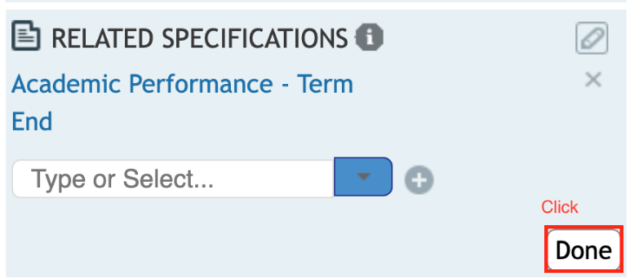

Related Quality Rules

- This feature is not implemented and should not be used.

Quality Issues

- This feature is not implemented and should not be used.

Community Sharing

- There is an option to share Definitions with other higher education institutions via Community Sharing. Definition editors and approvers are able to share definitions with the community. Definitions should only be shared with Functional Area approval.

- To share definitions with the Higher Education Community, click the pencil icon next to Community Sharing. Click the checkbox next to Higher Education and click “save”. A green checkmark will show next to Higher Education indicating the definition is currently shared with the community.

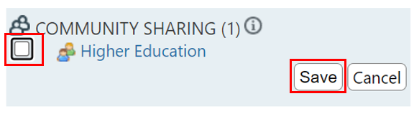
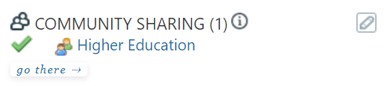

Functional Area Review of Definition

After a definition is created, edited if necessary, and the “Submit” button is selected, it moves to the next stage, Functional Area Review. There, other(s) with a create/edit role for that functional area begin their review of the definition. They may make edits and consider it ready for the functional data owner to do a final review and approve. Or they also can send it back to Drafting and add a comment on why it needs more work. It is not recommended to reject definitions. If the definition is no longer needed, contact idata@purdue.edu to delete the definition.

Options to Find Definition(s) Ready for Review

- From an email received that a definition is ready to review, use link to definition embedded in email.

- Use Search box on Home tab or Search box on Browse Definitions tab, if you know the object name.

- Use My Tasks on Home tab:
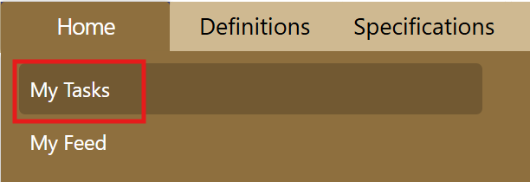

- Go to Definition queue and use the cascading prompts as shown below; click on Definition Queue:

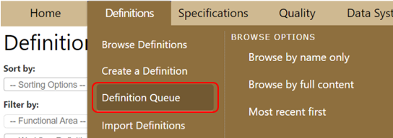
  - Definition Approval Queue page will open. You can search the list of definitions under the Filter by section or by paging through the list. There is an option to bulk approve definitions, for more information about this feature, see the Appendix.

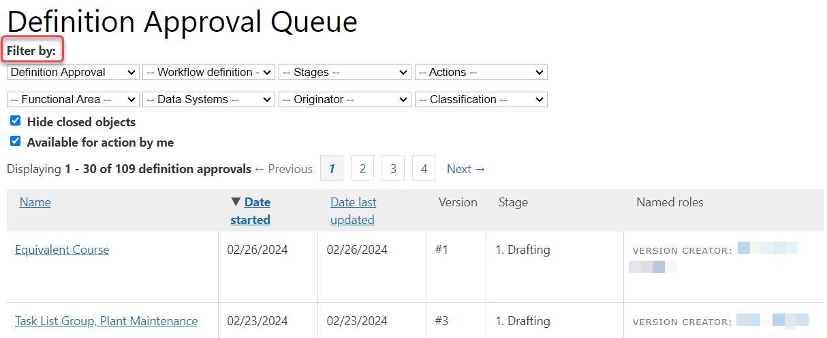
  - The top row of the search is cascading prompts. You must select a value in the first search box - Workflow type - to populate the next search box - Workflow definition. Workflow type is prepopulated with Definition Approval. And you must select the Workflow definition - select the Current Workflow # at the top of the list.

  - Stages (Drafting, Functional Area Review, Final Review) can be used to narrow the search.

  - The second row of the search you can select individually and should filter by Functional Area to narrow the search.

  - “Hide Closed Objects” option: Check the box to limit to those definitions awaiting further action.

  - “Available for Action by Me” option: Check the box to further limit the list.

  - By clicking on the Name field or any of the column titles, you can change the sort order.

Editing Definitions

- Once you have narrowed down your selection, under the Name column, click on the definition you wish to edit. This will open the Definition window.

- Click the Edit button.

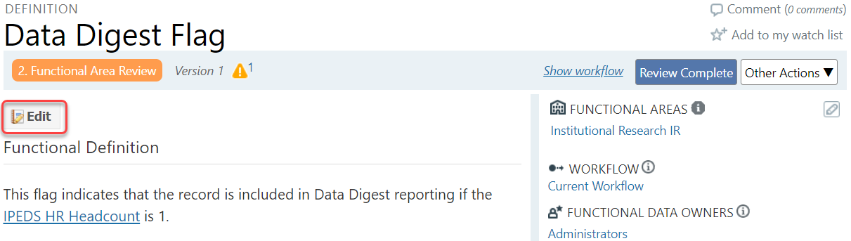
- After updating the definition, click the “Update” button at the bottom of the page to save the work. The definition may be edited again before moving to the next workflow step which is the Review Complete step.

- Once the “Review Complete” is clicked, you no longer can make edits as the next person in the review process has ownership. Click “Back to Drafting” if you think definition needs more work. It is not recommended to reject definitions. If the definition is no longer needed, contact idata@purdue.edu to delete the definition.

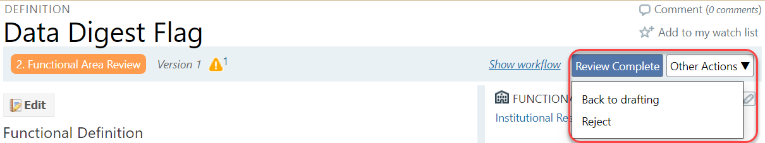

Final Review and Approval of Workflow

- The Functional Data Owner with approver role begins a final review for accuracy, completeness and adherence to standards.

- Options include “Back to Drafting” if definition needs more work, “Reject”, and “Approve”. It is not recommended to reject definitions. If the definition is no longer needed, contact idata@purdue.edu to delete the definition.

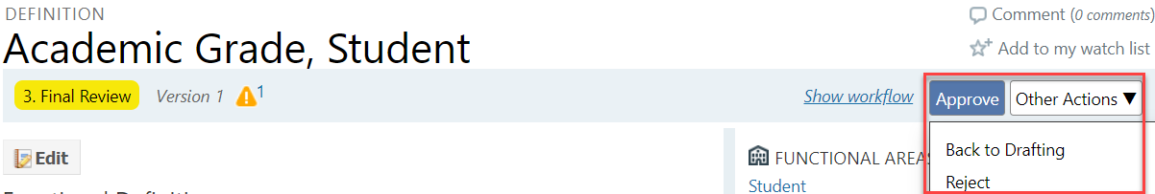
- Once the “Approve” button is selected, definition will have a green “Approved” label and the definition version # will be also green when browsing the list of definitions.

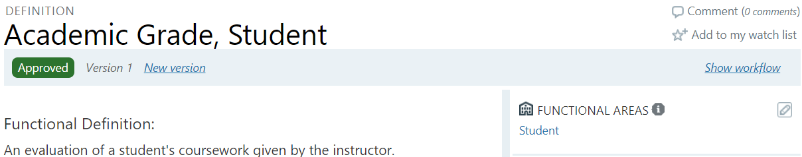
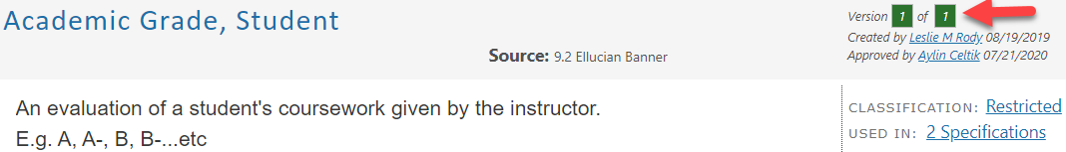

New Version of Definition

- Later, if additional edits are needed, a new version can be created, and it will go through the workflow process again. Use the “Add a Comment” field to document what edits created the need for a new version.

