Data Cookbook
Recently Created & Recently Modified Sorting Features

The purpose of the new feature is to make Data Cookbook users aware of any newly approved Definitions or Specifications, or modifications to Definitions or Specifications, affecting subjects or areas of relevance to them.

When browsing Definitions or Specifications, Data Cookbook users now have a new option of sorting the item lists by “Recently Created” or “Recently Modified.”

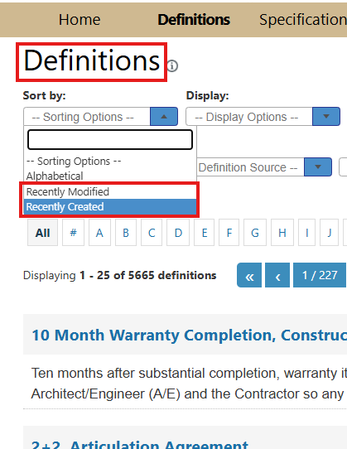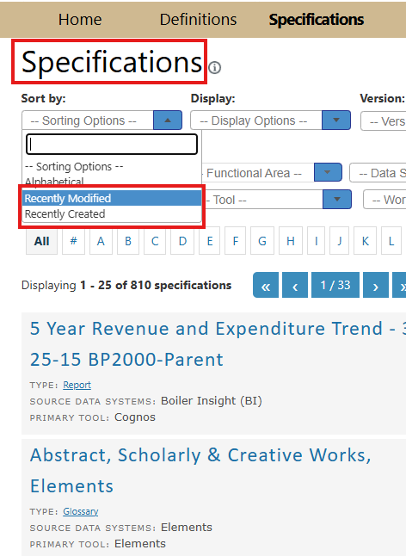

Selecting the “Recently Created” option from the “Sort by” dropdown menu will sort the lists of Definitions or Specifications from the most-recently to the least-recently created.

Selecting the “Recently Modified” option from the “Sort by” dropdown menu will sort the lists of Definitions or Specifications from the most-recently to the least-recently modified.

