Summary:
This process outlines the steps for verifying SAP/ECP/IT0015 for accurate information on Additional Payments.

Access SAP/ECP
Access SuccessFactors through the OneCampus Portal  https://one.purdue.edu  Login using your Purdue career account, user ID and password. | 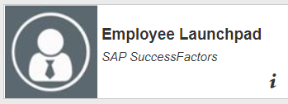  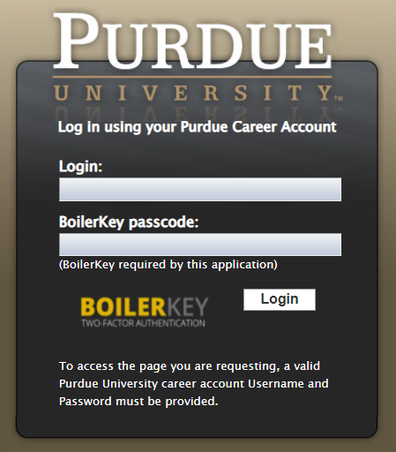
Once in SuccessFactors, Access SAP/ECP through Launch SAP GUI X7L Production on profile.  *Need to be connected to the VPN to sign into ECP. | 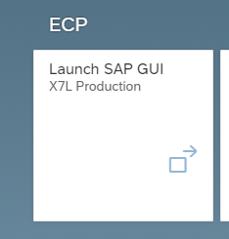
Access PA20
Enter PA20 into search bar.  Hit Execute or enter on keyboard | 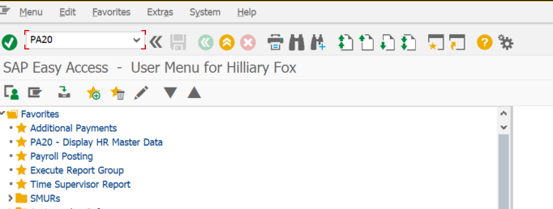
Enter PERNR of person you are validating | 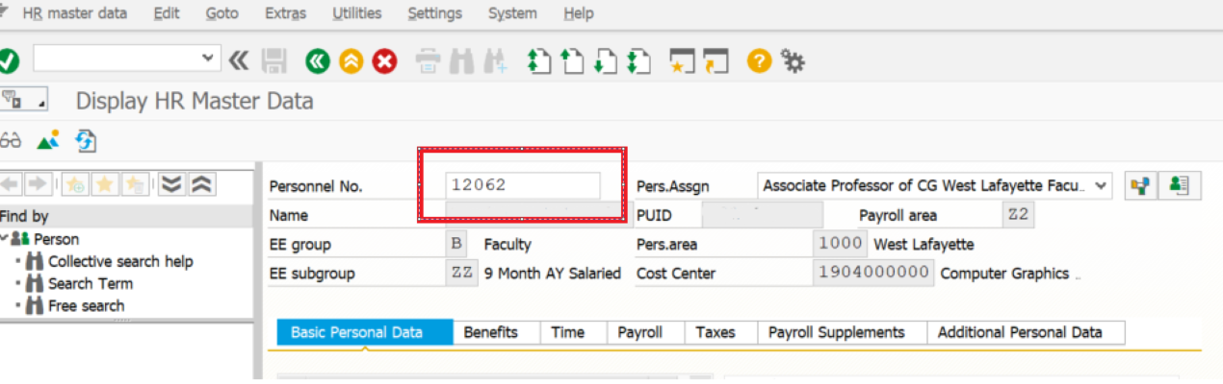
Enter 0015 in to InfoType and 1315  This can also be found under the Payroll Tab and click on Additional payments.  To view, click Moon over the mountain  Tip: If you only want to view Summer Pay entries, you can also enter 1315 in the STY. If you want to see all entries, leave blank. | 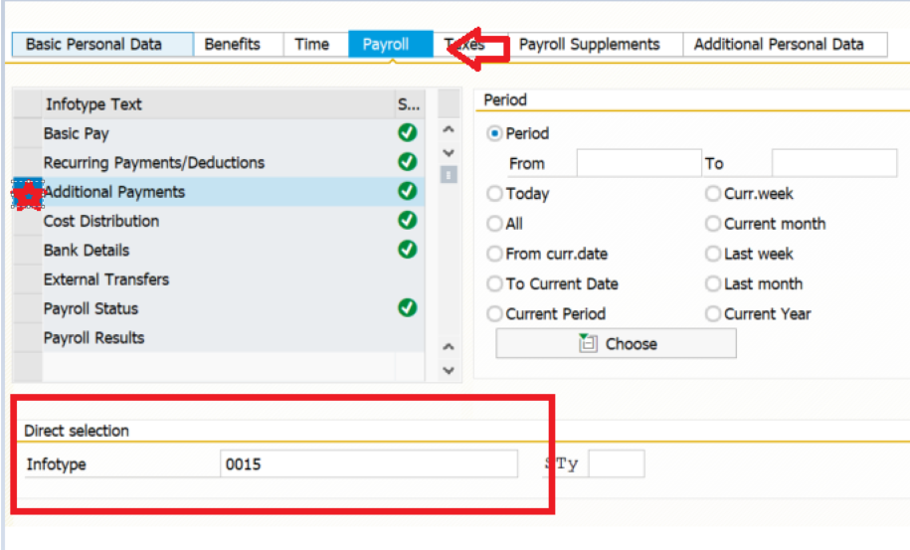  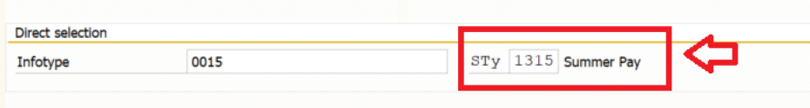
Click entry line you want to check.  Click the Magnifying glass  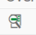 | 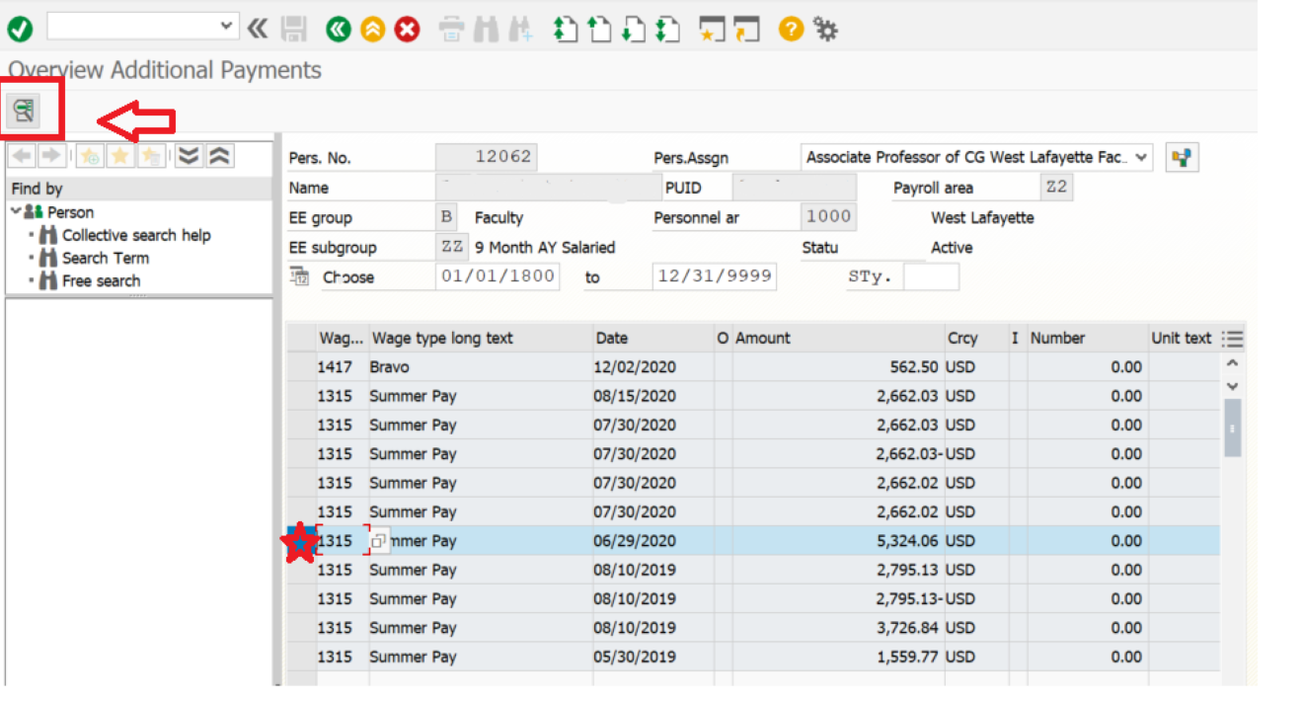
Verify the amount in ECP matches the Summer calendar in SEEMLESS  Beginning in 2022, this will be a lump sum amount.  Verify the date of origin is correct for the pay period submitted. | 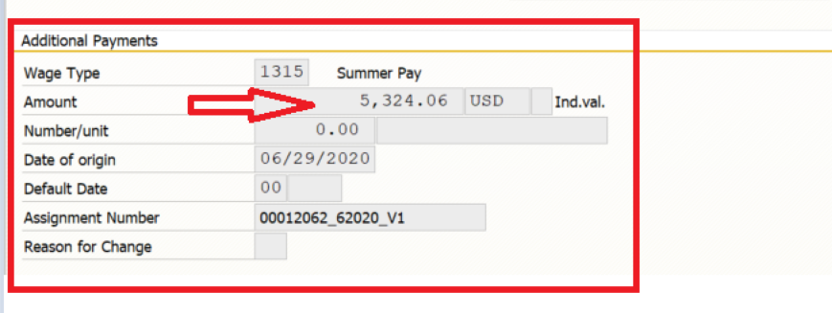  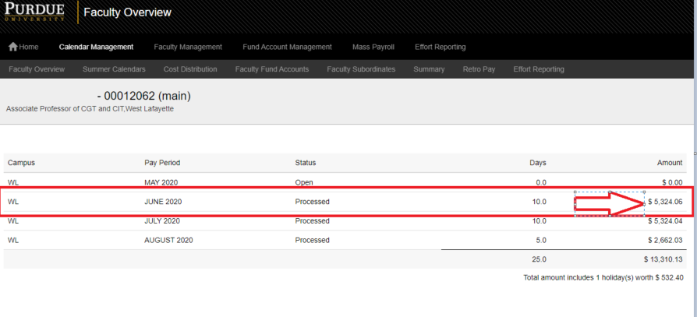
If you find any discrepancies, discuss them with your Business manager.

