Outlines the steps for business offices to complete and submit mass payroll entries for summer pay employees.
- This function is most often used for teaching activities.
- Creating a mass entry utilizes templates for both the Cost Distribution and Work schedule.

CAUTION: Do not use multiple FTE’s within the same pay period as it will cause the pay to calculate incorrectly. For more information on creating templates, see the Manage Templates QRG.

Access the Summer Pay Tool
- Visit OneCampus and select SEEMLESS.  - 2. Log in using Purdue Career Account ID and BoilerKey | https://one.purdue.edu/

Mass Payroll Entry
Once logged in, the Summer Pay Dashboard is displayed. | 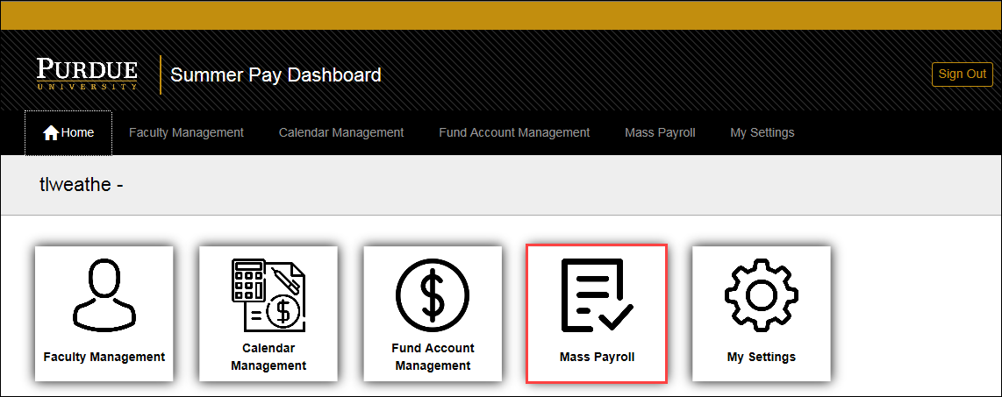
Click Mass Payroll.
Click +Add Mass Payroll Lines and add a line for each employee entry. | 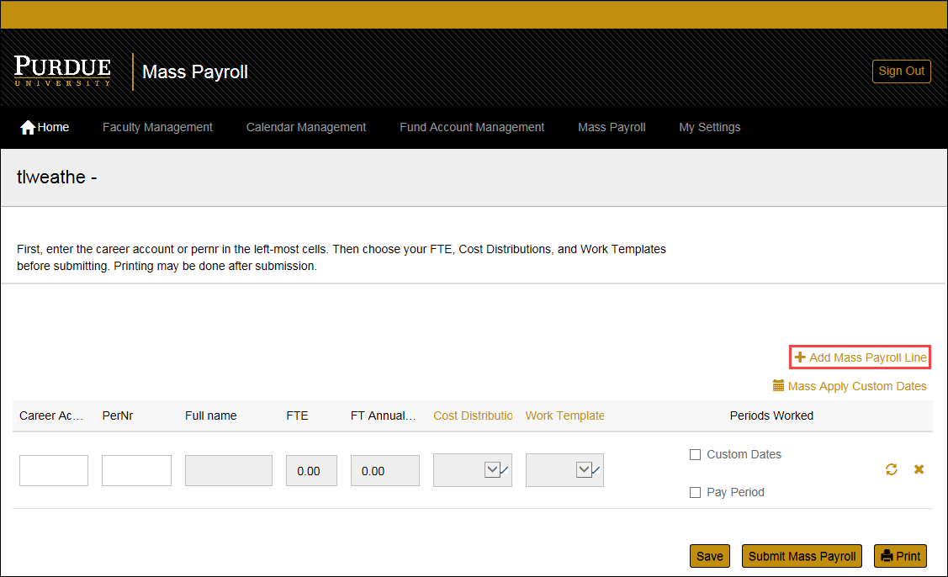
Enter the Career Account ID or PERNR of each individual.  Once entered, the Full Name, FTE, and the FT Annual Rate will auto-populate using the employee’s payroll data.  CAUTION: Do not use multiple FTE’s within the same pay period as it will cause the pay to calculate incorrectly. | 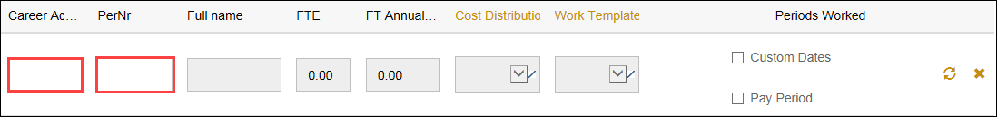

Templates
Select the appropriate Cost Distribution Template from the drop-down. | 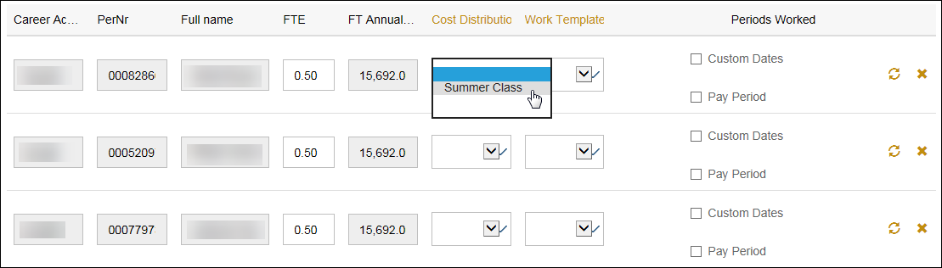
Select the appropriate Work Template from the drop-down. | 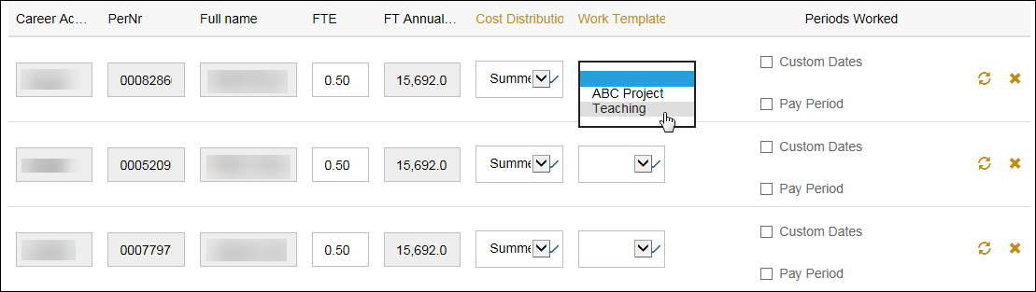
NOTE: Templates can be created from the Mass Payroll tab, but it is encouraged that Templates are created prior to data entry to make the Mass Payroll process more efficient.

Dates
Dates can be entered by selecting the applicable Pay Period(s) or by creating Custom Dates.
Click Pay Period to select months that will include the summer pay activity. | 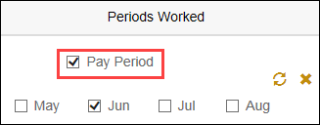
Click Mass Apply Custom Dates to apply the same custom pay period dates to all entries. | 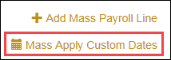
To manually input specific dates, enter the Custom Start and End Dates.  Click the button to select to use the custom dates on all lines. | 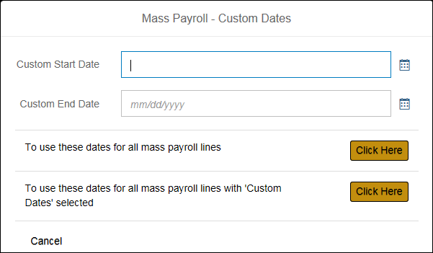
The dates are now applied to all mass entry lines. | 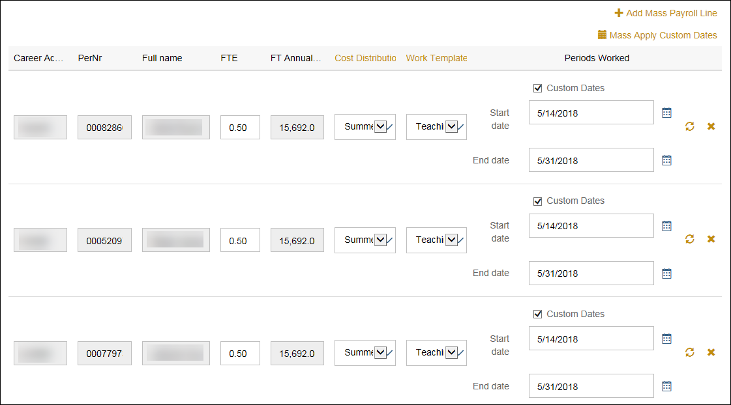
Click Submit Mass Payroll to send to Payroll.

Click Save if the list is incomplete and more entries will be completed at a later time.
Click Yes, proceed. | 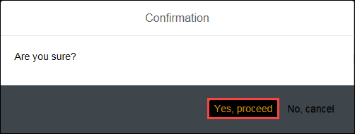
Click OK.  The summer pay information is submitted to Payroll for processing. | 